THE FIFE COUNCIL

NOTICE OF ORDER TO EXEMPT LAND FROM ACCESS RIGHTS

Notice is hereby given under section 11(9) of the Land Reform (Scotland) Act 2003 (“the Act”) that on 25th October 2025, the Scottish Ministers acting under section 11(7) of the Act confirmed The Fife Council (Dalgety Bay) (Exemption) Order 2023 (“the Order”) with modifications, proposed by The Fife Council under section 11(1) of the Act.

The effect of the Order is to exempt part of the Fife Coastal Path in Dalgety Bay (including core path number P709/11) from the access rights which would otherwise be exercisable in respect of that land by virtue of Part 1 of the Act.

The purposes for which the Order has been made are due to Galaween Ghostal Path fundraising event being held on the site. The Order will take effect between noon on 25th October 2025 and 20:00 on 25th October unless revoked earlier.

Full details of the Order together with a Plan showing the land affected may be examined during normal working hours at Reception, Fife House, North Street, Glenrothes and on www.fife.gov.uk.

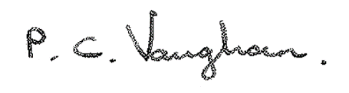

Paul Vaughan

Head of Communities & Neighbourhood