THE FIFE COUNCIL

NOTICE OF ORDER TO EXEMPT LAND FROM ACCESS RIGHTS

Notice is hereby given under section 11(9) of the Land Reform (Scotland) Act 2003 (“the Act”) that on 5th September 2025, the Scottish Ministers acting under section 11(7) of the Act confirmed The Fife Council (Broomhall ) (Exemption) Order 2023 (“the Order”) with modifications, proposed by The Fife Council under section 11(1) of the Act.

The effect of the Order is to exempt part of the grounds of Broomhall estate (including core path numbers: P829/01 | P699/03 | P699/02) from the access rights which would otherwise be exercisable in respect of that land by virtue of Part 1 of the Act.

The purposes for which the Order has been made are to provide for public safety during a charity fundraising event on the site. The Order will take effect between 7AM on 5th September 2025 and noon on 8th September unless revoked earlier.

Full details of the Order together with a Plan showing the land affected may be examined during normal working hours at Reception, Fife House, North Street, Glenrothes and on www.fife.gov.uk.

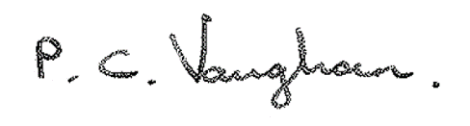

Paul Vaughan

Head of Communities & Neighbourhood