**Community and Housing Sub-Committee**

**26th August 2021**

**Agenda Item No**.

|  |
| --- |
| **Customer and Online Services Performance Report** |
| **Report by:** Diarmuid Cotter, Head of Customer and Online Services, Communities |
| **Wards Affected:**  All |

**Purpose**

To present the performance scorecard for Customer and Online Services for 2020/21

Recommendation(s)

Members are asked to:

1. Consider the Customer and Online Servicesperformance information detailed in the report and presented at appendix 1
2. Consider if any further review work or scrutiny is required and the scope of that review.

Resource Implications

None

Legal & Risk Implications

None

Impact Assessment

An EqIA is not required because the report does not propose a change or revision to existing policies and practices.

Consultation

None required

## 1.0 Background

1.1 Audit Scotland published the Statutory Performance Direction in December 2018. 2020/21 is the second year to which that direction applies. The Council is required to report a range of information setting out:

1. Its performance in improving local public services, provided by both (i) the council itself and (ii) by the council in conjunction with its partners and communities.
2. Its progress against the desired outcomes agreed with its partners and communities.
3. Its performance in comparison (i) over time and (ii) with other similar bodies including information drawn down from LGBF in particular and from other benchmarking activities
4. Its assessment of how it is performing against its duty of Best Value, and how it plans to improve against this assessment

1.2 This is the first Performance Report submitted following implementation of Oracle Cloud. This system has sophisticated reporting tools and better reporting functionality but some of these reports are still in development, particularly those relating to sickness absence.

1.3 Members should therefore be aware that the numbers in this section are different due to the system change. Previously, absence was reported as WDL per FTE. At the moment, the output data being produced is for WDL per employee and as a result, there is likely to be a slight but immaterial difference in the figures.

1.4 Customer & Online Services formed as a service in September 2019 with the creation of a revised structure that consolidated many of the resources and teams who handled external customer contact. The main areas were Customer Service and Revenues. This was based on work carried out by the Customer Programme that proposed an overall ‘to be’ operating model. This operating model is designed to deliver a single view of the customer experience including assessment and decision making for eligibility to services. The aim was also to achieve a significant shift to maximise the use of digital channels in service access and fulfilment.

1.5 Customer & Online Services has staffing of 400fte and an operating budget of £12m. It consists of eight main areas

* Contact Centre
* Customer Service Centres (including Registration)
* Scottish Welfare Fund
* Revenues (Assessment)
* Revenues (Collection)
* Online Services
* Information Team ( FoIs etc)
* Customer Escalations Team (complaints etc.)

1.6 While some of the work in the service is self-contained there are numerous interdependencies across services particularly, Building Services, Housing Environment, Transportation and Health & Social Care. Management of these relationships is vital to the success of the service.

**2.0 Contact Centre**

2.1 Table 1 outlines the overall call performance of the contact centre in recent years. This is based on calls only and excludes the 156,000 community alarms calls and 40,000 e-mails dealt with annually.

2.2 The contact centre aims for a performance of 88% of calls answered. It should be noted that this is a centre wide average and there are variances across the various phone lines. Answering percentages in the high 90s is challenging due to the nature of contact centres.

2.3 Another target is ‘speed to answer’ on phone calls. With the target 88% you would expect 65% answered in 20 seconds (this is referred to as ‘grade of service’ – GOS)

Table 1

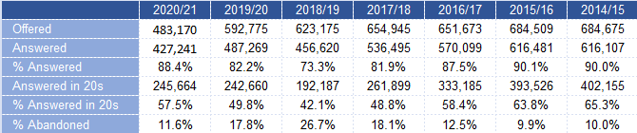

2.4 While call answering and speed to answer are important it should be noted that the most important criteria is that customers are dealt with by well informed, professional advisors who leave customers clear as to what is to happens next.

2.5 Tables 1 and 2 shows how performance has improved since 18/19. Answering levels were at reasonable levels across all lines in 19/20 while improving significantly in 20/21. This is evident across all of the metrics, answered %, speed to answer and % answered in 20 seconds (GOS). There are a number of factors for this which are detailed below.

Table 2



2.6 Q1 of 20/21 saw a drop of 50,000 calls. Covid-19 resulted in all non-emergency call lines being closed. However, after three months lines returned to a degree of normality even if all services weren’t fully available. e.g. blue badges.

2.7 Customer service centre staff while dealing with the Covid Community Helpline (section 2.10) also provided crucial support to some of the main contact centre lines. This was important as we were able to increase the number of people working from home as the pandemic progressed.

2.8 Access to the contact centre beyond phone calls had been increasing but the pandemic ensured there was a step change in volumes. Table 3 shows the move to digital solutions in comparison to calls. Digital contact has now come on stream fully, offering the customer a wider range of ways to contact the council. Digital channels for example, emails, social media, and webchat has seen a marked increase from the end of Q4 19/20. Table 4 shows the comparison between the digital channels.

Table 3

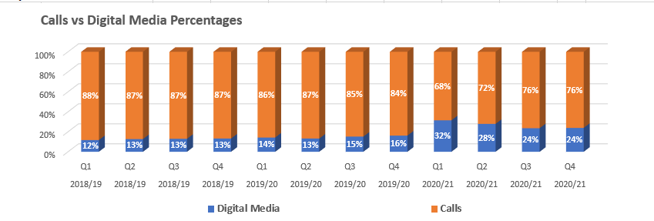

Table 4

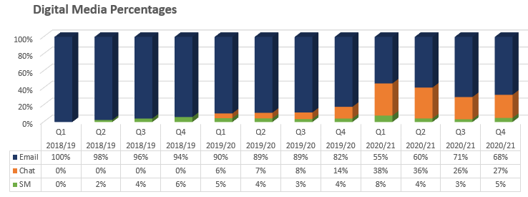

2.9 This crossover between phone calls and digital means there is now much closer working with the Online Services team, and this is something that will continue to be built on.

2.10 The Covid Community Helpline was set up to provide support to people who were affected by the lockdown, people who were shielding or having to self-isolate. This was managed by customer service centre staff who worked from the Townhouse, Kirkcaldy and liaised closely with Health & Social Care colleagues and the NHS. The helpline was transferred to the Contact Centre in May 2020. There have been over 13,000 calls to the helpline, and we have arranged access to food, pharmacy deliveries, dog walking and vaccination transportation. An online form is also available to request support.

2.11 The contact centre also make isolate & support pro-active outbound calls daily to people on the Test & Protect database. This work is done in conjunction with the NHS. The purpose of the calls is to engage with people who have been asked to self-isolate to identify where they may require support to meet essential needs. Over 3,600 outbound calls have been made.

2.12 The contact centre was approached by Aberdeenshire Council at the start of 2020 with the view of taking out of hours social work calls on their behalf.  Aberdeenshire run a very similar service to Fife Council’s out of hours social work. Work was undertaken to agree processes and the project went live in December. Since December, the out of hours team have answered 3111 calls, an average 444 calls a month with an average call answer rate of 90%.

**3.0 Contact Centre Performance & Recovery**

3.1 As we progressed through the first recovery phase in September 2020 all Contact Centre phone lines reopened. This phase was relatively short lived as we entered another lockdown and ultimately call volumes were manageable as not all services were working to full capacity e.g. housing repairs. Staff from the customer services centres also helped to spread the load.

3.2 Coming into the most recent phase of recovery has been challenging. Speaking to colleagues in other councils they are similarly experiencing significant demand pressures. Members will be aware that certain lines (mainly repairs and environment) have faced long waiting times.

3.3 The team still have responsibilities around test and protect where they undertake outbound calling on behalf of the government and administer self-isolation support grants, all of which puts pressure on resources. Understandably there is a backlog in areas such as housing access, housing repairs and passes & concessions which is increasing call volumes.

3.4 Having successfully navigated most of the pandemic the table below outlines the call answering statistics that highlight the problems the contact centre has had recently as services opened up and customer expectations increased.

Table 5

|  |  |  |  |  |  |
| --- | --- | --- | --- | --- | --- |
| **Line**  **% calls answered** | **20/21** | **21/22 Q1** | **w/c 26th July** | **w/c 2nd**  **Aug** | **w/c 9th Aug** |
| Council Tax | 90% | 91% | 87% | 87% | 83% |
| General | 88% | 73% | 54% | 74% | 75% |
| Repairs | 81% | 60% | 47% | 53% | 60% |
| Social Work | 86% | 88% | 87% | 83% | 82% |
| Out of hours | 93% | 93% | 91% | 93% | 93% |

3.5 The general line (environment, transportation, housing advice, passes and concessions) which is the busiest in the contact centre has had a difficult time because of some backlogs. Some adjustments have been made to the team and the response times will continue to improve once we add additional resource.

3.6 The repairs line is improving slightly. The team is getting help from customer service centre staff We are also working on a technological solution to help improve the reporting of repairs for tenants and to speed up the processing of repairs and appointments for staff. This is the most challenging area as repairs are linked to the scheduling of the work.

**4.0**  **Online Solutions**

4.1 The Council moved to a new web platform www.fife.gov.uk in October 2019, giving the site a fresher look while improving many features. As of April 2021, the transfer of information that was hosted on the old system has now been completed, ending a 3-year project. The technology underpinning the old www.fifedirect.org.uk was out of date, so there was a need to create a website for Fife Council on a new content management system, with new online forms and a customer account. The website also needed to be simplified. The content had become unwieldy overtime, which made it difficult to navigate. We have been improving our digital solutions throughout 2020 and into 2021 and this team now work in tandem with the contact centre to provide a more joined up service.

4.2 The new site was launched with a customer account which is part of the national myaccount. The account is used to simplify authentication across a number of services, something that will help us improve the customer experience. By using the national myaccount for authentication, the individual uses a single username and password to access both local and national services. Registration is only done once.

4.3 Most Scottish councils already use myaccount and in Fife we have approximately 97,000 total accounts in use with 55,000 of these being created through our online forms. For example, most parents have an account already for school payments, as do many who signed up for an online account for Council Tax. We have 15,000 households signed up to the new council tax account which allows customers to deal with any discounts or changes to their account online and in one place.

4.4 Feedback received about the use of myaccount suggested it was making it difficult for citizens to report or request certain services and this is something we have reviewed. We will now make it optional when someone wants to report something to the Council.

4.5 The Customer Programme continues to develop and implement new online offerings, enabling us as a service to provide more services 24/7 for our customers. There have been considerable online developments within each directorate, including a significant shift to digital for Education with primary 1 and nursery applications being 100% online. During Covid and with the closure of our customer service centres, customers have been able to request access to our customer advisors via the new online room booking system, ensuring our customers have felt supported during such a challenging period.

4.6 Our newer channels of communication are being well used as highlighted in section 3.8. Webchat, which is accessed through fife.gov.uk, has been expanded and the average number of webchats answered per day is around 300. Webchat saw a huge increase during lockdown at the start of the pandemic and this has continued. In Q4 4,483 were offered and this has increased to 15,505 in Q1 of this financial year. Contact centre staff are also communicating with customers on social media through Facebook and Twitter. Table 5 gives a sample of social media interaction over a three-month period. This shows how numbers fluctuate depending on what customers are engaging with.

Table 6

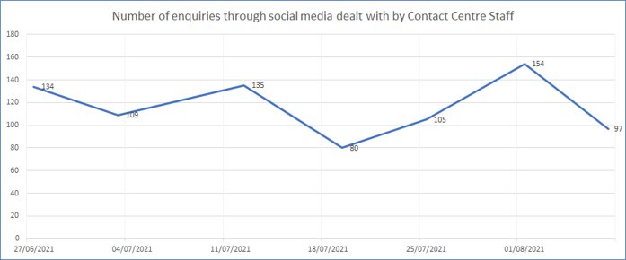

4.7 We monitor online activity on an ongoing basis to see where adjustments may be required based on feedback from customers and from contact centre staff.

4.8 The Contact Centre is currently putting in a new telephony system and it anticipated that this will help as we converge phone and online technologies.

**5.0**  **Customer Service Centres**

5.1 Transactions for customer service centres were low in 20/21 (down from 321,877 to 83,192) and through this year so far due to the restrictions of the pandemic. However, our local office staff set up and ran the Covid Community Helpline out of the Townhouse in Kirkcaldy. A key focus as we emerge from the pandemic will be the future of face to face.

5.2 Registration was the main activity over the pandemic at one point our registration staff were working 7 days a week and doing only death registrations. The main metric of % accuracy of input was maintained by the team at 98%.

**6.0**  **Scottish Welfare Fund**

6.1 The Scottish Welfare Fund has had increasing demand over recent years and was under additional strain during the pandemic. The Scottish Government increased the fund by £1.5m meaning there was a total allocation of £4.1m. There was some additional administrative funding, but it was a challenge to meet timescales over the year.

6.2 Demand for crisis grants is increasing consistently year on year with 20/21 having the added impact of the pandemic. Table 6 below shows volumes of applications and amount spent. The average payment is £106.06. The current ward rate is 71%, slightly above the national average of 69%.

Table 7

|  |  |  |
| --- | --- | --- |
| **Year** | **Applications**  **Received** | **Amount spent (£’s)** |
| 2018/19 | 19,549 | 1,478,643 |
| 2019/20 | 27,606 | 2,072,019 |
| 2020/21 | 31,062 | 2,540,079 |

6.3 Community care grant applications saw a reduction in the first half of 20/21 with an increase back to normal levels by the second half of the year. The average grant is £421.99. The award rate is 63% which is on par with the national average.

Table 8

|  |  |  |
| --- | --- | --- |
| **Year** | **Applications**  **Received** | **Amount spent (£’s)** |
| 2018/19 | 4259 | 1,014,678 |
| 2019/20 | 3939 | 925,348 |
| 2020/21 | 4198 | 822,416 |

6.4 Processing timescales have been affected due to demand for crisis grants. At one point in 2020 the timescale for community care grants was over 50 days (the target is 15 days). Extra staff from the Housing service, Revenues and the customer service centres managed to bring this under control. Processing times were prolonged again over the Christmas period, but again additional staff brought this within timescale. Through the first quarter of 21/22 timescales are again stretched due to demand particularly for self-isolation support grants.

6.5 In 20/21 £3,362,495 has been awarded. This would be 30% over the normal budget if the Scottish Government had not added the £1.5m to the Fund.

**7.0**  **Self-Isolation Support Grants**

7.1 Self-isolation support grants were developed by the Scottish Government and were introduced in October 2020 to provide financial support to meet the basic needs during a period of self-isolation for workers on low incomes. The grants have undergone several amendments to improve the eligibility criteria during the period. At the end of 20/21 we had received 1387 applications and awarded 412. The award rate last October was 22%, rising to 51% in March and is now at 61%.

7.2 It was expected that self-isolation might ease through the summer but the opposite has occurred. Between October ‘20 and May ‘21 we received 1625 applications. Since June we have received 1384 a dramatic spike. This is something that has happened nationally. The affect has been to increase the backlog again in the Welfare Fund.

**8.0 Revenues (Assessment)**

8.1 As stated in September 2019 Customer & Online Services was formed to bring together a number of the customer facing areas. The largest of these was Revenues. The Revenues team are responsible for the billing, collection and recovery of council tax and business rates as well as the collection of council house rent and sundry debt. The team also deal with assessing entitlement to housing benefit, council tax reduction, discretionary housing payment, education benefits and financially assessing a service user’s contribution to their residential care costs. The team is split into two areas assessment and collection.

8.2 In March 2020 when the UK first went into lockdown the assessment side of the team continued with business as usual whilst the collection side initially stopped recovery action and assisted with the assessment area until July when recovery action restarted. Performance as outlined in appendix 1 has been impacted by the pandemic particularly in the area of Council Tax Reduction (CTR). It is expected that performance will return to normal as the year moves on. However, we will need to be aware of unemployment levels as this will put a strain on the need for CTR.

8.3 In addition to carrying out business as usual work the assessment team was tasked with delivering Scottish Government grants to individuals and businesses. This was broadly split into two areas, free school meal replacement payments and business support grants.

8.4 Entitlement to free school meals is financially assessed using criteria provided by the Scottish Government. Weekly lists are provided to schools advising which children are eligible. When school closures were announced the decision was made to convert this into a weekly payment of £11.50 to parents directly into bank accounts. Fife Council were one of the first councils to deliver this payment directly into parents’ bank accounts from the 23rd March 2020 when the schools closed. Following on from the free school meal replacement, Scottish Government announced further grants including the winter hardship payment of £100 for each child as well as a spring payment of £100. Free school meal payments have also been made through the school holidays and paid to children who have had to self-isolate when the schools returned. To date £6,802,912 has been paid to families in Fife using this method as illustrated in the table below.

Table 9

|  |  |  |
| --- | --- | --- |
| **Scheme** | **No of Children** | **Amount Paid** |
| Term Time Payments (23.03.20 to 11.08.20) | 11,369 | £2,713.110.50 |
| Term Time Payments (06.01.21 to 26.03.21) | 11,128 | £1,216,239 |
| Christmas Holidays | 11,046 | £254,058 |
| Easter Holidays | 11,172 | £256,956 |
| Self-Isolation | 686 | £10,949.30 |
| Winter Hardship | 11,049 | £1,104,900 |
| Spring Hardship | 12,467 | £1,246,700 |
| **Total** |  | **£6,802.912.80** |

8.5 Scottish Government has new announced a future pandemic support payment which includes two family pandemic payments of £100 to be paid to the parent of every child eligible for free school meals, one at the start at the summer holidays and the other at the start of the Christmas holidays. In addition, there will be a Low-Income Pandemic Payment of £130 paid to everyone who was in receipt of council tax reduction (CTR) between 1st April 2021 and 30th April 2021 along with some agreed groups who are exempt from council tax. There are currently 31,316 households entitled to CTR who will be contacted to arrange this payment directly to bank accounts by 31st October 2021. The team are working with our software supplier to automate this process where possible.

8.6 The Scottish Government also introduced a series of business support grants for businesses who had to close when the country went into lockdown. A process to administer these grants had to be developed quickly with the application being available on Fife Council’s website by 12 noon on the 24th March 2020. Due to the volume of applications received and the quick turnaround needed to get payments to businesses resources were brought in from other areas within Revenues, Finance, Licensing and Economic Development to assist the Rates team which only consisted of 5 members of staff. At its peak over 20 staff were working on the grants. The detail is in appendix 2. Rates work had to be suspended with annual billing delayed until the end of June.

**9.0** **Revenues (Collections)**

9.1 The collections team collected (in year) 94.38% of the Council Tax due in financial year 2020/2021 (£163m). Despite the initial operational challenges and the delaying of formal recovery until October, the final collection performance rate was down less than 1% on the year before. During the pandemic work done by our debt collection partners (Sheriff Officers) to collect council tax debt such as wages arrestment’s and charge for payments were put on hold. This team are working closely with money advice and Citizens Advice Rights Fife to identify where early intervention would help. A new write-off policy for council tax debts has been put in place and will prevent customers being forced further into poverty. Comparison with previous years is in table 10.

Table 10

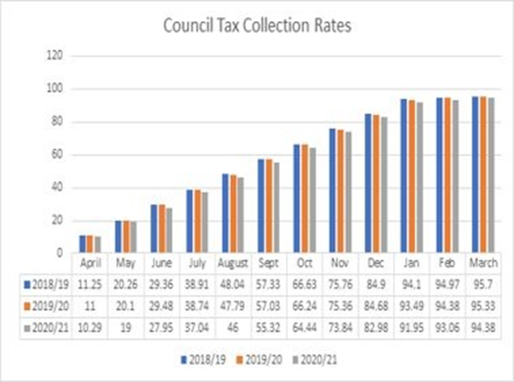

9.2 The rent arrears team who collect outstanding housing rent debts in excess of £500 work closely with colleagues in the Housing service to ensure the maximum amount of rent is collected. For the financial year 20/21 99% of rent billed was collected (£119m). This is compared to 99% in 19/20 and 98% in 18/19. The rent officers who normally visit tenants to collect outstanding rent and support them by signposting and working closely with other services, switched to working from home at the beginning of the last financial year. The high collection rates show that despite the challenges the team have continued to maintain performance. It should be noted that Fife has seen a continued reduction in current tenant rent arrears over the last 3 years which bucks the national trend where current tenant rent arrears in Scotland are increasing.

9.3 Evictions have been suspended due to the pandemic. A Covid support fund was also made available and this ran alongside the already existing Universal Credit support fund. This totalled a combined £2m rent support fund for unemployed, self-employed, and furloughed tenants. At year end of 20/21 £1.476m had been awarded - £1.119m through the Universal Credit scheme and £337k through the Covid 19 scheme with over 5,800 households assisted.

9.4 The income recovery team who deal with outstanding invoices on behalf of various services including Social Work, Environmental Services and Housing continued to concentrate on collection over the past year. The team collected £72.35m which is 89.9% of all invoices raised by the council. The target is 88%.

**10.0 Information Team & Escalation Team**

10.1 Details on Freedom of Information requests (FOI) and Environmental Impact Requests (EIR) are detailed in appendix 1 as are the service statistics on complaints. Given the fact that staff had to work from home and deal with services that were working through a pandemic our response rates have been very good. A more detailed report goes to Standards and Audit Committee in October.

10.2 Reporting on complaints for the Council goes through the seven area committees with an overall report going to Standards 7 Audit.

**11.0 Conclusion**

11.1 Almost all aspects of the Customer & Online Service provision have been affected by the Covid-19 pandemic. While certain services were limited in nature e.g., housing repairs, others were extended e.g., business grants. We also had to adapt to circumstances on an ongoing basis. While the service was stretched at various times the flexibility and willingness of staff to adapt meant that in general performance was maintained.

11.2 The Scottish Welfare Fund was an exception to this, and processing timescales have been affected due to demand for crisis grants and latterly self-isolation support grants. Any backlogs were brought back within timescale several times, but the team is currently stretched again, and some temporary resource will be put in place to alleviate this.

11.3 Free school meal payments and pandemic support payments were also out of the ordinary and not reflected in our normal reporting. These were introduced as the government reacted to the pandemic and consequently, we helped deliver a variety of support mechanisms for individuals and businesses. This impacted some of our performance figures for processing times in revenues, but we should get back on track in 21/22.

11.4 The Council moved to a new web platform www.fife.gov.uk in October 2019, giving the site a fresher look while improving many features. As of April 2021, the transfer of information that was hosted on the old system was completed, ending a 3-year project. The pandemic has meant we have had to rely greatly on the website.

11.5 Increasingly we need to see the contact centre and fife.gov.uk as part of the same mechanism for dealing with customer information and transactions. Adding to the transactions available and ensuring all content is up to date will be the main focus for 21/22 and beyond. A project has begun with Health & Social Care to improve their online presence.

11.6 A key focus as we emerge from the pandemic will be the future of face to face. It will still be a crucial strand of our customer service approach but should be used for more detailed advice and interactions rather than simple transactions. This will be the direction of travel moving forward concentrating initially on ‘housing advice’.

List of Appendices

1. Customer and Online Services Performance Report 2020/21
2. Pandemic Grant Payments

Report Contact:

Diarmuid Cotter

Head of Customer and Online Services

Communities Directorate

Email**:** [Diarmuid.Cotter@fife.gov.uk](mailto:Diarmuid.Cotter@fife.gov.uk)

Iain Duncan

Programme Manager

Communities Directorate

Email**:** [Iain.duncan@fife.gov.uk](mailto:Iain.duncan@fife.gov.uk)

**Appendix 1**

**Customer**

| **Performance** | **Progress** |
| --- | --- |
|  | Complaints totals have increased year on year and response times are still acceptable. Total 2019/20 - 190 and 20/21 - 264  This is the second year reporting of Customer & Online Services which includes Revenues. |
|  | While stage 2 complaint numbers are relatively low, the response rate is still excellent. |
|  | Compliments are on a downward trend.  This is understandable for 20/21 as face-to-face services and registration of weddings closed for a significant period of time. |
|  | The number of Facebook fans and Twitter followers have risen to their highest levels to date.  This is partly due to increased usage since April 2020 with the pandemic, but also with the continued growth of social media as a key method of communication. |
|  |
|  | As illustrated in section 5 we have made progress in our online service offering. This included new services. We have also have a stricter measure for ‘online transactions’ hence the reduction in volume. |
|  | The number of accounts has decreased this year due to the decommissioning of the old FifeDirect account. We found that there were a large number of inactive accounts, so this allowed us to start again when introducing the new MyAccount.  The number of valid operational accounts in July 2021 is 97,000 |
|  | Due to the pandemic, the offices were closed for a significant period of time, hence the low volumes. They opened in September 2020, but to appointments only. Some of these appointments were carried out face-to-face but many were done over the phone. This period has demonstrated what may be possible in the future. |
|  | Registration accuracy continues to improve and there are now core staff carrying out this function. They are specialised in registration and all their time is allocated to this task. |
|  | The team continue to work hard to maintain the 1 working day turnaround of applications.  Based on increased volume of applications and the processing of Self Isolation Support Grants, this has been a challenge at times. |
|  | The target timescale for processing a Community Care Grant application is 15 working days.  The pandemic put a severe burden on the Fund with Crisis Grants applications increasing and Self-Isolation Grants being added.  Help from other services helped keep timescales manageable in 20/21. |

**People**

| **Performance** | **Progress** |
| --- | --- |
|  | Absence rates increased slightly year on year.  Most COS staff still had to attend offices for the majority of 20/21 so didn't benefit fully from getting staff working from home. |
|  |
|  |
|  | Workforce figures for noting |
|  | Workforce figures for noting. |
|  | Workforce figures for noting. |
|  | This relates to workforce change associated with the implementation of the Customer Programme aim of better integrating customer service operations across the Council as outlined in section 2. |
|  | Due to budget constraints, recruitment has been limited in recent years with staff under 24 reducing. However, we are part of the Kickstart programme and this will introduce younger staff to the service. |
|  | Workforce figures for noting. |
|  | We have focussed on the Kickstart programme to bring younger staff into the service. The WYI scheme needed permanent posts at the end of the programme. We weren't able to offer these at the time. |
|  |
|  | Workforce figures for noting. |

**Key Business Delivery**

| **Performance** | **Progress** |
| --- | --- |
|  | Call answering performance for 20/21 exceed the 88% call answering target but has dropped slightly this year. |
|  | Collection call answering has been maintained above target. Recovery was suspended for 4 months from March 2020 to September 2020. |
|  | The improvement in performance is due to different way of working during the lockdown - including emergencies only for a significant period and extra support from other COS teams when all lines gradually reopened.  This has not been maintained as outlined in section 4. |
|  | Performance was maintained throughout the pandemic. |
|  | Performance has improved in 20/21 and this is due to pandemic and lockdowns. We had a period of emergency calls only then gradual reopening of critical lines. When we fully reopened all lines, the had extra support from our CSC Advisors.  This has not been maintained as outlined in section 4. |
|  | This line underperformed but action is being taken to address the issues.  This has not been maintained as outlined in section 4. |
|  | A dedicated email address was set up in response to the pandemic and this has proved to be very successful. Customer inbound contact is now split even between calls and emails.  Calls answered - 42,163  Emails - 52,183  Call answering includes the Covid Community Helpline. |
|  | Request response times have improved over the past year. Requests are down slightly due to a decrease caused by the shutdown in the first two months of the year.  However, the average received per month over the year, only equates to a reduction in 10 requests per month from previous years. |
|  | EIR performance has improved over 20/21. A decrease in requests being received was identified between April - June. However, the average number being received compared to 19/20 only relates to 3 requests less per month. This therefore suggest a rise in the average number of these types of requests received during July-March. |
|  | As with FOIs and EIRs, the number of SARs being received fell significantly in April and May. The average being received however only relates to 5 a month, again indicating a rise in the numbers received Jun - March.  This rise has led to a further review of how SARs are dealt with within Fife Council and work will begin on this in the near future. |
|  | The Rates collection rate has increased from 98.2% from 2019/20 which is excellent performance given the impact the pandemic has had on businesses. It will also be reflective of the 100% Retail, Hospitality and Leisure relief awarded so this year the target has been set at 98.7% |
|  | Target has not been met due to increased workload arising from the pandemic and targets for next year have been adjusted accordingly to allow us to recover |
|  | As above |
|  | As above |
|  | As above |
|  | While the in-year collection rate reduced by 0.9% compared with 2019-20, the actual income collected, in cash terms, rose by £6.389 million in 2020-21 to £231,939 million - and increase of 2.83% on the previous year (2019-20) |
|  | Collection rate is much better than expected give the pandemic and the impact this had had on some citizens' income. The collection team have worked closely with customers and sheriff officers to exercise care and compassion during these unprecedented times |

**Financial**

| **Performance** | **Progress** |
| --- | --- |
|  | The cost of collecting NDR has increased this year due to the high volume of Covid 19 Business Grant Applications. |
|  | The cost per debtor account has risen due a significant reduction in the number of invoices issued, whereas costs have remained static. |

**Appendix 2**

A summary is shown in the tables below detailing a total of £59,656,500 paid out through Revenues as well as £72,265,555 though the schemes administered by Economic Development/Business Gateway and £1,167,000 paid to Taxi Drivers by the Licensing team. In total £133,089,055 was paid to businesses in Fife through this grant funding. As well as administering the grants staff had to cope with the eligibility criteria constantly changing to make sure support was reaching those that needed it. Council officers played a key role in the oversight and strategic approach to the development of these grant schemes. Working with colleagues from other Councils, COSLA and Scottish Government to ensure a consistent approach across Scotland was taken and that advice to Scottish Ministers and COSLA leaders was provided throughout the development and implementation processes. The following tables provide details of the grants paid out to Fife Businesses.

|  |  |  |  |  |
| --- | --- | --- | --- | --- |
| **Grant** | **Dates** | **Rcvd** | **Paid** | **Total £** |
| Small Business Grant Fund/Retail Hospitality and Leisure | Mid-March 2020 - 05/07/2020 | 5497 | 5216 | £58,102,500 |
| Phase 3 - Subtenants | June - 05/07/2020 | 91 | 55 | £55,000 |
| Nightclubs/Softplay | Oct 2020 - Nov 2020 | 15 | 14 | £310,000 |
| Brewery | January 2021 - February 2021 | 9 | 5 | £80,000 |
| Travel Agents | January 2021 - February 2021 | 22 | 15 | £255,000 |
| Large Self Catering | February 2021 - March 2021 | 89 | 52 | £104,000 |
| Small Accommodation Providers – Council Tax Fund | 05/04/2021 - 12/04/2021 | 52 | 50 | £300,000 |
| Small Accommodation Providers – Council Tax Fund Restart | 19/04/2021 | 50 | 50 | £450,000 |

|  |  |  |  |  |
| --- | --- | --- | --- | --- |
| **Grant Fund** | **Dates Open** | **No. Received** | **No. Approved** | **Value** |
| Discretionary Fund | 29/01/21 – 08/04/21 | 1896 | 1600 | £6,400,000 |
| Strategic Framework Business Fund (inc. Jan Top-ups & Restart Grants) | 13/11/20 – 22/03/21 | 3,702 | 2,774 | £64,134,050 |
| Small Accommodation Providers Paying Council Tax Fund (Waves 1 & 2) inc. Restart Grants | By invitation to previous recipients of the 2020 B&B Fund or Creative, Hospitality & Tourism Hardship Fund | 18 | 18 | £270,000 |
| October Brake Restrictions Fund | 20/10/20 – 03/11/20 | 472 | 344 | £521,105 |
| Covid-19 Town Centre Business PPE Grant | 18/08/20 – 19/09/20 | 505 | 304 | £30,400 |
| Bed & Breakfast Hardship Fund | 15/06/20 – 10/07/20 | 18 | 14 | £42,000 |
| Newly Self-employed Hardship Fund | 30/04/20 – 10/07/20 | 503 | 434 | £868,000 |

|  |  |
| --- | --- |
| **Taxi and Private Hire Driver Grants** |  |
| Number of Eligible Drivers | 1490 |
| Number of Drivers contacted | 1490 |
| Number of applications | 1098 |
| Total Paid | £1,167,000 |