Fife Community Justice Outcome Improvement Plan
2021-2022
Introduction
National Context
The Community Justice (Scotland) Act 2016 defines community justice as:
‘The collection of individuals, agencies and services that work together to support, manage and supervise people who have committed offences from the point of arrest, through prosecution, community disposal or custody and alternatives to these, until they are reintegrated into the community. Local communities and the third sector are a vital part of this process which aims to prevent and reduce further offending and the harm that it causes, promote desistance, social inclusion, and citizenship.’
The diagram below from Audit Scotland reflects both national and our local thinking around the needs of those with convictions. Addressing these wider needs - which are often shared by the families of those who have offended and those who have been harmed - will work towards achieving Fife’s overall outcome of reducing offending and reoffending and creating safer communities for everyone.
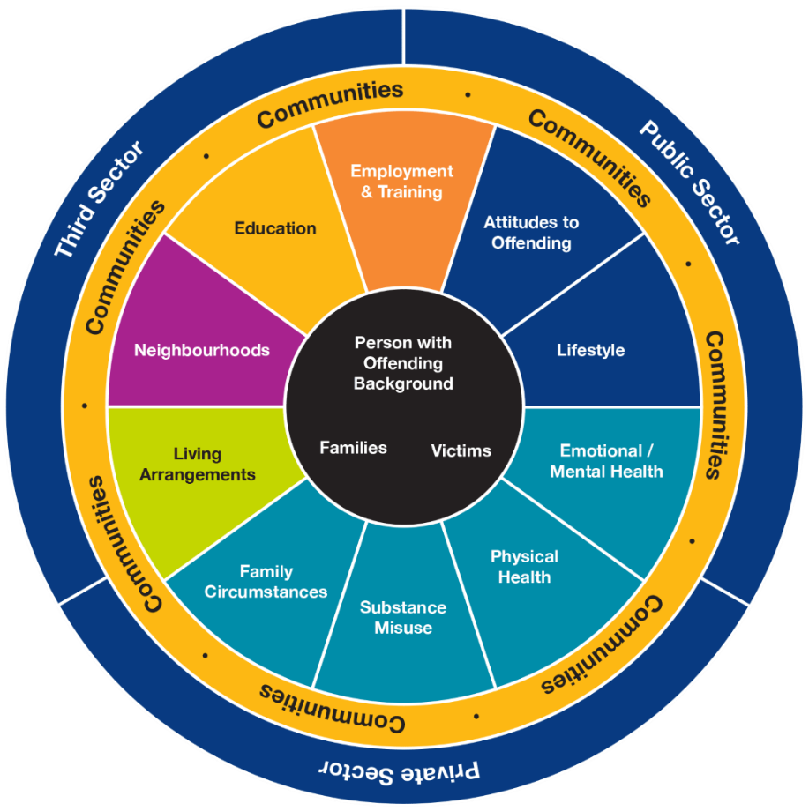

The National Strategy for Community Justice and National Outcomes and Performance and Improvement Framework provide a shared vision which supports work locally. The vision is underpinned by four priorities and six principles that are designed to deliver both structural and person-centred outcomes:

Priorities
- Improved community understanding and participation.
- Strategic planning and partnership working.
- Effective use of evidence-based interventions.
- Equal access to services.

Principles
- People must be held to account for their offences, in a way that recognises the impact on the victims of crime and is mindful of risks to the public, while being proportionate and effective in preventing and reducing further offending.
- Reintegrating those who have committed offences in the community and helping them to realise their potential will create a safe and fair society for all.
- Early intervention should maximise opportunities for preventing and reducing offending as early as possible before problems escalate.
- Community justice outcomes cannot be improved by one stakeholder alone. We must work in partnership to address complex issues.
- Informed communities who participate in community justice will lead to more effective services and policies with greater legitimacy.
- High quality, person-centred and collaborative services should be able to address the needs of people who have committed offences, their families and the victims of crime

Structural Outcomes
- Partners plan and deliver services in a more strategic and collaborative way
- Effective interventions are delivered to prevent and reduce the risk of further offending
- People have better access to the services they require including welfare health and wellbeing and housing
- Communities improve their understanding and participation in community justice.

Person Centred Outcomes
- People develop positive relationships and more opportunities to participate and contribute through education, employment and leisure activities
- Individuals’ resilience and capacity for change and self-management is enhanced
- Life changes are improved through needs, including health, welfare, housing and safety being addressed.

It is expected that our local priorities align to one or more of the above outcomes as well as reflect national priorities and principles.
Local Context
Fife has a proven track record of working to deliver on ‘community justice’. The 2016 Act introduced a new way of working, as opposed to a new way of thinking. Community Justice partners have long recognised the importance of acting at an early stage and supporting people in changing behaviours and reducing risk. There is a strong commitment to working closely with individuals and communities to find solutions to local problems.
The aim of community planning in Fife is to strengthen Fife’s future by bringing together public and voluntary organisations to work together in Fife’s communities, an aim shared with the National Community Justice Strategy. Community justice work in Fife is firmly embedded within this community planning structure.
From 2015 to 2019, community justice activity in Fife was co-ordinated through the Reducing Offending and Reoffending (ROAR) Group. In 2020, a decision was made by Fife Council to reinvigorate community safety partnership activity in Fife and re-establish a local Community Safety Partnership (CSP)
It was agreed that Fife Community Safety Partnership would include in its
membership seven Elected Members and report on a regular basis to Fife Council’s
Community and Housing Services Sub Committee.

The CSP is underpinned by Fife’s Safer Communities Vision:

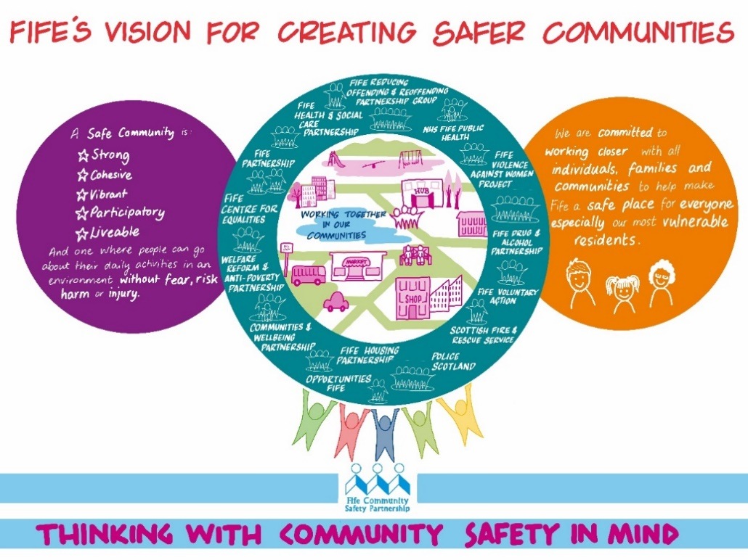

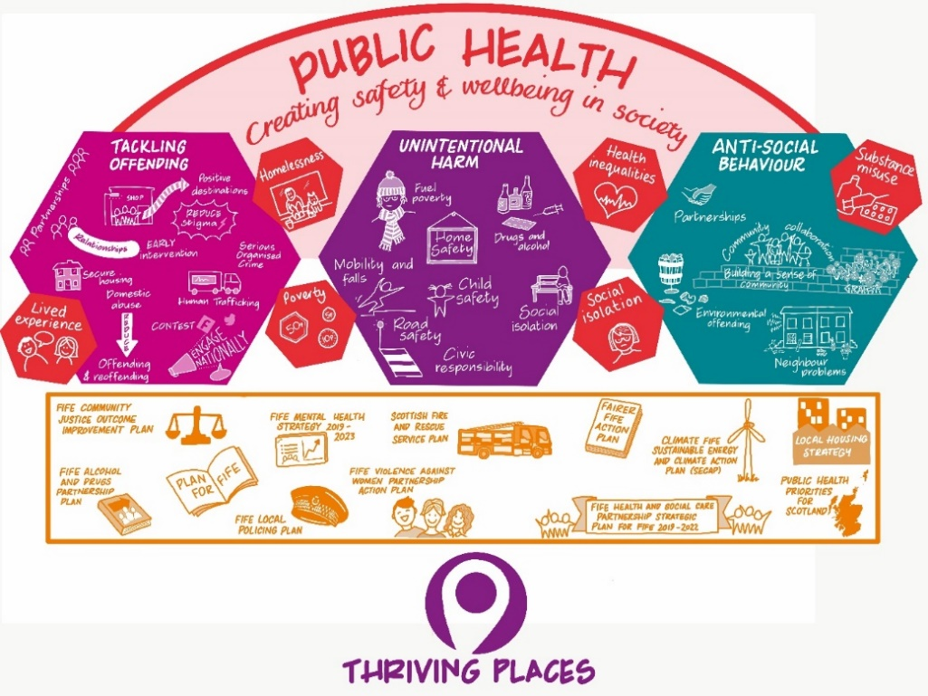

This vision includes three priorities, each of which has a strategic lead:
- Tackling offending: strategic lead Police Scotland
- Unintentional injury: strategic lead Scottish Fire and Rescue Service
- Antisocial behaviour: strategic lead Fife Council
The remit of the CSP (as decided by Fife Council) includes:
- Delivery of the Reducing and Reoffending Group as required under the Community Justice (Scotland) Act 2016, including the oversight and agreement of allocated Social Work (Scotland) Act 1968 section 27 funding and any other funding for the purposes of local community justice prevention

- CSP will deliver the community safety element of the ‘Thriving Places’ theme within the Plan for Fife and oversee work to fulfil the current ambition: ‘All our communities benefit from low levels of crime and antisocial behaviour’.

The original intention was to have the ROAR Group report to the CSP, however a further revision led to the agreement to amalgamate the work of the ROAR Group, fully into the CSP. Co-ordination of the delivery of the CJOIP will remain the role of the local Community Justice Lead but will be very much part of the wider Tackling Offending theme. Membership of the CSP is still evolving and it is recognised that for some CJ partners, attending this full meeting may not appropriate. Strategic Leads will ensure that engagement with these partners continues (in line with national duties and requirements).
This restructure streamlines the local landscape around community justice and improves local governance, providing a direct link to a committee and, importantly, to the wider Community Planning Partnership. Community justice partners are confident that structure provides a strong basis on which to deliver the 2021-2022 CJOIP.
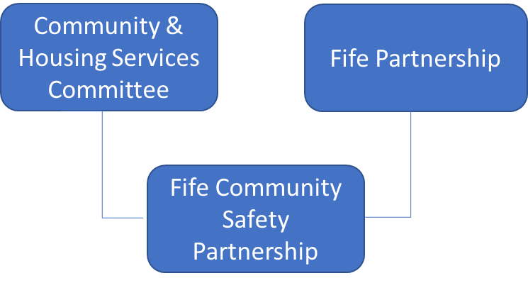
Coronavirus Implications
The ongoing coronavirus (Covid-19) pandemic has had an unprecedented and all-encompassing effect on all aspects of community justice and there remain several unknowns within the frontline justice system in terms of recovery including, among others, backlogs in Unpaid Work and Court business. Fife CJ partners continue to show innovation, compassion and determination, developing and delivering services in new ways. This work is ongoing with discussions continuing as to lessons learned and what ‘recovery’ will look like. Short- and long-term budget implications are anticipated and changes to priorities and working practices expected.
Additionally, the impact of coronavirus restrictions has increased risk for those facing domestic abuse, sexual violence and other forms of violence against women. Working towards gender equality, safety and wellbeing are national priorities and this commitment is mirrored here in Fife. Community justice partners continue to strive to make our communities safer and fairer for everyone regardless of gender, age, ethnicity or disability.
While not specifically noted as standalone priority within this plan, this CJOIP is written with the understanding that violence against women is the most prolific offence within Fife. Work to address violence against women is delivered through the Fife Violence against Women Partnership. Cross representation on both the CSP and VAW Partnership from relevant partners allows collaboration and joint working towards shared outcomes (this will include reporting on VAW activity towards national and local CJ priorities). While CJ partners have a role to play in supporting deliver of all the VAW priorities, it has its most significant role with regard Priority 4:
Equally Safe Priority 4 Men desist from all forms of violence against women and girls and perpetrators of such violence receive a robust and effective response
Fife has reviewed its local VAW action plan to take cognisance of the Coronavirus (COVID-19) Supplementary National Violence against Women Guidance.

Plan for Fife Review
Community justice activity in Fife supports the delivery of the Plan for Fife priority ‘Thriving Places’:
Thriving Places are safe, well designed and maintained places that promote wellbeing, where people are proud to be, and where they have access to the services and facilities they need at different stages of their lives’
and contributes to work to fulfil the ambition ‘All our communities’ benefit from low levels of crime and antisocial behaviour’. Progress against this ambition is measured against an expected change ‘reduction in offending and reoffending through prevention’.
The deliberate alignment between the Plan for Fife and the CJOIP allows ease of reporting for partners and a consistency of approach. The local Community Justice Lead will be asked to contribute to the annual Plan for Fife update report.
During the end of 2019, work began to review the Plan for Fife’s three-year actions. However, experience from the Covid-19 pandemic has resulted in the decision to undertake a review focused on a small number of priority areas that are key to post-Covid recovery.
The priority areas identified are:
- Tackling poverty and crisis prevention
- Leading economic recovery
- Sustaining services through new ways of working
- Addressing the climate emergency
The review included an analysis of Fife’s strategic partnerships with a view to better understand how they fit into the plan and assist in delivering the priority outcomes. Initial findings are that the current community planning landscape is complex and cluttered. Partnership groups have been asked to review membership and ways of working to maximise opportunities for more focused discussion and challenge around the key policy priorities.

While it is anticipated that work to deliver ‘Thriving Places’ will continue, this review - along with uncertainty around the impact of Covid - has implications for the Community Safety Partnership/Community Justice Partners. In response, CJ Partners agreed to develop a much-simplified CJOIP (compared to the initial report), with reduced priorities and for one year only. This is an evolving piece of work; partners will amend and review as appropriate.

Community Justice Outcome Improvement Plan 2017-2021
This plan for Community Justice builds on the original Fife Community Justice Outcome Improvement Plan 2017-2020 which ran from 2017 to 2021 (extended from original end date of 2020) and worked to the following outcomes:
- Offending and reoffending in Fife is reduced (high level outcome)

- The needs of people with convictions and their families are supported

- Barriers to education, employment and skills training are removed

- Sustainable housing is provided at the point of need

- Health and wellbeing are improved

- Community-based sentences are developed and promoted.
These outcomes linked clearly to the national person and structural outcomes and reflect the overarching belief at the heart of the community justice activity in Fife, the necessity of addressing the underlying causes of offending and supporting those who have committed offences to help them reintegrate into the community.
The 2017 plan also had underlying themes around inequalities, trauma and ensuring the needs of those who have been harmed by incidents and offences are not detrimentally affected by any of the actions delivered to support those who have offended.
The plan was supported by detailed action plans which contained both current work (including some of the day to day community justice activity) as well as more ambitious actions.
While the overall view is that this plan successfully outlined both the why and the what relating to local community justice activity and provided an ideal starting point for a more coordinated approach to local work, it is also the case that reflections three years on include:
- The inclusion of the day to day community justice activity led to duplication of discussion and reporting
- The plan was inspirational but, at times, overly ambitious and not manageable.
These reflections have led to the decision that the new plan (2021-2022) will be significantly streamlined and focus on a small number of key actions. This plan is only part of the ongoing activity in Fife to reduce offending and reoffending and must be read as such. It compliments and supports work which is done by individual community justice partners and the wider work of other community planning partnerships. While progress against actions will report to the Community Safety Partnership, community justice partners see their role as more than just delivering on this plan but about building relationships and influencing.
The streamlined nature of this plans means it does not fulfil all the CJOIP requirements as set out in the Community Justice (Scotland) Act 2016.
For example, it is not set out in relation to all the national outcomes, nor does it relate to a full assessment of local achievement against each national outcome. It is however important to note that it has been developed with cognisance of national priorities and focusses on what has been agreed as several key priorities for Fife. These will be actioned alongside the other ‘every day’ community justice activity.
Community Justice Needs Assessment
This plan is underpinned by a Community Justice Needs Assessment (appendix one). This assessment provides a demographic data profile of the local area aligned with complex needs to be addressed (needs as identified with the National Strategy for Community Justice). This assessment is supported by Fife’s Strategic Assessment 2021 and other data sources/information provided by individual partners.
Key points to note from this assessment include:
- Most of Fife’s pockets of deprivation are concentrated within Mid–Fife
- Findings from the Scottish Household Survey show that in 2018 Fife had 53% of households managing well (compared with 55% in Scotland), however there is a clear correlation with inequality, with a greater percentage in the most deprived areas just getting by or not performing well
- The economic picture across Fife varies, again affected by pockets of deprivation and with the mid–Fife area particularly affected
- There is a strong association between prisoners and homelessness, both prior to and post incarceration
- There is a very significant link between areas of deprivation and likelihood of incarceration
- Drug supply/harm is a priority focus for local Policing in Fife.
A potential barrier to the implementation of a successful community justice strategy is that of public perception and how the issue is understood. This assessment supports the continuation of the focus of the original plan around the key issues of deprivation, poverty, housing, employment, education, community engagement and perception. This does not mean this plan will contain actions on each of these issues but, more importantly, that community justice partners will influence the work of other strategic partnerships/local services to help ensure that the needs of those with community justice experience are being recognised and addressed. A key aim is to encourage others to ‘think with community justice in mind’.
Hard Edges Scotland
The Hard Edges report has had a significant influence on the development of this plan (as well as Fife’s wider Safer Communities Vision).
This report makes a ‘renewed case for taking a whole system approach to severe and multiple disadvantage, with sustained and deep collaboration and coordination required at all levels.
And in its foreword notes:
“There is growing recognition that disadvantages or harms such as poverty, mental ill health, drug misuse, violence or homelessness put you at much greater risk of others”.
While building on the report Hard Edges: Mapping Severe and Multiple Disadvantage (England) which focused on a key manifestation of Severe and Multiple Disadvantage (SMD) involving adults facing issues of homelessness, offending and/or substance dependency, the Scottish exercise went further and recognised that the wider perspective brought by also considering mental ill-health and domestic abuse.
The report highlights the fact that routes into SMD are driven by poverty, violence and trauma. This is a view widely acknowledged here in Fife, with it being further recognised that existing inequalities have been exacerbated by COVID. A key role for us as CJ partners is to continue to promote the need for all services to be trauma informed and to acknowledge that one size really does not fit all.
The influence of this report is particularly evident within the development of Fife’s ‘Arrest Referral’ and Bail Supervision’ priorities.

Community Justice Outcome Improvement Plan 2021-2022
Community Justice Scotland asked that local partnerships to consider ‘arrest referral’ and ‘bail supervision’ within their local context. Both of these were already being worked upon in Fife and development and delivery of both were agreed by partners as key priorities within this one year CJOIP.
Partners also agreed ‘Improved Community Understanding’ and ‘Improved Community Engagement’ as key priorities. Detail on why is given below but, in essence, while success and progress were evident in many of the areas of community justice activity, anecdotal evidence/comments on social media/response to local survey indicated a lack of understanding among local communities as to what community justice is.

2020-21 Priorities
Priority/Theme | Lead Community Justice Partner | National Links
To Improve  community understanding | Local Community Justice Lead | National priority - Improved community understanding and participation  Structural outcome - Communities improve their understanding and participation in community justice
To improve community engagement | Local Community Justice Lead | National priority - Improved community understanding and participation  Structural outcome - Communities improve their understanding and participation in community justice
To improve engagement with those with community justice experience | Fife Criminal Justice Social Work | National principle - Informed communities who participate in community justice will lead to more effective services and policies with greater legitimacy
To improve engagement with those who have been harmed by offending | Local Community Justice Lead | National principle - High quality, person centred and collaborative services should be able to address the needs of people who have committed offences, their families and the victims of crimes
To deliver a decisive shift in the balance between community and custodial sentences | Fife Criminal Justice Social Work | Links to all four national priorities  National principles – early intervention should maximise opportunities for preventing and reducing offending as early as possible, before problems escalate  National Structural outcomes – effective interventions are delivered to prevent and reduce risk of further offending, people who have access to services they require, including welfare, health and wellbeing and housing  Person centred outcomes – individuals’ resilience and capacity for change and self-management is enhanced. Life changes are improved through needs, including health, wealth, housing and safety being addressed
To work to ensure Equivalence of Support for People in the Criminal Justice System” by providing additional and specific provision to address potential inequalities in access and outcome. | Local Navigator Project | Links to all four national priorities  National principles – early intervention should maximise opportunities for preventing and reducing offending as early as possible, before problems escalate  National Structural outcomes – effective interventions are delivered to prevent and reduce risk of further offending, people who have access to services they require, including welfare, health and wellbeing and housing  Links to all four person centred outcomes.

To improve Community Understanding
The aforementioned ‘Community Justice Needs Assessment’ notes that ‘much work is needed to change the public perception’ around the effectiveness of community justice in protecting the public and keeping communities safe’. This is crucial to building community support and understanding for less traditional community justice interventions. In particular, to improve understanding of the effectiveness of trauma informed services for individuals with community justice experience.
Findings from the most recent Fife survey, in 2019, include the following main points:
- Imprisonment and fines were the most recognisable court punishments.
- Less than half of respondents recognised Restorative Justice as a court option.
- Community Payback Orders / Community Service have ambiguity in terminology.
- Most important of the Scottish Justice Objectives were protecting the public, preventing/stopping crime and keeping communities safe.
- Television and Newspapers are the most used source of information on Scottish Justice but are not the most trusted sources.
- Of the public sector agencies, the Police were both more used, and more trusted as a source of justice information, than the Scottish Government and Fife Council.
- Around half of respondents were unaware of Community Justice in their area
- Most common means of awareness were through witnessing work taking place, local newspapers and through word of mouth.
- Community Justice is not seen as effective as prison in achieving most of the Scottish Justice outcomes.
- The term “Smart Justice” had not been heard of by the majority of respondent
Community justice partners will use these findings as base from which to develop and deliver a coordinated and focussed awareness raising campaign. Moves towards a more decentralised People and Place approach within Fife (led by Fife Partnership) provides the opportunity for community justice partners to make better links with local areas. Through these very local links, CJ partners will not only be able to raise the strategic aim locally but more importantly be able to build on the work of criminal justice social work to date and raise awareness of community justice in action.
This work will be primarily led by the local community justice lead, supported by the wider CSP.
To improve community engagement
There will be enhanced focus on community engagement, with partners ensuring they engage with key groups including people harmed by crimes, those who have offended and their families
One way in which this is being progressed is through a Service User Participation Group.
In 2020, Fife Justice Service created a forum to discuss practice and performance-based topics. The group agreed that as a result of the impact on service delivery due to COVID-19 (among other things), it was pertinent to gain the views of service users. A survey was undertaken and it was clear from responses that service users were eager to have their voices heard.
In response, a Service User Participation Group (SUPG) was created:
- Small group of practitioners involved – one Team Manager, 3 Social Workers and one Social Work Assistant
- Invitations to attend sent to all service users who responded to the original survey
- Communication sent out across all service to address of challenge of ensuring representation from across the service as well from geographies across Fife.
- First meeting took place (via Microsoft Teams) in January 2021
- The following broad topics were raised
  - Community Payback Orders – information for services users – leaflets/route maps
  - Development of skills during unpaid work and greater focus on employability support for those who have evidence commitment to unpaid work.
Further development of the group includes steps to:
- Consider challenges faced by service users who cannot access internet or devices due to restrictions/personal circumstances
- Attempt to engage ‘hard to reach’ service users to gain views i.e., recalled prisoners, individuals who have failed to comply with community order.
The SUPG will serve as a solid foundation to build upon in respect of embedding service user involvement within Fife Justice Services.
To increase engagement with those who have been harmed by offending
Recurring feedback during the period of the original CJOIP was a lack of focus on those who had been harmed by offences. Partners will revisit the commitment in the original plan to:
- To always consider the impact to a person harmed by an incident or offence when working to address the needs of people with offences
- To have up to date knowledge of the most appropriate support for a person harmed by an incident, and assist individuals to access this when required
- Ensure a person harmed by an incident or offence is kept informed at all stages of the community justice process
- Engage with people harmed by an incident or offence on an ongoing basis, to better understand how the community justice process affects them.
It is hoped the revised structure in Fife will allow community justice partners to strengthen relationships with organisations who support those who have been harmed. The CSP sits firmly within the wider Community Planning Partnership, with members being part of a number of partnerships, partners will use the opportunity this provides to not only raise the profile of community justice, but also ensure that within the CSP we are taking cognisance of what is important from other partnerships. An example of how this is already done is through the strong links with the Violence Against Women Partnership.
To deliver a decisive shift in the balance between community and custodial sentences
Based on research that early intervention in addressing the welfare needs of individuals is key to reducing the risk of re-offending, periods on remand and custodial sentences, Fife Justice Service have re-interpreted the use of supervised bail as a community-based disposal in which to provide welfare support early in the justice process. This supervised bail project will work in accordance with the PASS legislation:

- A supervised bail team will initially be created to aid the development of this project, led by a Criminal Justice Social Work Team Manager. A Senior Social Work Assistant will be appointed prior to the project commencing, with this role overseeing the practice, supervision and functioning of the team.
- Fife Criminal Justice service will expand the criteria for supervised bail, which will provide all individuals in police custody due to appear at Court the opportunity to have an assessment for supervised bail. Assessments of need and risk will be completed, and a report generated for the Court to consider.
- Housing Services will support the project by identifying and providing accommodation for those who will present as homeless if supervised bail is imposed.
- When an Order is imposed the supervised bail Order will be managed in accordance with National Standards, with more of an emphasis on addressing welfare needs. Area workers will work intensively with individuals supporting and facilitating access to local health and social services.

The project has a start date of 5 April 2021 and will run in its proposed format until 31 March 2022, at which point Scottish Government funding will be reviewed.

The success of the project will be measured on the number of supervised bail Orders imposed and successfully completed in Fife. The number of custodial remands will also indicate the confidence and use of the supervised bail project by Fife Sheriffs.
Softer key performance indicators as noted below will also be recorded in relations to the improvement in the welfare needs of service users.

- Accommodation
- Access to Food/Clothing
- Physical Health
- Emotional Health
- Sexual Health
- Drug misuse
- Alcohol misuse
- Personal safety
- Financial problems
- Access to employment/training

To work to ensure Equivalence of Support for People in the Criminal Justice System” by providing additional and specific provision to address potential inequalities in access and outcome
Beginning in April 2021 and expected to run for a 12-month period SACRO, funded by the Violence Reduction Unit, is due to start a test of change project in Fife.
Based in one of Fife’s custody suites, the project will follow a navigator model to engage with people who have both alcohol and drug problems which have led to their arrest and continual re-arrest. The project aims to divert service users from future contact with the criminal justice system by connecting to various services within Fife to help meet their needs and improve their individual outcomes.
- Two workers will be based in Kirkcaldy Police Custody Suite and work intensely with up to 10 individuals at a time for a 12 week period. (although this may vary depending on service user need).
- Overall, the service expects to engage with 80 individuals per annum.
- Fife Alcohol and Drug Partnership (ADP) and its services, plan to include this service in its operational subgroups to ensure that it is fully linked to the existing system of care and can use existing referral routes.
- There are potential plans to streamline triage assessments to prevent unnecessary delays and prevent exposing the client group to multiple assessments.
- The project workers will also be trained in Take Home Naloxone (THN) and overdose prevention which will further reduce the risk for people who are in police custody suites.
Fife ADP intends to commit some investment to augment the capacity to ensure that more people are offered a service. This allows individuals to be move from crisis towards planned support.

Conclusion
This plan outlines proposed priorities for the period April 2021 to April 2022, progress on these actions will be reported to
- Fife Community Safety Partnership (and from there to Fife Council’s Communities and Housing Sub Committee)
- Fife Partnership – as part of the annual ‘Thriving Places’ themed report
- Community Justice Scotland.
There have been key points made throughout this report which are important enough to be reiterated in conclusion:
- This plan is only part of Fife’s ongoing activity to reduce offending and reoffending. It compliments and supports work which is done by individual community justice as well wider Community Planning partners.
- Whilst the detail noted within the original plan around trauma/inequalities/reflecting need of those harmed by offences is not similarly detailed here, these themes remain as important to local CJ partners, with activity reflecting this.
- The ongoing coronavirus (Covid-19) pandemic has had an unprecedented and all-encompassing effect on all aspects of community justice and there remain several unknowns within the frontline justice system in terms of recovery. This is reflected in the decision to create a streamlined plan, covering 12 months only.
- This plan recognises the role of CJ partners in influencing the work of other strategic partnerships/local services in ensuring that the needs of those with community justice experience are being recognised and addressed. A key aim is to encourage others to ‘think with community justice in mind’.
Fife Community Justice Partners, working as part of the Community Safety Partnership remain committed to working together towards the shared outcome – Offending and Reoffending in Fife is reduced.

Appendix 1

Criminal Justice Needs Assessment

In order to understand need within the community, it is important to first understand the community itself. Fife is notable in that the needs and demands of its population differ greatly across the Kingdom. Within Fife’s boundaries are areas of great wealth and others of significant deprivation. While some parts are urban and well served by local facilities and transport links, others are highly rural, with all the connectivity problems this entails. This rich variety across Fife points to some of the difficulties involved in any attempt to assess need.

This section will follow the model suggested by Community Justice Scotland, presenting a demographic data profile of the local area, and then aligning this with complex needs to address. These have previously been identified in the National Strategy for Community Justice as follows
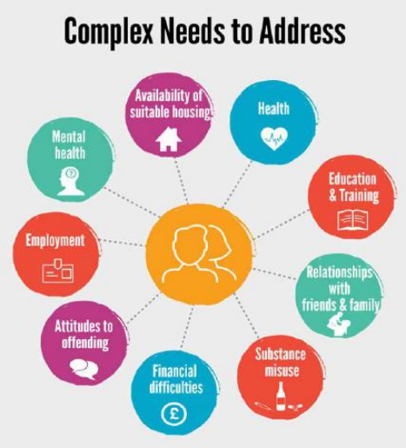
Figure 1. Justice system users – Complex needs to address

Population
One of 32 Scottish local authorities, Fife’s resident population of 373,550 makes it the third most populated authority. While Fife has a mixture of rural and urban settlements, two-thirds of the Fife population live in an urban setting. Dunfermline, Kirkcaldy and Glenrothes are the largest towns in Fife, with the remaining population living in smaller towns and villages. The committee areas of North East Fife and South West Fife are the most rural parts of Fife, although each of the seven committee areas features a mix of urban and rural settlements. The gender breakdown in Fife mirrors that of Scotland, with 51.5% of the population female and 48.5% of the population male.
Children under the age of 16 make up 17% of the Fife population (64,552), with the working age population comprising 62% (231,974) and the 65+ population 21% (77,024). In common with other areas of Scotland, Fife is projected to see an increase in older people over the next twenty years, at the same time as the proportion of children and working age people reduce. This is forecast to lead to Fife being one of 18 Scottish councils to experience population decline. This will be most evident among children (-10,300) and working age people (-21,000). In contrast, there is forecast to be a sustained increase in the number of older people (+26,400), particularly those aged over 75 (+19,000).

Deprivation
Fife continues to track Scotland as a whole in relation to both income and employment deprivation. While there are several pockets of deprivation in Fife, the majority of these continue to be concentrated in mid-Fife, particularly the committee areas of Levenmouth, Kirkcaldy and Glenrothes.
- 19.8% of Fife’s datazones are in the 20% most deprived for Scotland (19.2% in SIMD16)
- 15.8% of its 494 datazones are in the 15% most deprived for Scotland (compared to 11.9% in SIMD16)
The imbalance between different areas of Fife is striking. Buckhaven South, in Levenmouth, is the most deprived datazone in Fife, and the 5th most deprived datazone out of 6,976 datazones in Scotland. In contrast, Canongate in St Andrews is one of the least deprived datazones in Scotland, placed 6962 out of 6,976. Identification of deprivation level by area can be a blunt instrument, with these figures being a weighted average of area characteristics and not fully representative of individual circumstances. Nevertheless, it offers an initial insight into area characteristics and allows wider comparisons to be made.
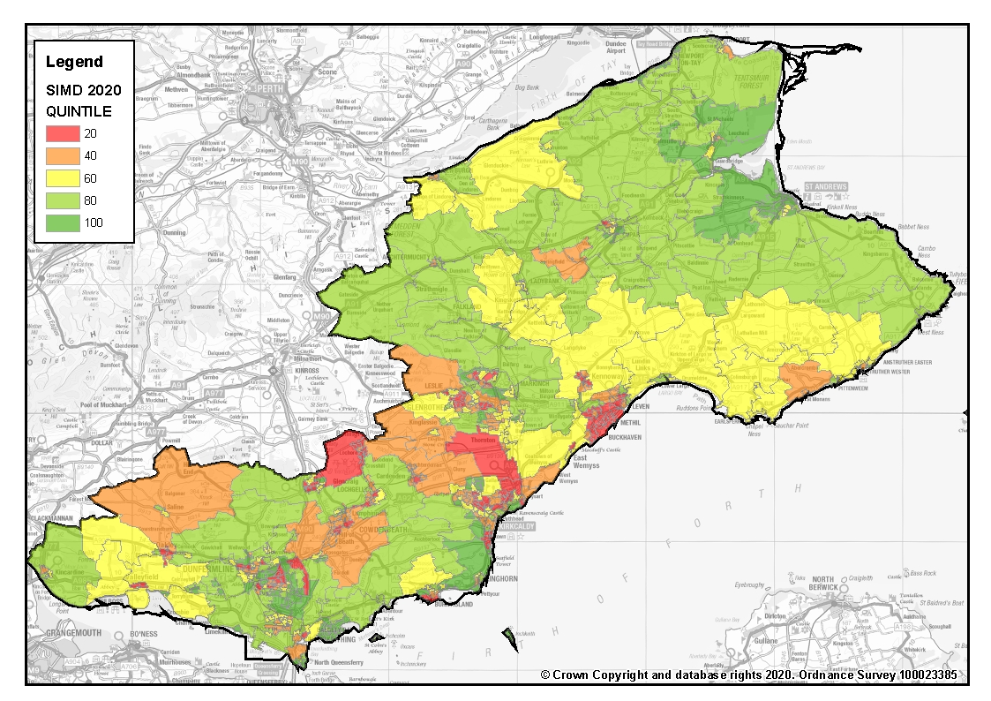
Figure 2 Scottish Index of Multiple Deprivation (SIMD) 2020.
A. SIMD by quintile, from red (most deprived) to green (least deprived)

Crime rates
The effects of the COVID-19 pandemic are reflected in Fife calls and charges for 2020, as they have been throughout Scotland. The six-month period from April – September 2020 saw 284 incidents classified as serious or non-sexual crimes of violence, a small increase on the equivalent 2019 period (+4). A larger increase was seen in incidents classified as common assault (+141) and common assault (of emergency workers) (+29). The bulk of this increase was COVID related, comprising various breaches of regulations and instances of putting others at risk.
Crimes recorded under the Domestic Abuse (Scotland) Act 2018 saw a reduction (-17), but a constant was the high proportion of such crimes recorded with a female victim (93.1%). An increase in online crimes is thought to be linked to heightened online connectivity due to lockdown and other aspects of the COVID pandemic.
Crimes of dishonesty have decreased year on year (-375). The effects of lockdown and working from home have likely contributed to falls in Theft by Shoplifting and Housebreaking charges. Fraud incidents (+198) have seen the greatest increase, reflecting the national online footprint, and the increasing number of transactions and communications being carried out in this manner.
ASB crimes have seen a continual reduction in recent years, particularly relating to disorder crimes (threatening and abusive behaviour, breach of the peace and stalking), vandalism, and crimes relating to drunkenness and minor assaults. Nevertheless, such incidents remain widespread, with concentrations in particular areas of Fife including the towns of Glenrothes and Kirkcaldy. ASB calls have seen a year-on-year increase in 2020/21, largely due to COVID related calls. Accounting for 90% of such calls, this includes complaints against neighbours for breaching guidelines, and other neighbourhood tensions linked to lockdown restrictions and their aftermath.
Problem drug use and associated harm is proportionately higher in Scotland compared with the rest of Europe, with drug supply/harm identified as one of Police Scotland’s six ‘very high’ operational priorities and a priority focus for Local Policing in Fife. Supply of drugs (inc. possession with intent) increased year on year (+27), with it being recognised that drug supply and use is linked to other forms of criminality, particularly acquisitive crime, violence, and antisocial behaviour.

Income levels
The cost of everyday living, including how much a family pays for housing, food, fuel, childcare and other household costs, is a key driver of poverty. Housing costs in Fife tend to be lower than the Scottish average, although this difference increases with property size. In 2018 the average monthly rent for a 2-bedroom property (£548) was £104 cheaper than the Scottish average of £652, whereas a 4-bedroom property was £299 cheaper per month than the Scottish average of £1278.
The Scottish Household Survey offers an insight into the proportion of households managing well financially. While only a snapshot, this can be used as an indicator of the financial resilience of households. Of note is that Fife has traditionally performed better than Scotland for households managing well but has dipped below the Scottish level in recent years. In 2018 Fife had 53% of households managing well financially, compared with 55% in Scotland. Again, there is a correlation with inequality, with a greater percentage of households in the most deprived areas either just getting by, or not managing well.

Employment rates
The economic picture across Fife varies greatly, affected by pockets of deprivation, areas of above-average unemployment, and repercussions of ongoing job losses linked to traditional industries and High Street stores. The mid-Fife area (containing Levenmouth, Glenrothes, Kirkcaldy and Cowdenbeath) is particularly exposed to such factors and is currently the focus of a targeted council approach.
The job density in Fife, at 0.66 per person, is below both the Scottish (0.82) and UK (0.86) figures, while the Fife employment rate is also below that of Scotland. Of particular concern is how the economic ramifications of COVID will affect Fife employment, with enforced lockdown already having contributed to job losses and store closures. The effects of this have already been seen in the Fife claimant rate. Fife’s average monthly claimant rate in 2019 was 3.8%, with the economic impact of COVID contributing to an increased rate of 6.5% in August 2020.

Education and attainment
While education is a key factor in improving future outcomes, pupils’ progress in Fife continues to be affected by levels of inequality, as is the case throughout Scotland. This is evident in both primary and secondary settings, with levels of attainment decreasing as levels of deprivation rise. While the Scottish Government works with Local Authorities through the National Improvement Framework and Attainment Challenge programme, it may take some time for the impact of targeted investment to become apparent.
In the combined percentage of primary pupils who are achieving the expected levels of literacy and numeracy, there is an 18% difference between those in the most deprived and least deprived areas in literacy (SIMD1 65%, SIMD5 83%) and 16% in numeracy (SIMD1 72%, SIMD5 88%), this gap widening as pupils advance through the primary stages. In secondary school the attainment gap is still apparent, with this gap widening with increasing SCQF difficulty. The difference between the percentage of pupils achieving one or more SCQF level 3 qualifications in the 20% most deprived areas compared with the least deprived is only 4.3%; this increases to 43.7% difference at SCQF level 6. A similar picture is seen at the Scottish level; however, the gap is generally smaller than in Fife.
In 2018/19, 94.4% of school leavers in Fife entered an initial positive destination (comparable with the Scottish figure of 95.0%) and this has been an increasing trend over the last decade. Around 70% of school leavers are remaining in education either in a Higher Education (37.1%) or Further Education (33.2%) establishment. The Further Education figure is higher than the Scottish rate of 27.3%. Fife has a relatively large college sector, and the continued popularity of this route may suggest a targeted pathway towards local employment opportunities, as well as a potential lead-in to Higher Education progression.
The transition of young people into the workforce is one that points to a growing inter-generational inequality, one that is compounded by the developing ramifications of the COVID pandemic. Young people are more likely to be in poorer quality jobs and have a greater likelihood of being on temporary contracts and earning lower wages. UK level analysis by the IFS shows that those born in the 1980s are the first post-war cohort to start their working lives earning no more than the previous generation. The ramifications of the COVID pandemic have already led to suggestions that the 16-24 population will face significant challenges, increasing the likelihood of insecure unemployment, reduced access to housing, and mental health issues.

Housing
78% of the occupied dwellings in Fife are privately owned (of which 4% are vacant private dwellings or second homes). The breakdown of privately owned dwellings is similar to that of Scotland as a whole, with 60% owner occupied, 14% rented privately, and 4% vacant private dwellings or second homes. A significant difference is seen in the breakdown of socially rented dwellings within Fife households. 5% are from housing associations, with 17% from local authorities. The distribution at a Scottish level is more equal, with 11% from housing associations and 12% from local authorities. It should be noted that this distribution of council properties is not uniform across Fife. While central Fife has large numbers of council housing, areas such as North East Fife – and St Andrews in particular – have less availability and a higher number of rented properties.

Complex needs to address

Health
When self-reported health conditions are broken down by age group, some age-related trends are evident. As would be expected, conditions such as deafness, blindness and physical difficulty are closely associated with ageing, with almost half of the 85+ age group reporting some form of hearing loss.
Younger age groups are linked with the highest proportion of learning difficulty conditions, peaking at 6% of the 16-24 age group. This may be due to the increased likelihood that these age groups are in some form of educational environment where assessments are common, combined with changing practices in how such conditions are screened.
The youngest age groups show the lowest link with mental health conditions (0.4% for 0-15 and 2.6% for 16-24). However, this condition may be underreported and is likely to have increased in the period since this snapshot was taken. Indeed, it is likely that the effects of the COVID pandemic will have caused an increase across each age group. Recent years have seen several studies explore the decline in mental wellbeing among Scottish young people, with adolescent girls particularly affected and the influence of social media thought to be a clear factor.
Latest data from the Scottish Household Survey has 82% of Fife respondents reporting participation in any sport, including walking. Swimming, at 15% of respondents, was the single most common reported activity. 11% either walked or cycled to work, below the Scottish figure of 15%. Travel restrictions relating to the COVID pandemic, as well as potential reluctance to use public transport, may lead to an increase in active travel in coming months.

Substance misuse

Drugs
Scotland continues to be linked with a higher volume of drug deaths than other parts of the UK and other European countries. National Records of Scotland figures for 2019 highlight rising drug deaths for each of the previous six years in Scotland, with drug deaths at their highest volume since records began in 1996.
In 2019 there were 81 drug-related deaths recorded in Fife. This is an increase of 26% from 2018 when 64 deaths were recorded.
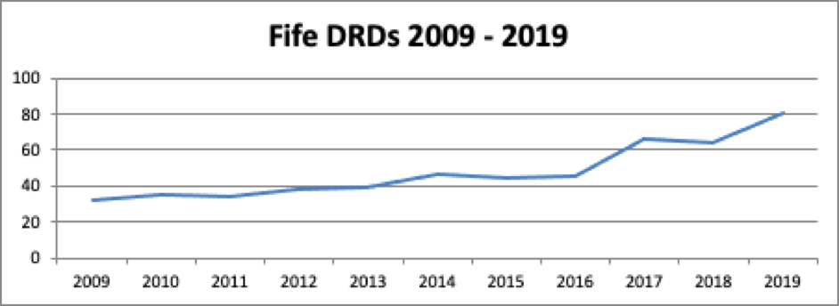
Fig 1 shows the rate of increase in drug-related deaths within Fife between 2009 and 2019:
Fig 1
In Fife, over a ten-year period, there is an increase of drug-related deaths occurring each year. There was a small decrease in 2018 from the previous year but 2019 figures are the highest recorded in Fife. This acceleration rate and increasing numbers of DRDs is not particular to Fife and is occurring across the country as a whole.
Previous years have shown that the majority of drug-related deaths are clustered around areas of higher deprivation. Unfortunately, 2019 is no different and when compared to Scottish Index of Multiple Deprivation (SIMD) data, the two datasets overlap considerably. Specifically, high numbers of death occur in Leven, Methil, Glenrothes, Kirkcaldy and Dunfermline and special focus is to be applied in these areas to reduce the rates of drug related deaths.
Most of the people who died - for both males and females - where in the 35 – 44 age range. An important point to note is the rise in women’s deaths in 2019 to 29 from 15 in 2018, an increase of 93% compared to the increase of 6% in male deaths. Again, this acceleration rate is consistent with national figures. Fife ADP in partnership with Violence Against Women Partnership, Women’s Criminal Justice Team and Scottish Drugs Forum will conduct a piece of peer-to-peer qualitative research to ascertain women’s experience of alcohol and drug service provision in Fife.
As in 2018, benzodiazepine was the most common substances present in drug deaths in 2019 as a feature of high levels of poly drug use. Heroin and Methadone were also present in 51% of the deaths and 53% respectively.
It is worth briefly mentioning some of the other work streams currently in development and supported by the ADP Support Team to reduce drug-related deaths. These are:
Prison Peer Mentoring - Recently liberated prisoners are at a high risk of drug-related death due to reduced tolerance for their drug of choice and varying strengths of drugs compared to those accessible within the prison system. Phoenix Futures, with direction and support from the ADP Support Team, have developed a team of peer mentors to reduce this risk by engaging with prisoners at the point of liberation and immediately prior.
Levenmouth Recovery Cafe - Funding was awarded to Restoration to develop a Recovery Cafe and increase capacity focused on the Levenmouth area. This has been successful with approximately 7% of Restoration membership now coming from this area.
Take Home Naloxone – Criminal Justice Teams including the Women’s Criminal Justice Team, homeless teams and ADP staff working in hostels have received training. There are developments to increase distribution by training those with lived and living experience to

NHS Addiction Services - Funding was awarded to the service to offer a next day ORT prescribing service to qualifying new patients in the Kirkcaldy area. This reduces attrition rates and provide access and treatment support quickly to people.

The median age for Fife drug users in the Scottish Drug Misuse Database is 36. 179 of the 911 individuals were aged 35-49, with 223 aged over 45. The percentage of users under 20 doubled from 2% in 2017/18 to 4% the following year. This was the highest Fife percentage for this age group since 2011/12, although still below the Scottish proportion of 5%. 69% of Fife recorded individuals in 2018/19 were male. This was the lowest proportion of males in any Scottish NHS Board, and below the Scottish figure of 73%. At 15%, Fife had the lowest NHS Board percentage of individuals in employment, below the Scottish figure of 19%. Fife individuals in the database were most likely to live alone (39%), followed by with a spouse or partner (17%). A high proportion of Fife individuals reported cooccurring health issues (29% physical health, 67% mental health, and 34% alcohol). The most common illicit drugs linked with Fife users were Heroin, Cannabis and Diazepam. Crack cocaine, which was linked to 33% of individuals across Scotland, only accounted for 16% in Fife.

Alcohol
Alcohol related hospital admissions in Fife have been increasing for some years, with the 2018/19 figure of 672.1 stays per 100,000 people being a new high. The greatest proportion of stays (494.8) were linked with mental and behavioural disorders due to use of alcohol. Of note is that the increased number of stays is linked to an increase in the total number of stays per patient, not an increase in the number of patients. In 2018/19 the average number of stays per patient was 1.5, an increase from the previous year’s figure of 1.4 and the highest number recorded.
For Fife individuals in the Scottish Drugs Misuse Database who reported alcohol consumption, 30% drank every day, in line with the Scottish proportion. A slightly higher proportion reported only drinking for one day per month – 16% compared with 13% for Scotland.
In 2017, two in five prisoners (who completed a questionnaire in the Scottish Prisoner Survey) reported being drunk at the time of their offence. 18% reported that drinking harmed their ability to hold down a job, with 32% reporting that alcohol affected their relationship with their family.
Alcohol related deaths have increased in Fife from 59 in 2018 to 70 in 2019. This is not a trend being experienced across other Health Boards in Scotland and Fife ADP has established a subgroup to explore this spike and provide service improvement recommendations to reduce the number of deaths occurring in Fife.

Prison population
The Scottish Government produces yearly statistics on the Scottish prison population. Additionally, the Scottish prisoner survey is compiled every two years, offering an insight into key health and care data related to prisoners.
Statistics for the 2019-2020 period show 8198 prisoners in Scottish jails, continuing the increase seen in recent years. Men have a much greater chance of being sentenced to prison, with there being 7796 males and 402 females in 2019-2020. For both sexes, those aged 25-29 made up the largest percentage of inmates. The number of white (3.82) and Asian inmates (2.45) per 1000 population has seen a steady decline in recent years, continuing into 2019/20. African, Caribbean or Black (7.64) and Mixed or Multiple (4.47) and other ethnic group (6.91) are all more likely to be in prison.
Of those prisoners declaring an affiliation with the armed services, the Army (2.6%) is linked with more prisoners than the Navy (0.2%) and Air Force (0.1%). 9% of prisoners have a self-declared disability. The incarceration rate per 1,000 people is 2.3 for Scotland, compared with 2.2 in Fife. The Fife figure has been on a downward trend for some time, down from 3 per 1,000 in 2013/14. There is a very significant link between areas of deprivation and likelihood of incarceration. 52.7% of prison arrivals in 2019/20 came from the 20% most deprived areas of Scotland. In contrast, only 3% came from the 20% least deprived areas.

Mental health
The 2019 Scottish Health Survey found that mental wellbeing was higher among older adults in 2019. The 65-74 and 75+ age groups were the only ones to record a mean WEMWBS score of over 50. There was also an association evident between mental health and deprivation. Adults in the 20% least deprived areas had a score of 51.5, while those in the 20% most deprived areas had a score of 46.9. Adults in the most deprived areas were also more likely to have two or more symptoms of anxiety or depression and have ever attempted suicide or self-harmed. Women were slightly more likely than men to report feelings of loneliness, with the difference more pronounced among younger age groups.

Homelessness
Homelessness is an issue that is affected by many factors, with there being a variety of pressure points that place people at greater risk of becoming homeless or coping with unstable accommodation. The implications of this – on a person’s physical and emotional health, on their personal circumstances and on their prospects – are significant.
The most important driver of homelessness in all its forms is poverty, with housing costs, welfare changes and demographics all playing a significant part. While the causes of homelessness are many and varied, certain factors have consistently emerged as being likely to increase a person’s vulnerability to future homelessness. Of course, it is important to recognise that while individuals in such groups perhaps have heightened vulnerability to homelessness, their needs and trigger points within this context may differ substantially.
- Armed Forces - In Scotland in 2018/19, 993 households identified as homeless contained someone with experience of serving in the armed forces. This accounted for 3% of all homeless applications. Research has previously found that there are consistent differences between homeless veterans and the wider homeless population. They were found, on average, to be older, to have slept rough for longer, to be less likely to use drugs, and to have a higher probability of alcohol-related problems.
- Care leavers - In 2018/19, 1,437 households applying as homeless contained someone under 25 who had been looked after by a local authority, accounting for 7% of homeless applicants. In the same year, 2% of Scottish children were looked after or on the child protection register. This suggests that the cohort of care leavers are overrepresented in homeless applications; perhaps caused – in part – by reduced levels of family support and opportunities for ‘sofa surfing’, both of which may help to prevent or delay homeless applications.
- Prisoners - There is a strong association between prisoners and homelessness, both prior to and post incarceration. Estimates vary, but it is possible that between 15% and 32% of prisoners were either homeless or not living in permanent accommodation prior to imprisonment. Even for those prisoners who did have settled accommodation, it is highly likely that this will be lost during their incarceration. A 2012 study for the Ministry of Justice found that 60% of prisoners believed that having a place to live was important in stopping them reoffending in the future. Supporting this, 79% of prisoners who reported being homeless before custody were reconvicted in the first year after release, compared with 47% of those who did not report being homeless. There is also the risk that released prisoners who have no option but to ‘sofa surf’ may reconnect with old associates, thereby falling back into an unhealthy lifestyle that may lead to future offending.
- Mental health - Mental health issues are frequently described as both a contributor to homelessness and something that may occur because of homelessness. For households assessed as homeless who identified at least one support need, mental health was the most common condition, having shown a continual increase since 2014/15. At 51%, the proportion of Scottish homeless households with an identified mental health issue was the highest on record. Elements of the homeless application process have the potential to impact on mental health. Instability of accommodation – including spells in temporarily furnished flats, B+Bs or hostels – was found to negatively affect some individuals’ mental health.

Public Perception
A potential barrier to the implementation of a successful community justice strategy is that of public perception and how the issue is understood. Previous surveys at a Scottish level have found low awareness of community justice options, apart from the option of unpaid work. This is not a new trend. 2007 research conducted by the Scottish Government found that many respondents perceived community penalties as ‘soft’, and a less effective punishment than prison. Accordingly, a key remit of Community Justice Scotland, upon its formation in 2016, was to promote public awareness of the benefits of community justice.
Fife mirrors the Scottish findings, with previous public consultation highlighting substantial variation in both the public’s awareness of community justice options and understanding of its goals. Findings from the most recent Fife survey, in 2019, include the following main points:
- Imprisonment and fines were the most recognisable court punishments.
- Less than half of respondents recognised Restorative Justice as a court option.
- Community Payback Orders / Community Service have ambiguity in terminology.
- Most important of the Scottish Justice Objectives were protecting the public, preventing/stopping crime and keeping communities safe.
- Television and Newspapers are the most used source of information on Scottish Justice but are not the most trusted sources.
- Of the public sector agencies, the Police were both more used, and more trusted as a source of justice information, than the Scottish Government and Fife Council.
- Around half of respondents were unaware of Community Justice in their area
- Most common means of awareness were through witnessing work taking place, local newspapers and through word of mouth.
- Community Justice is not seen as effective as prison in achieving most of the Scottish Justice outcomes.
- The term “Smart Justice” had not been heard of by the majority of respondents.
The results of this, and other such surveys, highlight the benefits of familiarity when assessing opinion. The concept of prison, for example, is a court punishment that is widely known and easily understood. Concepts such as restorative justice, which use more specialised terminology, are less recognised as options available to a court. While imprisonment and fines were both recognised by over 90% of Fife respondents, the term ‘restorative justice’ was recognised by less than half. Similarly, write-in comments revealed some confusion about the targeting of restorative justice, including whether it only applied to young people, and what activities were included in Community Payback orders.
A further factor in the high recognition of imprisonment as a potential court punishment is what the public believe the priorities of the justice system should be. The three factors most identified as very or fairly important by Fife respondents all involved prevention and ensuring safety. Protecting the public, preventing crime and keeping communities safe were each seen as important by over 95% of respondents. In this context, support for prison may be viewed less as a means of punishment, but perhaps as a successful method to remove offenders from communities. This appears to be supported by an almost even split among respondents in whether prison was an effective deterrent to crime, suggesting that even some of those who support prison sentences do not necessarily expect it to lead to behavioural change. A lower margin of 2/3 identified retribution as a very or fairly important objective of the justice system, while only 40% of Fifers agreed that community justice was an effective substitute for prison.
When community justice is assessed against prison for achieving the seven aims of the Scottish justice system, community justice was only rated higher than prison at achieving two aims: Rehabilitation and Repairing harm. For all others, prison was regarded as the more effective option. In particular, the biggest differences were in Protecting the public and in Keeping communities safe, where community justice was viewed as far less effective than prison in achieving this (41.9% and 33.7% difference respectively). This suggests that if community justice is in fact a more effective means of achieving these aims than prison is, there is little indication that this message/evidence is clearly understood or believed by the general public. If prisons do not achieve these outcomes, then the belief still exists that they do, or that they are a more effective method than the alternatives. Much work is therefore needed in order to change this public perception.
The ways in which people access news and reporting in the UK, and the trust they place in specific sources, is changing. Almost 2/3 of Fife respondents would choose to use mainstream media (television and newspapers) to access information about the justice system. Among government and public sector options, the Police (43%) were used more often than the Scottish Government (36%) and Fife Council (27%). With the question reframed as one of trust in media, trust in television (28%) and newspapers (32%) was lower than that in public sector bodies, particularly the police at 63%. Write-in comments revealed that many respondents had knowledge of community justice through their own line of work. Members of the general public with less experience in this field may have more trust in the mainstream media narrative. Recent political events, and the effects of the COVID pandemic, have caused some to question traditional print and broadcast media, while social media has also attracted controversy for the accuracy of its reporting. This may contribute to a further shift in trust levels in coming years.
It is likely that regardless of the form of media used as an information source, many of those not directly involved with community justice are only exposed to a partial picture of what this term encompasses. It was notable that even those Fife respondents familiar with the term were divided on its impact for society and members of the public. While community justice was associated by many with fairness – offenders atoning for their crimes and paying back to the community – there was recognition that a single agency could not provide all the solutions in isolation. Similarly, there was acknowledgement that the process could only work if society trusted in its methods, requiring offender rehabilitation to be balanced with the expectations of the community.
Uncertainty about the impact of community justice is not helped by an ambiguity around the term and its purpose. Despite the belief of some respondents, the term does not mean that ordinary members of the community are involved in the decision-making process of the justice system, while there was also some confusion about the nature of any crossover with the criminal justice system. Perhaps more damaging is the strong association of community justice with community service options such as litter picking, with reduced awareness of other available options. Knowledge of only some of the disposal options available will make it harder to portray the benefits for victims as well as offenders. There exists an opportunity here to make better links with local areas, perhaps by using community councils as a route for having CPOs carried out in their areas. This could lead to local communities identifying which local projects would benefit from the assistance of unpaid work teams, increasing both local awareness of criminal justice in action, and perhaps its perception in the community.
Such ambiguity of terminology seems to suggest that many members of the public are less concerned with the branding of community justice initiatives and more with results. Recognition of the term ‘Smart justice’ is particularly low among those not already working in this field, with over 80% of Fife respondents not recognising the term, and 45% answering that they did not know if Scotland operated a Smart justice system that was effective, robust and fair. Public expectation of what Smart justice is likely to entail will vary greatly, depending on a person’s view of the justice system and its priorities. With 87% of Fife respondents agreeing that justice should be about offenders repaying their debt to society, there appears to be potential for the role of community justice in this process to be promoted. Lower support for justice being about offenders rebuilding their lives (70%) suggests that initiatives which could achieve both aims would attract the broadest public support.

Participation Statement

The Community Justice (Scotland) Act 216 sets out a requirement for community justice partners to work together in preparing a Community Justice Outcome Improvement Plan for their local authority area, following engagement and consultation with relevant stakeholders.
The Participation Statement demonstrates how statutory and Third Sector bodies were involved in the development of this plan.
It is important to note that engagement in the development of this plan was limited because of the Covid-19 pandemic, with all consultation taking place online.

Structure
Governance of Fife’s Community Justice work is provided by Fife Community Safety Partnership, providing a direct link to Fife Councils Community and Housing Sub Committee and Fife’s Community Planning Partnership.

Fife Community Safety Partnership
FCSP includes seven Elected Members and core membership from:

- Police Scotland
- Scottish Fire and Rescue Service
- Fife Council Safer Communities Team
- Fife Council Criminal Justice Services
- Fife Council Education Service
- Fife Council Housing Services
- NHS Public Health
- Fife Violence against Women Partnership
- Fife Drug and Alcohol Partnership
- Fife Centre for Equalities
- Families Outside

All members of the CSP were consulted in the development of priorities and actions- being remitted to share questions and draft plans with their own networks.

Community Justice Partners
Those statutory Community Justice not members of the CSP were consulted separately.

Community Planning Partners
Wider consultation took place with community planning partners primarily through Fife’s Communities and Wellbeing Partnership but also directly with local partnership leads.

People and Place
Moves towards a more decentralised People and Place approach within Fife (led by Fife Partnership) provided the opportunity to consult with colleagues working at a local, draft versions of the plan were circulated to all via the local Community Managers.
It is important to note that while the above outlines the consultation process as the plan was being written, the priorities are underpinned by wider engagement and consultation, led primarily by the lead community justice partner responsible for each. Detail is contained with the wider plan, (and individual service/agency plans) with a clear example seen in the development of the Service Users Participation Group.
Plan for Fife
This plan is underpinned Fife’s Community Plan – Plan for Fife. Consultation and engagement are at the centre of all development of this plan and particularly so with regard the latest revision of the plan. Not only did CJ partners feed into this process but importantly used findings to identify priorities for the CJOIP
Fife People’s Panel
In 2019, a survey was undertaken via Fife’s People Panel to gain some insight into local understanding of community justice (the meaning itself) and more importantly the impact of community justice activities, support for community sentencing etc.
Social media
The ROAR Twitter feed is no longer actively used, with the focus instead of the wider Fife Council and Safer Communities Facebook and more recently the local Community Justice Services Twitter. This Twitter feed is proving successful in raising awareness of community justice services and engaging directly with partners and the wider community.

As identified in the National Strategy for Community Justice (2016). Reproduced in Community Justice Scotland, Strategic Needs and Strength Assessment Guidance Document (2020)
Fife Strategic Assessment, 2020 (Fife Council Research Team)
Strategic Needs Data (Fife Division, 2021)
RENT trends across Scottish local authorities - Broad rental market area profile: Fife
Scottish household survey: local authority tables - gov.scot (www.gov.scot)
Percentage of school leavers by total qualifications achieved, by local authority and SIMD1, 2012/13 to 2018/19
Summary Statistics for Attainment and Initial Leaver Destinations, No. 2: 2020 Edition, released on 25th February 2020
The life chances of young people in Scotland: Report to the First Minister (https://www.gov.scot/publications/independent-advisor-poverty-inequality-life-chances-young-people-scotland-report/pages/3/)
Cribb, Hood & Joyce, The Economic circumstances of different generations: The latest picture (Institute of Fiscal Studies, 2016)
NHS Fife - Fife population: An analysis by protected characteristics, 2016)
Scottish Government 'Mental wellbeing among adolescent girls in Scotland', 2019)
Scottish Household survey 2019. https://scotland.shinyapps.io/sg-scottish-household-survey-data-explorer/
Scottish Drugs Misuse Database, 2017-18 (Available from: https://www.isdscotland.org/Health-Topics/Drugs-and-Alcohol-Misuse/Publications/2019-10-08/2019-10-08-SDMD-Tables.xlsx)
Prisoners: Health in prison (Available from ScotPHO - https://www.scotpho.org.uk/population-groups/prisoners/data/prisoner-health/)
Scottish prison population statistics, 2019-2020 (Available from: https://www.gov.scot/publications/scottish-prison-population-statistics-2019-20/pages/2/)
Scottish Health Survey, 2019
Literature Review: UK veterans and homelessness, (The Royal British Legion, 2009)
Children’s Social Work Statistics Scotland, 2017-2018 (Available from: https://www.gov.scot/publications/childrens-social-work-statistics-2017-2018/)
No Fixed Abode, (The Howard League for Penal Reform. 2013)
Accommodation, Homelessness and Reoffending of Prisoners: Results from the surveying prisoner crime reduction (SPCR) survey, (Ministry of Justice. 2012)
Behind the statistics, p 26
Beth Watts et al. Temporary accommodation in Scotland, (Social Bite, 2018)
Community Justice Scotland survey (2019)
Andrew Coyle & Jacqueline Tombs, Community Justice Scotland: The past, present and future (2018)
People’s Panel survey: Community Justice (2019). Commissioned by Fife ROAR group. 721 people completed the survey, slightly more females than males, and just under a fifth had a disability. The age profile of those responding was mainly older people (83.2% being over 45) with only 3.7% of respondents under 35. Over three quarters were from a white Scottish background. Respondents came from across all seven localities of Fife and in terms of their own experience of the justice system, the majority (81%) of respondents, or persons in their household, had been neither a victim nor offender in the last two years. Around one in ten had been a victim of a crime in the last 2 years and less than 1% had been an offender or victim and offender.
The seven defined aims are: Keeping communities safe, repairing harm, punishment, protecting the public, rehabilitation, retribution and preventing crime.

