PUBLIC NOTICE
THE COMMUNITY EMPOWERMENT (SCOTLAND) ACT 2015
NOTICE OF CONSULTATION ON DISPOSAL OR CHANGE OF USE OF COMMON GOOD PROPERTY

Disposal by way of lease of part of former Nursery at Ravenscraig Park, Dysart Road, Kirkcaldy
The Council has received a request to lease part of the former Nursery at Ravenscraig Park, Dysart Road, Kirkcaldy for a period of 20 years. Before taking a decision, the Council requires to consult under Section 104 of the Community Empowerment (Scotland) Act 2015.
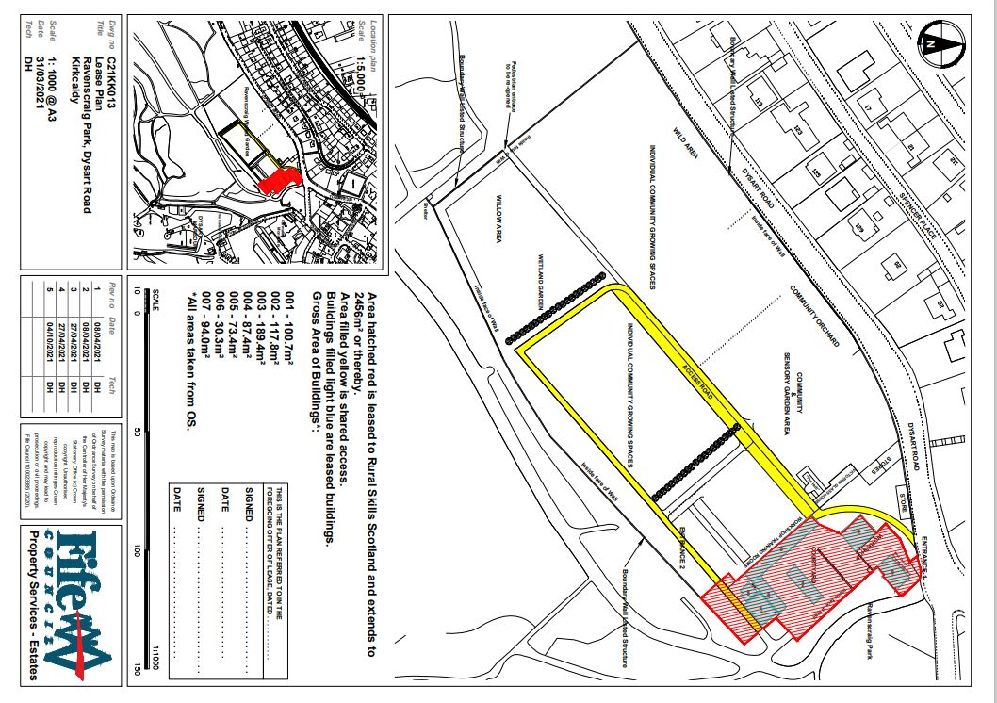
The area to be leased is outlined and hatched red on the plan below (“the Area”).

The Area includes former janitorial accommodation and storage facilities which have been declared surplus to operational requirements by the Council.

Disposal by way of Lease Request:

Rural Skills Scotland (RSS) have requested a 20-year lease of the Area. RSS are a not-for-profit social enterprise with a strong focus on equalities and reducing poverty through skills training and employment. They propose to use the Area for training and administration and move their office to the Area. The lease would allow RSS to develop pre-employment training for local young unemployed people and a volunteering programme at the Area. It would also allow the development of a programme of pre-employment with the Council’s Employability Team leading to apprenticeships. The lease would enable employment of 8 people and three apprenticeships on the Area in the first year. RSS intends to apply for funding to refurbish the Area and a long lease is crucial to securing any funding. RSS are an SQA accredited learning centre and currently hold a Modern Apprenticeship Contract with Skills Development Scotland. They deliver apprenticeships across the whole of Scotland and are also involved in the development of new learning materials.
The lease qualifies for the Council’s Subsidised Lease Policy and the rent will be reduced by 95% to reflect the Community Benefits the lease brings to the Area. These benefits include those mentioned above and RSS carrying out initial maintenance on the Area to bring it back into use from being a derelict area of land. In addition, subject to successful funding, RSS will refurbish and repurpose the existing empty buildings on the Area. RSS will also work with the other Tenants of the Ravenscraig Walled Garden area – Greener Kirkcaldy and Kirkcaldy Community – to advance the masterplan for the larger site which is likely to include re-instating the potting sheds and greenhouses as a training tree nursery leading to further employment and volunteering opportunities.
The proposals would be subject to planning and all other statutory consents.

Representations:
Anyone may make representations about this request to Fife Council. Representations must be in writing and include the name and address of the person making it. All representations will be published on Fife Direct (Common Good)
Representations must be received by 30th November 2021. They should be sent to Zahida Ramzan, Policy Co-ordinator, Fife House, Glenrothes, KY7 5LT or (Zahida.ramzan@fife.gov.uk) or to communityasset.transfer@fife.gov.uk

Date of Notice [4th October 2021]

