THE FIFE COUNCIL
NOTICE OF ORDER TO EXEMPT LAND FROM ACCESS RIGHTS
Notice is hereby given under section 11(9) of the Land Reform (Scotland) Act 2003 (“the Act”) that on 3rd September 2025, the Scottish Ministers acting under section 11(7) of the Act confirmed The Fife Council (Tulliallan ) (Exemption) Order 2023 (“the Order”) with modifications, proposed by The Fife Council under section 11(1) of the Act.
The effect of the Order is to exempt part of the grounds of Tulliallan Police College (including core path number: P749/02 03) from the access rights which would otherwise be exercisable in respect of that land by virtue of Part 1 of the Act.
The purposes for which the Order has been made are to provide for public safety and security during police training on the site. The Order will take effect between 07:00 on 3rd September 2025 and 16:00 on 3rd September unless revoked earlier.
Full details of the Order together with a Plan showing the land affected may be examined during normal working hours at Reception, Fife House, North Street, Glenrothes and on www.fife.gov.uk.

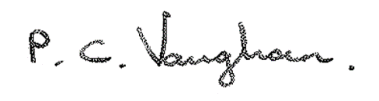
Paul Vaughan
Head of Communities & Neighbourhood

