**PUBLIC NOTICE**

**THE COMMUNITY EMPOWERMENT (SCOTLAND) ACT 2015**

**NOTICE OF CONSULTATION ON DISPOSAL OF COMMON GOOD PROPERTY**

Fife Council propose to dispose of a Common Good property **Denburn Wood, Crail**. Before taking a decision, the Council requires to consult under Section 104 of the Community Empowerment (Scotland) Act 2015.

**Denburn Wood Location**

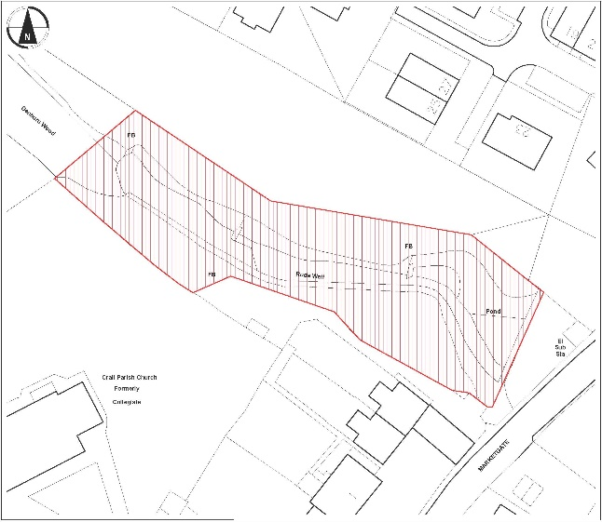 A aerial view of the proposed area at Denburn Wood, Crail to dispose of a Common Good property


**History**

Denburn Wood is a highly valued woodland asset in Crail providing a scenic route between sections of the community, a resource used for well-being, and education by Crail Primary School. Denburn Wood is divided into four segments with Fife Council owning one quarter share and the remaining sections owned by Crail Preservation Society. Development of Denburn Wood as a community green space started in the 1960s and the area was gifted to Crail Preservation Society by the adjacent developer in the 1990s. Fife Council still owns one quarter share.

**Disposal Request**

Crail Community Partnership (SC 049189) have made a Community Asset Transfer application to purchase Denburn Wood. Crail Community Partnership, with support from Crail Preservation Society, would like to take over management of Denburn Wood to allow simpler and faster decision making and seek funding to manage the area as a community green space.  A main goal for the community is to make the end to end path more accessible and less vulnerable.  The best way to achieve this is obtain funding given to local community charities that is not available to Fife Council. The purchase of Denburn Wood would allow the organisation to secure external funding to improve accessibility for benefit of the local community. This project would contribute to the Crail Local Place Plan 2018-2019

The proposals would be subject to all statutory consents.

**Representations**

Anyone may make representations to Fife Council in respect of this proposal. Representations must be in writing and include the name and address of the person making it. All representations will be published on www.fife.gov.uk at [Common Good](https://www.fife.gov.uk/kb/docs/articles/council-and-democracy/land-and-property/common-good)

Representations must be received **by 4th January 2025.** Representations should be sent to either [Zahida.ramzan@fife.gov.uk](mailto:Zahida.ramzan@fife.gov.uk) or [communityasset.transfer@fife.gov.uk](mailto:communityasset.transfer@fife.gov.uk)

or by post to Zahida Ramzan, Communities and Neighbourhood Service, Fife Council, Fife House, North Street, Glenrothes, KY7 5LT.

**Date 30th October 2024**