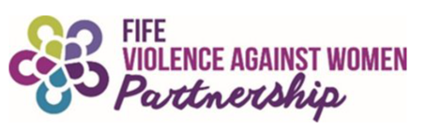

As part of National Stalking Awareness Week 2024, Fife Violence Against Women Partnership (FVAWP) invite you to join us for:

Stalking Awareness Online Information Session
Wednesday 24th April, 10:00am – 1:00pm, Online via Teams

Free and open to everyone - staff, volunteers and members of the public - this session will raise awareness of stalking, the impact of stalking on victims and emphasise the local response to stalking in Fife.

Speakers:
- Karen Fullerton-Chalmers, Action Against Stalking
An introduction to stalking, including the national picture and why it’s important for all of us to understand and take action on stalking behaviour.

- Professor Nancy Lombard, Glasgow Caledonian University
An overview of the findings of a research project conducted by the university, exploring women's lived experiences of stalking in the criminal justice system.

- Melanie McLeod and Len Pennie, Fife Women’s Aid
A local perspective on the impact of stalking, including a victim’s lived experience.

- Sandy Brydon, Police Scotland - Fife Division
An outline of the investigation of stalking by the Fife Domestic Abuse Investigation Unit, including the response that the public should expect from Police Scotland when reporting stalking.

Book your place:
This session will take place online using Teams. Please email fvawp@fife.gov.uk to book your place and receive joining instructions.

More information:
If you would like more information about any of these events or about stalking awareness week, please visit our FVAWP Campaigns Webpage or email fvawp@fife.gov.uk

More information about stalking can be found here:
Forms of Violence Against Women - Stalking | Fife Council
Action Against Stalking Scotland
Stalking - Police Scotland
Surviving Stalking • A podcast on Spotify for Podcasters

