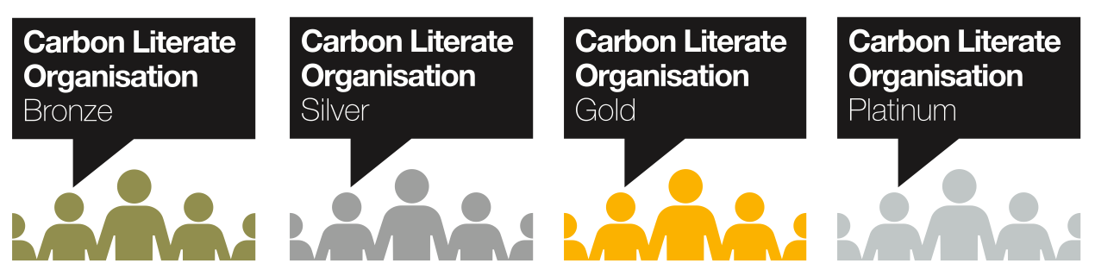

Fife Council, Planning Service Case Study

Who we are...
Fife Council is a unitary Local Authority in the East central belt of Scotland, we provide services to 170k Households and approximately 380k people. Planning Services’ key objective is to provide statutory duties in respect of planning applications (development management), development planning, enforcement, climate change and other matters including infrastructure delivery. The Council’s Climate Change team joined Planning Services in April 2021. The council became partner in Climate Action Fife Project in October 2020.
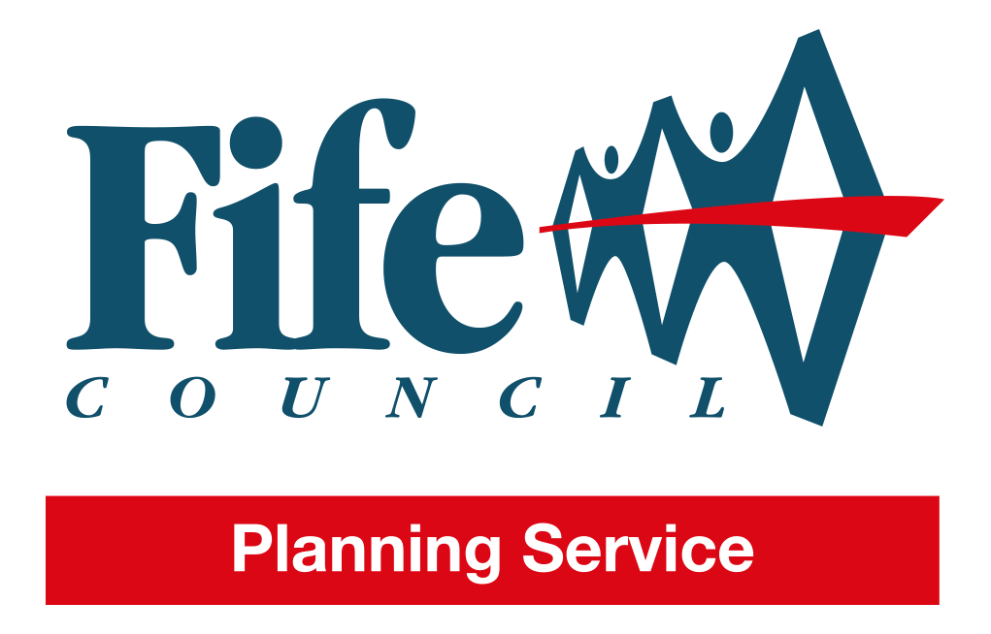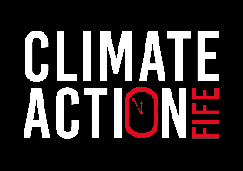
Climate Action Fife (CAF) brings together individuals, communities, local government and businesses to tackle the climate emergency and make Fife a greener and fairer place to live. Climate Action Fife is a Fife-wide partnership project between Carbon Literate Organisation Gold award Greener Kirkcaldy as the lead and 12 local partners including Fife Council.
Our Carbon Literacy Organisation Journey, in the beginning...
Fife Council has a Climate strategy, declared a climate emergency and prioritises tackling climate change in the area’s recovery and renewal plan out of COVID. Planning Services affect the wider Fife area through policy, strategy and services. A Local Authority is estimated to affect the wider area emissions by as much as a third. It is increasingly clear that for effective action to be taken on climate change, its effects and how we transition, everyone needs a basis of understanding to build on. Climate action needed to be incorporated into everyday thinking and action, like Health & Safety, which requires a massive sea change.
Carbon Literacy was used as a basis for wider Climate training, it provides staff with the tools, knowledge and inspiration to take action on the climate emergency and deliver to Fife Council's ambitions.

Climate Literacy started within the Council as part of a Development project CAF, that now has 5-year funding from the National Lottery.
Within Fife Council, the Planning Services lead the training programme of Climate Knowhow for the Public Sector, including the CLP Literacy accredited toolkits for LA’s. Local examples and common language with the community and education courses means that shared dialogue across all of Fife’s sectors is possible. The Climate Action Fife project aims to build capacity of communities to take action on the climate emergency, challenging the public sector to lead the way, a challenge that Fife Council is taking forward.
The cascade model of training allowed by the carbon literacy project with the provision of a free toolkit has increased capacity for delivery within the Council. We started by delivering to colleagues within the service first, as a trusted space, which resulted in a delivery model of 4x2hr online sessions as it works best around other commitments. As the project started in the pandemic, delivery has been online. This has been beneficial as a variety of groups with cross sectoral learners has pollinated fruitful discussion.
There have been challenges with split attention with emails etc, low participation in plenaries, difficulty in pledging group actions and low returns of pledges. As a result, the format was changed so that learners start their action plan as homework out of the 3rd session and complete in session, on the 4th. This has increased the number of submissions to 97% of learners.
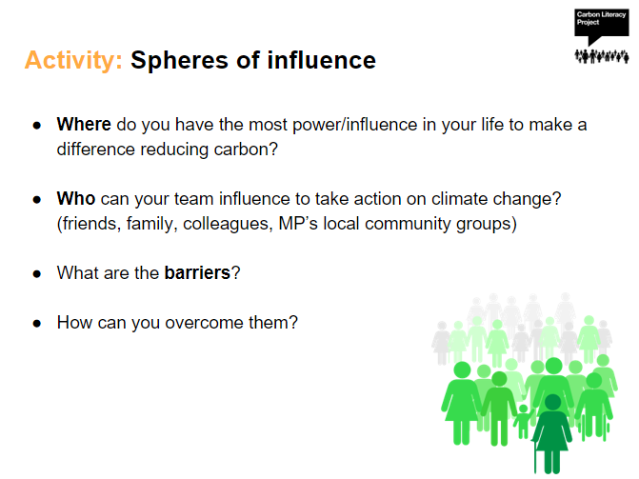
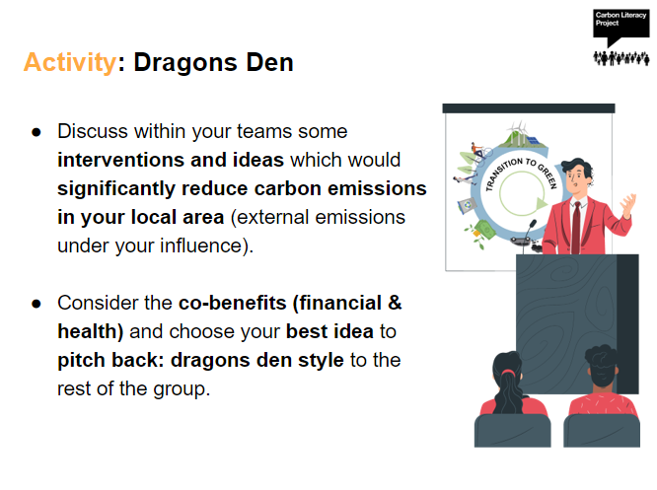
© The Carbon Literacy Trust 2020
The ‘Spheres of influence’ and ‘Dragon's Den’ activities are conducted after learners have prepared in their homework between sessions. This has yielded deeper thought and discussion and enables learners to trial their actions out before submitting. The trainer also makes themselves available for questions between session 3 and 4, a benefit of in-house training. The last hour is dedicated to adaptation and resilience to climate change based on Adaptation Scotland’s Climate Ready Places web resource. Learners are also put into smaller groups for discussion more often when the plenary sessions are monopolised by one or two voices.
Feedback for the training has been positive;
"It doesn't shy away from the scale of the problem but offers practical ways for making better decisions for the climate, professionally and personally. " Lauren Bennet, Policy Officer
“I thought the course was really interesting, with good mix of video and group activities. Good presenting, you made it relaxed and interesting for something that can be difficult to digest.” Steve Anderson, Building Services Commercial Service Manager.
“Thanks again for conducting a really insightful and thought-provoking course, which sadly needs to be done! “Chris Smith, Lead Officer Development Management.
“Thanks again for leading the training, it was really engaging and informative and I look forward to my team's participation in courses going forward.” Gordon Mole, Head of Business & Employability.
Fife Council uses the Local Authority Toolkits, delivered by Planning staff.
Through this training Planning Services will ensure that its influence is contributing to net zero emissions, ensuring a resilient Fife to the effects of climate change, in a just manner.
The future..
The Planning Services will continue to deliver Climate Training as part of Climate Action Fife, to Fife Council and the public sector. The Senior management team for the Enterprise & Environment Directorate responsible for most council emissions and a considerable influence over Fifewide emissions have completed the Managers climate training, as have the Plan4Fife Addressing the Climate Emergency Board. Climate action is addressed and aided through the approvals process with all levels of the council understanding the urgency. Officers feel empowered to make change and deliver council and Plan4Fife objectives, with a confidence and knowledge of co-benefits and how to deliver to multiple objectives in crowded landscape of priorities.
Planning Services have developed a Climate Action Plan based on officer pledges, led by the Head of Service. This action plan is the first in Fife Council and will hopefully encourage other services to contribute to Fife’s net zero ambitions and other Planning Authorities across Scotland.
The Climate team within Planning have been approached for advice by other sectors with climate actions they can practically implement.
Procurement is seeking to make climate training mandatory and have contributed to the generic climate training to ensure the embodied carbon of things is not omitted from the council net zero carbon journey.
The Climate Emergency is a priority or being considered for a wide range of plans and strategies that the council is responsible for, to name a few:
- Local Development Plan
- Local Community Plans
- Local Transport Strategy
- Food Strategy

Fife Council, Planning Services will continue working with Climate Action Fife on a cohesive Climate Knowhow programme to empower all communities, private and public sector to take action on climate change. We are planning a Climate place-based toolkit to be trialled in Kirkcaldy, to enable communities to take advantage of and mitigate climate opportunities and risks. We are also working with the further education sector in Fife to deliver the free CLP toolkits available to them. We advocate for the Carbon Literacy courses in all our internal and external engagements. Externally at:
- National Lottery, Climate Action Fund cohort meetings which has led to a few further conversations with other projects.
- Sustainable Scotland Network, Local Authority Forum, leading to discussion with 3 other Scottish LA’s and the Improvement Service.
- Fife Environmental Partnership, a partnership of public sector organisation within Fife and Advisory Group to CAF, have been challenged to become climate literate and promote the training in their organisations.
- Head of Planning Services, Pam Ewen in her role during 2021/22 as Chair of Heads of Planning Scotland promoted the Service literacy journey to further Scottish Local Authority engagement.
Planning Services will continue with promoting and delivering literacy within the service as it has become mandatory, with an annual refresher, and externally. Climate Action Fife is the delivery method for the next 5 years and during that time we will embed the process within the Council

Lead and manage the delivery of the Climate Emergency priority, ensure risks affecting this priority are being effectively managed.

