Environment & Protective Services Sub Committee
*

2nd September 2021
Agenda Item No. 16
Enterprise and Environment Directorate Section/Service Performance Reports
Report by: Keith Winter, Executive Director, Enterprise and Environment
Wards Affected: All
Purpose
To present the performance scorecard for Protective Services, Grounds Maintenance and Domestic Waste & Street Cleansing Service for 2020/21 and to provide information on environmental service requests/complaints and workforce profiles.
Recommendation(s)
Members are asked to:
- Consider the Protective Services, Grounds Maintenance and Domestic Waste & Street Cleansing Service performance information presented at appendix 1& 2.
- Consider if any further review work or scrutiny is required and the scope of that review.
- Consider the detailed Environmental service requests and complaints information at appendix 3.
- Note the arrangements set out to fulfil the Council’s obligation to comply with Audit Scotland’s 2018 SPI Direction.
- Note the information regarding the workforce profile at appendix 4.
Resource Implications
None
Legal & Risk Implications
None
Impact Assessment
An EqIA is not required because the report does not propose a change or revision to existing policies and practices.
Consultation
None required

1.0 Background
  - Audit Scotland published the Statutory Performance Direction in December 2018. 2020/21 is the second year to which that direction applies. The Council is required to report a range of information setting out:

- Its performance in improving local public services, provided by both (i) the council itself and (ii) by the council in conjunction with its partners and communities.
- Its progress against the desired outcomes agreed with its partners and communities.
- Its performance in comparison (i) over time and (ii) with other similar bodies including information drawn down from LGBF in particular and from other benchmarking activities
- Its assessment of how it is performing against its duty of Best Value, and how it plans to improve against this assessment

  - The first requirement, to report the Council’s performance in improving local public services (including with partners) will be satisfied by the series of reports (of which this is one) that will be presented to the Council covering the whole of the Council’s performance for 2020/21

  - The other requirements of the Statutory Performance Direction will be satisfied by a combination of

- Update reports to the Fife Partnership regarding progress against the Plan for Fife, with reports also going to Policy and Co-ordination Committee.
- public performance reporting, assurance statements and governance arrangements.
- Reviewing the External Audit Annual Report for its view on our Best Value performance and any action plans thereafter.
- Carry out a Best Value Self-Assessment using the updated Audit Scotland Guidance in conjunction with the Council’s Corporate Governance Statements.
1.4 Taken together, these reports will cover the whole of the Local Government Benchmarking Framework, plus selected service performance indicators that give a balanced picture of Council performance.
1.5 The appendix to this report is presented in the form of a balanced scorecard covering the areas of Financial, Key Business Delivery, People and Customer results. This mirrors the approach used for internal management reporting throughout the year.
1.6 This is the first Performance Report submitted following implementation of Oracle Cloud. This system has sophisticated reporting tools and better reporting functionality but some of these reports are still in development, particularly those relating to sickness absence.
1.7 Members should therefore be aware that the numbers in this section are different due to the system change. Previously, absence was reported as WDL per FTE. At the moment, the output data being produced is for WDL per employee and as a result, there is likely to be a slight but immaterial difference in the figures. WDL per FTE will be available for next year’s report.

2.0 Best Value and Plan for Fife
2.1 Fife Council and the Fife Partnership are currently completing a three-year review of the Plan for Fife to ensure that adequate progress is being made towards the Plan's twelve ten-year ambitions, while at the same time setting out a recovery and renewal plan following the Covid-19 emergency. A draft Plan was considered by the Fife Partnership Board and by Fife Council's Policy and Co-ordination Committee. Once agreed, the updated Plan will provide the basis for regular reporting to the Fife Partnership Board and relevant Fife Council committees on the delivery of agreed outcomes, this will in turn drive service performance and improvement activities.

2.2 Following the BVAR in 2018, the Best Value Action Plan will be reviewed and updated as per the new Best Value direction. From 2021/22, Councils will be asked to self-assess against this new direction and then produce a new action plan.

3.0 Service Performance
Protective Services
3.1 Protective Services performs a range of functions relating to buildings standards and safety, building warrants, Monitoring and inspection in the fields of Metrology & Consumer Safety, Food & Workplace Safety, Housing standards, Public Protection and animal health/licensing with a view to ensuring the protection of public health and well-being.
3.2 Strong cross service working across the Council and with partners was one of the dominant themes of activity over the last year. In the case of Protective Services this involved working with other services and partners, particularly NHS Fife, to support our collective response to COVID and the lockdown.
3.3 The impact of the COVID-19 pandemic has been significant for local authorities in terms of resource impacts, in protecting public health and at the same time delivering critical services to support our communities and in particular the vulnerable.
3.4 New COVID enforcement powers placed a duty on both Environmental Health & Trading Standards to ensure businesses adhered to the law and ensure that they were COVID compliant if operational. In addition, as numbers of positive COVID cases increased there was a requirement for EH & TS managers to attend regular Problem Assessment Groups (PAGs) and Incident Management Teams (IMTs) notified by NHS Fife Public Health Team (PHT). Settings referrals from PHT (where cases had visited hospitality premises, close contact services such as hairdressers, cafes, supermarkets etc) required follow up investigation to assess the risk of transmission within these businesses.
3.5 Whilst the Scottish Government had issued a relaxation to LAs until end February 2021 (then extended to September 2021) in terms of requirements to carry out food hygiene/standards inspections the additional workload due to COVID has been considerable. From March 2020 to July 2021 the following workload has been noted: -
- 2081 complaints/enquiries from the public/businesses/elected members to our dedicated COVID mailbox
- Over 10,000 proactive interventions to businesses including settings referrals from NHS HPT
3.6 There were also a number of additional activities in relation to EU Exit, both pre and post 1 January 2021, which placed an additional demand on the already stretched resources, including a requirement to inspect of all Fife fishing vessels prior to 31st December 2020 (over 80 vessels).
3.7 Whilst the majority of functions carried out by Protective Services remained business as usual, albeit delivered in a remote way wherever possible, during the pandemic, some areas of work such as food hygiene/standards inspections and test purchases by Trading Standards were stopped; this is reflected in the performance report in Appendix 1.
3.8 Preparation work is complete to re-start the food hygiene/standards inspections on 1st September, however, this will only be possible if the workload associated with COVID decreases considerably. All other remaining services which have not yet re-started will be phased to return to business as usual by end of December 2021.
3.9 Environmental Health and Trading Standards continue to face recruitment challenges; however, it is expected that 2 new additional Environmental Health Officers within the Food and Workplace Safety Team will commence employment in the next few months.
3.10 Performance within Protective Services remains high with the majority of indicators within Appendix 1 showing similar trends or improvements on previous years.
Grounds Maintenance and Domestic Waste & Street Cleansing
3.11 Grounds Maintenance Service are responsible for delivering high-quality environments in all communities within Fife by providing well-managed and carefully-maintained parks, streets and open spaces.
Domestic Waste are responsible for all aspects of household waste collection services and Street Cleansing are responsible for the removal of litter, weeds, and other debris from public roads and pavements.
3.12 The Grounds Maintenance, Domestic Waste and Street Cleansing Services were materially impacted by Covid-19 over 2020/21. Staff resources have been depleted over extended periods by Covid related illness, shielding arrangements and numerous track and trace group isolations.
3.13 Grounds Maintenance had to reduce grass cutting frequencies and summer bedding displays were stopped.
3.14 For a short period of time during the initial lockdown period some domestic waste collections were delayed, and recyclate frequency schedules extended to manageable timescales for the staff numbers in attendance. Street cleansing standards were also difficult to recover with less staff on the ground to do this manual work.
3.15 Despite pandemic associated challenges, the Grounds Maintenance Service did begin a grassland management initiative in support of ‘the ‘Plan 4 Fife’ biodiversity objective. Following a public consultation, previously cut areas of grass all over Fife were approved by Area Committees for rewilding. This work has begun, and minor modifications are being made to proposals in response to community feedback.
3.16 Despite the extenuating circumstances of 2020/21, the Grounds Maintenance, Domestic Waste and Street Cleansing Services have worked hard to maintain the performance standards of recent years and no major deviations are recorded.
3.17 When staff attendance returns to normal, improvement projects such as annualised hours, increased fleet and workforce resilience and dedicated team delivery models will further transform these frontline business units and improve service delivery.

Environmental service requests and complaints
3.16 The number of services requests and complaints for each of the environmental functions reported through the Environment & Protective Services Sub-Committee is shown in Appendix 3. The number of complaints against the relevant services is extremely low when compared with the number of service requests dealt with in each category. In most categories no corporate stage 1 and/or stage 2 complaints have been noted. For other categories the number of complaints received as a percentage of service requests ranges from 0.2% to 6.8%. The highest recorded complaints on a percentage basis aligns with more contentious issues such as seagull complaints where there are limited actions the council can take to resolve the issue of concern.
3.17 The statistics for 2020/21 have seen a large increase or decrease when compared with previous years in some categories; the final column in the table provides an explanation of these variances where relevant. For example, there has been a large reduction of 66% in communicable disease notifications from 2019/20 to 2020/21 - most likely associated with increased personal hygiene and cleaning during the pandemic. People’s behavioural changes during the pandemic has likely influenced other indicators, for example, complaints of bonfires has more than doubled compared with a typical year and is most likely associated with staying at home during lockdown periods and carrying out more gardening and DIY activities.

4.0 Conclusions
4.1 This report is the first in a series covering the whole of the Council’s performance against key indicators, including the Local Government Benchmarking framework.
4.2 The overall performance of Protective Services, Grounds Maintenance and Domestic Waste & Street Cleansing Service has been affected by the pandemic and this is highlighted in appendix 1& 2.
4.3 Comparison of service requests and complaints over the last 5 years has shown that the pandemic has affected the normal yearly trends expected with some categories being higher than expected and others lower.

List of Appendices
- Protective Services Performance Report 2020/21
- Grounds Maintenance and Domestic Waste & Street Cleansing Performance Report 2020/21
- Environmental Service Requests/Complaints Report 2020/21
- Workforce Profile

Report Contacts
Ken Gourlay Nigel Kerr
Head of Assets, Transportation and Environment Head of Protective Services
Enterprise and Environment Directorate Enterprise and Environment Directorate
Email: ken.gouraly@fife.gov.uk Email: nigel.kerr@fife.gov.uk

Iain Duncan
Programme Manager
Communities Directorate
Email: iain.duncan@fife.gov.uk

Customer
Performance | Progress
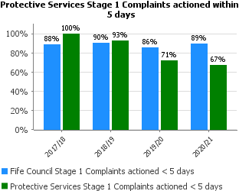 | Protective Services strives to maintain a high level of compliance when dealing with complaints within timescales however there has been a reduction in performance for stage 1 complaints target in 2020/21.  It should be noted. However, that only 6 complaints were received in this time period and 4 were actioned in time.
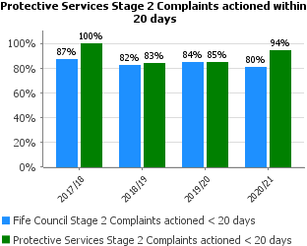 | The performance for stage 2 complaints has improved from the previous year and is above the Fife Council average.  18 stage 2 complaints were received and 17 actioned in time.
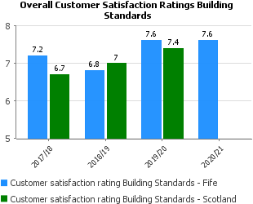 | Satisfaction rates remain high for 2020/21 and exceed the Scottish Government target of 7.5.  Please note that Scottish data for 2020/21 is not available at time of reporting but will be shared later in the year.

People
Performance | Progress
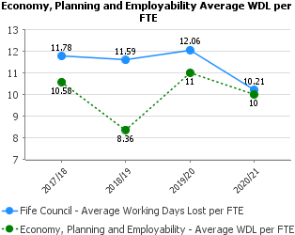 | Absenteeism across Planning, Protective Services, Business & Employability Services is slightly below the Council average and has reduced since 2019/20.  Currently staff absence is only available on Pentana at EPES (mentioned above) Level but will be broken down specifically for Protective Services in future reports.
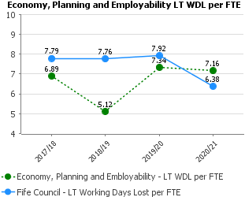 | The Services continue to monitor long term absenteeism and support staff. In particular through the pandemic, wellbeing has been a focus to encourage staff to look after their physical and mental health. Teams are using the Just Ask Listen Talk toolkit to identify the way they are being supported and supporting each other.
In line with the Fife Council average the %age absence rate has decreased from the previous year.

Overall, the absenteeism with the Service is managed and Staff are supported through training on areas such as Mental Health Awareness, utilising Reality Check tools and ensuring where required Staff are provided support through the Council’s Support Services.
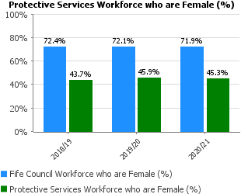 | The percentage of the workforce who are female has remained constant at just under 50%
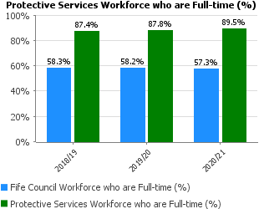 | The percentage of the workforce who are in full-time employment remains high at just under 90%
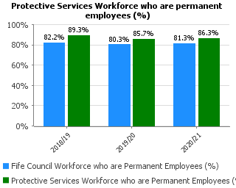 | The percentage of the workforce who are permanent are above the Fife council average and remains steady at just below 90%
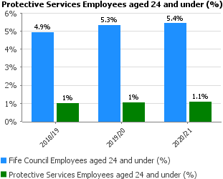 | Protective Services has an ageing profile, and this is reflected in this graph with only 1% below aged 24.  Due to recruitment issues within the service a “grow your own” approach has been adopted which should see, albeit slowly, an increase in young people coming into the service.
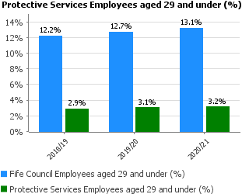 | As above the percentage of employees aged 29 and under is well below the Fife Council average.
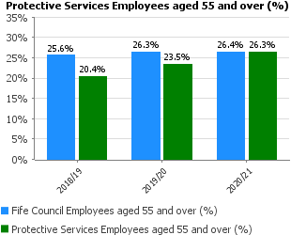 | In 2020/21 we are tracking the Fife Council average in terms of employees aged 55 and over. Due to the age profile in the service this statistic is going to rise considerably over the next 5-10 years.
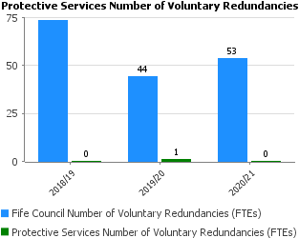 | There was only 1 voluntary redundancy in 2019/20 which was part of the change planning/budgeting process.  There were none in 2020/21
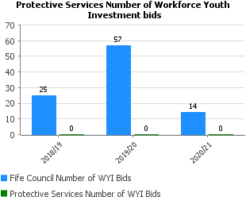 | There were no bids to this scheme for 2020/21, however, there has been 2 successful bids in 2021/22
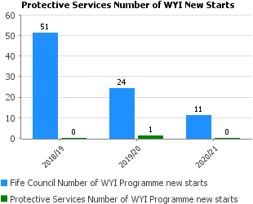 | There were no WYI new starts in 2020/21

Key Business Delivery
Performance | Progress
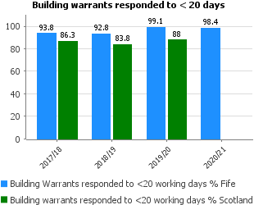 | Excellent performance following a difficult year when we were forced to switch to home working. Fewer inspections has meant that first response times were maintained - as inspections increase, we are working on IT equipment and processes required to continue delivering a full service within KPO target times. Please note that Scottish data for 2020/21 is not available at time of reporting but will be shared later in the year.
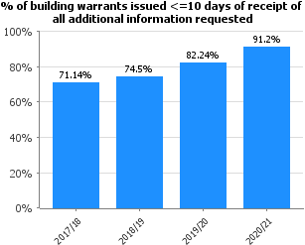 | This has met the annual target of 90% for the first time. The main reasons for success are encouraging customers to use our generic building warrant inbox (enables the Assistant Surveyors to support the indicator) & scheduling of inspections allowing more time to be allocated to approval tasks. However, this balance may change as site work continues to increase and new compliance during construction requirements are implemented 2021/22.
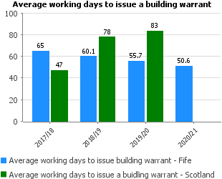 | Our deemed refusal process has been suspended due to the Covid-19 pandemic; this means that there are a higher than normal number of older applications in process at the moment. This also gives a lower number of average days to approval - once the deemed refusal process re-starts the average time for approval will increase, possibly significantly, but for a limited period.  Please note that Scottish data for 2020/21 is not available at time of reporting but will be shared later in the year.
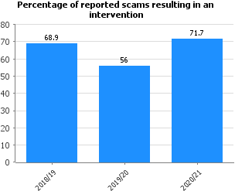 | Due to collaborative working with Nation Trading Standards, we receive a number of referrals in relation to scams in addition to the service requests that relate to scams. There are a number of different interventions that can take place to help protect consumers from becoming a victim of a scam and/or putting support in place - ranging from advice and guidance to installing call blockers in homes to stop calls of this nature getting through and making people feel safe again in their own home.
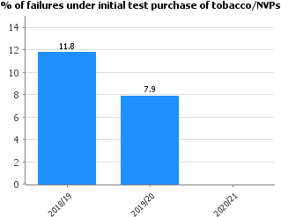 | No test purchases of tobacco or e-cigarettes we carried out this year due to the Covid pandemic, therefore there were no failures.
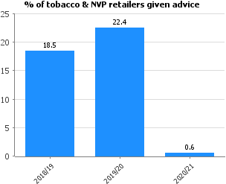 | This is much lower this year than the 10% target we aim to meet and report back to Scottish Government on due to the Covid pandemic and not being able to make these visits to the businesses that sell tobacco and e-cigarettes.
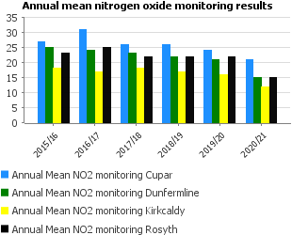 | Levels of air pollution have been decreasing in many areas. Reductions have been helped by action planning undertaken by Fife Council in Cupar and Dunfermline, and by an overall improvement in engine technology generally. Travel restrictions imposed during the Covid-19 pandemic caused levels to fall even further. Fife Council is continuing to work with national initiatives and local fleet owners (including the council’s own vehicle operators) to continue to improve air quality in Fife
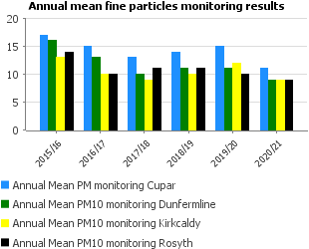

Financial
Performance | Progress
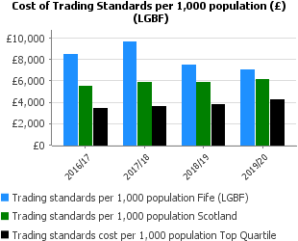 | The cost of trading standards per 1000 population has decreased over the last year and sits at approximately £1000 above the Scottish average. These costs are influenced by the inclusion of costs for the Money and Consumer Advice service which Fife Council pays an annual sum. These costs are not included within some LGBT returns for other local authorities.  The APSE return does not include these costs (but was not available for this year) generally places Fife about £1000 below the family grouping in terms of costs.
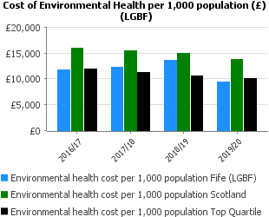 | The cost of Environmental Health per 1000 population has decreased significantly since 2018/19 and Fife now sits below the top quartile for Scottish local authorities.  These cost reductions are due to an increase in vacancies within Environmental Health – these posts have been advertised numerous times over the last 3 years with very limited success.
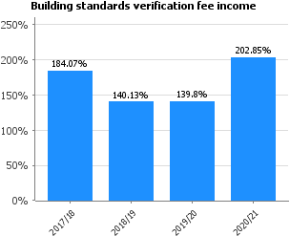 | Fee income was above average last financial year due to a significantly higher than usual number of non-domestic building warrant applications with a value of work > £50k and a change in legislation from 1st March 2021 effecting new build flats. Staff costs were lower than normal due to secondments & vacancies; recruitment to the vacant positions was delayed during the pandemic but has now started to deal with increasing workload.

Customer
Performance | Progress
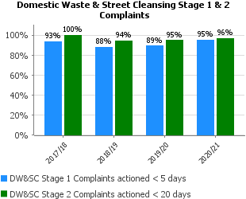 | Performance levels exceed the target for dealing with complaints.
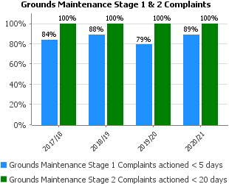 | Performance in dealing with stage 1 complaints is improving and stage 2 complaints were all actioned on time.
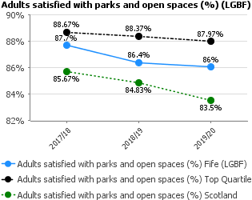 | The Grounds Maintenance Service continues to work through a transformational improvement programme of projects. A new operating model and management structure is bedding in and should see adult satisfaction increase in coming year.
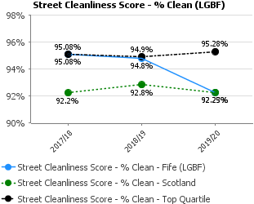 | Performance remained consistent in 2019/20). Changes in delivery models, refresher training and the management of performance should help see a continued strong performance in this area.
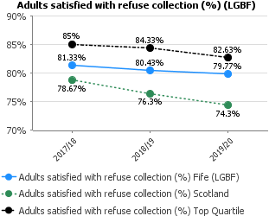 | Performance was affected for a short period at the end of 19/20 by pandemic impacts. Moving forward greater resilience has been built into the delivery by providing assistance from other staff areas within AT&E
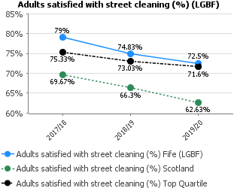 | Improved street cleanliness performance will take time to translate into adult satisfaction. Wider visibility of enhanced environments should see satisfaction increase.

People
Performance | Progress
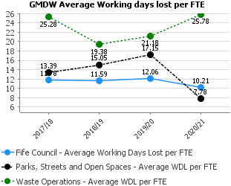 | The increase in absence figures in Waste Operations and the decrease in these in PSOS would seem to be consistent with the split with grounds maintenance and street cleansing from PSOS and subsequent shift in manpower to Waste Operations.  Trying to gauge absence rates etc during a global pandemic may not be a fair reflection this year on manpower. Not only is there Covid absences but also an increase in stress related absence due to the high levels of uncertainty and stress in the workplace that Covid 19 has caused.
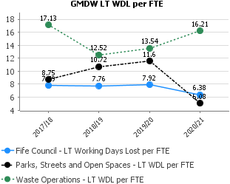
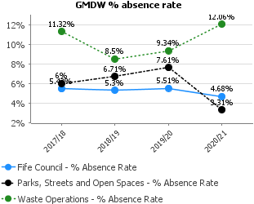
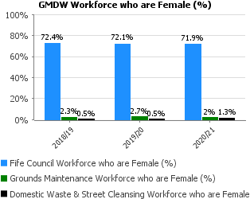 | No discernible increase in female workers in these frontline services. Percentages broadly reflect the gender response volumes to advertised positions.
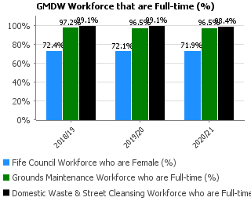 | Figures are consistent with previous years and are reflective of the services resource requirements and capacity to accommodate flexible working.
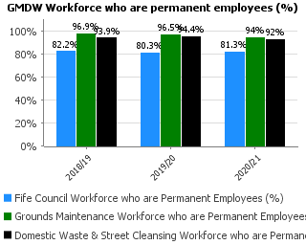 | Figures are consistent with previous years and are reflective of the services resource requirements and capacity to accommodate flexible working.
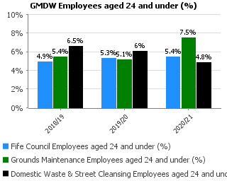 | Figures are consistent with previous years and are reflective of the services resource requirements and capacity to accommodate flexible working.
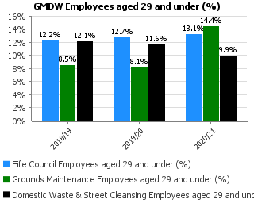
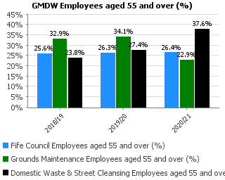
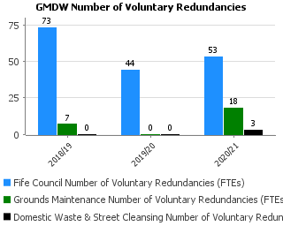 | The managing change exercise to separate Street Cleansing and Grounds Maintenance saw a management tier removed and 21 staff take voluntary redundancy.
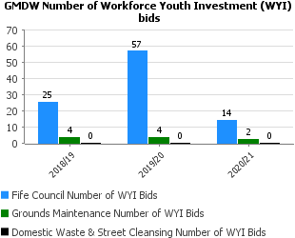 | Grounds Maintenance continue to bid for apprenticeships. The Domestic Waste Service has developed an Environmental Academy to train and recruit young people and funding is sourced through the Employability and Skills Team.
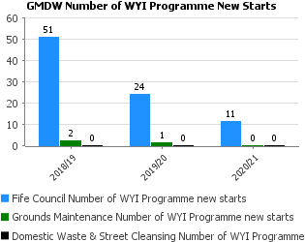 | Grounds Maintenance were unsuccessful with their bids.

Key Business Delivery
Performance | Progress
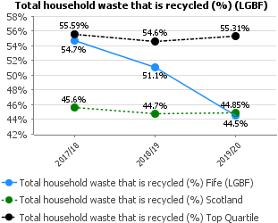 | Contributing factors to the reduction in recycling rate include stricter guidelines on compost accreditation thereby reducing the percentage of material which can be recycled and increasing the percentage sent to landfill. Moreover, wood waste is now used as biomass for district heating and cannot now be included in the recycling tonnage but is diverted from landfill.

Financial
Performance | Progress
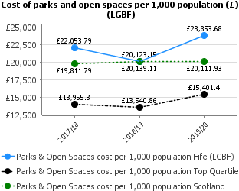 | The graph is misleading in that the figure for 2018/19 is lower than would be normal as it includes significant income from a property transaction in relation to Kinkell Braes Caravan Park.  The cost of parks remains higher than the Scotland average although satisfaction levels are also higher in Fife.
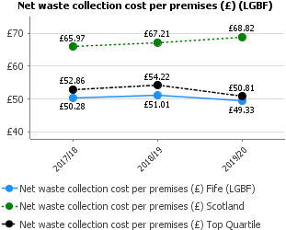 | The Domestic Waste Service continues to deliver top quartile performance.
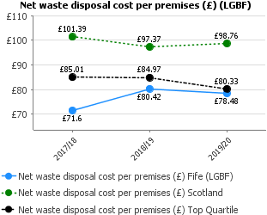 | Disposal costs continue within top quartile performance.
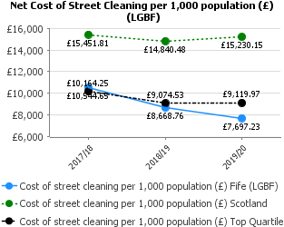 | Street cleansing costs remain within the top quartile.

Service Request/  Corporate Complaint | Service | Corp | Service | Corp | Service | Corp | Service | Corp | Service | Corp | Commentary
 | 2016/17 |  | 2017/18 |  | 2018/19 |  | 2019/20 |  | 2020/21
Pollution | 448 | 0 | 367 | 0 | 407 | 0 | 372 | 0 | 460 | 1 | Increase in service requests in 2020/21 mainly associated with bonfire complaints - evidence to suggest working from home and increased gardening activities
Communicable Disease (Food/Water borne) | 155 | N/A | 109 | N/A | 146 | N/A | 129 | N/A | 44 | N/A | Large reduction in reported cases of communicable disease – may be attributed to increased hygiene practices during the pandemic.
Domestic Noise including dog barking | 2695 | 4 | 2464 | 8 | 2482 | 4 | 2252 | 6 | 1717 | 5
Commercial and other noise | 232 | 246 | 244 | N/A | 300 | N/A | 275 | N/A | 290 | N/A
Other public nuisances | 170 | N/A | 191 | N/A | 216 | N/A | 206 | N/A | 80 | N/A | Considerable reduction in public nuisance service requests mainly due to lower complaints about bird nuisance
Abandoned Vehicles | 578 | N/A | 1421 | N/A | 1536 | N/A | 2164 | N/A | 1017 | N/A
Illegal Dumping | 3134 | N/A | 3282 | N/A | 4405 | N/A | 4346 | N/A | 4079 | N/A
Complaints about gardens | 784 | N/A | 663 | N/A | 782 | N/A | 952 | N/A | 778 | N/A
Food Safety & Hygiene | 789 | 1 | 735 | 1 | 861 | 3 | 715 | 1 | 1042 | 0 | Slight increase in service requests associated with food premises. May be linked to proactive food inspection programme being stopped.
Health & Safety | 337 | N/A | 318 | N/A | 275 | N/A | 244 | N/A | 1026 | N/A | Large increase in 2020/21 service requests - these mainly relate to COVID related concerns
Trading Standards Consumer Service Request | 1,400 | 0 | 1,356 | 1 | 2,890 | 1 | 1,790 | 0 | 1,743 | 0
Trading Standards Business Service Request | 231 | N/A | 214 | N/A | 433 | N/A | 518 | N/A | 441 | N/A
Trusted Trader Service Requests | 350 | N/A | 259 | N/A | 64 | N/A | 63 | N/A | 98 | N/A
Dangerous and defective buildings reports | 223 | N/A | 283 | N/A | 257 | N/A | 224 | N/A | 132 | N/A | Large reductions in 2020/21 service requests - these can often be affected by weather, however, impacts of COVID cannot be discounted e.g., people spending money on building repairs
Private sector housing enquiries | 422 | N/A | 398 | N/A | 284 | N/A | 286 | N/A | 85 | N/A | Large reductions in 2020/21 service requests - these can often be affected by weather, however, impacts of COVID cannot be discounted e.g., people spending money on building repairs
Dog Fouling | 1,123 | N/A | 1,112 | N/A | 1,080 | N/A | 1,143 | N/A | 661 | N/A
Signs for Dog Fouling | 0 | N/A | 0 | N/A | 96 | N/A | 107 | N/A | 78 | N/A
Birds including seagulls | 104 | 4 | 122 | 3 | 135 | 1 | 160 | 7 | 58 | 4
Animal Welfare | 11 | N/A | 9 | N/A | 12 | N/A | 15 | N/A | 9 | N/A
Recycling Centres | N/A | 5 | 26 | 5 | 61 | 22 | 29 | 12 | 6 | 32
Recycling Points | N/A | N/A | 177 | 3 | 292 | 4 | 119 | 2 | 150 | 4 | Service requests decreasing as cleaning schedules improve.
Missed bins | 7,963 | 148 | 10,827 | 185 | 9,875 | 173 | 9,860 | 170 | 11,520 | 466 | Increase in March 2018 led to an increase in missed bins in 2017/18.  The beast from the east 2 in February 2021 led to an increase in missed bins.  As at 31/03/21 there were 1,275,422 bins serviced in Fife. This equates to 0.090% missed bins.
Bulky Collections | 147 |  | 244 |  | 301 |  | 425 |  | 1,293 |  | Software problem led to error in bulk uplift sheets not being printed in July 2020.
Street Cleansing; | 1,928 | 3 | 1,788 | 1 | 1,408 | 5 | 1,470 | 4 | 982 | 2 | Service requests are reducing as standards are recovered with new operating model.
Grounds Maintenance | 683 | 30 | 998 | 37 | 1,805 | 35 | 1,732 | 32 | 982 | 57 | Service requests are reducing as standards are recovered with new operating model.
Flood Prevention. | 332 | 6 | 540 | 6 | 478 | 5 | 1,651 | 26 | 1,254 | 30

- Note where N/A indicated in table it has not been possible to break down formal complaints to the level of detail supplied for Service requests as numbers extremely low.

PROTECTIVE SERVICES, PARKS, STREETS & OPEN SPACES AND WASTE OPERATIONS – WORKFORCE PROFILE
2020/21 FINANCIAL YEAR (01 APRIL 2020-MARCH 2021)

Service | Budgeted FTE April 2018 | Budgeted FTE April 2019 | Budgeted FTE April 2020 | Budgeted FTE  April 2021 | Difference in FTE 2020-2021
Protective Services Management | 1 | 1 | 1 | 1 | 0
Protective Services | 106.99 | 104.82 | 104.51 | 112.04 | 7.53
ATE Management | 1 | 1 | 1 | 1 | 0
Grounds Maintenance | 447.57 | 455.73 | 446.21 | 248.72 | -197.49
Domestic Waste & Street Cleansing | 226.77 | 226,77 | 226.77 | 382.75 | 155.98
Total | 783.33 | 789.32 | 779.49 | 745.51 | -33.98

Note: the increase in Domestic Waste & Street Cleansing and the decrease in Grounds Maintenance is due to a re-structuring of the business units.

