Economy, Tourism, Strategic Planning & Transportation sub-committee

9th September 2021
Agenda Item No.
Enterprise and Environment Directorate Section/Service Performance Reports
Report by: Keith Winter, Executive Director, Enterprise and Environment
Wards Affected: All
Purpose
To present the performance scorecard for Planning, Business & Employability and Roads & Transportation Services for 2020/21
Recommendation(s)
Members are asked to:
- Consider the Planning, Business & Employability and Roads & Transportation Services performance information presented at appendix 1, 2 & 3.
- Consider if any further review work or scrutiny is required and the scope of that review.
- Note the arrangements set out to fulfil the Council’s obligation to comply with Audit Scotland’s 2018 SPI Direction.
- Note the information regarding the workforce profile at appendix 4.
Resource Implications
None
Legal & Risk Implications
None
Impact Assessment
An EqIA is not required because the report does not propose a change or revision to existing policies and practices.
An environmental assessment is not applicable for this report.
Consultation
None required

1.0 Background
  - Audit Scotland published the Statutory Performance Direction in December 2018. 2020/21 is the second year to which that direction applies. The Council is required to report a range of information setting out:

- Its performance in improving local public services, provided by both (i) the council itself and (ii) by the council in conjunction with its partners and communities.
- Its progress against the desired outcomes agreed with its partners and communities.
- Its performance in comparison (i) over time and (ii) with other similar bodies including information drawn down from Local Government Benchmarking Framework (LGBF) in particular and from other benchmarking activities
- Its assessment of how it is performing against its duty of Best Value, and how it plans to improve against this assessment

  - The first requirement, to report the Council’s performance in improving local public services (including with partners) will be satisfied by the series of reports (of which this is one) that will be presented to the Council covering the whole of the Council’s performance for 2020/21

  - The other requirements of the Statutory Performance Direction will be satisfied by a combination of

- Update reports to the Fife Partnership regarding progress against the Plan for Fife, with reports also going to Policy and Co-ordination Committee.
- public performance reporting, assurance statements and governance arrangements.
- Reviewing the External Audit Annual Report for its view on our Best Value performance and any action plans thereafter.
- Carry out a Best Value Self-Assessment using the updated Audit Scotland Guidance in conjunction with the Council’s Corporate Governance Statements.
1.4 Taken together, these reports will cover the whole of the Local Government Benchmarking Framework, plus selected service performance indicators that give a balanced picture of Council performance.
1.5 The appendix to this report is presented in the form of a balanced scorecard covering the areas of Financial, Key Business Delivery, People and Customer results. This mirrors the approach used for internal management reporting throughout the year.
1.6 This is the first Performance Report submitted following implementation of Oracle Cloud. This system has sophisticated reporting tools and better reporting functionality but some of these reports are still in development, particularly those relating to sickness absence.
1.7 Members should therefore be aware that the numbers in this section are different due to the system change. Previously, absence was reported as Working Days Lost (WDL) per Full Time Equivalent (FTE). At the moment, the output data being produced is for WDL per employee and as a result, there is likely to be a slight but immaterial difference in the figures. WDL per FTE will be available for next year’s report.

2.0 Best Value and Plan for Fife
2.1 Fife Council and the Fife Partnership are currently completing a three-year review of the Plan for Fife to ensure that adequate progress is being made towards the Plan's twelve ten-year ambitions, while at the same time setting out a recovery and renewal plan following the Covid-19 emergency. A draft Plan was considered by the Fife Partnership Board and by Fife Council's Policy and Co-ordination Committee. Once agreed, the updated Plan will provide the basis for regular reporting to the Fife Partnership Board and relevant Fife Council committees on the delivery of agreed outcomes, this will in turn drive service performance and improvement activities.

2.2 Following the Best Value Audit Review (BVAR) in 2018, the Best Value Action Plan will be reviewed and updated as per the new Best Value direction. From 2021/22, Councils will be asked to self-assess against this new direction and then produce a new action plan.

3.0 Service Performance
Planning Services
3.1 Planning Services leads on considering how places should change both through its statutory duties relating to development applications and permissions, local development plan policy, and enforcement. In addition, a range of work is undertaken through environmental planning, transportation aligned with new development, planning for Fife’s strategic growth areas and the related strategic infrastructure required. The Service has an important role corporately working collaboratively with other Services, Councils and organisations to promote investment in Fife and assist with Fife’s economic recovery.

3.2 This performance year has been particularly challenging. The Services’ Planning Performance Report 10 was submitted to Scottish Government Ministers in July 2021 for the same reporting period (ppf10-fife.pdf (wordpress.com) ) and sets out in detail performance against national agreed planning performance indicators. The Planning Service has had an important role through the pandemic in assisting the economy and has a critical role in Fife’s economic recovery in determining planning applications, providing environmental planning and climate change advice, and preparing for a review of the Local Development Plan.
3.3 Nationally there has been a significant increase in householder applications, and this is reflected in Fife. Whilst this is good for Fife’s economy, the Service has continued to manage high work levels with the same staff resource. The small householder and minor applications have small fees associated and the Service and therefore this increase in applications has not had the same uplift on fees overall.
3.4 Whist the pandemic has brought many challenges for the Service, it also has provided an opportunity to identify and implement improvements. A Communications Project was established and continues to identify and implement actions to improve. Within 2020/21 improvements related to streamlining processes, this included reducing unnecessary tasks for case officers: improving communication with our customers through a review of our website information and developing automatic system updates to customers on the progress of their application. Physical site visits at stages through the pandemic stopped and applications have been assessed utilising photos, videos, and online resources. The Service is looking to retain this way of working where possible, which will also assist with reducing the need to travel.

3.5 Overall, the Service has performed well particularly under the circumstances. Customer response times have been slower, as well as determination periods for applications, and improvements continue to be identified within the staff resources available.

Business & Employability Services
3.6 The service combines long-term thinking about the development of Fife’s economy, and short-term actions to deliver immediate “wins” for the economy. This includes capital projects, inward investment support, and sector initiatives. The portfolio also manages Fife’s Business Gateway contract, providing advice to small and growing Fife businesses.
3.7 The service seeks to ensure that all Fife's communities benefit from the overall growth in its economy and supports employability initiatives to help clients in disadvantaged groups and local communities to jobs, particularly targeting young people and the long term unemployed. It also covers Fife’s built and natural heritage, urban design and has a key role in helping regenerate Fife’s town centres.
3.8 The 2020 global Covid-19 pandemic has had an unprecedented economic impact, the full scale of which has still to fully emerge. Government support has so far helped to mitigate the immediate impact on businesses, but the concern remains that unemployment will increase significantly once the Coronavirus Job Retention Scheme (furlough scheme) and Self-Employment Income Support Scheme come to an end.
3.9 The economic impact of Covid-19 has seen uneven recovery during the pandemic. Demand for Fintech services has increased as online retail has thrived. Manufacturing has demonstrated a high degree of resilience and adaptability during the crisis. Construction has bounced back quickly, bolstered by accelerated investment in infrastructure, although material costs have increased. The high proportions of employment within the public sector and health and social care sector in Fife have protected many residents in the region, many of whom have been working from home. Further high-profile failures within the high street retail sector (particularly fashion retail) are having a major impact on city centres, although the crisis has prompted a welcome rejuvenation in local town centre trading. The biggest impact, however, has undoubtedly been felt by the tourism and hospitality sector. Ongoing and rapidly changing travel restrictions have undermined any significant form of recovery, although the tourism market is now benefitting from ‘staycation’ breaks.
3.10 Concerns regarding inequalities have also been exacerbated as a result of the pandemic. Some of those in lower paid occupations, and already suffering in-work poverty, have been at greatest risk of redundancy and unemployment – although, to date, this has largely been mitigated by the continuation of the furlough scheme. The crisis is also clearly seen to be impacting most significantly on areas and localities that were already struggling before the pandemic.
3.11 The report cover the period until March 2021, before restrictions were eased. Within this period, the UK also exited the European Union. The full impacts, and opportunities, for businesses are still to be realised, however some issues such as materials supply (with multiple causal factors) and staff shortages are emerging.

Roads & Transportation Services
3.12 Roads and Transportation Services are responsible for developing, managing and maintaining Fife’s transport network along with protecting and managing Fife ’coastal and flooding risks. The Service strives to deliver a balanced transport network that accommodates the safe and efficient movement of people and goods which helps to deliver Fife’s key economic goals, supports social inclusion and provides environmental and health benefits. The maintained assets have a replacement value of £5bn, covering our Roads, Bridges, Lighting, Car Parks, Bus Interchanges, Flood Prevention, Coast Protection, and other marine infrastructure such as harbours and piers.
3.13 Due to the Covid lockdown restrictions there were two periods where operational activity was impacted and works delayed or postponed. Throughout the year the service operated a blended approach with essential operational staff working from the depots at Bankhead and Halbeath and office staff working mostly from home other than those where it was essential to work from the office. When compared with pre-Covid working arrangements, there was a general loss of productivity and performance. This was mainly as a result of reduced supervision, direction, mentoring and lost social interaction across team working. In addition, mental health concerns came to the fore and remain a cause for concern during the current working arrangements.
3.14 Not only did Covid have a major impact on the service budget with significant and potentially sustained reductions in Car Parking and Bus Stations income but also the service trading account became imbalanced. These issues remain a challenge in the current year.
3.15 As part of the Reform & Recovery agenda, the service led on a major review of Passenger Transport Services with a member working group that led to a detailed report and action plan being approved for implementation by Policy & Coordination Committee on 1 April 2021. The action plan is now being implemented and involved a number of key initiatives across the various public transport services.
3.16 The service led on two successful bids for funding from the Bus Partnership Fund initiative and these have both moved to the next phase of development and will provide genuine opportunities to improve public transport services in Fife.
3.17 The Levenmouth Reconnected programme remains on track with good partnership working across several strands and as agreed by ETSP&T in April this year, the service is now progressing actively with a review and update of the Local Transport Strategy for delivery next year.
3.18 Following the extended and difficult winter period 2020/21, there remained a strong public focus on road conditions and the step increase in potholes and road defects. In response, the service diverted all available operational resources onto pothole repairs. This meant that the normal 2-4 squads per day was increased up to circa 12-14 squads. Whilst this had secondary impacts on the completion of other priorities, it allowed an intense effort on tackling the pothole backlog. In addition, external sub-contractors have now been engaged to continue the efforts on eliminating the backlog.
3.19 Additional resources (£9m over 2 years) were included in roads maintenance budgets, and this was most welcome. Since there is a direct linkage between investment in road maintenance and road condition. To maximise the benefit of these resources every effort is made to target the funding at the areas of highest priority. Beyond the next 2 years, the forecast reduction in capital budgets for road maintenance will need to be reviewed. In addition, the move to a risk-based approach to road inspections with more first-time permanent repairs is improving the efficiency of the road repair process. Further, the insufficient resources for street lighting replacements will begin to further impact on the quality and resilience of this key infrastructure in the years ahead.

4.0 Conclusions
4.1 This report is the first in a series covering the whole of the Council’s performance against key indicators, including the Local Government Benchmarking framework.
4.2 The overall performance of Planning, Business & Employability and Roads & Transportation Services has been affected by the pandemic and this is highlighted in appendices 1, 2 & 3.

List of Appendices
- Planning Performance Report 2020/21
- Business & Employability Performance Report 2020/21
- Roads & Transportation Services Performance Report 2020/21
- Workforce Profile

Report Contacts

Pam Ewen Gordon Mole
Head of Planning Head of Business & Employability
Enterprise & Environment Directorate Enterprise & Environment Directorate
Email: pam.ewen@fife.gov.uk Email: gordon.mole@fife.gov.uk

Derek Crowe Iain Duncan
Senior Manager, Roads & Transportation Services Programme Manager
Enterprise & Environment Directorate Communities Directorate
Email: derek.crowe@fife.gov.uk Email: iain.duncan@fife.gov.uk

Customer
Performance | Progress
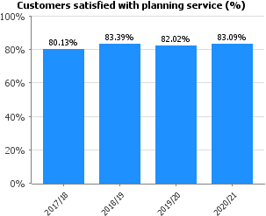 | Satisfaction with the level and quality of service being provided to customers remains high. Work through into 2021 is introducing widening our customer feedback and this will be reflected in the 2022 performance report.
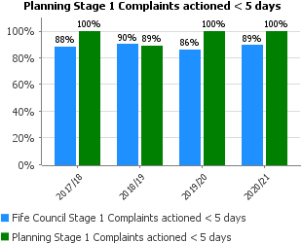 | Listening to customer’s complaints, considering, and responding comprehensively to these is important to Planning Services. Where possible complaints are responded to within corporate timescales, however on occasion where the nature of the complaint is complex an extension is needed.  The Service reviews where complaints are upheld and considers whether any actions are required relating to staff training, process changes etc. to assist with continuous improvement.  During the pandemic with a significant increase in email correspondence, a Communications Project was established to identify and implement actions to improve our communications, particularly to customers. It is expected that benefits from this project will begin to show in improved performance in future years.
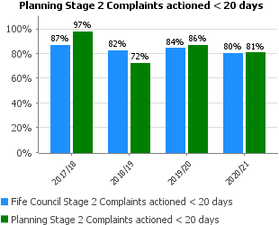

People
Performance | Progress
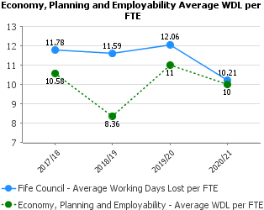 | Absenteeism across Planning, Protective Services, Business & Employability Services is slightly below the Council average and has reduced since 2019/20.  Currently staff absence is only available on Pentana at EPES (mentioned above) Level but will be broken down specifically for Planning Services in future reports.
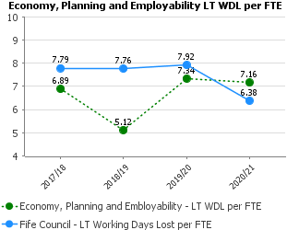 | The Services continue to monitor long term absenteeism and support staff. IN particular through the pandemic, wellbeing has been a focus to encourage staff to look after their physical and metal health. Teams are using the Just Ask Listen Talk toolkit to identify the way they are being supported and supporting each other.
In line with the Fife Council average the %age absence rate has decreased from the previous year.

Overall, the absenteeism with the Service is managed and Staff are supported through training on areas such as Mental Health Awareness, utilising Reality Check tools and ensuring where required Staff are provided support through the Council’s Support Services.
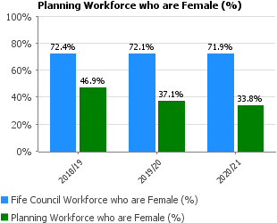 | The Service workforce strategy has sought to increase opportunities for Planners and planning students early in their career. Some of these posts are temporary and allow for continued opportunities. This has been an important aspect of assisting with growing talent and recruitment.  The performance relating to the service workforce demonstrates the success of a strategy to widen the age profile of the workforce, having a greater number of people at the start of their career. This is important to the Service for growing talent and succession planning.
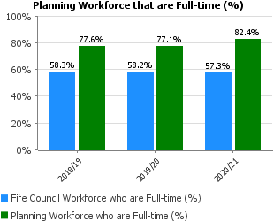
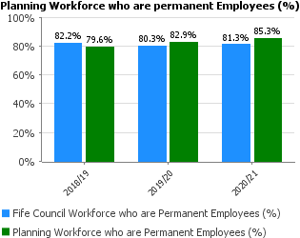
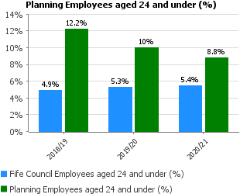 | The Service workforce strategy has sought to increase opportunities for Planners and planning students early in their career. Some of these posts are temporary and allow for continued opportunities. This has been an important aspect of assisting with growing talent and recruitment.  The performance relating to the service workforce demonstrates the success of a strategy to widen the age profile of the workforce, having a greater number of people at the start of their career. This is important to the Service for growing talent and succession planning.
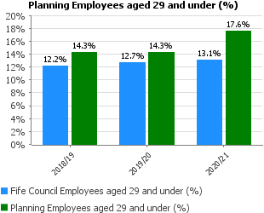
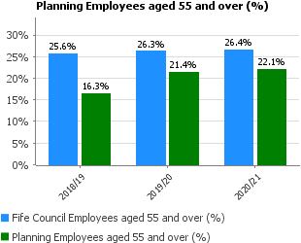
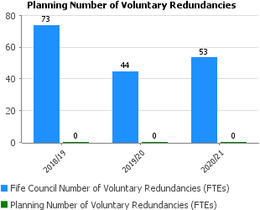 | No voluntary redundancies have been required, with staffing savings over a number of years being achieved through vacancy management.
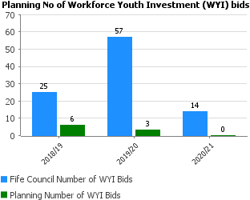 | Planning Services commitment to Workforce Youth Investment continues in 2021/22 with 2 bids for (total 4 posts), matched funded being submitted for full time and part time placements in for students who have recently graduated or are in a town planning course. Planning Services is committed to developing the young workforce by giving them the relevant work experience and skills to develop in the planning profession.  4 WYI new staff in 2020/21  2 Graduate Planner – 2 year full time placements for recent graduates  2 Part time Student Planning Assistant posts – 1 year (part time) posts for students who are studying in a town planning course.
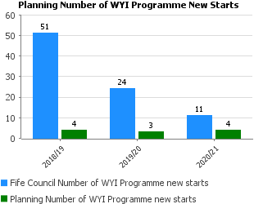
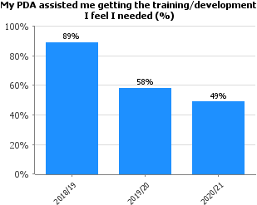 | The 2020/21 staff survey which was undertaken as part of the Planning Services virtual staff day identifies that there are less staff having their twice yearly Personal Development meetings with a plan agreed. The Service Management team have actioned where there are gaps, meetings arranged to have increased performance in 2021/22.  The Service continues to provide regular CPD training events, and whilst during the first 6-9 months of the pandemic these were reduced, a full programme was resumed.
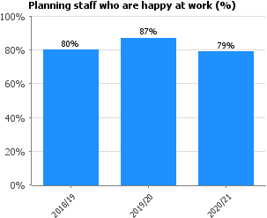 | This demonstrates that the majority of staff within Planning Services are happy at work. The staff survey was undertaken in Dec 2020 as part of the Service virtual staff day. A small reduction in % happy from last year and a return to 2018 levels is expected given the impact of the pandemic on staff. The staff survey results have been discussed within teams to consider and respond to the results.

Key Business Delivery
Performance | Progress
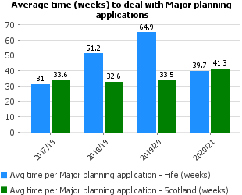 | This statistic is susceptible to variation, given the low number of Major applications determined in a year and the lengthy periods sometimes needed to conclude negotiations on complex legal agreements. Nonetheless, it’s encouraging to note a significant reduction in the average time taken over the past year.
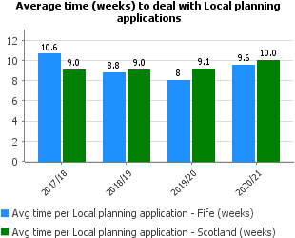 | The impact of the COVID 19 pandemic both in terms of adapting to new ways of working and maintaining a service was compounded by a number of long term absences in 2020. Despite these challenges’ performance did not drop significantly relative to the previous year’s national average time.
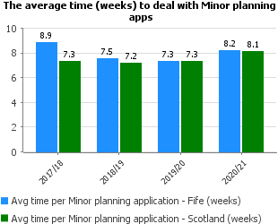 | The implications noted above arising from the COVID pandemic impacted on the processing time in relation to Minor applications. Moving into Q3 and Q4 of 2020/21 a significant and almost unprecedented increase in the number of minor and householder applications were submitted. Despite this performance over the year while slower than 2019/20 only increased by 0.9 of a week overall.
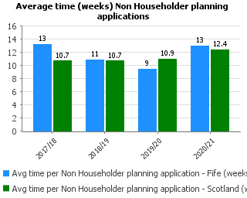 | The implications noted above arising from the COVID pandemic impacted on the processing time in relation to non-householder applications. Our performance in 2019/20 was faster than the national average and unfortunately, our performance in 2020/21 due to absences and impact of the pandemic as well as increasing numbers of application has slowed our processing time.  Additional staff are being redeployed temporarily from other teams in the service to provide additional capacity on an interim basis.
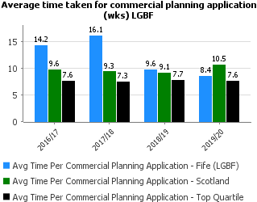 | The processing times for commercial applications in 2019/20 was 2.1 weeks less than the Scottish national the average processing time. This also represented a reduction on the previous year’s figure. The improvement in processing time reflects the steps taken to prioritise and manage applications from our business priority customers. We identified these customers as business priorities during the COVID pandemic to ensure capacity was maintained to support businesses and investment.
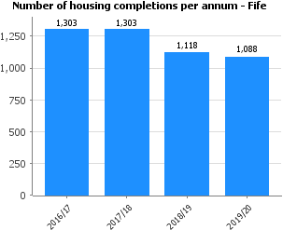 | Completions have remained stable over this period compared to 2018/19. COVID will not have impacted greatly on completions for 2019/20 as the first lockdown hit right at the end of the audit year.  As the 2021 Housing Land Audit (HLA) is in the early stages of preparation, there are no completion figures available for 2020/21. The completions over this period are expected to decline compared to previous years to reflect the impact of COVID and the period of lockdown when housing construction stopped. Post lockdown, the pandemic has continued to affect the house building industry with supply chain disruption and COVID restrictions. However, despite this, progress has continued to be made on strategic development sites through the last year.  The 2021 HLA is expected to be finalised later this year and will bring reporting back into line for next year’s performance report.
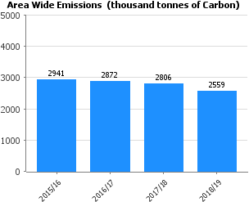 | As with the rest of Scotland, the majority of emission reduction has come from the decarbonisation of the grid (Renewables were the single largest source of electricity generated in Scotland in 2018 at 54.9 per cent, followed by nuclear generation at 28.2 per cent with fossil fuel generation making up only 15.7 per cent). Out of the sectors reported on to make this total, Industry contributes the greatest reduction with the closure of fossil fuelled power plants and the off shoring of heavy industry. A reduction in Fife of nearly 200 kt CO2 from 2018 to 2019.
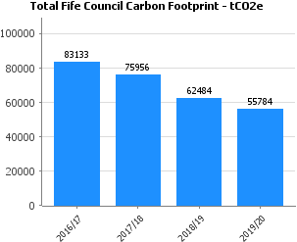 | Over this period Fife Council have benefited from Scottish decarbonisation of electricity supply, a few mild winters leading to less gas and electricity used for heat (2018/19 markedly so) and Light Fife Green energy efficient streetlamps.
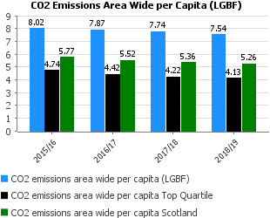 | See Area wide emissions above for context on trends. Fife in significantly higher that both the Scottish average and the Top Quartile. This is primarily due to the higher levels of “large industrial installations”. Fife compares favourably to the Scottish average in the other elements which make up the footprint (e.g. Commercial, Public Sector, Transport etc.).
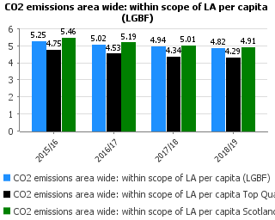 | See Area wide emissions above for context on trends. Progress follows the national trajectory and comparable to the national average.  This indicator is a sub-set of the above and excludes emissions where the Local Authorities has no direct influence, notably Motorways and EU Emissions Trading System sites (mostly large industrial sites).

Financial
Performance | Progress
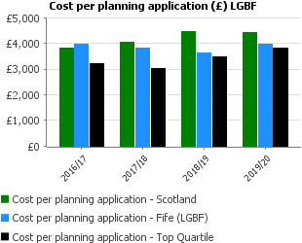 | The cost of assessing and determining planning applications remains lower than the Scottish average.  Heads of Planning Scotland research with CIPFA (2018) demonstrated nationally that only 66% of core Development Management costs are recovered through planning fees. The Scottish Government consulted upon an increase in national planning fees in 2019, however the progress of this has been impacted by the pandemic. A national fee increase is required to assist in properly resourcing planning authorities nationally.

Customer
Performance | Progress
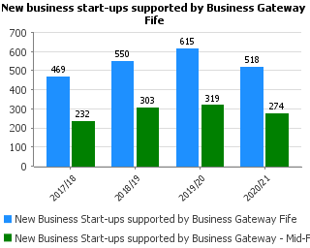 | While the number of business start-up enquiries was similar to the previous year, the conversion rate was down due to the impact of Covid-19 restrictions on some of the practical tasks associated with starting a business as well as the involvement of the Business Gateway Fife Start-up Team in the delivery of the various Covid-19 business grant funds.
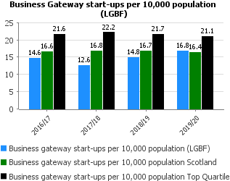 | For the first time, the number of start-ups per 10,000 of population was slightly higher than the figure for Scotland as a whole (16.8 compared to 16.4) after having been considerably lower for the past few years.
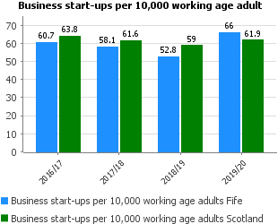 | In 2019, both the number of new business start-ups and the business start-up rate in Fife increased for the first time since 2016. A total of 1,530 new businesses started up in 2019, 305 more than the previous year and the highest figure recorded. For the first time, Fife's start-up rate (66.0) was higher than the Scottish start-up rate (61.9).  It is anticipated that the number of business start-ups in 2020 will be significantly impacted by the Covid-19 pandemic, however the data will not be available until November 2021.
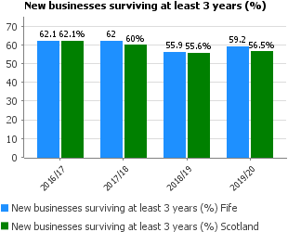 | Businesses born in 2016 had a higher 3-year survival rate than those starting up in 2015 both in Fife and Scotland as a whole. This is the first increase since survival rates fell from their highest rate in 2015. As in previous years, Fife's 3-year survival rate was higher than that for Scotland as a whole (56.5%).  It is expected that the number and rates of businesses surviving during 2020 will be significantly impacted by the Covid-19 pandemic, however the data will not be available until November 2021.
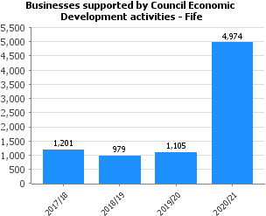 | The significant increase in 2020/21 figure is a result of the Economic Development team’s role in delivering a number of Covid-19 business support grants throughout the year.
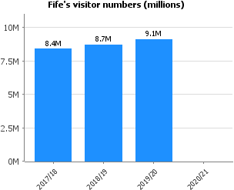 | Film tourism continues to draw significant numbers of visitors to the Kingdom with popular TV Shows such as Outlander leading to global interest and cruise passenger numbers have shown an increase year on year'. A strong digital presence for Fife has also been a key factor in engaging with audiences from all over the world with over half a million users on welcometofife.com. Uncertainty around EU exit and fluctuations in currency have been contributing factors for Fife strengthening its domestic market for overnight "staycations" and day trips from the central belt.  Data for 2020/21 will not be available from source until November 2021.
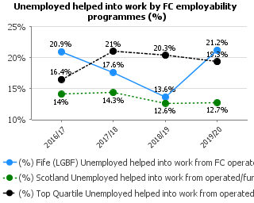 | In the first phase of the ESIF Employability Pathway (2014-2020) activity, employability delivery shifted focus to concentrate on longer-term, more intensive interventions, supporting those from the most disadvantaged groups in Fife (both social and geographic), into healthy, sustainable employment.  Although engagements have been consistent and positive progressions and softer outcomes have been strong, entry into employment has been slower.  As we come to the later stages of the second phase of Pathway activity, delivery partners are concentrating less on progression into employment.  The graph outlines the direction of travel, prior to the Covid-19 pandemic and it is unlikely that this improvement will be sustained in 2020, due to a reduction in the number of available jobs, and employers recruiting during the restrictions. The implementation of job creation schemes such as Kickstart will increase entry numbers for the next year.
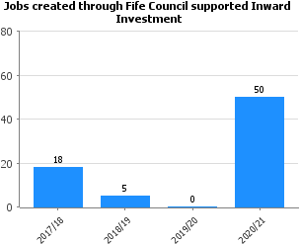 | Cesscon Decom, a new decommissioning facility at Energy Park Fife, Methil, has been awarded Scotland’s largest decommissioning contract to date, with the creation of up to 50 jobs.

People
Performance | Progress
Absenteeism across Planning, Protective Services, Business & Employability Services is slightly below the Council average and has reduced since 2019/20.
Currently staff absence is only available on Pentana at EPES (mentioned above) Level but will be broken down specifically for Business & Employability Services in future reports.
 | The Services continue to monitor long term absenteeism and support staff. In particular through the pandemic, wellbeing has been a focus to encourage staff to look after their physical and mental health. Teams are using the Just Ask Listen Talk toolkit to identify the way they are being supported and supporting each other.
In line with the Fife Council average the %age absence rate has decreased from the previous year.

Overall, the absenteeism with the Service is managed and Staff are supported through training on areas such as Mental Health Awareness, utilising Reality Check tools and ensuring where required Staff are provided support through the Council’s Occupational Health Support Services and through the Supported Employment Service.
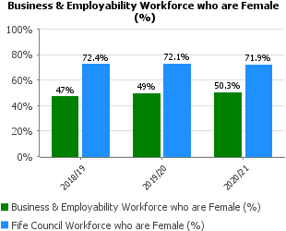 | The proportion of workers who identify as male and female remains largely unchanged from previous years. These ratios are across all grades within the service, except service management roles, which are 100% female.
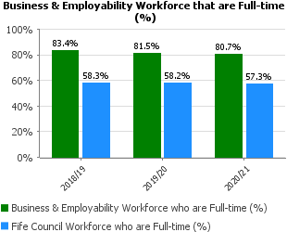 | The proportion of workers within Business & Employability who are full time has been stable across recent years and reflects the nature of the work, linked to funding from external sources.
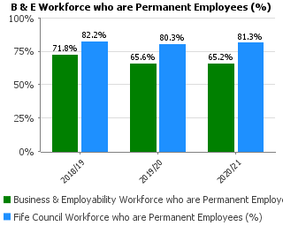 | The shorter term nature of external funding means that a higher proportion of B&E staff are on temporary contracts. This reflects the mix of core and external funding contracts operated by the service.
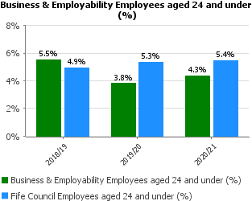 | There has been a slight increase in staff aged 24 or under within the workforce. The change reflects recruiting for new roles. In 2019/20 the service’s Modern Apprentices were recruited to higher grade roles following successful completion of their frameworks.  The service has a large number of specialist roles which require a level of training and experience.
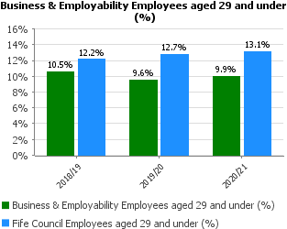
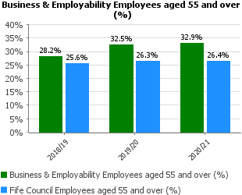 | A strategy for succession planning within the service is in development as part of the service workforce action plan. However, there are few staff in the service who are at an age of retirement in 2021/22.
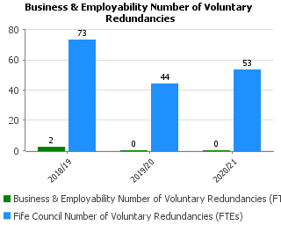 | There were no new staff savings identified within the service for 2020/21 and this is reflected in the number of voluntary redundancy figures.
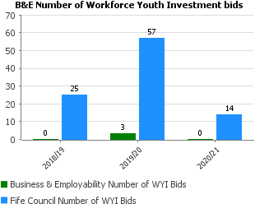 | The year on year change reflects a wider range of funding options to support youth employment, including the Council securing DWP Kickstart Gateway status to support 16-24 year olds within Fife. 30 young people have been supported through this route into Council work opportunities.
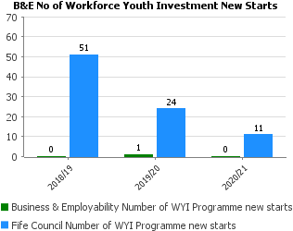

Key Business Delivery
Performance | Progress
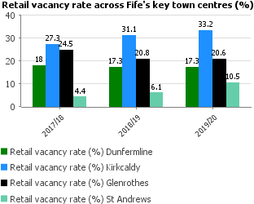 | No data is currently available for 2020/21.  Vacancy rates remained unchanged in Dunfermline and Glenrothes during 19/20. However, increases have been recorded in St Andrews and Kirkcaldy.  St Andrews saw a significant increase of 4.6% and representing several smaller footplates across the town centre.  Kirkcaldy saw an increase of 2.1% largely reflecting the closure of some bigger units including Debenhams. This unit is currently being refitted for a new operator.  Cowdenbeath had a vacancy rate of 15.2% when surveyed representing a significant improvement of around 5% additional occupancy.  Leven saw a small rise of just over 1% which we believe reflects the turnover of businesses in the town centre.  It is difficult to ascertain what the full impact of Covid-19 has and will continue to have on the retail and service sector vacancy rates. Fife Council is investing in projects across the key towns and Cowdenbeath and Leven, aligning to the Covid recovery effort and aspirations to deliver on key strategic themes such as community regeneration and renewal, community wealth building, net carbon zero- and 20-minute neighbourhoods.
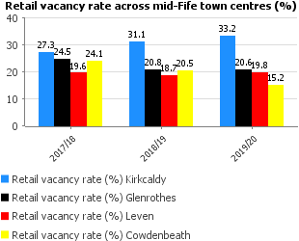
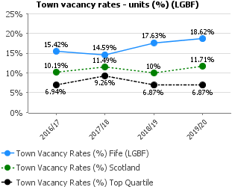
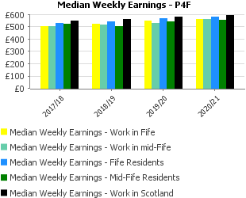 | The average weekly earnings of people working in Fife increased between 2019 and 2020 but at the same rate as that for Scotland as a whole (+2.7%) so that the gap between the median wages in Fife and Scotland remained the same. The average wage for people working in Fife in 2020 was 5.7% or £33.70 below the Scottish average wage. Whilst the earnings of people significantly lower than those for people living in Fife, the gap remained the same as in 2019 (£20.20).  An estimated 20,000 employees in Fife earned less than the Real Living Wage (£9.30) in 2020. This was 5,000 fewer than in 2019. The proportion of employees earning less than the Real Living Wage fell by 3.6 percentage points from 18.9% in 2019 to 15.3% in 2020, closing Fife's gap with the Scottish average (15.2%).  The implementation of a focused campaign for Glenrothes – which has been accredited as the UK’s first Real Living Wage Town has contributed to this.  The impact of the Covid-19 pandemic and government business support schemes on these figures is not yet known. The estimates are based on data collected by the ONS's Annual Survey for Hours and Earnings (ASHE) in April 2020. The estimates include furloughed employees and are based on actual payments made to the employee from company payrolls. ASHE estimates for 2020 are subject to more uncertainty than usual as a result of the challenges collecting the data under government-imposed public health restrictions.
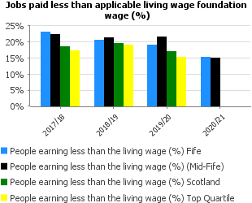
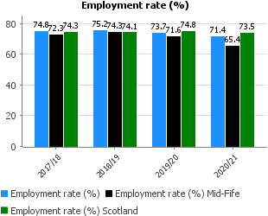 | Fife’s employment rate fell by 2.3 percentage points between 2019 and 2020. All parts of Scotland and the UK saw employment rates fall in 2020 as result of the economic impact of the Covid-19 restrictions, though Fife's decrease was at a higher rate than that seen in Scotland as a whole so that its employment rate is now 2.1 percentage points below the Scottish rate (73.5%). It is expected that the employment rate will fall further once the government's business support schemes come to an end.
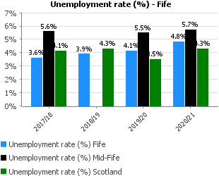 | This is the unemployment rate for the period January to December 2020. Fife's unemployment rate increased from 4.1% to 4.8% between 2019 and 2020 as the estimated number of people unemployed in the region rose from 7,300 to 8,500. The economic impact of Covid-19 resulted in increases in unemployment throughout Scotland and the UK; the increase seen in Fife's unemployment rate (+17%) was not as high as that for Scotland as a whole (+22%). In 2020 Fife's unemployment rate was however higher than both the Scottish and UK rates (4.3% and 4.6% respectively). Government support helped mitigate the impact of lockdown restrictions on businesses during 2020, and unemployment could increase significantly once business support schemes like the Coronavirus Job Retention Scheme and Self-Employment Income Support Scheme come to an end.
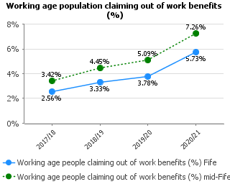 | Following the onset of the Covid-19 pandemic in March 2020, all parts of Scotland and the UK saw major increases in the number of people claiming out-of-work benefits. Fife's average claimant rate rose from 3.78% in 2019 to 5.73% in 2020.as the number of claimants in the region rose from an average of 8,753 to nearly 13,300.  These figures do not represent the full impact of the pandemic as they include the 3 months prior to the pandemic's onset. It is expected that the number of people claiming out-of-work benefits will increase further once the government's business support schemes come to an end.
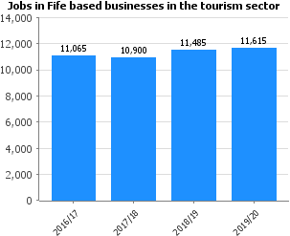 | Between 2018 and 2019, the number of jobs in tourist-related businesses in Fife increased by 130 jobs or 1.1%, a much lower growth rate than that seen in Scotland as a whole (4.6%). This rate was also less than the 5.4% growth in jobs seen over the previous year. Over the past four year period however, the number of jobs in tourist-related businesses in Fife increased by 7.8%, a much higher rate of growth than that seen in Scotland as a whole for the same period (2.9%).  In 2019, around 8.5% of Fife's jobs were in tourist-related businesses, a slightly lower proportion than that in Scotland as a whole (8.7%) but an increase on the previous year (8.3%).  Data for 2020/21 will not be available from source until November 2021.
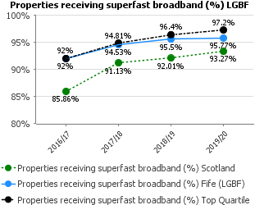 | Fife has benefited from commercial investment as well as from the Scottish Government’s Digital Scotland Superfast Broadband (DSSB) Programme. The DSSB programme has been able to extend it build due to higher than anticipated take up across Scotland. The R100 programme is now underway. This performance reflects the population densities in Fife – the mix of urban and rural premises.
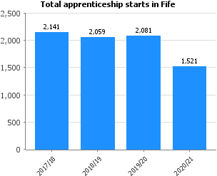 | In 2020/21 the number of Modern Apprenticeship starts fell by a third in both Fife and Scotland as a whole. Covid-19 has fundamentally changed the context in which employers make decisions about recruitment and training. Whilst there was an encouraging uplift across Scotland in MA starts during the final quarter of the year, it is expected that unemployment will rise as furlough schemes end causing challenges going forward. Covid-19 has had a varied impact across the sectors, with tourism, hospitality and retail businesses particularly affected and this is likely to be reflected in a lower uptake of apprenticeships in these sectors in the short term at least.  Figures from Skills Development Scotland indicate that 12.0% of 16-24 year olds in employment in Fife were MAs, a higher proportion than in Scotland as a whole (8.4%). 76.4% of Fife's MAs completed their training in 2020/21, the same rate as for Scotland as a whole.  Despite the challenges and disruption caused by the pandemic, there was continued growth in Foundation Apprenticeship uptake from pupils. During 2020/21, an additional 112 pupils in Fife took an SCQF Level 4/5 pilot FA qualification, which is not included in these figures at present.  Graduate Apprenticeships were largely uninterrupted by the pandemic. Higher Education Institutions quickly extended and mobilised digital platforms and apprentices continued their qualification by working and learning from home.
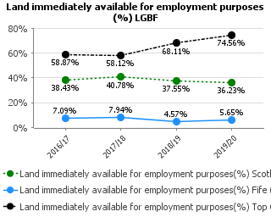 | The Scottish Average being higher than Fife can be explained by Fife having a very large proportion of employment land in comparison to city authorities and discrepancies in how immediately available employment land is classified across all authorities.

Financial
Performance | Progress
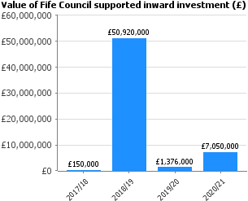 | In 2020/2021 Fife Council’s Economic Development team & Invest Fife supported new businesses relocating to Fife and existing businesses growing in Fife. Major projects contributing to the latest figure are:  • Cesscon Decom, a new decommissioning facility at Energy Park Fife, Methil, has been awarded Scotland’s largest decommissioning contract to date, will create up to 50 jobs in mid-Fife.  • Bravado – development of composites manufacturing for motorsport and tidal energy devices.  • Carr’s Flour Mill - £2m investment to enable discharge of larger grain carrying vessels, moored in the outer harbour.  • Skyhook Helicopters relocated to Fife Airport.  • Infrastrata acquisition of Methil and Arnish yards from the collapsed Scottish manufacturer Burntisland Fabrication (BiFab) for £850,000.
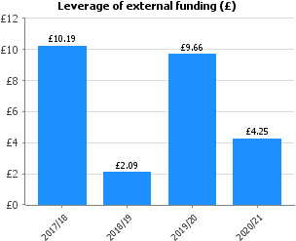 | This indicator assesses the value of external funding that the council's own financial contributions to economic development and employability projects has secured.  In 2020/21, Fife Council secured external funding for 14 economic development and employability projects, the estimated cost of these projects was £25 million and for every £1 of council spend, an additional £4.25 was levered through external funding sources. These figures do not include City Deal projects.  As these figures only include funding that has been drawn down, not awarded or committed, they can vary considerably from year to year.
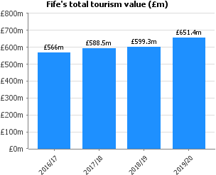 | This increase in value from £599 million to £651 is a result domestic and international visitors and has generated tourism related employment for over 13,000 people in Fife. Fife's tourism strategy continues to focus on increasing spend rather than increasing numbers as this is an indication of resilience and sustainability. These results demonstrate that the work is having an effect.  Data for 2020/21 will not be available from source until November 2021
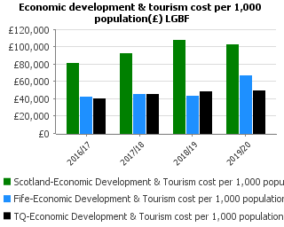 | The increase in spend per 1,000 population reflects an uplift in external funding during the period 2019/20.

Customer
Performance | Progress
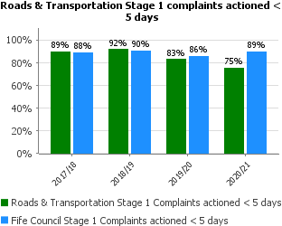 | Performance in both Stage 1 and Stage 2 Complaints has dipped from last year. This relates to the rise in road condition, flooding and winter related complaints during a period when normal office working has been restricted.  Getting staff group back to full complement and investment in the infrastructure should see a reduction in complaints and a resultant improved performance.
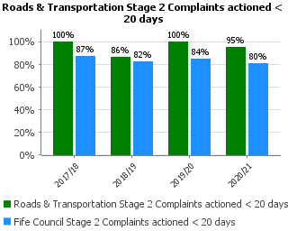
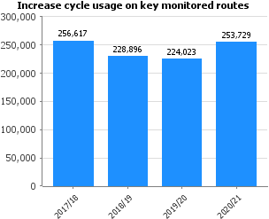 | The decrease in cycle usage from 2017/18 to 2018/19 was mainly due to the decommissioning of a bicycle count site at the Forth Road Bridge.  COVID-19 restrictions on travel during 2020 saw a significant increase in cycle usage on all routes except for St Andrews. This was due to University students not attending face-to-face classes with many heading home for an extended period of time.  When comparing 2020/21 to the previous year, Dunfermline saw an increase of 78%, Kirkcaldy 98% and Glenrothes 60% with a decrease of 36% in St Andrews. Cycle usage at the Tay Bridge increased by 12%.
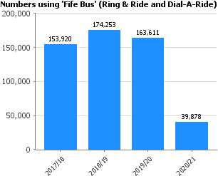 | As a result, of the COVID-19 pandemic, Fife Bus only provided transport for food shopping and medical / personal care appointments as well as ASN School Transport and transport on behalf of the NHS for Renal Appointments (during first lockdown) and Vaccination Transport.  DRT (All Services)  In 2020-2021 across all services DRT provided 39,878 passenger journeys including escorts and companions.  Details by Service:  Fife Bus  In 2020-2021 Fife Bus provided 21,727 passenger journeys including escorts and companions.  ASN School Transport  In 2020-2021 Fifebus provided 15,262 passenger journeys including escorts.  Covid School Transport (Children's Activity Centres)  In 2020-2021 Fifebus provided 1,638 passenger journeys including escorts.  Minibus Management  In 2020-2021 Fifebus provided 0 passenger journeys including escorts.  NHS - Renal Transport (Scottish Ambulance Service)  In 2020-2021 Fifebus provided 1,181 passenger journeys including escorts.  NHS - Vaccination Transport  In 2020-2021 Fifebus provided 70 passenger journeys including escorts.
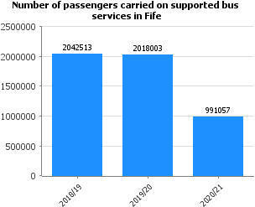 | Due to the covid-19 virus an emergency bus network was introduced. The public were advised only to use public transport unless necessary.  The Fife Council supported bus network was resumed on 10th August 2020. There were still limited people using public transport and as restrictions have eased, the numbers using buses has steadily risen but remains below pre-Covid levels.

People
Performance | Progress
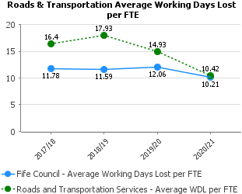 | Improving attendance was identified as a key priority for the Roads & Transportation Services Management Team in 2019 and the significantly improved results are clear evidence of the good work and progress in this area with dramatic improvement being achieved from 2018/19.
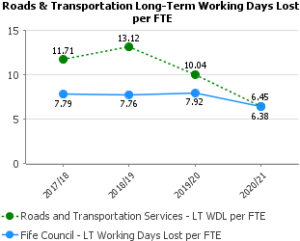
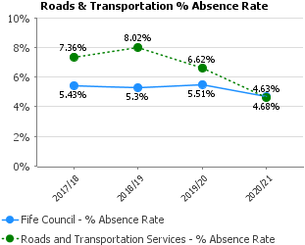
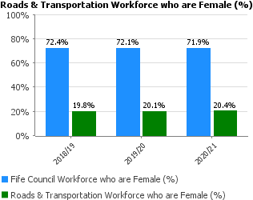 | The Roads/Civil Engineering industry is male dominated – particularly in the roadworker, parking attendant, bus driver areas. Efforts have been made to increase more balanced recruitment but without success due to turnover.
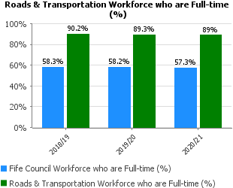 | Most employees in Roads & Transportation Services are full-time. Those not full time are generally on flexible working; job share or term arrangements in line with current HR policies. These levels have generally remained steady in recent years.
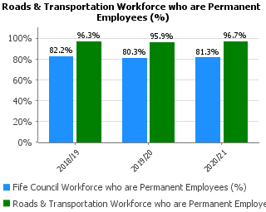 | Similarly, most employees in Roads & Transportation Services are permanent. Those not permanent are generally on temporary contracts arising from external funding opportunities and often such employees succeed in gaining permanent posts through staff turnover. These levels have generally remained steady in recent years.
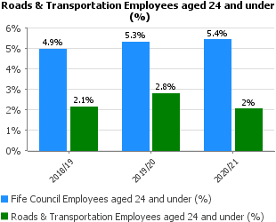 | Roads & Transportation Services has been a downsizing service for several years with the last major restructure in late 2017/18. There has been little staff turnover since then with recruitment being mostly filled by internal applicants. This means that the % of employees across each age group has not changed much since 2018. The level of employees aged 55 and over remains a cause for concern but reflects the experienced and long serving nature of the R&TS employee group.
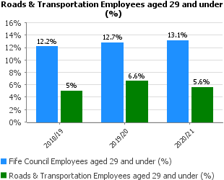
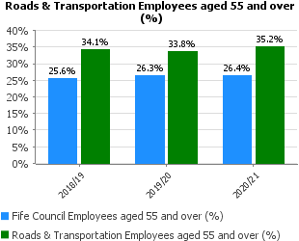
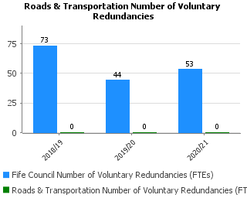 | As mentioned above, Roads & Transportation Services has been a downsizing service for several years with the last major restructure in late 2017/18. The service is now at a lean level with little opportunity for voluntary redundancies without significant service impacts.
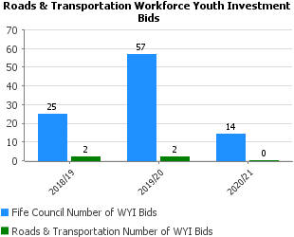 | During the Pandemic period with normal office working not available it was not appropriate to bring in WYI posts since they could not be adequately directed, developed and supervised when working in a remote manner. In 2021/22 the service submitted 2 bids for WYI funding now that office working, or hybrid working is more available.
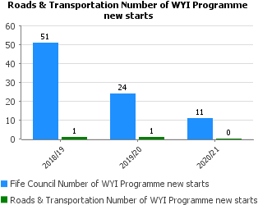

Key Business Delivery
Performance | Progress
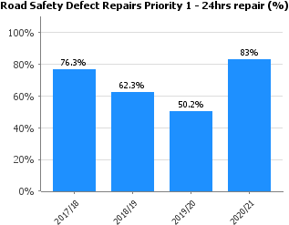 | Main issues occurred in the 4th Quarter due to a combination of resources having to be redeployed on extended winter maintenance activities and the subsequent increase in repairs identified as a result of the severe weather conditions encountered between January and February.  Other issues included the introduction of the new ALLOY road repair management system and the “teething” problems associated with this in the inputting of repair data.
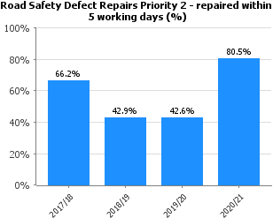
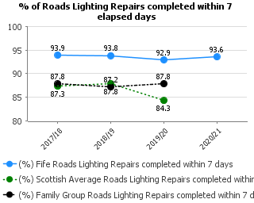 | As the overall number of faults reduces due to the reliability of the newer LED lanterns, the proportion of complex faults has increased. Due to the longer repair time required for these more complex faults, this remains a challenge. However, the results in Fife are above the Scottish average and that of our Family Group.  Please note family group and Scottish average data is not available till later in the year.
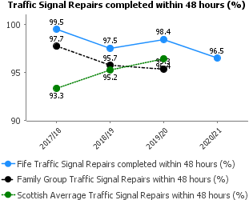 | The traffic signal repair performance remains consistently high except for a small number that require more extensive repairs due to RTA’s. The slight dip in performance during the pandemic period was not surprising as staff availability was impacted.  Please note family group and Scottish average data is not available till later in the year.
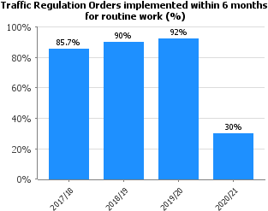 | Due to the Covid 19 pandemic there has been a dramatic drop in performance on this KPI. This is due to changes and restrictions on working practices in this and other teams involved in implementing the various stages of delivering TRO's on the ground.  In total 10 traffic regulation orders qualified for this KPI. 1 from the North Fife area and 9 from the South Fife Area. Of these 1 from North area was completed within 6 months and 2 from South.
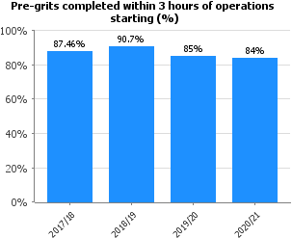 | The main reason why we failed this year is due to the number of breakdowns which we had over the period. As a result, routes were delayed in starting and couldn’t be finished within the timescale. Also issues with the Fleet during the actual treatment resulting in another vehicle having to finish the route – this could only be done once this latter vehicle had finished their particular route.  The age of the fleet and prolonged winter period impacted on availability.
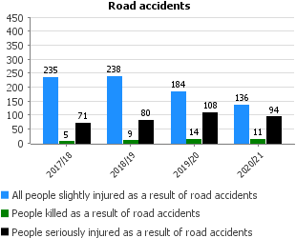 | The figures show a strong long-term reducing trend with the total number of casualties in 2020 being a record low for Fife. The number of slight injuries reduced significantly over the period. The numbers of fatal and serious injuries are relatively small, and as such can fluctuate year on year within an overall reducing trend, and Fife did not meet the Scottish Government targets for the year 2020 in reducing casualties for these categories. Due to the Covid pandemic traffic volumes were significantly lower in 2020 but the number of casualties was only slightly reduced from previous years. The number of casualties on urban roads and also the number of pedestrian casualties were noticeably higher in 2020 than recorded in the past, indicative of more local journeys being undertaken with people remaining closer to their homes.  The ongoing work with our partners in Road Safety to investigate causes, identify trends and develop interventions to prevent future injuries has carried on, but continued investment will be required to ensure the reducing trend continues with the aim of meeting further reducing casualties and achieving future reduction targets.

Financial
Performance | Progress
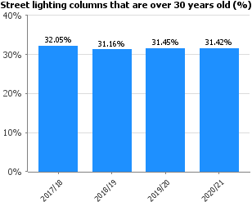 | The proportion of street lighting columns that are over 30 years old continues to hold around 31% of the lighting stock. The street lighting column replacement programme continues but will have reduced impact due to reduced capital resources in future years. This is likely to result in an increase in the proportion of columns over 30 years old. The service will continue to make a case for necessary capital investment in street lighting column replacement.
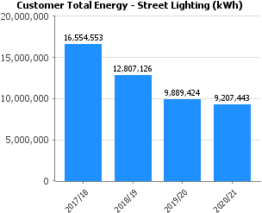 | The continuing reduction in energy consumption for street lighting reflects the lighting efficiency programme and the move to energy efficient LED lanterns. However, this programme is now complete. As new private developments come forward for adoption by the council and with the column replacement programme continuing to add more columns than are removed to allow modern lighting standards to be achieved, the inventory of lighting continues to increase and therefore the energy consumption will at some point start to rise.
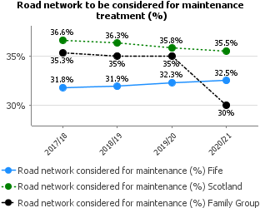 | There has been a steady deterioration in the road network overall since 2017-18. The Service still continues to perform better than the Scottish average of 35.5% but is above the family group average of 30.0%. It is anticipated that the 2021-22 result will be similar to the 2020-21 result.
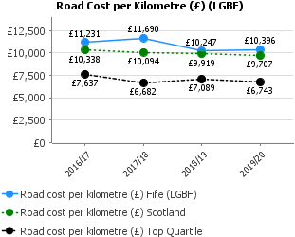 | This Indicator does not tell the whole story and needs to be compared with the relevant percentage of the road network that should be considered for maintenance treatment. Road condition tends to relate directly to investment in roads maintenance, so Road Cost per Kilometre tends to follow the capital expenditure on carriageways. With capital budgets increasing during 2021-22 and 2022-23 it is expected that the Road Cost per Kilometre will increase over these years.
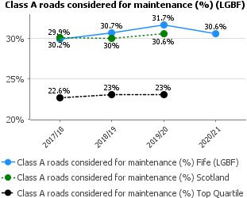 | The deteriorating trend from 2016/17 to 2019/20 has been reversed. The Service continues to perform worse than the Scottish and family group averages, which are 29.8% and 24.4% respectively. It is anticipated that the result will remain much the same in 2021-22.
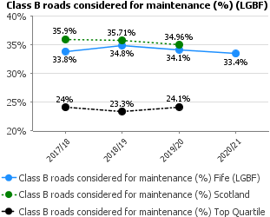 | The deterioration in condition of Class B roads from 2016-17 to 2019-20 has been reversed. The Service has performed better than the Scottish average of 34.0% but worse than the family group average of 27.1%. It is anticipated that the result in 2021-22 will remain similar to that in 2020-21.
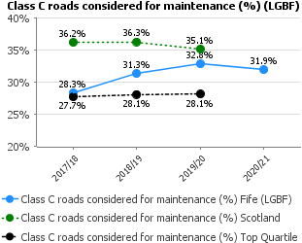 | The deteriorating trend from 2017-18 to 2019-20 has been reversed. The Service continues to perform better than the Scottish average of 33.6% but worse than the family group average of 27.1%. It is anticipated that the 2021-22 result will be similar to the 2020-21 result.
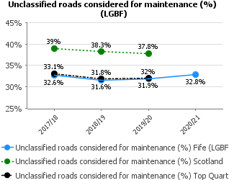 | The deteriorating trend from 2018-19 to 2019-20 has continued. The Service continues to perform better than the Scottish and family group averages, which are 38.3% and 33.8% respectively. It is anticipated that the 2021-22 result will be similar to the 2020-21 result.

PLANNING, BUSINESS & EMPLOYABILITY AND ROADS & TRANSPORTATION – WORKFORCE PROFILE 2020/2021 FINANCIAL YEAR (01 APRIL 2020 – MARCH 2021)

Service | Budgeted FTE April 2018 | Budgeted FTE April 2019 | Budgeted FTE April 2020 | Budgeted FTE  April 2021 | Difference in FTE 2020-2021
Planning Management | 1 | 1 | 1 | 1 | 0
Planning | 60.69 | 66.34 | 63.55 | *72.09 | 8.54
Business & Employability Management | 1 | 1 | 1 | 1 | 0
Business & Employability | 152.07 | 156.87 | 156.84 | 160.35 | 3.51
ATE Management | 1 | 1 | 1 | 1 | 0
Roads & Transportation | 386.27 | 381.3 | 383.53 | 383.63 | 0.1
Total | 602.03 | 607.51 | 606.92 | 619.07 | 12.15

- This includes 3 Workforce Youth Investment Posts

