D. Crail
Two green and blue networks were identified in Crail:

CRAGN01: Crail Green and Blue network
CRAGN02: Crail Coast and Fife Ness Green and Blue network

A short description summarising their key features, functions and opportunities is provided on the following pages.

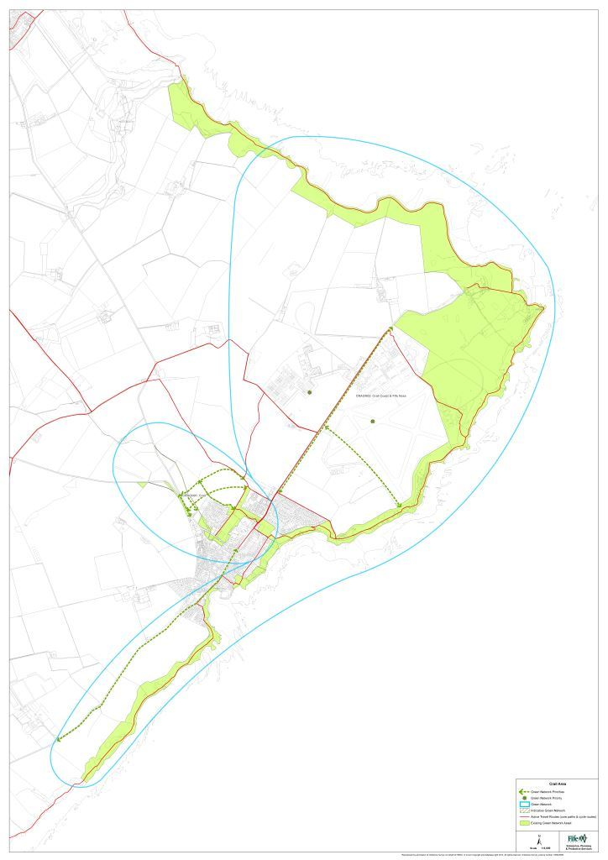
CRAGN01: Crail Green and Blue network
Connecting north of Crail to the coastline at Roome Harbour, the Crail Green and Blue network follows the route of the Crail and Den Burns through a series of high-quality greenspace assets which include Victoria Gardens, Beech Walk Public Park and Denburn Wood.

Key Features:
- There is a good network of quality greenspaces through the settlement, which connect to the coastal edge. Assets include Victoria Gardens, the Public Park and Denburn Wood.
- Some core paths which provide connectivity between the greenspaces. An existing cycle path connects to the former airfield east of Crail and to the north east.
- Includes part of the Crail Burn, which runs through the caravan site to the north of Crail and through Victoria Gardens, but is in culvert through the main part of town. No flooding problems.
- The Den Burn which is tributary of Crail Burn runs through Denburn Wood and is in culvert through the field which lies between Roomebay Avenue and Kirk Wynd. No flooding problems.
- Contributes to a high quality landscape setting.
- Habitat assets include the riparian corridors associated with the Crail and Den Burns.

Opportunities for Enhancement:

- Local demand for an off-road route linking the East Neuk villages, as an alternative to the Coastal Path route. The current route along the A917 is considered busy and unpleasant.
- Local demand to deliver an inland, off-road route to connect Crail to Fife Ness, as a popular destination.
- Proposed cycle route to be delivered along the A917 road corridor - part of the East Neuk 50 route.
- Potential to enhance riparian habitat value along the Den and Crail Burns. Both would benefit from improved management.

Development Plan Priorities:
- Protect existing green network assets.
- The green and blue network priorities below relate to proposals in FifePlan (2017). These will be reviewed at the Proposed Plan stage of Fife’s LDP2.
- LDP proposals CRA 002 (Crail North) – priorities in developing this area should be to:
- Capitalise on the site’s existing green network assets, and establish new greenspace as an integral part of a strong green network through the site incorporating active travel, habitat and SUDS provision. Proposals should seek to enhance the riparian habitat along the Crail and Den Burns.
- Create a high quality gateway to Crail from the north and establish a high quality landscape edge with the wider countryside, which will provide an appropriate landscape setting for the development and should incorporate access provision.
- Ensure good connectivity is provided to link to the new development to Crail.

CRAGN02: Crail Coast and Fife Ness Green and blue network
A high quality, scenic green and blue network which incorporates high quality coastal assets through Crail and connects to Fife Ness, forming a key element within the strategically important Fife Coastal Path route.

Key Features:
- Part of the longer Fife Coastal Path route, which connects with other core path routes which run in land.
- Coastal greenspace and beach assets, including the high quality beach at Roome Harbour.
- Likely to be some coastal erosion of coastal greenspaces overtime. Existing defences will be protected. The Dynamic Coast mapping identifies some predicted coastal erosion north and south of Crail and at Fife Ness. It will be important to protect the greenspace onto Roome Bay as a buffer against the potential impacts of long term coastal erosion.
- High quality landscape setting and coastal views.
- Coast is heavily designated for its intertidal habitat value. Other assets include the coastal grasslands; protect and enhance existing high quality habitat assets.

Opportunities for Enhancement:
- Proposed cycle route to be delivered along the A917 road corridor - part of the East Neuk 50 route.
- Local demand to deliver an inland, off-road route to connect Crail to Fife Ness, as a popular destination.
- Active travel opportunity to create a shared use path to connect Crail to Anstruther.
- Crail Community Partnership proposal to rewild brownfield and amenity grassland site (North of Sauchope Links Park and East of Balcomie Golf Links) into a wetland, meadow area and woodland.

Development Plan Priorities:
- Protect existing green and blue network assets.
- The green and blue network priorities below relate to proposals in FifePlan (2017). These will be reviewed at the Proposed Plan Stage of Fife’s LDP2.
- Opportunity to enhance and expand the green network in relation to any future development of the former airfield east of Crail - LDP proposal LWD 022 (Crail Airfield).
- Landscape and green network issues, including opportunities to deliver access improvements to provide improved connectivity to Fife Ness, including an off road route from Crail, should be considered as part of the preparation of a development framework for the airfield site.

