THE COMMUNITY EMPOWERMENT (SCOTLAND) ACT 2015

Proposed Change of Use Common Good Property
Dunfermline Public Park, St Margaret’s Drive, Dunfermline KY12 7JA

Fife Babies Memorial Proposal

Fife Council propose a Change of Use for an area within Dunfermline Public Park. It is proposed to site the Fife Babies Memorial garden within this area of the park. The memorial garden will be meaningful to the parents and inclusive for everyone visiting the park. The design is inspired by nature and specifically designed to integrate with the park surroundings.

The memorial will be commissioned, funded, and maintained by the Council.

Background:

Following an investigation across crematoria in Scotland, failures in communication and working practice meant that ashes were not routinely returned to families following the cremation of infants.

Fife Council formally apologised to the families for their part in the hurt and anguish caused by the way Dunfermline and Kirkcaldy Crematoria operated in the past.

"Fife Council recognise our failure to return your baby’s ashes will have caused considerable hurt and pain and for that that we are deeply sorry and very aware of the distress and anguish we have caused."

"While we take full responsibility, we recognise that there is nothing we can do or say now to remove the hurt we have caused."

"Like other councils, we want to support proposals for a baby memorial in Fife that is dedicated to the babies whose ashes we failed to return. We know everyone deals with grief differently and individual families will have different views on what kind of memorial they want to see in Fife. That is why it is so important we hear from as many parents as possible to allow the vision of a memorial to reflect the broader wishes of everyone."

The Fife Babies Memorial Working Group was established as an advisory group to represent the interests of the parents. This group includes parents and stakeholders and is supported by Fife Council Bereavement Services. The Fife Babies Memorial project is guided by the parents, through the working group and wider parent group through online consultation.

Location:

Several parks in Fife were considered. Public Park, Dunfermline was chosen as the preferred location. 3 sites were considered within the park, with preference for Site 1 (indicated on map below).

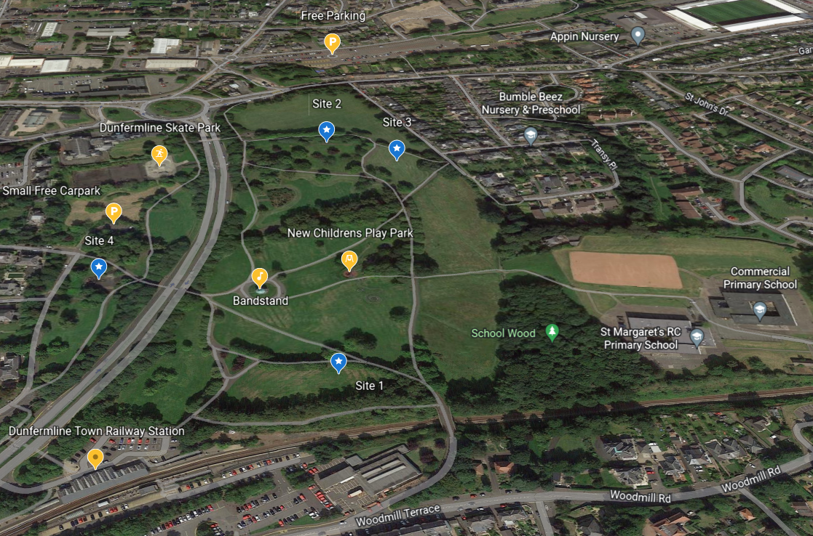

Fife Babies Memorial Proposal Community Consultation was presented via Sway and received 508 views (283 glanced, 130 quick reads and 95 deep reads), 6 representations were received, 1 from the Central Dunfermline Community Council and 5 from individuals.

Through the Fife Babies Memorial Proposal Community Consultation an alternative site option was proposed through representation by the Central Dunfermline Community Council (site 4). This option and the concerns raised were considered by the Fife Babies Memorial Working Group.

The following representations have been received in response to the consultations carried out under section 104 of the 2015 Act.

Representation Received: | Central Dunfermline Community Council  5th July 2022

While Central Dunfermline Community Council and the wider community we represent have a huge amount of sympathy and empathy with the bereaved parents, we feel very strongly that the proposed location in Dunfermline’s Public Park is absolutely not the right location for this memorial. We feel that we, as representatives of the Community, have a duty to the bereaved parents to advise them of the reasons for this not being a suitable location. We also have a duty to the community we represent. Park users – when questioned, have overwhelmingly expressed the view that this is absolutely not a suitable location. The bereaved parents have a right to know this. They do not want this valuable and much needed memorial to be placed in a site which is not suitable, and which will not have the sympathy of the community.

CDCC and the wider community feel strongly that Location 1 in Dunfermline Public Park is not the correct location for the memorial for the following reasons:

- The memorial is highly likely to be vandalised in this position. A seated area which is partially screened by trees in summer is highly likely to become a locus for youths to gather, drink and desecrate. This would be incredibly distressing for parents. This view was expressed very strongly by park users and CDCC members and is sadly based on recent past experience. This includes the vandalism of the Giant’s Seat and the complete destruction of our much loved cows which were placed on a much more visible and open site than the one proposed for this memorial. This weekend also seen the destruction of the children’s slide in the playpark area which is near to the proposed memorial site. We wonder if Fife Council has consulted with Community Police and Community Wardens in considering this location, and what its plans are to prevent vandalism.

- The proposed site is heavily used on a daily basis and therefore does not offer the possibility for the degree of privacy and quiet reflection that the survey of parents said was so important to them.

- While the site is near to the limited transport link offered by train, it is not nearly so accessible by bus. There are car parks accessible from both the north and south of the park, so car parking is not a relevant consideration when comparing sites.

- The Public Park is Common Good Land. Common Good Legacy titles stipulate that as such the Public Park is for the ‘’recreation and enjoyment of the people of Dunfermline’’. This area is heavily used by many groups. These include runners and fitness groups, other sports including walking and cycling, Dog walkers use it constantly. Over the summer it is frequently used by families having picnics. At the Fresh Air Festival, it is used for the Bouncy Castles (as the only flat area available). The Public Park is small and limited in space. It would make much more sense to choose an area which is not already used extensively for recreational purposes.

- The current plans don’t include any proposal for replacing the public greenspace area lost, in terms of Scottish Government common good land guidance and legal precedent.

- CDCC has recently carried out public consultation re the way the Public Park is used. This had nearly 300 respondents and the community plan for the Public Park greenspace have been based on this and now forms part of the Dunfermline Greenspace Strategy. In planning the Baby Ashes Memorial, Fife Council has made absolutely no reference to this extensive consultation of which they have been made aware. Instead they are carrying out a token and rushed consultation with the people of Dunfermline.

For the above reasons, Central Dunfermline Community Council have a duty to represent the views of our community and we will actively oppose the plan to build the memorial in this location. We also feel that we have a duty to make the bereaved parents aware of the negative issues associated with their choice of site.

Because we are very empathetic to the wishes of the bereaved parents, we have already suggested alternative sites. In discussion with members, we would now like to propose another site. This is the site of the former small playpark on the quiet side of the Public Park. (See map below.) This is a much-loved play park but has sadly come to the end of its life and is due to be removed. It is proposed that it be replaced with a family / community space. The beauty of choosing this site is that it could provide a real opportunity for the bereaved families and the community to come together, rather than preventing park users from using the other location by repurposing it solely as a memorial. It would provide a real legacy for the lost children to leave behind.

This location is excellent because:

- It is quiet, beautiful and secluded – but still open and less likely to be vandalised. (It is near the end of Park Avenue housing)
- It is near both rail and bus links. It is not much further from the rail station than location one and can also be reached by bus via the New Row or St Margaret’s Drive.
- It offers easier access to more car parks.
- It would repurpose an existing site rather than taking away a valuable recreational area.
- The shape of the area would lend itself very well to having a memorial garden. In fact, a sensory garden is one of the suggestions already made for the area. It could also possibly combine some small wooden play equipment / seating for other little children. We are sure that some bereaved families have other children who would benefit from this combination.
- The repurposing of this area meets the needs of both the community and the bereaved parents. By planting, enhancing and maintaining this area, the whole community would benefit. We feel that there would be a huge amount of support for this option across the community.

This suggestion just feels so much better. It would improve the plan towards a living legacy and would be inclusive to all children using the park, as well as providing an area of remembrance and contemplation. This would not necessitate the removal of a well-used community greenspace and provide for a great compromise by repurposing and re-imagining an existing site.

We are concerned that detailed designs have already been drafted for this chosen site. Proposals are supposedly inclusive of the local community, yet the wishes of local people have not been considered in these designs, even though the current proposal involves the removal of a considerable area of community greenspace from its current recreational use. We look forward to hearing how the views of the community will now be included in a revised design and location.
Figure 1 Appendix1 - Proposed Location (green)
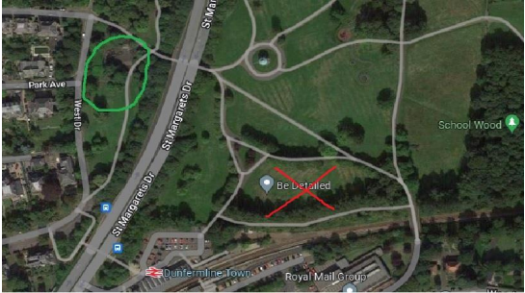

Representation Received: | LB (Received 7th July 2022)

I must strongly object to the construction of a memorial in the Public Park.

My empathy, sympathy and compassion goes to the families affected by these events. However, our Public Park is a place for walking dogs, children running around, exercising, and enjoying all that life has to offer. Please do not put a memorial here and reduce the space available to all those who love our park.

The memorial should be in a crematorium or graveyard grounds, not a park.

Representation Received: | JS (Received 7th July 2022)

It is right and proper that the parents of these poor babies have a memorial, a peaceful place to grieve and reflect.

However, the proposed location is unsuitable for several reasons.

- It is too 'public'. The location is neither secluded nor peaceful, with trains going by and many park users passing through.
- Any built structure would be at high risk of graffiti and vandalism. A recent relevant comparison is the public art installation of metal cow sculptures on a nearby knoll. These were vandalised soon after installation and had to be removed.
- I am a user of the park daily, as a dog walker. All the people I've spoken to have mentioned items 1 and 2 above as their main concerns. They have suggested the memorial should go in an existing area of loss and remembrance, such as a cemetery or crematorium. If it has to be in a public place, it should go in a quieter and more closed-off area, perhaps in the Western part of the park to the south of the skate park.

Representation Received: | RM (Received 7th July 2022)

In response to your choice of positioning of a Babies Memorial at Dunfermline Public Park, I sincerely hope it will be “walled in and padlocked” after this week sickening act of vandalism seen at the children's play area within the Public Park which is very close to your 1st choice site.

I live close to the park and use it on a regular basis but I feel there is not enough security or lightening for any of your chosen sites to be used for such a precious project without it ending in even more tears.

The pdf plans and information look lovely but on behalf of the grieving parents, I hope you think carefully about the choice of site, factor in security (CCTV) and choose indestructible materials so that it doesn’t become just a new skateboarding site or a hangout for individuals without morals.

Representation Received: | JS (Received 21st July 2020)

Please accept this letter/email as my input to the consultation process.

As a daily user of the public park I definitely do not want this to go ahead, and I wish to object in the strongest terms. In principle, greenspaces are for wellbeing and public enjoyment of the outdoors, not for memorials. There already exist Fife council spaces for memorials – The crematorium, Halbeath graveyard and the memorial gardens near to the cenotaph.

The proposal looks to repurpose the greenspace, taking away one of the areas in the park that is well used for sports, picnics, and dog walkers. A memorial would not in any way be complimentary in purpose, and would most certainly be vandalised.

I do have every sympathy and empathy with the bereavement group and hope that they find a suitable location from the suggested alternatives.

Representation Received: | KM (Received 24th July 2020)

I am fully supportive of a memorial but I am not sure the public park is a suitable space for a number of reasons

- The park is already has a children’s play park and nature trail - both of these have been vandalised before
- The proposed locations are close to the railway line or the main road - neither are quiet or peaceful
- The park is used by dog walkers there is already limited space in Dunfermline to allow dogs to run, this will further limit their space
- I don’t think a memorial is appropriate this close to a primary school or a children's park
- The park is not actually that large and this further removes available green space - what other locations were considered? There is Duloch woods and the Glen - why were neither of these considered
- If there is a memorial then it would not be appropriate for items/ flowers to be left as this impacts other users of the park - has this been considered?

Please take time to review this & answer my points.

I am not against a memorial I am just not sure this space is suitable

Representations Received: 6

Review of the consultation representations:

Fife Babies Memorial Working Group considered the alternative site proposed by the Central Dunfermline Community Council. Site analysis, site visits and local advice from the Greenspace Partnership Officer, Community Safety and Crime Prevention Reduction Officer, Dunfermline Community Education Worker and Dunfermline Central Community Council were used in finalising the proposal.

Site 4, the alternative site proposed by the Central Dunfermline Community Council, had potential to be a very interesting space with opportunity for integrating the memorial garden and could have degrees of enclosure and privacy. However, there is a high level of traffic noise and pedestrian activity. There is a current project to regenerate the skate park close by which may increase activity. This area did not provide the place suitable to host the memorial garden.

Site 1 remains the preferred location for the memorial garden good access from the path system in the park, good visual relationship with other elements in the park, views out across the park and to the southwest across the town, tree cover providing a degree of enclosure.

Concerns from the representations have been appreciated by the Fife Babies Memorial Working Group.
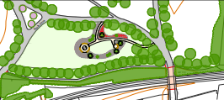
The memorial garden design is based on being meaningful to the parents and inclusive for everyone using or visiting the Park. The design takes account of park activity and the parents hope it will be a positive addition to all users of the park.

A public park location was established early in the consultation with parents. Possibility of vandalism was discussed during several meetings. There is possibility of vandalism in any public area. There is no increased risk of vandalism in this park. Advice on risk reduction for vandalism has informed the design of the memorial.

Dunfermline 2030 Greenspace Strategy is at a draft stage at present; it has been confirmed that there are no formal or informal plans which would impact the proposal of the Fife Babies Memorial at Public Park, Dunfermline. The natural landscape garden will include plants to encourage natural wildlife and enhance the green space.

Fife Council decision: Pending

Request for the City of Dunfermline Area Committee to hear the Fife Babies Memorial Proposal on 7 February 2023 has been made.

22 December 2022

