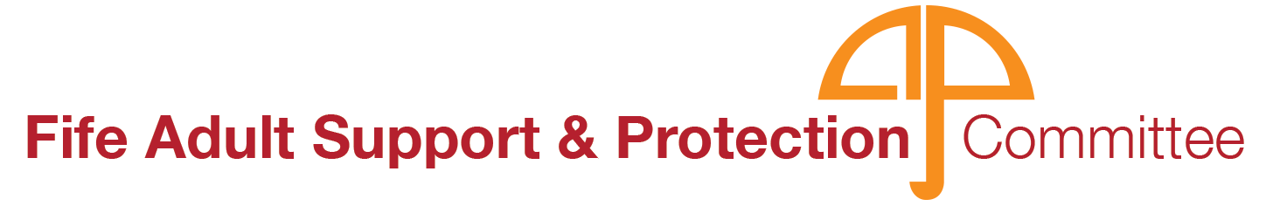

**Strategic Improvement Plan 2021-23**

# **Preface by Chief Officers**

The Fife Chief Officer of Public Safety Group is pleased to endorse Fife Adult Support and Protection Committee’s (ASPC) Strategic Improvement Plan and priorities for 2021-2023. They reflect our direction to the ASPC and our views based on the available various briefings and formal reports presented to us. As Chief Officers we give a continued commitment and support to the work of the Committee and would like to acknowledge the improvements made under the framework of the 2018-2020 Improvement Plan.

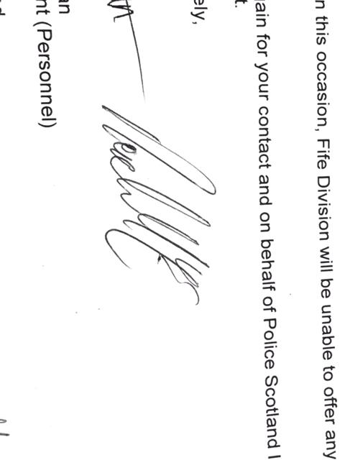We take this opportunity to extend our thanks to partners, staff and managers who deliver frontline services for adults at risk of harm and commend their professionalism, sensitivity and diligence in meeting the demands and responsibilities facing them. We would also like to extend our thanks to People First and our service user representatives, whose voices are of the utmost importance to guiding the direction of our work.



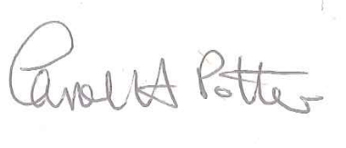

Steve Grimmond Derek McEwan Carol Potter

Chief Executive Divisional Commander Chief Executive

Fife Council ‘P’ Division Police Scotland NHS Fife

# **Foreword on behalf of the Adult Support and Protection Committee**

On behalf of Fife Adult Support and Protection Committee and as the Convener I am pleased to present our Strategic Improvement Plan 2021–2023. Fife Adult Support and Protection Committee (ASPC) is committed to the support and protection of adults at risk of harm and in achieving better outcomes for individuals and their families. The five priority objectives and corresponding actions set out in this plan have been informed by our self-evaluation activity, data analysis, learning from local Initial and Significant Case Reviews and feedback from staff and national influences.

The plan includes actions which are SMART (specific, measurable, attainable, relevant and time-bound) and progress will be monitored and reviewed quarterly by the Committee and working groups. A report on the progress of this work will be produced after year one and a final report will be concluded after year two. The outcome of this report will guide our direction for our next Improvement Plan.

At-risk adults should be at the centre of any intervention and their views in relation to their circumstances and beneficial supports are crucial. The ASPC is aware that evidence of the at-risk adult’s views of both the harm they are exposed to and the support and protection subsequently offered and delivered has been limited when using standard post case follow up. A range of approaches will be developed in order to ensure the voices of our services users are heard and our processes and procedures are developed with consideration to this lived experience.

Fife’s Adult Support and Protection Committee and all associated working groups are committed to providing a strong signal of leadership to our workforce that the delivery of trauma informed practice across all partners and within all adult support and protection practice, is a priority. This commitment to trauma informed practice is an overarching principle of our Improvement Plan and will be threaded throughout all the work undertaken to achieve the outcomes identified within.

I am excited by the opportunities identified within this Improvement Plan to promote best outcomes and as an Adult Support and Protection Committee. We endeavour to achieve excellence in practice and outcomes across all partners in order to raise awareness of potential harm and to support and protection adults at risk of harm across Fife.



Convener

Fife Adult Support and Protection Committee

# **Fife ASPC 2021-23 Improvement Plan on a page**

Our Improvement plan is guided by the following key **principles:**

Risks to the adult are recognised, and responded to at the earliest stage

Adults will be empowered to make choices about keeping safe from harm

Adults at risk, their carers and family (where appropriate) will be listened to, understood , respected and will have the opportunity to express their views

Adults at risk will be safer as a result of our activity, which will be based on the least restrictive intervention

Adults will have access to integrated and personalised services to keep safe from harm

Our **shared vision** is to ensure that all adults at risk feel safe, supported and protected from harm

ASPC have identified the following **five priority areas**

What **success** will look like

Our **aims**: what we want to achieve

# **Introduction**

Our shared **vision** is to ensure that **adults at risk feel safe, supported and protected from harm**. This strategic Improvement Plan for Fife sets out the actions we will take over the next two years (2021-23) to work towards achieving this vision. ASP leaders should continually influence and communicate the shared vision and ongoing commitment to the ambition of the improvement plan. The members of the Adult Support and Protection Committee are Fife’s Adult Support & Protection Leaders. These Senior Managers and representatives from statutory and partner agencies across Fife see how improvements can be made and motivate and inspire people to move toward that vision.

The plan builds on achievements to date, using the previous improvement plan as our foundation and drawing on learning from Single and Interagency Case File Audits, Activity and Performance Data, Stakeholder feedback, and Initial and Significant Case Reviews.

This document sets out our vision and principles, five priority areas for development and subsequent aims and objectives for each. To ensure alignment and shared understanding of our vision, each priority will be driven forward by one of our working groups, the ASP Team or by ASP leads across partner agencies. **From our vision and principles through to our workplans, our approach is person centred and outcome focussed.**

Shared core values of kindness, dignity and compassion guide us on our long-term collective outcomes. We need to think differently in how we measure outcomes and move away from a focus on numbers and performance indicators to a more qualitative, deeper understanding of the complexities of people’s lives. Underpinning our approach is a focus on transforming the way that we collect and use data to evaluate the impact of our activities and gain greater insight of the quality of our response to reports of harm, and the lived experience of all stakeholders.

A range of outcome focussed indicators will be developed to evaluate our success against the following strategic outcomes:

1. Risks are recognised and responded to without delay
2. Adults are safer as a result of our intervention
3. Adults are empowered to make decisions about keeping safe
4. Interagency staff feel confident and supported

These will be measured through an outcome focussed performance framework which is a fundamental objective of this plan (Priority 2). All actions throughout this plan will be linked to the achievement of these outcomes.

Leadership and Trauma Informed Practice are overarching themes of the Improvement Plan and will link between the National Adult Support and Protection Forum, Fife’s ASPC, Working Groups and Action Plans going forward. The leadership pledge of support for trauma informed practice has a strong correlation with the ASP principles set out in this plan as shown in the diagram on the following page.

**Key Principles**

Our key principles link with our statutory duty and our focus on continuous improvement. All partners should ensure that these principles are embedded into their organisations practice and procedure.

# **What we want to achieve**

To achieve our vision, this plan sets out five priority areas for development, each with a specific aim. Each priority will be driven forward by the Adult Support & Protection (ASP) Team, ASP Leads across partner agencies, or one of the ASPC subgroups[1] who are tasked with developing and delivering a strategy or workplan to achieve the aims set out for each priority. The objectives within these plans will be specific, measurable, achievable, relevant and time-bound (SMART). The diagram below shows who will lead the delivery of each of the five priorities with the Case Review Working Group (CRWG) feeding into all workplans as appropriate. Similarly, the Stakeholder Engagement Strategy and Performance Framework, once developed, will have actions linked to all priorities.

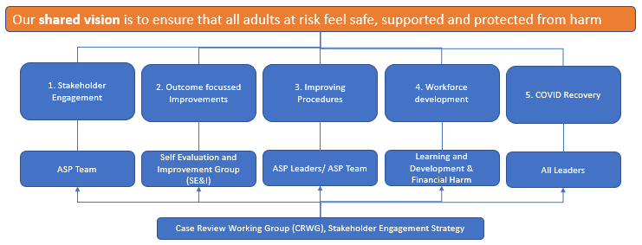

The following pages set out the workplans which accompany each priority area and associated aim. Each objective set out in these plans will likely be supported with a number of more specific actions or tasks which will be agreed by the working groups at quarterly meetings and updates provided to ASPC thereafter.

# **Priority 1: Stakeholder Engagement**

*The ASP Team will develop a comprehensive stakeholder engagement strategy and communications plan detailing how we will work together with partners, individuals and in our communities to raise awareness and support the safety of vulnerable people in Fife who may be at risk of harm. Value will be placed on eliciting the voices of people with lived experience of the ASP process to drive outcome focussed improvements to practice.*

**Aim: Supportive & engaged communities and partnerships where adult protection concerns are recognised and responded to appropriately and without delay**

|  |  |  |
| --- | --- | --- |
| **PRIORITY 1: STAKEHOLDER ENGAGEMENT** | | |
| **What needs to happen** | **By Who** | **By When** |
| Communicate the vision, principles, aims and success measures set out in this plan to all stakeholder groups. | Adult Support & Protection Team | Mar 2021 |
| Coordinate activities and campaigns for Adult Protection awareness week | Feb 2021 |
| Develop Communication plan for 2021 including social media plan and accessible information plan, to promote a wider understanding of Adult Support and Protection across all stakeholder groups | Jan 2021 |
| Evaluate ASPC Webpage, and make any necessary recommendations for improvement  Development and analysis of webpage survey: [ASP Webpage Popup survey](https://forms.office.com/Pages/ResponsePage.aspx?id=L6Vp-cBC8UCYutrtbEMIfMijjnT5YuZMhwulFPAwotpUNDlZTzlDMDM3NkFMSVZGWVBBSFhOTzQzRy4u) | Dec 2021 |
| Review resources for carers and families of adults at risk of harm, produce glossary of resources | Mar 2021 |
| Review Service User Engagement Strategy and develop Stakeholder Engagement Strategy   * Develop approach to practitioner forums (L&D Group to deliver) * Develop approach to Service User and Carer Forums * Consideration to be given to engaging with minority groups and those with specific language requirements, for example, BSL. | Jun 2021 |
| Targeted work to strengthen links and ensure effective pathways of support for a workforce confident in ASP practices. | Dec 2021[2] |

# **Priority 2: Outcome Focussed Improvements**

*The SE&I Group will transform our approach to collecting and using data in order to drive forward evidence based, and outcome focussed improvements to Adult Support & Protection practice and procedure. The ASPC have agreed four strategic outcomes. The role of the SE&I Group is to develop the tools, analysis and processes needed to evaluate the extent to which these four strategic outcomes are met. Following this, the SE&I Group are equipped to make evidence-based recommendations to inform future priorities and improvement activities.*

**Aim:** **to have a comprehensive and systematic approach to evaluating process and practice and making outcome focussed improvements.**

|  |  |  |
| --- | --- | --- |
| **PRIORITY 2: OUTCOME FOCUSSED IMPROVEMENTS** | | |
| **What needs to happen** | **By Who** | **By When[3]** |
| Develop and launch annual interagency staff survey to measure staff confidence and views on collaborative working practices, support, leadership and opportunities to influence change. | Self-Evaluation and Improvement Group. | Feb 2021 |
| Review and launch of interagency case file audit methodology and tools, embed approach to sharing good practice | May 2021 |
| Single agency audits undertaken across partner agencies aligned to Quality Indicator 2.2. Review of Social Work ASP Audit tools and processes. | May 2021 |
| Develop local interagency Adult Protection Performance Framework and comprehensive suite of indicators to measure outcomes to compliment existing activity and profiling data | Nov 2021 |
| Mixed methods review coordinated to consider the reduction in investigations in care homes and learning from this. (Ad hoc self-evaluation activity resulting from SG Return 2019-20) | Apr 2021 |
| Develop Service User (and carer) feedback mechanism and methodology (post intervention questionnaire) | Aug 2021 |
| Standardised tools/ processes to be developed to measure the impact or quality of training, communications, and documents against key quality indicators. Service user and staff forums to be utilised to consult on specific topics. | Jan 2021 |

# **Priority 3: Improving Procedures**

*Supported by the ASP Team, our ASP Leaders across all partner agencies will contribute to ensuring that there are clear and streamlined referral pathways as well as effective procedures and tools to enable outcome focussed discussions around managing risk. All ASP Leaders will provide: clear leadership, ensuring that policies and procedures are embedded and that the workforce is knowledgeable, confident and supported in relation to ASP. This will be a key focus of the impending inspection.*

**Aim: Effective leaders, procedures and tools to guide outcomes focussed practice**

|  |  |  |
| --- | --- | --- |
| **PRIORITY 3: POLICY & PROCEDURE** | | |
| **What needs to happen** | **By Who** | **By When** |
| Annual single agency review of internal ASP Procedures to align with Inter-agency updates. Procedures to be submitted to ASPC following reviews and annually thereafter | All ASP Leaders. | Dec 2021 |
| Post Referral actions: Review of IRD paperwork to enable reporting on protective actions taken  (if not progressed through ASP legislation) and consideration of LSI | SW Lead & ASP Team | Jun 2021 |
| Post Referral actions: Refresh Investigation paperwork and embed process for monitoring service user outcomes (QoL, safer from harm) and evidence consideration of advocacy | SW Lead & ASP Team | Jun 2021 |
| Single agency review for the process of recording concluded IRDs that have been received by participants | All ASP Leaders | Jun 2021 |
| Launch Microsoft Teams site for LSI, ICR and SCR information to enable secure collaborative working | ASP Team, SW Lead | Jun 2021 |
| Interagency review of LSI Process and paperwork | ASP Team, All ASP Leaders | Jun 2021 |
| Review of Interagency engagement escalation protocol | ASP Team, All ASP Leaders | Jun 2021 |
| Develop a protocol to guide use of an Interagency Chronology across partners | ASP Team, All ASP Leaders | Mar 2021 |
| Self-Assessment in relation to Process and Leadership Quality Indicators and implementation of resulting action plan | Inspection Preparation Group/ ASP QA. All Leads | April 2021 |
| Update SW Performance Monitoring Protocol and continue to embed this process | SW Lead/ ASP QA | April 2021 |

Priority 4: Workforce Development

*The L&D Group will continue to support our workforce, ensuring staff across all agencies are confident, knowledgeable and supported. We need to make sure that training is supported and sustained through active implementation, supervision and coaching and a continued focus on staff wellbeing. This means building in enough time and resources where staff can talk, reflect, and be listened to.*

**Aim: All staff across partner agencies feel supported and are confident in identifying and responding to harm and in providing an integrated response to reduce harm**

|  |  |  |
| --- | --- | --- |
| **PRIORITY 4: WORKFORCE DEVELOPMENT** | | |
| **What needs to happen** | **By Who** | **By When** |
| Annual consultation, review and updates to Inter-agency ASP Procedures and Competency Framework | L& D Group | Mar 2021 |
| Ensure all local authority and private care at home workers receive standardised Adult Protection Training | Jan 2022 |
| Develop a training programme of ASP courses which have been made available virtually | April 2021[4] |
| Implement any improvement actions as required following the interagency staff survey  (SE & I to advise) | December 2021 |
| Implement any improvement actions as a result of mixed methods review of investigations in care homes (SE & I to advise) | December 2021 |
| Professional curiosity group - eLearning module/ programme to support staff feeling confident in asking difficult questions | Sep2021 |
| Take forward an ongoing Practitioners Forum in each locality in order to promote best practice, share and learn from experiences and increase staff confidence in the application of ASP practices (link to Stakeholder engagement strategy) | Dec 2021 |
| Issue post training questionnaire following all training and evaluate responses | Oct 2021[5] |
| Embed our Financial Harm Protocol and proactively develop financial harm prevention strategies | Financial Harm Subgroup | September 2021 |

# **Priority 5: Covid-19 Recovery Plan**

*It is critical that we all work together to support our service users, patients, communities and workforce throughout and after this traumatic period to ensure that harm continues to be identified and reported and that services and supports are able to reach all those who need it.*

**Aim: Minimise the impact of COVID-19 on working practices and risk of harm**

|  |  |  |
| --- | --- | --- |
| **PRIORITY 5: COVID-19 RECOVERY PLAN** | | |
| **What needs to happen** | **By Who** | **By When** |
| Keep under review all processes in light of COVID-19 and identify and act on any practice issues raised | All (ASP) Leaders | December 2021 |
| Implement recovery plan and update / make recommendations for improvement | December 2021 |

Measures of Success

We want to transform our approach to collecting and using data in order to drive forward evidence based and outcome focussed improvements to Adult Support & Protection practice and procedure. This plan has identified four strategic outcomes, as shown below**:**

Strategic Outcomes

To achieve these strategic outcomes, the SE&I work plan is focussed on developing a suite of tools and indicators to measure the extent to which the above strategic outcomes are being met. Fundamental to the plan is the development of a supporting Performance Framework. This Framework will: identify the indicators we will measure; the data sources we will consider; how they link to our strategic outcomes and how the information will be reported on to enable informed evidence-based decision making. The diagram below shows the sources of data we will draw upon to develop our framework. Essentially, these are the tools which will be reviewed or developed as part of the SE&I work plan.

Developing a framework:

As the tools have not yet been developed and agreed, the specific outcome measures have not yet been agreed. However, for illustrative purposes only, the table below contains some indicators which could be considered for each strategic outcome when developing the Performance Framework and tools. The colours used correspond to the colours for the tools above which would be used to produce the indicator.

It is important to note that these strategic outcomes are not linked to one workplan or priority area but are achieved through the interlinking actions of all plans. When developing specific workplans every action should consider how it links to achieving these outcomes, thus providing a golden thread through everything we do. The Performance Framework will be fully consulted on prior to implementation.

**Consultation**

In order to ensure that all ASPC partners and lead were able to contribute to this Improvement Plan, as consultation meeting was held on the 9th December 2020. Following this the Improvement Plan was updated and all ASPC partners and leads were given a further opportunity to consult via EForm between 6th January 2021 and 20th January 2021. The Improvement Plan was on the agenda for each of the ASPC Working Groups between 11th January 2021 and 22nd January 2021 where there was a further opportunity to provide feedback. The Improvement Plan was submitted to the ASPC on 3rd February 2021 and to COPS on 4th March 2021.

**Governance, monitoring and review**

The Improvement Plan will be monitored by the Adult Support and Protection (ASP) Team who will seek feedback from Working Groups and Partners on a quarterly basis. Updates will be provided by the ASP at each ASPC. A report will be compiled at the end of year one, identifying the achievements and areas requiring further work. A final report will be completed at the end of year two. This report will acknowledge the achievements of the ASPC in the implementation of the plan and will guide to actions required to be taken forward in the next plan.

1. The ASPC subgroups are Self Evaluation and Improvement Group, Learning and Development Group, Case Review Working Group, and Financial Harm Working Group.
2. This will always be an ongoing endeavour.  However specific actions will be undertaken by Dec 2021
3. In line with the approach to continuous improvement these dates are the launch dates of the tools, the activity will not be concluded but will form a continuous cycle of implementation, analysis and review.
4. This will be an ongoing action with newly available courses to be added to this programme as and when they are ready
5. Ongoing action following implementation, tool reviewed annually at SE&I