Licensing (Scotland) Act 2005, Section 33(1)  Application for Transfer of Premises Licence on Application of Licenceholder | 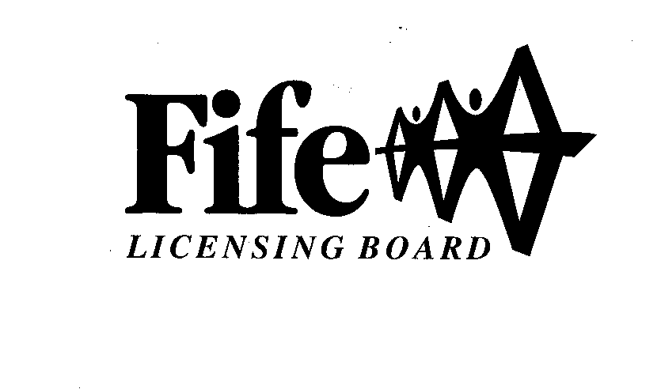
This application should only be completed by the Licenceholder of the appropriate Premises Licence or their Agent. These applications can take up to 6 weeks to process.

Please complete all sections of the application form.

Section 1: Premises Licence Details

1(a) Licence Number of Premises

1(b) Name and Address of Premises
Post Code |  | Phone No.
E-Mail

1(c) Full Name and Address of Current Licenceholder
Post Code |  | Phone No.
E-Mail

Section 2: Transferee Information

Where the transferee is an individual complete part 2(a) only

Where the transferee is a partnership, company or club/other body please complete part 2(b), 2(c) or 2(d) respectively. If the transferee is a partnership, company or club/other body then part 2(e) must also be completed

2(a) Full Name, Home Address, Date and Place of Birth of Transferee if Individual
Date of Birth |  | Place of Birth
Post Code |  | Phone No.
E-Mail
2(b)/

CFP/V6.1/09-05-28/APP FOR TRANSFER OF PREM LIC (LIC HOLDER)/FJ/PD

- 2 -

2(b) Full Name and Address of Transferee if Partnership
Post Code |  | Phone No.

2(c) Full Name, Address of Registered Office and Company Registration Number of Transferee if
Company
Company Registration Number
Post Code |  | Phone No.

2(d) Full Name and Address of Transferee if Club or Other Body
Post Code |  | Phone No.

2(e) Where transferee is a partnership, company or club/other body please provide the names, home addresses, dates and places of birth of all connected persons as defined by Section 147(3) of the Licensing (Scotland) Act 2005.

Continue on a Separate Page if Necessary

Date of Birth |  | Place of Birth
Post Code |  | Phone No.
Date of Birth |  | Place of Birth
Post Code |  | Phone No.

SECTION 3/

-3 -

Section 3: Licence to be Amended
(See note 1 below)

Does the appropriate Premises Licence accompany this application?

YES NO

If the answer is NO, please provide an explanation.

I am unable to produce the Premises Licence because…

The licence has not yet been issued by the Board

The licence has already been returned to the Board in respect of an earlier application for variation or transfer

Other (provide details)
……………………………………………………………………………..

Declaration by Applicant or Agent on Behalf of Applicant

If signing on behalf of the applicant please state in what capacity.

I confirm that (a) the contents of this Application are true to the best of my knowledge and belief; and (b) the appropriate fee of £50 is enclosed. (See note 2 & 3 below)

Signature
…………………………………………………………………………………. (See note 4 below)

Date
……………………………………………………………………………………………………………..

Capacity: APPLICANT / AGENT (delete as appropriate)

If agent, please provide name, address,
phone number and (if applicable) email address ………………………………………..

Online payments can be made at: www.fife.gov.uk click Pay then Make a Payment, Click Liquor Licence from the list, add your reference as your FLB number or Premises Name.
Please attach a copy of the receipt with this application, which is your proof of payment.

Note 1/
- 4 -

Note 1:
The appropriate premises licence (including summary licence, operating plan and layout plan) must be returned to the Fife Licensing Board so that the licence documents can be updated to reflect the details of the transfer. If you are in possession of the appropriate Premises Licence but unable to provide said licence with this application, you must ensure the licence is forwarded to the Licensing Board within 14 days in order to complete the process of transfer.

Note 2:
Please note also that once the transfer is completed, any certified copies of the appropriate Premises Licence must also be updated to reflect the details of the transfer.

Note 3:
If this application is submitted together with an application for variation then it will be subject to a combined fee. Please refer to the Table of Fees or contact the Licensing Team directly to clarify the exact fee.

Note 4:
“How we use your information
The information provided by you on this form will be used by Fife Council in order to process your application. It will be shared with Police Scotland and other Council Services and if appropriate NHS Fife and Scottish Fire and Rescue and information will be obtained from Police Scotland and other Council Services and if appropriate NHS Fife and Scottish Fire and Rescue. Further information on how your information is used and why can be found here: https://www.fife.gov.uk/kb/docs/articles/privacy-notices/liquor-licence
The Licensing Board’s Data Protection Officer can be contacted on: dataprotection@fife.gov.uk”.

Contact Us:

Fife Licensing Board,  Fife House,  North Street,  GLENROTHES,  Fife.  KY7 5LT. | Phone: 03451 55 11 77  Email: liquor.admin@fife.gov.uk

FOR OFFICE USE ONLY

Received and Receipt No. | System Updated | Transfer Granted

