THE FIFE COUNCIL (DISABLED PERSONS' OFF-STREET PARKING PLACES) (AMENDMENT) ORDER 2025

On 04/06/2025 Fife Council made an Order under the Road Traffic Regulation Act 1984, the effect of which is as stated in the issue of the St Andrews Citizen published on 25/04/2025.

A copy of the Order, which is operational from 09/06/2025 and a drawing showing the affected roads, may be inspected, without payment of fee, during normal office hours at Fife Council Headquarters, Fife House, North Street, Glenrothes and via public access pc's at your closest library. The documents will also be available online at www.fife.gov.uk/notices. Any person wishing to question the validity of the Order or of any provision contained in it on the grounds that it is not within the powers conferred by the Road Traffic Regulation Act 1984, or on the grounds that any requirement of that Act, or of any instrument made under it, has not been complied with in relation to the Order, may, within six weeks from 04/06/2025 apply to the Court of Session for the purpose.

Any queries regarding this Order should be directed to Traffic Management, Roads & Transportation Service, Bankhead Central, Bankhead Park, Glenrothes, Fife KY7 6GH or by e-mail to traffic.management@fife.gov.uk.

06/06/25

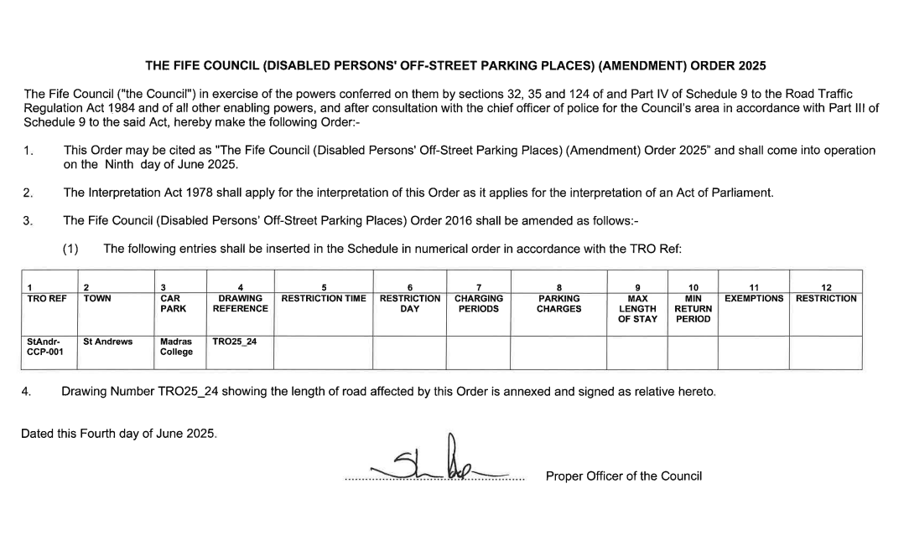

Picture caption: Plan showing disabled bays at Madras College

