Postal Voting Pack Guidance
Below is a step-by step guide on how to complete a postal voting pack
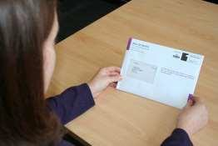
- Do not open the postal vote envelope unless it is addressed to you. Remember, it is an offence to use a ballot paper addressed to another person.
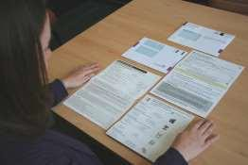
- Contained in your pack will be:
  - A ballot paper or ballot papers
  - A postal voting statement attached to a ballot paper envelope A
  - A ballot paper envelope A
  - A white return envelope B
  - An instruction leaflet
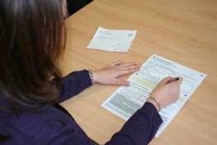

- Check that the ballot paper number on your postal voting statement matches the number on the back of your ballot paper(s). Complete your postal voting statement by signing and adding your date of birth in the boxes provided. If you have a signature waiver there will be no signature box. A power of attorney cannot sign a postal vote.

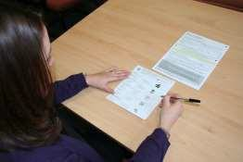

- Mark your ballot paper(s) following the instructions at the top of the ballot paper.
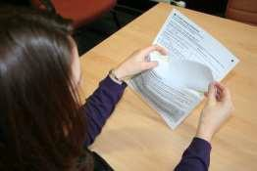

- Place your ballot paper(s) into envelope A. leaving the postal voting statement attached. Moisten the yellow gummed strip, fold down to secure. If you detach your postal voting statement by mistake it does not matter so long as you return it in the white envelope B along with envelope A.
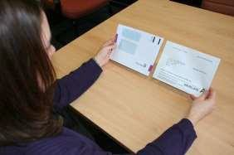

- Now place envelope A, containing your completed ballot paper(s) and the attached postal voting statement, into the white envelope B
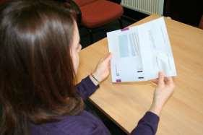

- It is important that you ensure that the address of the Returning Officer is showing through the bottom window. If you can see your address you need to turn the contents around before sealing the envelope.
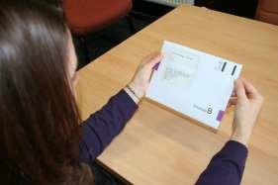
- Your postal vote is now ready to return to: The Returning Officer
Fife Council Fife House North Street
Glenrothes

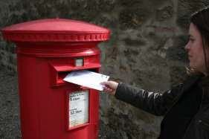

- You can post your completed postal vote back to us – no stamp is required

- OR you can hand your postal vote into the Election Office, Fife House, North Street, Glenrothes.

- OR you can hand your postal vote in at any Fife polling station on polling day.

For your vote to count we must receive your completed postal vote back no later than 10pm on polling day.

Not received your postal vote or made a mistake while completing your postal vote – please contact the Election Hotline immediately.

