PUBLIC NOTICE
THE COMMUNITY EMPOWERMENT (SCOTLAND) ACT 2015
NOTICE OF CONSULTATION ON DISPOSAL BY WAY OF LEASE - COMMON GOOD PROPERTY

Fife Council propose to enter lease agreements on a common good property Town House Inverkeithing, 6-8 Townhall Street, Inverkeithing. Before taking a decision, the Council requires to consult under Section 104 of the Community Empowerment (Scotland) Act 2015.

Town House and Location
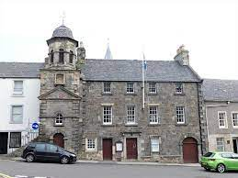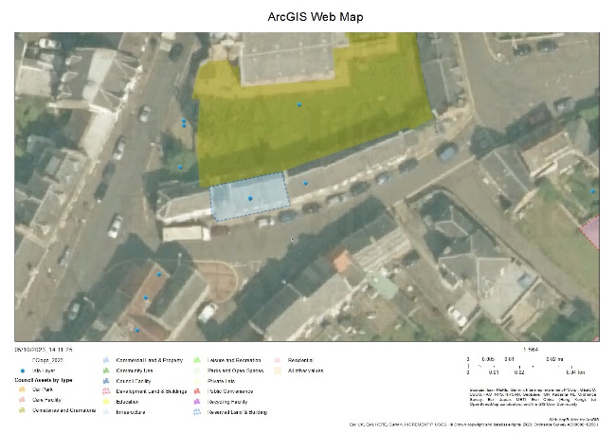

History
The first municipal building dated back to the mid 16th Century. A new tower was completed in 1755 and was used as meeting place for the then burgh council and more recently as a community hall by variety of groups and as a base to deliver activities from. This has included the Inverkeithing Community Council, Highland Games Committee, Pipe Band, Local History Society, Foodbank, Floral Society, youth projects, adult learning and small community events. The property was recently included as part of Fife Councils Inverkeithing Heritage Regeneration programme. The programme secured funding from a variety of sources which included the modernisation of the Town House. The layout and access to the building has been transformed during the last 2 years.

Disposal By Lease Request
Inverkeithing Town House (SC 051887) have agreed to enter new lease agreements for the period of 25 years to regulate the occupation of the property. The permitted use is for the provision of community activities under Class 10 of the Town and Country Planning (Use Classes) (Scotland ) order 1997. As part of the funding proposal the management of the facility would move from Fife Council to ITH (SCIO) once the building works are concluded. This delivers on the Inverkeithing Regeneration Scheme’s aim, agreed with local stakeholders, to repair and adapt the Town House to create a vibrant and accessible community hub – managed by the community for the community.
The proposals would be subject to all statutory consents.

Representations:

Anyone may make representations about this request to Fife Council. Representations must be in writing and include the name and address of the person making it. All representations will be published online at www.fifedirect.org.uk/commongood.

Representations must be received by 11th February 2024. They should be sent to Zahida.ramzan@fife.gov.uk or to communityasset.transfer@fife.gov.uk

Date of Notice 12th December 2023

