Licensing (Scotland) Act 2005, Section 29  Application for Minor Variation  of Premises Licence | 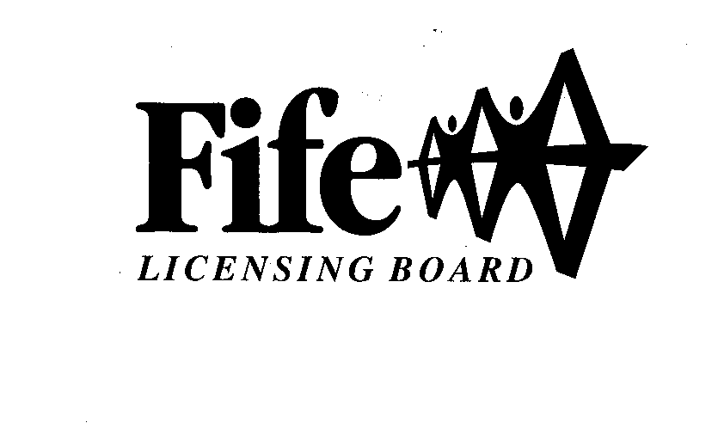
This application should only be completed by the Licenceholder of the appropriate Premises Licence or their Agent.

Acceptance of this application does not prejudice the rights of the Licensing Board to determine that the variation is not a minor variation and to seek the balance of the appropriate fee.

Section 1: Type of Variation

1(a)

This application for Minor Variation of a Premises Licence is made under Section 29(6) of the Licensing (Scotland) Act 2005 in order to vary-
(Tick all relevant boxes)

The Layout Plan which does not result in any inconsistency with the operating plan
(See Note 1)

The Operating Plan to restrict the terms on which children and young persons are allowed entry to the premises

The information contained in the licence relating to the Premises Manager (including the substitution of a new Premises Manager)

Section 2: Premises Licence Details

2(a) Licence Number of Premises

2(b) Name and Address of Premises
Post Code |  | Phone No.

2(c) Full Name and Address of Current Licenceholder
Post Code |  | Phone No.

section 3/
CFP/V6.1/09-05-28/APP FOR MINOR VARIATION OF PREM LIC/FJ/PD

- 2 -

Section 3: Nature of Variation

Complete the relevant section(s) regarding the variations sought:-

3(a) Variation to the Layout Plan which does not result in any inconsistency with the operating plan

Five Copies of the proposed Layout Plan must accompany this application. (See Note 2)
In addition please provide details of the proposed change to the layout of the Premises.

3(b) Variation to the Operating Plan to restrict the terms on which children and young persons are allowed entry to the premises

Provide details of the proposed restrictions to the current Operating Plan

Terms under which Children and Young Persons will be allowed entry

Ages of Children and Young Persons to be allowed entry

Times during which Children and Young Persons will be allowed entry

Parts of the premises which Children and Young Persons will be allowed entry

3(c)/

- 3 -

3(c) Variation to the information contained in the licence relating to the Premises Manager (including the substitution of a new Premises Manager)

(i) If variation is only to amend details of Current Premises Manager then complete this part

(ii) If variation is to intimate the substitution of a new Premises Manager then complete this part

Full Name and Address of Proposed Premises Manager
Post Code |  | Phone No.

Date of Birth of Proposed Premises Manager

Details of Personal Licence held by Proposed Premises Manager
Date of Issue | Name of Licensing Board issuing | Licence No. of Personal Licence
Please note that the holder of a Personal Licence may only be named as the Premises Manager of one premises in Scotland at any time subject to Article 4 of the Licensing (Vessels etc.) (Scotland) Regulations 2007.

SECTION 4/

- 4 -

Section 4: Licence to be Amended
(See Note 3)

Does the appropriate Premises Licence accompany this application?

YES NO

If the answer is NO, please provide an explanation.

I am unable to produce the Premises Licence because…

The licence has not yet been issued by the Board

The licence has already been returned to the Board in respect of an earlier application for variation or transfer

Other (provide details)
…………………………………………………..…………………………

Section 5: Fee Payable

The fee payable in respect of the application for variation is-

- £31 for the substitution of a new Premises Manager (this can also include any additional minor variations sought under part 1(a))
- £20 for any minor variation under part 1(a) which does not include the substitution of a new Premises Manager

Online payments can be made at: www.fife.gov.uk click Pay then Make a Payment, Click Liquor Licence from the list, add your reference as your FLB number or Premises Name.
Please attach a copy of the receipt with this application, which is your proof of payment.

Declaration by Applicant or Agent on Behalf of Applicant

If signing on behalf of the applicant please state in what capacity.

I confirm that (a) the contents of this Application are true to the best of my knowledge and belief; and (b) the appropriate fee of £ is enclosed.

Signature
…………………………………………………………………. (See Note 4 & 5)

Date
………………………………………………..…………………

Capacity: APPLICANT / AGENT (delete as appropriate)

If agent, please provide name, address,
phone number and (if applicable) email address ………………………………………..

………………………………………..

………………………………………..

Note 1:/

- 5 -

Note 1:

Section 29(6)(a) of the Licensing (Scotland) Act 2005 intimates that a variation to the Layout Plan of a Premises qualifies as a minor variation only ’if the variation does not result in any inconsistency with the operating plan’. Since the Operating Plan contained within the Premises Licence reflects the relevant ‘on sales’ and/or ‘off sales’ capacity figures, a variation to the layout of the premises will only be considered ‘minor’ if the changes do not alter the capacity figures in any way.

If an application to vary the Layout Plan is submitted to the Licensing Board as a minor variation then Licensing Staff may seek clarification from Building Standard Officers before the application is accepted. Only when the Board are satisfied that the application is for a minor variation will it be regarded as lodged.

Note 2:

Please refer to Paragraph 5 of the Premises Licence (Scotland) Regulations 2007 regarding the format of Layout Plans.

Note 3:

The appropriate premises licence (including summary licence, operating plan and layout plan) must be returned to Fife Licensing Board so that the licence documents can be updated to reflect the details of the variation. If you are in possession of the appropriate Premises Licence but unable to provide said licence with this application, you must ensure the licence is forwarded to the Licensing Board within 14 days in order to complete the process of variation.

Note 4:

Please note also that once the variation is completed, any certified copies of the appropriate Premises Licence must also be updated to reflect the details of the variation.

Note 5:

“How we use your information
The information provided by you on this form will be used by Fife Council in order to process your application. It will be shared with Police Scotland and other Council Services and if appropriate NHS Fife and Scottish Fire and Rescue and information will be obtained from Police Scotland and other Council Services and if appropriate NHS Fife and Scottish Fire and Rescue. Further information on how your information is used and why can be found here: https://www.fife.gov.uk/kb/docs/articles/privacy-notices/liquor-licence . The Licensing Board’s Data Protection Officer can be contacted on: dataprotection@fife.gov.uk”.

Contact Us:

Fife Licensing Board,  Fife House,  North Street,  GLENROTHES,  Fife.  KY7 5LT. |  | Phone: 03451 55 11 77  Email: liquor.admin@fife.gov.uk
FOR OFFICE USE ONLY

Received & Receipt No. | System Updated |  | Variation Granted

