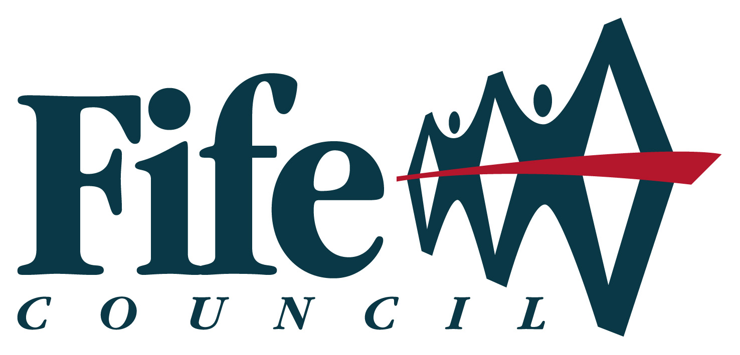
Community Asset Transfer
Policy Statement

Community Asset Transfer

National and Local Context

In July 2015, the Community Empowerment (Scotland) Bill 2014 received Royal Assent and became the Community Empowerment (Scotland) Act 2015. The Act comprises 11 parts, providing a framework and statutory guidance for a number of new duties and obligations for public bodies. The Act represents the culmination of work commenced following the publication of the Christie Commission report on the Future of Local Government in Scotland. Part 5 of the Act covers Community Asset Transfers.

Purpose

The purpose of this policy statement is to set out Fife Council’s commitment to enabling property assets to be transferred to local community bodies where a sustainable opportunity has been identified. This commitment will be underpinned by transparent and supportive processes.

Key Principles

Key principles underlying this policy statement are as follows:

- Fife Council holds its property assets as a resource to be used in the delivery of services and to support the delivery of Council and Fife Partnership outcomes.

- Fife Council believes that the transfer of assets to local community organisations can play a key role in supporting and sustaining local communities.

- Fife Council also recognises that community asset transfer may achieve better value for money and deliver more sustainable outcomes for both the Council and the wider communities it serves.

- As the processes for transferring assets must comply with the terms of the Community Empowerment Act 2015, and follow a different process to those followed for the commercial transfer of assets by sale or lease, it was considered appropriate to produce this separate policy statement for the transfer of assets to community bodies.

Policy Statement

Fife Council will react positively to all enquiries from community bodies seeking to pursue community asset transfer, and will support such groups to develop the organisational and operational processes and arrangements necessary to achieve their aims.

Fife Council has put in place a transparent process for supporting community asset transfers and assessing requests in accordance with the terms of the Community Empowerment (Scotland) Act 2015.

The community asset transfer process, which is attached as Appendix (i) to this Policy Statement, is driven by the aim of achieving better service provision, rather than by the availability of assets. The process provides an opportunity for any qualifying community body to engage in delivering services and adding value in their local communities. This could involve delivering services that the Council finds it can no longer afford to provide in the way it has done previously, or by delivering additional services identified by the local community. It may also enable a qualifying community body to develop a commercial venture, which would provide community benefit as an outcome of its activities.

Fife Council will give full consideration to the transfer of an asset to any qualifying community body that makes an application, which is supported by an appropriate business plan that demonstrates that the organisation has the skills and capacity to successfully manage the asset. This will include a critical appraisal as to whether the proposed service will assist in delivering agreed outcomes set out in the Fife Community Plan and the relevant Local Community Plan.

While the transfer of full responsibility for an asset, either through a long term lease or outright ownership, are the preferred options, Fife Council acknowledges that, in some instances, it will be appropriate to offer support for short-term flexible arrangements.

The following table identifies options for the operation of existing assets - from retention by the Council through to market sale:

Category 1 | Category 2 |  |  |  | Category 3
Facilities required for service and community provision and directly managed by Fife Council | Facilities where there is a community interest in the facility. The Community Asset Transfer Policy provides for four options in this category: |  |  |  | Facilities which are not required and where a decision has been made to proceed to market sale
 | Wind and Watertight Lease | Fully Repairing and Insuring Lease | Subsidised Lease | Community Ownership/  Transfer

Following full implementation of the Community Empowerment (Scotland) Act 2015, Fife Council will continue to support current ‘support in kind’ arrangements for an interim period. This includes short term leases of its surplus properties by community organisations. At the natural expiry date for these existing arrangements, or following other changes in circumstances, the organisations operating under this earlier support in kind arrangement will be invited to submit an application under the community asset transfer process if they wish to continue to occupy that asset. This will ensure full compliance with the Community Empowerment (Scotland) Act 2015 and ensure that all community bodies are dealt with in a fair, transparent and equitable way.

While fully supporting the principle of community asset transfer, Fife Council recognises that some assets must remain in Council ownership and management in order to:
- support delivery of essential services;
- provide an income stream to the Council, or;
- support economic activity in an area.

In particular, existing leased-out commercial and industrial assets, which play a key role in generating income for the Council, as well as supporting the economic development of an area, will not be considered suitable for transfer.

There are also assets that are owned or leased by the Council, which have title burdens or conditions of lease terms, which would make them unsuitable for transfer. Other assets may be required by the Council as a result of their potential to generate significant capital receipts, or for their inclusion in supporting wider Council objectives and programmes.

Assets that are declared surplus under Council asset modernisation programmes, where the capital receipts for those assets have been allocated as part of the funding arrangements to deliver that programme, will also be excluded from transfer by lease or sale at below best consideration.

The Council’s policy in respect of the transfer of assets to community bodies is based on the following principles:

- Any proposed asset transfer must support Community Plan and Local Community Plan outcomes, and should not to be to the detriment of other strategies and policies.

- The Council has an important role in supporting community bodies and the Third Sector, but also acknowledges its stewardship of publicly owned assets.

- The transfer of assets will be carried out in a transparent, equitable and accountable way and in accordance with the Council’s corporate asset management strategy and local asset plans.

- A strategic approach will be adopted for all assets, in accordance with the Council’s corporate asset management policy and asset management plan.

- All Council services will support the Council’s policy on the community transfer of assets and assist in delivering the aims and objectives contained in this policy statement.

- All assets being transferred for less than market value will be subject to satisfying the terms and conditions of the Disposal of Land by Local Authorities (Scotland) Regulations 2010.

Appendix (i) sets out an agreed process for supporting and managing asset transfer requests from community bodies. In order to support the anticipated demand from local communities wishing to take advantage of the provisions outlined in the Act, a team of officers has been identified to support projects and applications. The team is multi-disciplinary, drawing together from a number of services officers with the necessary skills and expertise to support community groups with the application and transfer process.

Detailed guidance has been prepared to provide community organisations with advice on how they should take forward a community asset transfer application in Fife. This aims to ensure that community organisations provide all the necessary information in support of their application, including information about the community organisation, the nature of the initiative being proposed, community consultation and engagement undertaken, advice received, any proposed partners, and essential property information. The multi-disciplinary Community Asset Transfer (CAT) team will provide support throughout the application process.

The governance procedures to manage this section of the Act have been agreed, and it is proposed that, as with the Council’s pilot transfer exercise in 2011, a panel of officers from relevant services in each committee area (Local Assessment Team) will assess applications and submit recommendations, in the first instance to the CAT team, and thereafter to the appropriate area committee. As set out in the Council’s Scheme of Administration, the Executive Committee is the decision making body for property transactions. A process for managing appeals to decisions has also been agreed. For local authorities this will be an internal process. For other bodies, appeals will be managed directly by the Scottish Government. Changes to the Scheme of Administration will be required in order to manage the appeal/review process set out in the Act.

Appendix (i)
