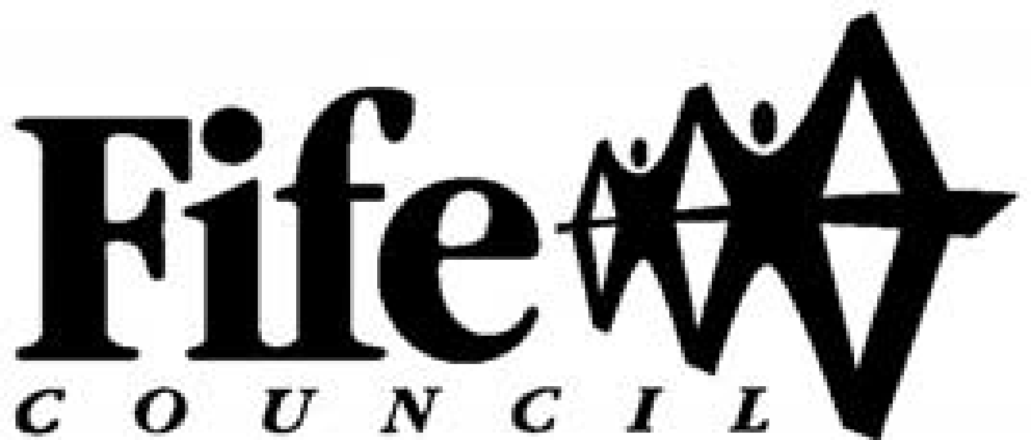

VO01 - Volunteering Policy

Introduction

Fife Council recognises and values the contribution volunteers make to Fife communities and to the work of Council Services. This policy supports the aims and goals of The Plan for Fife (2017-2027) also known as Local Outcome Improvement Plan (LOIP) Fife Council will work alongside Fife Voluntary Action to implement, monitor and review the policy.
This policy sets out a corporate framework for Council Services when engaging with and managing volunteers. This policy document is supported by Management of Volunteers Guidelines that will outline the systems and processes involved in recruiting and managing volunteers.
Definition of Volunteering

Fife Council defines volunteering as - "the giving of time and energy through a third party, which can bring measurable benefits to the volunteer, individual beneficiaries, groups and organisations, communities, environment and society at large. It is a choice undertaken of one's own free will, and is not motivated primarily for financial gain or for a wage or salary."

Statement of Policy Aims

This Policy will ensure:
- volunteers are treated equally and fairly
- there is a clear statement of the Council's commitment to and expectations of volunteers
- consistency of approach to volunteering across all Fife Council Services
- volunteers are covered by the relevant Council policies i.e. health and safety, equal opportunities etc
- the importance, effectiveness and enjoyment of volunteering is actively promoted throughout the Council
- the Council supports the four strands of the Scottish Governments Volunteering Strategy; promoting volunteering with young people; dismantling the barriers to volunteering and closing the opportunity gap; improving the volunteering experience; work alongside Fife Voluntary Action to develop, monitor and evaluate ongoing policy
Policy Implementation

The VO11 Management of Volunteer Guidelines that accompany this Policy provides advice and guidance to all staff and Services on implementing this Policy. Council Services will be required to produce evidence that they are adhering to this Policy and the guidance provided.

Employer Supported Volunteering

The Council recognises that many members of staff give their time and expertise as volunteers and practical assistance may be offered at the discretion of senior management. Managers should refer to the “VO51: Employer Supported Volunteering - Advice for Managers” for further information and guidance.

Commitment and Expectations
Fife Council will undertake the following responsibilities:

- Volunteering opportunities will be promoted widely, in ways that are accessible to all sections of the community, such as Fife Voluntary Action web-pages, local notice boards etc, specifying the tasks and time commitment expected of the volunteer.
- Recruitment advertisements will state clearly if the volunteer post requires membership of the Protection Vulnerable Groups Scheme (PVG)
- Volunteering opportunities will as far as possible be open and accessible to all sections of the community
- The Council's Equal Opportunities Policy will be applied when recruiting and selecting volunteers
- The Council will offer suitable and adequate induction training to all volunteers within an agreed timescale
- The volunteer will have access to a named Council representative for information, support and supervision
- To ensure all necessary insurance is in place
- A Volunteer Agreement will be drawn up and signed by the volunteer and Council representative. The agreement will outline all aspects of the volunteer and Council's roles and responsibilities. This is not a legal document or employment contract but will form the basis of regular support.
- Any expenses likely to be incurred by the volunteer whilst carrying out their agreed duties will be discussed and procedures for claiming agreed and recorded in the Volunteer Agreement.
- Volunteers will not be asked to perform tasks usually undertaken by paid employees or take on tasks formerly undertaken by paid workers whose posts have been made redundant, or hours have been reduced, or to work in an area, or in a way that contributes to any decrease in paid employment
- Volunteers will not be used in times of industrial action to do the work of paid employees. They may continue with their regular work, but should not be asked to undertake additional duties
● Volunteers will not be permitted to take up a post until all the necessary checks (references, Protection of Vulnerable Groups Scheme membership) are complete
Volunteers are expected to adhere to the following conditions:

- Where appropriate, the volunteer will comply with the requirements for Protection of Vulnerable Groups Scheme (PVG), checks and other safeguards put in place by the Council for the protection of protected adults and children.
- The volunteer will respect the need for confidentiality and operate within agreed policies and guidelines
- The volunteer will perform the tasks outlined in Volunteer Agreement and in a manner appropriate of a representative of Fife Council
- The volunteer can renegotiate the terms of the Volunteer Agreement on application to the named Council representative

Policy Monitoring and Review

Fife Council is committed to the ongoing monitoring and reviewing of this Policy and will carry out a formal review every 3 years, with the next review to take place in 2018.

