Education and Children’s Services - Policies and Guidance

|  |  |  |  |
| --- | --- | --- | --- |
| **Early Learning and Childcare Admissions Policy** | | | |
| **Category:** | | | |
| Risk Management and Legal Implications  Failure to manage risk may impact on the delivery of Service objectives and the outcomes achieved by Service users. Education and Children’s Services aim to mitigate the implications by ongoing management and review of risk in all elements of work activity.  The production of this document is one way in which we aim to reduce our exposure to risk. By providing staff with information on good practice, making reference to other guidance that is available across the Council and providing clarity on how we should do things, we can ensure that the management of risk is intrinsic to what we do. | | | |
| Document Owner | Version | date of publication | date of next review | |
| Early Years team | 1.0 | 30 September 2019 | 1 October 2021 | |



**Early Learning & Childcare**

**Admissions Policy**

Throughout this policy, the word *‘parent’* should be interpreted as including the child’s carer or legal guardian.

**INDEX**

**1.0 Introduction / Key Principles Page 3**

**2.0 Types of early learning and childcare provision available Page 4**

**3.0 Applying for a funded early learning and childcare placement Page 4**

**3.1 Application process for Fife Council provision - Page 4**

**3 and 4-year-old placements**

**3.2 Application process for Private Nursery, Playgroup Page 7**

**or Childminder - 3 and 4-year-old placements**

**3.3 Application process for 2-year-old placements Page 7**

**4.0 Inter-Agency Referrals for 2, 3 and 4-Year-Olds Page 9**

**5.0 Wraparound Care (additional paid hours) Page 9**

**6.0 Deferred Entry to Primary School Page 9**

**7.0 Appeals Process Page 10**

**Appendix 1 – Local Nursery Areas Page 11**

**Appendix 2 – Fife Council Local Committee Areas Page 13**

1. **Introduction / Key Principles**

Through the Blueprint for 2020 consultation, the Scottish Government has set out its vision for the expansion in early learning and childcare provision in Scotland. This is a ‘funding following the child’ approach underpinned by the principles of *Quality, Flexibility, Accessibility and Affordability*.

<https://consult.gov.scot/creating-positive-futures/expansion-of-early-learning-and-childcare/supporting_documents/451371_Blueprint%202020.pdf>

Fife Council is committed to providing high quality early learning and childcare for children across the area and the purpose of this policy is to ensure that early learning and childcare placements are allocated in a consistent way. It sets out the main principles and criteria used to allocate placements.

All children, including those with additional support needs, will be offered early learning and childcare (ELC) in accordance with the terms set down by the Scottish Government under the Children and Young People (Scotland) Act 2014:

<http://www.legislation.gov.uk/asp/2014/8/introduction>

Eligible children are entitled to a funded early learning and childcare place in line with the following dates:

* + August Intake – child’s qualifying birthday must be on or before 31 August.
  + January Intake – child’s qualifying birthday must be on or before 31 December.
  + April Intake – child’s qualifying birthday must be on or before last day in February.

The funding year is deemed to start on the first day of each academic year. Funded early learning and childcare entitlement is calculated on a pro-rata basis for children starting in January and April intakes.

The following principles apply when allocating a placement:

* Eligible children will have access to early learning and childcare regardless of age; disability; gender reassignment; marriage or civil partnership; race; religion or belief; sex or sexual orientation in line with the protected characteristics listed in the Equalities Act 2010:

<https://www.legislation.gov.uk/ukpga/2010/15/contents>

* Early learning and childcare will be provided on a non-denominational basis.
* Securing a place in a school nursery class does not entitle a child to a place in the corresponding primary school. The provision of early learning and childcare in early years establishments is not governed by primary school catchment areas.

1. **Types of Early Learning and Childcare Provision Available**

Funded early learning and childcare (ELC) is available in a number of different early years settings across Fife. These are:

* Fife Council Family Nurture Centres
* Fife Council nursery classes based in primary schools
* Fife Council stand-alone nursery settings
* Fife Council nursery settings based in other Fife Council buildings
* Private Nurseries contracted by Fife Council to deliver funded ELC
* Playgroups contracted by Fife Council to deliver funded ELC
* Childminders contracted by Fife Council to deliver funded ELC

All funded providers will need to meet the National Standards identified as part of the Scottish Government’s commitment to deliver high quality funded ELC across Scotland. These standards can be found at:

<https://www.gov.scot/publications/funding-follows-child-national-standard-early-learning-childcare-providers-principles-practice/>

Parents will be able to choose a range of different options to meet their needs. Not all options will be available in every provision. Information on current Early Learning and Childcare Funded Providers across Fife is available at:

[www.Fifedirect.org.uk\earlyyears](http://www.Fifedirect.org.uk\earlyyears)

If parents wish to access funded early learning and childcare for their child within another Local Authority area, then they should contact the relevant Local Authority directly for information on how to apply for a placement in their preferred nursery.

1. **Applying for a funded ELC placement**

There are different application processes depending on both the type of provision selected and the age of the child. Parents can also choose to use more than one ELC funded provider to meet their child’s needs but must apply for each place in accordance with the application process for that setting. Funded ELC placements for each child will only be available up to a maximum of 1140 hours per annum across all settings chosen, with any additional hours being charged as wraparound care (see section 5).

* 1. **Application Process for Fife Council Provision - 3 and 4-year-olds**

This application process applies to the following services:

* + Fife Council Family Nurture Centres
  + Fife Council nursery classes based in primary schools
  + Fife Council stand-alone nursery settings
  + Fife Council nursery settings based in other Fife Council buildings

All applications for Fife Council early learning and childcare placements, for 3 and 4-year-olds, must be submitted during January in the academic year before the child is due to start (i.e. application made January 2020 for children due to start either August 2020, January 2021 or April 2021).

Application forms are available from any Fife Council early learning and childcare establishment and can also be accessed online at [www.FifeDirect.org.uk/earlyyears](http://www.FifeDirect.org.uk/earlyyears). Completed application forms should be handed in by parents to their first choice Fife Council early learning and childcare establishment, along with evidence of eligibility as requested on the application form.

Parents are asked to list several choices (to include the choice of early learning and childcare establishment and session) on their application form, in order of preference. This is so these choices can be considered during the Early Learning and Childcare Admissions Panel process if, for example, a suitable placement is not available for their initial choices. If none of the choices indicated on the application form are available parents will be contacted by a representative of Fife Council to discuss further options for placements.

Applications for places for 3 and 4-year-olds must be received by **31 January,** at the latest, to be included in the Early Learning and Childcare Admissions Panel meetings held each February and March. These panels will allocate places for the following academic year and places will be awarded to applicants in line with the criteria listed below (except for 10-hour sessions which have separate priority levels):

* + - **Priority 1**

Children deferring entry from Primary 1 and staying at nursery, where an additional year of funding has been agreed by Fife Council.

* + - **Priority 2**

Children whose application form is supported by the appropriate inter-agency documentation, including children on the child protection register and those with additional support needs.

* + - **Priority 3**

Children who have siblings already allocated a place at the nursery and who will continue their nursery placement in the following academic year.

* + - **Priority 4**

Children from the local nursery area (see Appendix 1).

* + - **Priority 5**

Children from out-with the local nursery area (see Appendix 1).

* + - **Priority 6**

Children residing out-with the Fife Council area.

Criteria used for allocating Fife Council 10-hour session placements only is as follows:

* + - **Priority 1**

Children who have siblings already allocated a place at the nursery and who will continue their nursery placement in the following academic year.

* + - **Priority 2**

Children from the defined Fife Council local committee area (see Appendix 2).

* + - **Priority 3**

Children from out-with the defined Fife Council local committee area (see Appendix 2).

* + - **Priority 4**

Children residing out-with the Fife Council area.

Some establishments and session times will be oversubscribed based on capacity and, in this situation, places will be allocated in priority order, with higher priority children being allocated first. Where there are more applications than places available, children who have the same priority level will be balloted to establish the order that placements will be allocated. Once all suitable placements have been allocated in accordance with application details then a waiting list will be established for any remaining applications, based on the ballot order. This process will continue with any higher priority level applications until a full waiting list is established.

Following the Early Learning and Childcare Admissions Panel process, parents are informed of the outcome of their application. Parents will then be required to confirm if they are accepting the placement offered by the date indicated in the offer letter. If parents do not confirm acceptance of the placement, within this time, then the place may be withdrawn and offered to another child.

If parents wish to change the agreed placement at any point following acceptance of the place, then a new application for the alternative placement would need to be submitted. This would be treated in the same way as any other application form.

Applications for 3 and 4-year-old placements received on or after 1 February each year **will not** be processed until after the full Early Learning and Childcare Admission Panel process has taken place for this age group, except for children who are priority 1 or 2.

Applications for children who are identified as priority 1 or 2, which are received up to one week before placement offer letters are sent out, will be allocated a place in line with the nursery admissions panel process. If applications for priority levels 1 or 2 are received after this date, then they be placed at the top of any waiting list at that establishment.

Late applications for all other priority levels will be allocated places on a first come, first served basis, into any remaining places once the panel process has been completed. If a waiting list is in place at the preferred establishment then applications will be placed at the bottom of any established waiting list. This may reduce the choice of Early Learning and Childcare establishments available to parents if the nurseries they have chosen are oversubscribed.

Parents should be aware that they are applying for fixed session times at Fife Council nurseries. If parents choose not to send their child for the full session length, then any unused hours as part of that session will be counted as be part of their funded entitlement and cannot be used elsewhere.

If parents wish to change the agreed placement then they would be required to submit a new application form for the new placement. This would be processed as a late application.

* 1. **Application Process for Private Nurseries, Playgroups and Childminders – 3 and 4-year-olds**

This applies to the following services:

* + Private Nurseries contracted by Fife Council to deliver funded ELC
  + Playgroups contracted by Fife Council to deliver funded ELC
  + Childminders contracted by Fife Council to deliver funded ELC

These are businesses, both private and voluntary, which are contracted to offer funded early learning and childcare on behalf of Fife Council and each will have their own application process to secure a placement in that setting. If parents wish to apply for a placement at one of the above settings, then they should contact their first-choice provider directly and request an application form as soon as possible. Placements will be directly allocated by the provider depending on capacity available.

Parents should be aware that they will be required to enter into a contract between themselves and their provider of choice when choosing funded ELC in one of these settings. Parents should be notified of the terms and conditions of this contract when they either apply or accept the placement and this will set down details such as notice periods and any other charges that may be applicable out with their funded ELC entitlement.

* 1. **Applications for Children due to start at the age of 2**

Applications for 2-year-old children, who meet the criteria for eligibility as defined in the Children and Young People (Scotland) Act 2014, can be submitted at any time during the academic year and will be considered at the next available 2-year-old Early Learning and Childcare Admissions Panel meeting. Panels for this age group are held at least four times a year.

Application forms are available from any Fife Council setting offering funded ELC 2 year old placements or from [www.FifeDirect.org.uk\earlyyears](http://www.FifeDirect.org.uk\earlyyears) (where a list of current providers can also be found, including all providers offering funded 2 year old placements comprising private nurseries, playgroups and childminders, as well as Fife Council settings). Parents are encouraged to list three choices of provider in preference order on their application form. Application forms should be returned to any Fife Council setting offering 2-year-old placements, along with recent evidence of eligibility so this can be confirmed.

Children will be allocated places according to the criteria listed below. (N.B. eligibility criteria are subject to change in line with any amendments to the Children and Young People (Scotland) Act 2014):

**Admissions Criteria - Children aged 2 years old**

**Priority 1** Children on the child protection register. Children meeting this criterion can be offered an available place immediately upon application.

**Priority 2** Children as defined in section 47 (2)(c)(ii) of the Children and Young People (Scotland) Act 2014.

This is currently defined as children aged 2 (until they are eligible to start their 3-4- year-old placement) and residing in households in receipt of any of the following benefits and tax credits:

* Income Support
* Job Seeker’s Allowance
* Any income related element of Employment and Support Allowance
* Incapacity or Severe Disablement Allowance
* State Pension Credit
* Child Tax Credit (CTC), but not Working Tax Credit (WTC) and income is £16,105 or less
* Child Tax Credit (CTC) AND Working Tax Credit (WTC) and income is £7,320 or less
* Support under Part VI of the Immigration and Asylum Act 1999
* Universal Credit with household take-home pay of £610 a month or less

Children will be eligible to start their placement at the next intake after their 2nd birthday (intakes take place in August, January and April each year).

**Priority 3** Children who at any time after their 2nd birthday are or have been ‘looked after’ or subject to a kinship care order or have a guardian by an appointment under section 7 of the Children (Scotland) Act 1995.

**Priority 4** Children who require additional support as identified by the Educational Home Visiting Service. Children with this priority level are not entitled to receive 1140 hours of funded ELC and will be offered sessions in line with their identified needs within a Fife Council establishment.

**Priority 5** Children who have inter-agency involvement and have been referred by that agency. Children with this priority level are not entitled to receive 1140 hours of funded ELC and will be offered sessions in line with their identified needs within a Fife Council establishment.

Parents of children who fall into priority levels 4 and 5 should contact the lead professional involved with their family before applying for a placement. Supplementary information relating to the identified needs of children and families will be required to support these applications and this should be completed by the lead professional involved. Application forms will be available directly from the lead professional.

Inter–agency referral panels will take place throughout the year to allocate and review places for 2 year old children who fall into Priorities 4 or 5 and for those children who missed their panel date and are already entitled to start under priorities 1, 2 and 3. Places for children who fall into priorities 4 or 5 are not guaranteed for the full academic year as they are based on the needs of children and families and may be withdrawn or reduced depending on need.

In the situation where there are too many applications for a setting, a ballot process will be held in priority order to allocate places and establish a waiting list.

Children accessing 2-year-old placements must complete a new application form when applying for a 3 – 4-year-old nursery placement, as this is a separate process. Securing a place in a funded 2-year-old provision does not entitle your child to a place in the corresponding 3 – 4-year-old provision in that setting.

**4.0 Inter-Agency Referrals for 2, 3 and 4-Year-Olds**

All applications for an inter-agency priority allocation for Fife Council settings must be accompanied by supporting documentation from the appropriate professional involved. Appropriate evidence may include:

1. Fife Council Inter-Agency Referral Form provided by an appropriate agency e.g. GP, Health Visitor, Educational/Clinical Psychological Services.
2. Evidence of current Pre-school Community Team and/or Educational Home Visiting Service involvement.
3. Evidence of current Social Work involvement.

If a parent submits a nursery application form indicating that there are reasons for an inter-agency referral then education staff will contact the named person for that child, with the consent of the parent and/or carer. The named person will then be responsible for ensuring relevant documentation is submitted by the appropriate agency in time to be considered at the relevant panel process.

It is the responsibility of the Early Learning and Childcare Admissions Panel to determine if the details provided in the inter-agency referral form indicate that the child should be granted a nursery place under the appropriate priority.

If the panel decides that an inter-agency priority place is not appropriate, then the panel will re-prioritise the application. Parents will be informed of this decision by the headteacher of their first choice of establishment.

**5.0 Wraparound Care (additional paid hours)**

Some Early Learning and Childcare establishments may be able to offer additional hours to children, on a paid basis, if they have enough places and staff available to provide the additional care.

In Fife Council settings parents should be aware that these hours cannot be guaranteed for the whole year as circumstances may change at the establishment. There is an hourly charge to parents for this service and places for wraparound care are allocated on a first come first served basis. Further details can be found at [www.fifedirect.org.uk\earlyyears](http://www.fifedirect.org.uk\earlyyears).

In private nurseries, playgroups and childminders, any wraparound care provided is subject to their own terms and conditions. The purchase of wraparound care does not influence the allocation of funded early learning and childcare placements.

**6.0 Deferred Entry to Primary School**

Currently, children with January or February birthdays are entitled to a further year of funded nursery education, at parental request, within a local authority or a funded provider nursery.

Parents of children who are 5 after the start date of any new school session, and on or before the 31 December of that school session, are not entitled to, but can request, a discretionary additional year in a Fife Council nursery for their child. Requests are not always approved. Decisions on deferred entry requests are made by the central education management team based on information provided, including assessment by the Headteacher and staff of the nursery, and at times the link Educational Psychologist.

A deferred entry to school has significant implications for any child and these decisions are not taken lightly. There needs to be careful consideration of how a child’s needs can be best met, with full knowledge of the support that can be provided within a nursery setting, a mainstream primary school or a more specialist provision. If a school deferral is considered to be in a child’s best interest, existing resources are used to accommodate the additional year within a Fife Council establishment.

Parents should speak with their ELC provider if they have any concerns about their child starting school or should they wish to find out more about deferred entry to school. Further information on deferred entry can be found at [www.FifeDirect.org.uk\earlyyears](http://www.FifeDirect.org.uk\earlyyears) .

## Parents and/or carers are reminded that a request for deferred entry should be processed in enough time to allow for submission of an application for Early Learning and Childcare by 31 January, in order that this can be included in the panel process to allocate places. If an application is not submitted on time, then this will be treated as a late application and a place may not be available at the establishment(s) chosen by the parents.

**7.0 Appeals Process**

If a parent thinks their child has been given the wrong priority level, based on the criteria listed in this policy, then they will be able to submit an appeal. The appeal process will assess whether the correct procedures have been followed in allocating places based on information supplied in the application form, in accordance with the Early Learning and Childcare policy.

Information on how to submit an appeal is included in offer letters sent out following nursery panels. This information is also available at [www.FifeDirect.org.uk\earlyyears](http://www.FifeDirect.org.uk\earlyyears) . All appeals must be submitted within 28 days of parents being notified of the outcome of their application for Early Learning and Childcare. Additional information may be required to support an appeal. The outcome of any appeal will be final.

If the appeal is successful, then the child will be moved to the top of any waiting list for places at that location and will be offered the first available place. Where there are a number of successful appeals for the same location, then a ballot will be held to establish the order of entry.

**APPENDIX 1 – Local Nursery Areas**

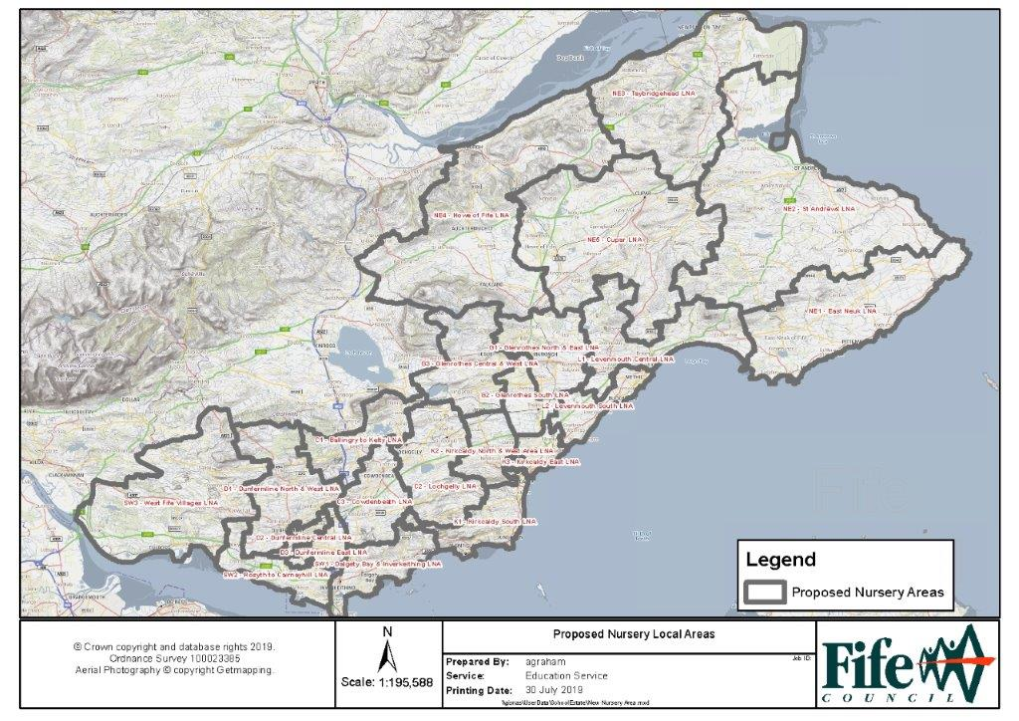

SW1 – Dalgety Bay and Inverkeithing

SW2 – Rosyth to Cairneyhill

SW3 – West Fife Villages

D1 – Dunfermline North and West

D2 – Dunfermline Central

D3 – Dunfermline East

C1 – Ballingry to Kelty

C2 – Lochgelly

C3 – Cowdenbeath

G1 – Glenrothes North and East

G2 – Glenrothes South

G3 – Glenrothes Central and West

K1 – Kirkcaldy South

K2 – Kirkcaldy North and West

K3 – Kirkcaldy East

L1 – Levenmouth Central

L2 – Levenmouth South

NE1 – East Neuk

NE2 – St Andrews

NE3 – Taybridgehead

NE4 – Howe of Fife

NE5 – Cupar

Confirmation of local nursery area can be found by entering individual postcode into the Nursery Local Area checker at [www.Fifedirect.org.uk\earlyyears](http://www.Fifedirect.org.uk\earlyyears)

**APPENDIX 2 - Fife Council Local Committee Areas**

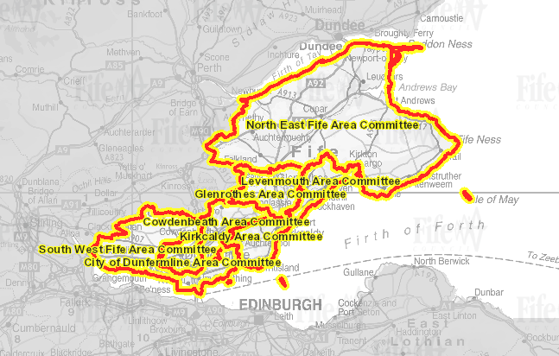

South and West Fife Area Committee

City of Dunfermline Area Committee

Cowdenbeath Area Committee

Glenrothes Area Committee

Kirkcaldy Area Committee

Levenmouth Area Committee

North East Fife Area Committee