**People & Communities Scrutiny Committee**

**Agenda Item No.**

|  |
| --- |
| COMMUNITIES & NEIGHBOURHOODS– ANNUAL SERVICE REVIEW REPORT 2023/2024 |
| **Report by:** Paul Vaughan, Head of Communities and Neighbourhoods |
| Wards Affected: N/A |

Purpose

To present an overview of the Service, detail the service planning, change and improvement work undertaken in 2023/24 and to provide an assessment of performance to inform scrutiny and future service planning.

Recommendation(s)

The scrutiny committee is asked to:

* consider and comment on the remodelled ‘annual service review’ report format and related products
* review the progress and performance of Communities and Neighbourhood Service for 2023/24 and the activity undertaken in 2024/25 to date
* note the Service planning objectives for 2024/25 and the three-year direction of travel

Resource Implications

There are no resource implications arising from this report.

Legal & Risk Implications

There are risks in not meeting Best Value requirements that can lead to additional monitoring/audit, external intervention and/or loss of public confidence.

Impact Assessment

An EqIA is not required as this report does not propose any changes to policies or services.

Consultation

Consultation is not required as the report does not propose a change to existing policies and practices.

## 1.0 Purpose of this report

* 1. This is the Communities and Neighbourhoods Services Annual Review for 2023-24. It looks back over the previous year and assesses how the service has performed in relation to its priorities and challenges and looks forward to the changes and improvements that need to be considered next and the Service’s priorities for the next 12 months.
  2. In the report you will find
* An overview of the Service’s roles and responsibilities.
* Budget and workforce information to put service delivery into context.
* The key priorities the Service has been working to and how these relate to the Plan for Fife and council reforms.
* An assessment of how the service has performed in relation to these priorities.
* Objectives and themes for service delivery, change, and/or improvement going forward.

This information is then used to inform annual service planning and the strategic direction of the service over the next three years.

* 1. This approach to annual review and reporting is part of the Council’s updated public performance reporting and scrutiny arrangements. More information on that and how the Council performs and compares with other local authorities can be found online here [www.fife.gov.uk/performance](http://www.fife.gov.uk/performance)
  2. Performance information and related case studies for Communities and Neighbourhoods Services will be available online <http://www.fife.gov.uk/performance>

## 2.0 Service Overview

### Key role and responsibilities 2023/24

2.1 The key role of the Communities & Neighbourhoods Service is to deliver:

* People and Place Leadership.
* Integrated community services.
* Community learning and development.
* Anti-poverty and local community planning.
* Projects and programmes and the development of community assets.
* Physical activity, sport, golf, culture, leisure, countryside and greenspace with the council’s Trusts and local communities.
* Area regeneration and development.

2.2 The service teams are allocated between the seven Area Teams and two Fife Wide teams.

2.3 The seven Area Teams cover the following functions:

* Community Learning & Development
* Community Management
* Local Community Planning
* Local Anti-Poverty

2.4 The Strategy and Commissioning Team covers

* Community Use (Halls, Centres and Community Use Schools)
* Lochore Meadows Country Park
* Community Development Support
* Active Communities (Physical Activity, Sports Development and Outdoor Education)
* Community Projects (Capital Projects, Parks Development, Allotments and Community Growing, and Access)
* Sponsor service for Fife Sport and Leisure Trust, Fife Culture Trust, Fife Golf Trust and Fife Coast and Countryside Trust

2.5 The second Fife-wide team covers Emergency Resilience and Events.

### Budget breakdown 2023/24

2.6 The Service had an annual budget of £62.068million. This included:

|  |  |  |  |
| --- | --- | --- | --- |
|  | **Net Expenditure by Business Area** | **Provisional Outturn** | **Variance** |
|  | **23/24** | **23/24** | **23/24** |
|  | **£m** | **£m** | **£m** |
| Communities & Neighbourhoods | 56.975 | 59.781 | 2.806 |
| **Total Net Expenditure** | **56.975** | **59.781** | **2.806** |
|  |  |  |  |
|  | **Gross Expenditure** | **Provisional Outturn** | **Variance** |
|  | **23/24** | **23/24** | **23/24** |
|  | **£m** | **£m** | **£m** |
| Employee Costs | 20.759 | 21.672 | 0.913 |
| Premises Related Expenditure | 7.296 | 8.879 | 1.584 |
| Transport Related Expenditure | 0.239 | 0.260 | 0.021 |
| Supplies and Services | 10.774 | 10.883 | 0.109 |
| Third Party Payments | 22.728 | 23.420 | 0.692 |
| Transfer Payments | 0.263 | 0.288 | 0.025 |
| Support Services Charges | 0.009 | 0.141 | 0.132 |
|  | **62.068** | **65.544** | **3.476** |
|  |  |  |  |
|  | **Gross Income** | **Provisional Outturn** | **Variance** |
|  | **23/24** | **23/24** | **23/24** |
|  | **£m** | **£m** | **£m** |
| Internal Income | -0.671 | -1.264 | -0.593 |
| External Income | -4.421 | -4.499 | -0.077 |
|  | **-5.093** | **-5.763** | **-0.670** |
|  |  |  |  |

### Workforce profile 2023/24

2.7 The service has 466.23 Full Time Equivalent Posts – employing 668 people in total. 47.5% of staff are part-time with 91.9% of permanent employees, 36.4% aged 55 and over and with 63.3% of the Service female.

#### Workforce

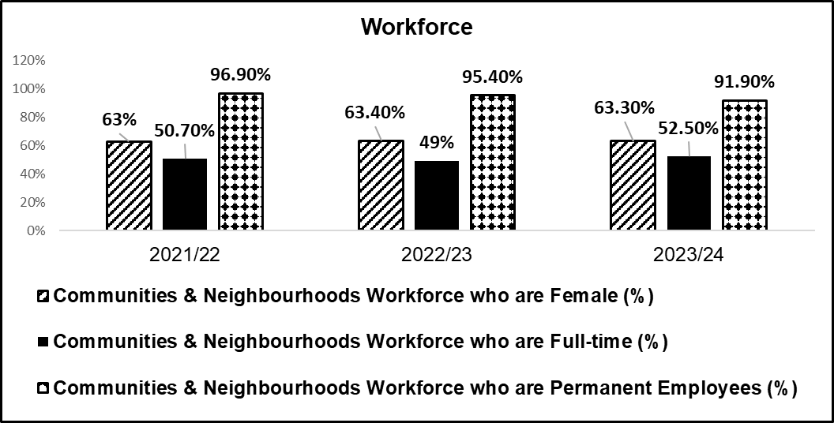

#### Employees age groups

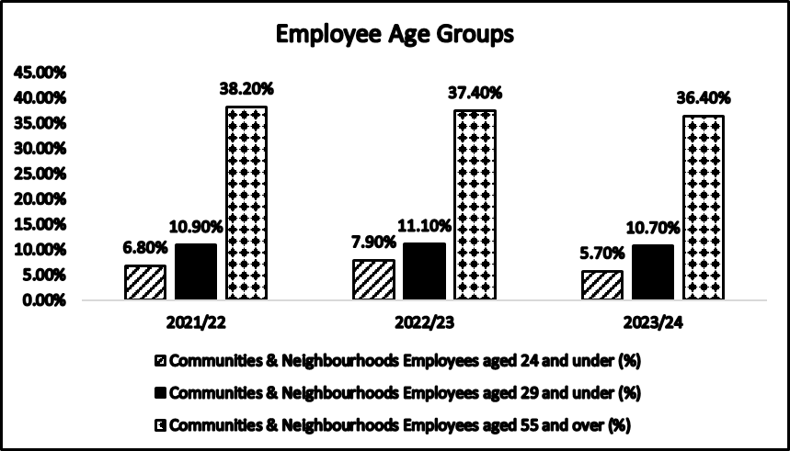

#### Working Days Lost (WDL) per FTE

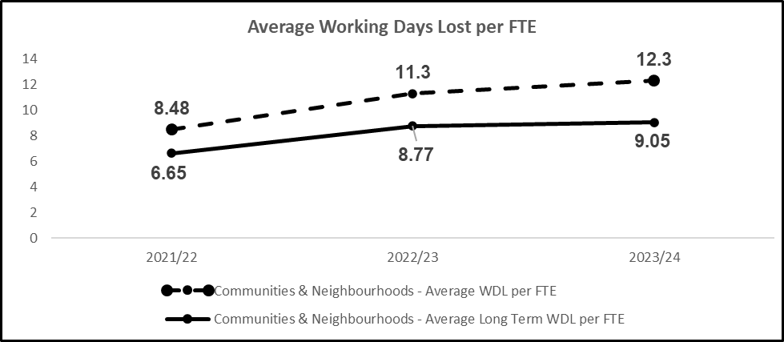

## 3.0 Priorities and Performance

### Service Priorities 2023/24

3.1 The service works to 5 strategic priorities:

* Reducing poverty through prevention and mitigation.
* Improving health and wellbeing through participation.
* Citizens improving the places where they live.
* Improving life chances for all through learning, personal development and active citizenship.
* Stronger, more resilient, supportive, influential communities.

**How we delivered**

|  |
| --- |
| Priority 1: Reducing Poverty through prevention and mitigation |

**What we said**

We would: deliver actions with partners tackling poverty and preventing crisis within communities.

**What we achieved**

* The development and use of a Low-Income Family Tracker (LIFT) to target resources and respond to change.
* Delivery projects supporting income maximisation.
* Providing welfare support through community job clubs.
* Supporting individuals across areas to tackle disadvantages from poverty.
* Supporting individuals and communities through the winter programme and Café Inc.

**How we know**

3.2 Targeted work around income maximisation to mitigate the impact of the benefit cap, has seen £1.3 million allocated directly to beneficiaries. Over 550 households have taken up their eligibility for pension credit of more than one million pounds. Seventeen households have increased the uptake of other allowances, including the attendance allowance, by £400,000.

3.3 In addition to the council delivery of the Scottish Welfare Fund, locally targeted approaches to support individuals are also delivered. In Northeast Fife (NEF), Fife Voluntary Action administer the NEF discretionary fund which can be goods, vouchers or cash into a bank account, which helps to prevent people moving into or further into poverty. The fund can be used for crisis intervention, small household appliances or essentials, clothing (including for interviews) and travel to and from work or volunteer placements. £11,308 was spent during 23/24.

3.4 Welfare Support Officers distributed 205 dayrider bus tickets and £4460 of shopping vouchers to ensure that those accessing Community Job Clubs can access food, household essentials, and travel to essential appointments.

3.5 2494 people have accessed welfare support via the welfare support assistant appointments and through the community job clubs. This is a small increase from the previous year. There is a decline in the number of people accessing welfare support via telephone contact. 2022/23 it remained high post COVID at 865 over 12 months but has reduced to 182 in 2023/24.

3.6 Following the review of the local concessionary travel scheme in NEF, Moffat and Williamson tickets are now included and more agencies have become involved this year expanding the reach of the scheme in the area to ensure those most in need can access free transport. The development of the work with the local health and social care partnership has resulted in increased promotion of the patient transport scheme.

3.7 The Winter Programme was supported with £5.3 million of funding. This was in addition to a £1.8million top up to the Scottish Welfare Fund. The support has been shared across fuel, food, and cash support, mostly accessed at the point of crisis (see below).

3.8 £200k of Community Recovery funding supported CARF to train and raise the capacity of staff and volunteers to give first level advice. This is helping to build the foundations for a No Wrong Door approach where people can get the early advice and support to avoid falling into crisis.

3.9 Welfare support assistants have built networks with key partner agencies and community groups across the 7 Areas providing early support and advice to people at risk of reaching crisis.

3.10 Café Inc in 2024 has served 171,601 meals. The changes agreed to delivery is allowing the project to stay on budget whilst ensuring our children, young people and their carers have access to a nutritional meal during holiday periods.

|  |  |  |  |  |  |  |
| --- | --- | --- | --- | --- | --- | --- |
|  | **2023** | | | **2024** | | |
| **Area** | **Easter** | **Summer** | **October** | **Easter** | **Summer** | **October** |
| Cowdenbeath | 19138 | 61544 | 19360 | 9131 | 26386 | 8040 |
| Dunfermline | 4488 | 11407 | 4100 | 2525 | 5745 | 1425 |
| Glenrothes | 4336 | 15231 | 5240 | 5615 | 17930 | 4710 |
| Kirkcaldy | 4855 | 18171 | 5830 | 4152 | 17512 | 4980 |
| Levenmouth | 6053 | 21787 | 6710 | 5091 | 20820 | 5650 |
| NEF | 1891 | 6920 | 2360 | 2259 | 7793 | 2310 |
| SWF | 5015 | 17422 | 3738 | 2743 | 13193 | 3531 |
| Fife | 45776 | 152482 | 47338 | 31516 | 109379 | 30646 |

Café Inc Comparison Data

3.11 Café Inc venues were a mixture of voluntary sector and Fife Council provision with slightly more voluntary sector providers on board in comparison to October 2023. There were 65 venues during the 7-week summer holiday period with 18 venues staffed by catering.

3.12 During the last two weeks of the summer holidays, families were given the opportunity to participate in a piece of research. This was done by including QR cards inside lunch bags and with Communities staff attending venues and engaging with families. The findings from 128 respondents included:

* 84 respondents were not eligible for free school meal payments but of those 38 were eligible for Universal Credit.
* 112 respondents were parent/carer(s).
* Without Cafe Inc 51 respondents would’ve made lunch for their children but skipped lunch themselves.

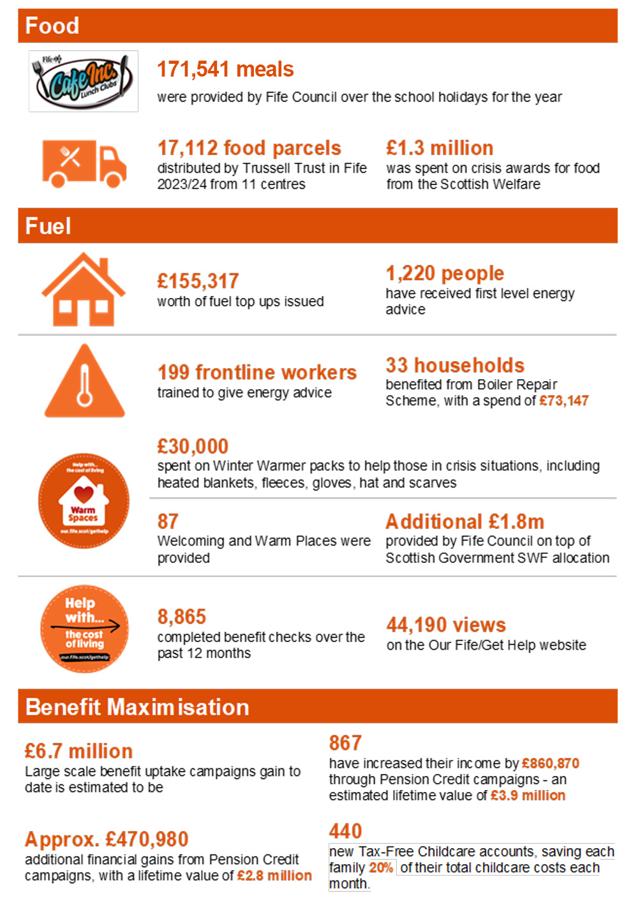

|  |
| --- |
| Priority 2: Citizens improving the places where they live |

**What we said**

We would:

* Deliver local community planning priorities and finalising local community plans in areas including the City Plan for Dunfermline.
* Deliver changes to decentralisation across the council and partners.
* Promoting and supporting multi-disciplinary working across local community planning partners.
* Managing the delivery of new community buildings, community building refurbishment, play parks, and nature restoration projects.

**What we achieved**

* Approval of Local Community Plans across Fife.
* Introduction of new reporting arrangements to area committees.
* Delivered projects including indoor, outdoor and green infrastructure projects for new builds, refurbishment or enhancements to existing facilities or outdoor space.

**How we know**

3.1040 allotment sites accommodate over 1450 plot holders. Waiting lists to access plots have exceeded 2360. ( info as per July / Aug 24). New allotment sites developed during 2023/24 included St Monans, Smeaton (Kirkcaldy) and Spittlefield (Inverkeithing).

3.11 A successful grant scheme was developed to provide local support for existing and new growing projects. 21 community groups benefited from the scheme delivering training, solar panels used for tool charging, security, fencing, irrigation, water butts, composting units, sheds, purchase of horticultural sundries, fruit trees and seeds.

3.12 Over £0.660m of the 2023/24 Scottish Government Nature Recovery Fund (NRF) has been distributed to various biodiversity enhancement projects across Fife and has included specialist equipment for Grounds Maintenance and FCCT to enhance grasslands across Fife as well as enabling the early stages of the Fife Climate Forest. Other projects have included the replacement of the Earlshall Muir boardwalk and a wetland habitat creation initiative has also been built into the allotment expansion in Crossford.

3.13 With additional funding from Scottish Government of £0.681m and supporting community funding the team have delivered a range of Play Park projects in 2023/24 at a value of £2.310m.

3.14 To date Fife Council has secured £3.600 m funding SEPA water environment fund (WEF) including:

* £1.500 m Lynburn River phase 3 was completed in 2023/24 which has improved river restoration works and greenspace improvements
* The River Leven Restoration Project phase 1 completed in 2023/24 with funding from SEPA of £0.607m. Phase 2 with a value of £1.663m has commenced.
* Backburn River project funding was secured with £0.850m SEPA funding, £0.200m Nature Restoration funding and £0.100m from Glenrothes area committee

3.15 The service is engaged in delivery of over 140 capital projects. Key updates over 23/24 include:

* Adam Smith Theatre refurbishment & enhancement project was completed in 2023 at a cost of £8.000m.
* Abbeyview Community Hub project opened September 2024 at a cost of £7.500m.
* Templehall Community Hub project budget was agreed and secured at a value of £15.300m and since then project has moved to detailed design stage with expected start date in 2025.
* East Sands Leisure Centre project - finalisation of the feasibility has been developed with several options including options for redesign through a new build option/PassivHaus build.
* Carnegie Hall (Dunfermline) - Detailed feasibility commissioned with the need for significant investment to upgrade the facility to the similar standard to the completion of the Adam Smith Theatre project.
* Glenrothes Golf Depot - Designs and options finalised with an estimated cost of £0.900m with expected start date early 2025.
* Lochore Meadows Destination Play Park was delivered in 2023/24 at a cost of £1m.

3.16 Across each of the areas of Fife Local place projects are included in Local Community Plans for example Dalgety Community Trust (see case study in Appendix).

3.17 In Glenrothes, Riverside Park secured almost £5 million investment from the UK Government’s Levelling Up Fund to restore the quality of, to rejuvenate and to provide more opportunities for family and community activity.

3.18 The Cowdenbeath area will see investment from the UK Shared Prosperity Fund 2022-25 investment plan. Community projects approved to date include Auchterderran Church Hall, Lochgelly Brass Band, Lochore Meadows Climate Biodiversity project, Brucefield allotment project, the Knights Templar Community Orchard and Biodiversity project and The Clearing. All these approved projects will contribute towards Fife’s net zero targets and targets for reduction in carbon dioxide equivalent (carbon) emissions.

3.19 Two projects benefitted from UK Shared Prosperity Fund awards in North East Fife during 23/24. Friends of Craigtoun were awarded £17,000 to purchase an electric vehicle and the Larrick Centre in Tayport were awarded £20,000 to install solar panels.

3.20 In 2023/34 lease arrangements were instigated for two large park areas in Leven, and a hall in Methil, to become community run facilities.

3.21 In Kirkcaldy development of the Town Centre and Waterfront has included:

* Installation of a Sun Dial the end of the waterfront to tell the story of Sir Sandford Fleming
* Completion of Volunteers Green in 2024
* Replacement of Bins across the Town.
* The installation of public art at the newly regenerated waterfront, the 'heart of Kirkcaldy’ provides a focal point for the town.
* Celebration of the 60th anniversary of the twinning arrangements with Ingolstadt.
* Celebration of the Adam Smith Tercentenary.
* A Memorial to mark the Seafield Disaster took place near Seafield beach.

3.22 A Dunfermline Strategic Tourism Evaluation report was launched in October 2023 and from this a Tourism Action Plan has been developed.

|  |
| --- |
| Priority 3: Improved health and wellbeing through participation |

**What we said**

We would:

* Deliver the Physical Activity and Sport Strategy and engage in the development of a Cultural Strategy for Fife.
* Manage community facilities and support the return of usage post pandemic

**What we achieved**

* Increased attendances at Community Use
* Delivery of Fife’s Cultural Summit in May 2024
* Increasing participation in Active Fife projects

**How we know**

3.23 Community Use Attendances have increased with a new plan developed[CU_Plan_final_2023-26.pdf (fife.scot)](https://active.fife.scot/__data/assets/pdf_file/0025/454264/CU_Plan_final_2023-26.pdf)

|  |  |  |  |
| --- | --- | --- | --- |
|  | Schools | Halls & Centres | Total |
| 21/22 | 537018 | 517039 | 1,054,057 |
| 22/23 | 812680 | 669749 | 1,482,429 |
| 23/24 | 825950 | 807098 | 1,633,048 |

* 48,800 attendances in our swimming pools (CU Schools).
* 417,052 attendances at our indoor sport and physical activities (CU Schools).
* 366,775 attendances at our outdoor sport and physical activities (CU Schools).

3.24 Community Use delivered

* 59 new social opportunities in partnership with community events or interactions that involve engaging with other people, typically in a leisurely and informal context.
* 12 new Advisory Groups were established to encourage ownership and shape programmes
* Developed a standardised start-up scheme to help new clubs and groups become sustainable.
* 22 more community venues now have public access Wi-Fi.
* Reviewed and refreshed marketing material leading to over 10,500 followers on social media platforms.
* Supporting over 27,500 partnership lets which equals a £650,000 investment in local communities.
* Supporting weekly bookings on behalf of Grounds Maintenance for 65 clubs, 161 teams, across 45 pitches for a variety of sports and activities.
* Providing 25 new volunteering opportunities to develop and enhance the skills, knowledge, experience and wellbeing of all participants.

3.25 For one week in November 2023, Community Use asked our customers - *How likely are you to recommend us to a friend or colleague?* We used the responses to calculate our Net Promoter Score (NPS). Top companies generally have an NPS of 70 and above. We are delighted to say, that from 1125 responses received across the Kingdom, Community Use Fife received a Net Promoter Score of **78**.

3.26 The below data highlights some of the key performance indicators set against Physical Activity & Sport over the past 3 years:

|  |  |  |  |
| --- | --- | --- | --- |
|  | 2021-22 | 2022-23 | 2023-24 |
| Total participation in Active Communities programmes | 54,408 | 40,904 | 169,033 |
| Total number of Active Communities classes / sessions | 3,565 | 3,569 | 8,302 |
| Female participation in Physical Activity | 22,408 | 26,259 | 67,104 |
| Older Adult Participation in Physical Activity | 11,793 | 11,797 | 7,949 |
| Participation from SIMD postcodes in Physical Activity | 3,230 | 3,231 | 3,339 |

3.27 The general trajectory during the above period has seen an increase in physical activity and sport participation across Fife post-COVID, with a significant increase in female participation and a steady increase in participation from SIMD 1-3 areas. Our early data for 2024-25 indicates we continue along this trajectory with a more deliberate approach to reach the least active in our communities.

3.28 Bums Off Seats (a walking initiative targeted mostly at older adults) illustrate this growth since 2020 by engaging people who are most vulnerable to poor health associated with ageing and residing in areas SIMD1-3.

|  |  |  |  |  |  |
| --- | --- | --- | --- | --- | --- |
| **Year** | **New participants** | **Total number of walks** | **SIMD1** | **SIMD2** | **SIMD3** |
| 2020 | 195 | 280 | 30 | 124 | 124 |
| 2021 | 255 | 448 | 88 | 344 | 344 |
| 2022 | 232 | 629 | 202 | 556 | 556 |
| 2023 | 283 | 670 | 247 | 587 | 587 |

|  |  |  |  |  |  |  |  |  |  |
| --- | --- | --- | --- | --- | --- | --- | --- | --- | --- |
| **Year** | **Diabetes** | **Heart Disease** | **Mental Ill Health** | **Overweight** | **COPD** | **High Blood Pressure** | **Cancer** | **Dementia** | **Other** |
| 2020 | 15 (7%) | 11 (5%) | 2 (1%) | 8 (4%) | 6 (3%) | 47 (24%) | 7 (3%) | 2 (1%) | 29 (14%) |
| 2021 | 13 (5%) | 11 (4%) | 22 (8%) | 16 (6%) | 5 (1%) | 36 (14%) | 4 (1%) | 3 (1%) | 31 (12%) |
| 2022 | 10 (4%) | 13 (5%) | 28 (12%) | 20 (8%) | 4 (1%) | 35 (15%) | 0 | 1 (0%) | 35 (15%) |
| 2023 | 13 (4%) | 7 (2%) | 23 (8%) | 21 (7%) | 1 (0%) | 39 (13%) | 3 (1%) | 1 (0%) | 50 (17%) |

3.29 Since September 2023, the Outdoor Education Fife team have been aligned to the management and leadership of Active Communities, and over the course of the last six months of 2023-24, Outdoor Education Fife registered a total participation of 1,300, which is reflective of the low season. During the first quarter of 2024 alone, the centre has registered a total participation of 4,539 which has been reflective of the start to a busy high season that demonstrates the potential contribution of the centre to Lochore Meadows Country Park’s as a key destination.

|  |
| --- |
| Priority 4: Improving life chances for all through learning, personal development and active citizenship |

**What we said**

We would:

* Deliver local community learning and development (CLD) activity in line with local CLD plans supporting more participation and engagement in delivering with local communities.

**What we achieved**

* Data gathered over the last two years shows increasing trends across the majority of national CLD key performance indicators. Participation and engagement with CLD services is almost similar to pre-pandemic levels across Fife.
* Refreshing our ESOL Partnership with Fife College.
* Targeted community capacity building (CCB) activities are supporting community led development and voluntary organisations
* Delivery of Employability and lifelong learning opportunities.

**How we know**

3.30 A recent progress visit by HMIe (December 2023) highlighted some particular strengths of across CLD activity in Fife **HMIe Report -** [Fife Council Community Learning and Development Progress Visit Report 13/02/24 (education.gov.scot)](https://education.gov.scot/media/2pobetrk/cld-fife-council-pv-130224.pdf)

3.31 Implementation of revised CLD performance metrics:

3.32 The Employability Access Support for Young People is a Fife wide employability pathway for young people aged 16-19 years who meet a ‘no one left behind’ criteria. A case study of the approach in South and West Fife is included in the appendix.

3.33 Rural Skills Scotland (RSS) are a not-for-profit learning provider directly delivering Apprenticeships and SVQ’s across Scotland. Working with the service we saw the re-use of a long-derelict Council Parks Service Nursery in Kirkcaldy as an employment and training hub for green jobs, primarily in the land-based sector. RSS, in September 2022, secured a 20-year lease on the site from Fife Council. The RSS national Apprenticeship programme will be based there, as will it’s contracting business and employability programme. RSS and Fife Council were then successful in attracting an additional £491,582 from the Scottish Government’s Vacant and Derelict Land Innovation Programme. Significant work to clear and prepare the sight has taken place.

3.34 Employability programmes have been running at Lochore Meadows Country Park over the last 18 months. Working with Fife Council’s Employability Team, Outdoor Education Fife, Rural Skills Scotland and Fife Coast & Countryside Trust over 22 participants have successfully completed programmes with most going on to further training opportunities or employment.

3.35 Various courses have been developed in collaboration with community partners to empower residents in Glenrothes. Notably, the “Lifeskills” course adopts an asset-based approach, helping participants build on their existing capabilities. The course focuses on practical skills that can reduce living costs while increasing participants' abilities to manage their daily lives more effectively. Collaborating partners in this initiative included Castle Furniture, YMCA, Men's Shed, Auchmuty & Dovecot Tenants and Residents Association, the CLD team, Leslie Community Pantry, and Fife Voluntary Action. As a result of these efforts, one participant secured employment by being linked to Community Use, where they were offered a casual contract to deliver sewing classes. Additionally, six individuals have signed up for a follow-up “PAT Testing” course.

|  |
| --- |
| Priority 5: Stronger, more resilient, supportive, influential communities |

**What we said**

We would:

* Promote People and Place Leadership in the areas through facilitating multi-disciplinary action and developing the decentralisation of services.

**What we achieved**

* Promoting and supporting participation and engagement, community leadership, and volunteer roles
* Responding to emergency situations within Fife
* Supporting the delivery of events
* Promoting local action and decision-making

**How we know**

3.36 The Emergency Resilience Team was involved in the response to 38 incidents during this period. The majority of these were minor incidents but there were two notable incidents, one a fire and the other flooding, that had a large impact on the affected residents resulting in evacuation and both temporary and alternative permanent housing accommodation being provided. Working with the emergency services, the Council supported those impacted.

3.37 Lessons identified from all incidents have been captured and improvements are being made to existing resilience plans and arrangements.

3.38 Staff from across all service areas participated in either internal and/or external training and exercises throughout the year to raise awareness of their role and gain experience in responding to incidents. In recognition of the increasing risk of cyber-attacks, two Council-wide resilience workshops were held during 2023 to develop the Council’s plans and arrangements in response to a potential cyber-attack. A plan has now been drafted and awareness increased across the Council on any potential impacts on services.

3.39 Approximately 480 events were held across Fife during 2023/24, an increase of over 100 events since 2022/23. The majority of these were community events organised by local community groups such as galas, funfairs, sporting events and parades such as remembrance, with the Events Team providing support and guidance where needed.

3.40 August 2023 saw Fife being part of the UCI World Cycling Championships with the Men’s Elite Road race route coming into Fife giving the opportunity for areas of Fife to be televised across the world. The Council’s events management process continues to be developed to support event organisers throughout the event planning process.

3.41 Participatory Budgeting continues to be an important feature in the delivery of community engagement. Across Fife Area strategic assessments highlighted that there is a need to better connect with people to have more of a sense of influence and control. In Kirkcaldy, an allocation of £300,000 allowed partners to develop a robust framework to distribute this money including opportunities to engage local communities across the Kirkcaldy Area in dialogue, discussion and deliberation leading to a direct influence on the spend. The planning to deliver Participatory Budgeting across the Kirkcaldy area is shaping up.

3.42 Alongside colleagues in Glenrothes, Team members benefitted from support from DEMOTEC a European Consultancy specialising in initiatives which engage citizens in decision-making. A citizen led steering group has been formed to ensure that the design and delivery of the programme is shaped and influenced using a bottom-up approach. Priorities will reflect those of the Local Community Plan.

3.43 The use of Local Community Planning Funding also supports local community groups. Four groups including St Andrews, Crail, Auchtermuchty and Cupar have been supported with funding from the local community planning budget to support community engagement with local place plans. Fife Council Communities and Neighbourhoods staff have supported the engagement of young people's voices in the Auchtermuchty and Strathmiglo Place Plan and the Cupar Place Plan.

3.44 Fife Council Communities and Neighbourhoods Service staff are also supporting residents in Aberdour and Blairhall to create Neighbourhood/Community Action Plans. The development of a Blairhall Community Action Plan was highlighted by residents after hearing about the success of the North Queensferry Action plan. In Blairhall, a group of six residents formed the nucleus of a steering group and decided to create a 3 Wishes postcard. This postcard, distributed to households, formed part of a community consultation and allowed residents the opportunity to highlight what they wished for in the village. Post boxes were placed in the community centre and the local primary school, and a QR code was included on the postcard, which gave the residents the chance to complete their wishes online. 118 responses were received.

3.45 The findings highlighted that the main area of focus is around play and recreation in the village, along with facilities and maintenance. The forum has met on 4 occasions and continue to work on developing community engagement methods to fully develop an action plan for the village. The work is also supported by Coalfields Regeneration Trust and the Headteacher from the primary school. The next phase is a wider community consultation.

3.46 Neighbourhood Development Plans in Kirkcaldy Area are being delivered with key target neighbourhoods for over 8 years. There have been 2 dedicated posts covering 4 of the most disadvantaged and disengaged areas.

**4.0 Priorities ahead**

4.1 The priorities for the coming years remain around the five strategic priorities. Specific actions being developed are:

4.2 **No Wrong Door** – increasing focus on community capacity building and participation, more preventative, dignified action on poverty, less emergency reactive mitigation, promoting opportunities for lifelong-learning, employability, family and individual development.

4.3 **Community Facilities** –Working with services, communities and partners, consolidate through sharing and rationalising to improve community venues.

4.4 **Decentralisation** –Increasing local decision making and helping to plan and deliver local responsive services.

4.5 **Physical Activity and Sport** –promoting integrated health and wellbeing opportunities.

4.6 **Culture and wellbeing** –supporting increased wellbeing, lifelong learning, community wealth building and participation.

4.7 **Outdoors and Nature** –addressing climate change and promoting sustainable outdoor space for leisure and recreation.

4.8 **Improving efficiency, effectiveness and digitally enabled services**. Including updating our performance management approaches with the corporate performance team and working on refreshing our quality framework.

**Report contacts**

Paul Vaughan, Head of Communities and Neighbourhoods

**Appendix - Case Studies**

**South & West Fife Financial Inclusion Case Study**

In early April 2023, Kingdom Community Bank (KCB) successfully recruited a Financial Development and Education Outreach Officer to be based solely in South and West Fife having received Community Recovery funding of £40,704. This project was jointly developed with KCB and Fife Council C&N Services Anti-Poverty & CWB Project Manager.

KCB track sign-ups by postcode and thus monitor those signing up in South and West Fife; they also look at the membership sign-up trend over time. Prior to this project, they saw an average of 30 new members from S&WF each year from 2021 to 2023. This is around 5% of the new member applications received in Fife for each of those years. The number of new members in S&WF increased by over 300% during this first year of funded activity and represented just over 15% of the new members across Fife in the same period.

The initial focus of the project was to work with community food providers and parent and toddlers’ groups in the area. The pantries and community cafés in S&WF attract high numbers of local people and fulfil a crucial role in offering affordable, locally sourced food. While they are all open to everyone, it is acknowledged that many people on low incomes benefit from the food on offer, as well as the social contact from attending.

KCB worked with five pantries in the local area to encourage their members to join their local credit union and start saving. The expectation was to help people with limited financial resources to begin their savings journey at a modest level and try to develop the habit of saving. Through this work, KCB secured 107 participants and invested just under £3,500 in saving incentives (matching the pantry charge for an initial 12 week period to ensure they were not directly out-of-pocket to start with). The incentive scheme was funded through the South and West Fife Poverty Action Group budget. At the time of writing, these members have saved just under £3,500 of their own money, almost exactly matching the subsidy level. A significant achievement with a demographic who may not have found it very easy to save at this time.

The ‘Find-a-Fiver’ savings challenge was targeted at local parents and toddlers’ groups, as a pilot, to encourage small scale savings through the local credit union. This was designed to develop a savings habit, make people feel better that they had some savings and give them a gateway to save more and borrow at an affordable cost should they need to. This project was piloted in Valleyfield and Saline and was successful in securing savings that outstripped the subsidised contribution. The pilot saw nine members join, receive a total savings contribution of £500 and then go on to save £800 of their own monies.

**Levenmouth Anti-Poverty Case Studies**

Several anti-poverty initiatives have been supported in the Levenmouth area over the past year. The general focus has been to start the move away from crisis interventions towards establishing support mechanisms that move individuals and families on to a more sustainable footing. The overall objective is to create a cash first framework to support local people in a dignified way. Examples of the approaches taken towards this goal are noted below:

**Plus Partnership** – In partnership with Furniture Plus this initiative employs one full time welfare support assistant embedded with Furniture Plus. The approach provides ongoing case management and community-based welfare support to people in Levenmouth who are identified as being in material deprivation. Over a period of 10 months since its inception, 165 referrals have been made to the project. In total over £86,000 of financial gains or savings have been secured for those referred.

**Levenmouth Independence Initiative** – In partnership with Castle Furniture local people can receive support for the purchase of furniture, white goods, and other household items through the issue of a voucher. This allows the client to directly purchase the items they want and that best meets their needs from the Castle Furniture stock. We have made provision for up to 60 households to benefit from this approach with an average package of assistance being in the region of £450. It is also important to note that most items distributed to households will be reused and reconditioned, which supports the areas stated aims on progressing activity that has a positive impact on climate change concerns.

**Justice Social Work – Welfare Support Worker –** Working with colleagues in Justice Social Work (JSW) the identification of concerns relating to the families of offender's was highlighted at the Welfare Reform and Anti-Poverty and Levenmouth People meetings. The need to provide guidance, information and practical interventions for people being liberated from custodial sentences was highlighted as key in promoting resilience. The choice was made to install a support worker within the JSW team to work alongside colleagues who had already built trust with the clients. A typical caseload for JSW shows a third of all clients have dependent children who are negatively affected by issues related to the benefits system. Accordingly, this type of targeted support is key to preventing financial harm to both to the individual client and those connected to them. In terms of sustainability the support worker also provides ongoing training to JSW colleagues to ensure their understanding of the benefits system is robust and up to date.

**Handy Person Service**

As part of the Housing Plus Programme, market testing was undertaken to explore demand for a handy person service in Fife. An online survey was the chosen methodology for respondents to share their views anonymously. The survey link was shared with staff, partner organisations, and service users via email, word of mouth, and social media and everyone was encouraged to participate and share. The survey ran for six weeks with 232 responses. A variety of age groups, from different tenure types, responded to the survey from age 16 – 85+. This displays the necessity for an inclusive service for all age demographics and all tenure types.

Findings identified a clear need and want for a handy person service with the majority of people responding stating they would use this service. Different services, residents and tenants have also promoted the need for this type of trusted, reliable, accessible, and affordable service.

The Handy Person Service will be delivered by The Community Trade Hub who have years of experience with key objectives and goals linking with education, training and youth development. They are a not-for-profit organisation with links to several areas in Fife. This test of change will provide an opportunity for school pupils, leavers and volunteers, in the Kirkcaldy area, to work with the Community Trade Hub delivering the Handy Person Service. This will include training in practical trade skills, customer care skills, real life working experience, and the development of a personal development plan/portfolio for each individual.

**Dalgety Bay Community Trust**

At the South and West Fife Area Committee on 25 January 2023, members approved £30,000 of Community Recovery funding for Dalgety Community Trust to conduct a comprehensive feasibility study in relation to the creation of a new Community Hub in the heart of Dalgety Bay.

Dalgety Community Trust (DCT) stated that this initial phase of the project would include:

* Understanding and interpreting the community’s requirements in the context of a new community hub.
* Developing a project brief including considering the project budget.
* Helping to refine the initial business case for the new community hub.
* Producing initial architectural concepts.
* Undertaking and participating in community engagement around the architectural concepts with the local community and with other key stakeholders.

Dalgety Community Trust have made significant progress with this initial phase of the project and, in most instances, concluded the required work.

Since March 2023, the Trust have spent 11 months preparing a full feasibility study for the new hub, including developing architectural concepts, a comprehensive business plan and conducting further engagement work with the local community. Working with Community Enterprise Scotland, and Lee Boyd Architects, DCT have gained valuable insights into the potential design and viability of the community hub in Dalgety Bay. This work has produced a Feasibility report, comprising:

* Architectural design concepts for new hub
* Cost estimate prepared by professional quantity surveyor
* Environmental Strategy
* Structural Engineering report
* Landscaping design
* Business Plan including the project brief.
* Community engagement research report prepared by Community Enterprise

‘Community Enterprise’ conducted a comprehensive community-wide survey, receiving responses from 255 individuals. In addition, DCT reached out to a wide range of individuals representing various organisations including Dalgety Parish Church, Primary Schools and local businesses. Through the survey results ‘Community Enterprise’ confirmed strong support for development of the new hub, with 92% expressing favourable views. Only 4% remained unsure and another 4% were not in favour.

Based on the consultation and community engagement and the continued discussions, the community have stated that they want a multi-purpose community space, café, local produce outlet, wellbeing activities space, enterprise, learning zone, events and heritage space.

Fife Council has committed to support the project with a further allocation of £2m of funding. The Community Manager is working closely with and supporting Dalgety Community Trust with their aspirations and delivery of this project.

**Glenwood Housing and Community Hub Development:**

Extensive member and public consultation began with the Glenwood Neighbourhood Charrette in 2016-17, covering the Glenwood Shopping Centre and flats. The redevelopment of this site was widely supported and confirmed that a Community Hub should be provided as part of the overall site development.

Following the CPO process by the Council, a Steering Group and Design Team was established in April/May 2023 to start discussing housing options for the redevelopment of the Glenwood Centre site. This partnership is led by Housing Services and Kingdom Housing Association and includes Communities and Neighbourhoods as a key partner in the ongoing community engagement and consultation required to progress Housing, Community Hub and Community Space designs.

The regeneration of the former Glenwood Centre site will bring new housing, social and economic opportunities for the area. The design and outline plan for Glenwood is directly linked back to the “Golden Glenrothes” Charrette completed in 2017, when the local community were involved in informing the Charrette outcomes.

A substantial programme of community engagement and consultation commenced in December 2023, concluding in February this year. Led by Communities & Neighbourhoods, in partnership with Housing Services, this involved several community events held at local schools and church spaces, online promotion and consultation, paper surveys and information posted to households in the area and publicised in local spaces. The Housing, Hub and Community Space design and layout has since developed in response to aspects of the findings from this exercise.

This redevelopment has provided an opportunity for Communities and Neighbourhood Services to initiate new local interest in the co-production of a joint Macedonia Neighbourhood and Housing Plan.

**Kirkcaldy**

**Choice First:**

Building on the success of a choice first pilot partnership initiative with Greener Kirkcaldy and Kirkcaldy Foodbank led by the area FC Anti-Poverty Manager in 2022 the initiative was further developed. The evidence and learning generated from this partnership pilot highlighted how vouchers alongside support packages can make an immediate difference to a person’s financial situation. This has led to a Fife wide SG application to test out other cash/choice first approaches.

**Winter and Spring Boost:**

Working alongside the Foodbank is not a new way of working for the FC Welfare Team. However, with the addition of 2 new Welfare staff (funded through CRF) the team were able to increase their reach and test out different ways of working in a more intensive way. Feedback from participants and foodbank volunteers have stated that this was a highly successful approach as people accessing the foodbank were supported by experienced staff who checked their entitlement to means based benefits often resulting in maximising their income. The data reinforced this and highlighted that having a wider range of support on site can enable a wider range of support to be accessed to help situations escalating. A Spring boost was then delivered and the Welfare Support team are also now able to offer outreach at local help hub settings, Nourish, Philp Hall, Cornerstone Café Burntisland and Gallatown Hub. Additionally, the team have increased capacity to deliver support to clients at the KY2 club, the Well and at Foodbank distribution points on a regular basis.

**Fundraiser @ Foodbank**

Rather than give an allocation of funds (from area CRF) for food a contribution was allocated to get a fundraiser to support the volunteers and trustees to raise the profile of the organisation as well as raise much needed funds. Early indications are this is a much more sustainable investment.

**North East Fife**

**"Warm Welcome" Venues**

Venues have continued to operate throughout the year, providing support beyond the winter months. Partner agencies, alongside the Welfare Support and CLD teams, regularly visit these venues to ensure attendees are aware of the available local resources, including food and fuel support.

Thirteen venues were allocated funding totalling £47k to support Warm Welcome, providing warm spaces where refreshments, food and activities are provided. Groups also carried out preventative work during these sessions, signposting to Welfare and cost of living support and agencies such as Cosy Kingdom. The Cosy Café based at the East Neuk Centre in Anstruther started in October 2022 as a community-based adult learning group and East Neuk Centre community project with Fife Council’s Warm Spaces Funding. After its initial success, further funding was awarded through Warm Welcome to support long term self-sustainability of the project in partnership with the East Neuk Centre Trust. 5 volunteers now work at the project. 2 volunteers have gained their food hygiene certificates. Each week, staff and volunteers meet and cook from scratch around 50 2 course hot meals for their community. Around 20 people attend the Cosy Café, with remaining hot meals portioned up and put into the Community Fridge for the community to benefit from. Some of the meals are also set aside for the St Monans based ‘Oor Space’ group who provide mental health and addiction support. Approximately 50% of the attendees have been going regularly for over 6 months, with many attending to make new friends and get to know other people.

Warmer Items (112 electric throws, 112 hoodies, 50 warm packs) were allocated through local ‘People Group’ partners. A need was also highlighted by Link Living who were supporting Afghan refugees in Leuchars for more warm items due to the change in environment and fear of excessive fuel bills. 2 of each item were allocated to each household.

**South & West Fife EASYP**

EASYP 16+ Employability programme and Next Steps 16-18yrs Employability programme will continue to provide accredited courses in general life skills, including financial resilience, health and wellbeing and capacity resilience. EASYP is a Scottish govt funded programme for 52 weeks 16hrs per across the 7 areas.

EASYP contributes to Fife’s Opportunities for All commitment to engage with young people at risk of not achieving a positive outcome and supporting them to progress to further learning, training and employability opportunities.

EASYP helps young people engage on a progressive journey that suits their circumstances and goals for the future. EASYP staff support young people to cope with personal, family, financial and health challenges that may be holding them back from taking part in training, employability programmes, work placements or paid work. Depending on the young person’s situation, in certain circumstances the programme can provide funding to pay for clothing etc, resources and other provisions that improve their ability to achieve their potential.

During 2023 – 2024, 24 individual clients were engaged on the S&WF EASYP programme. Most of the young people are key worked by Communities and Neighbourhoods Service staff to sustain their engagement within the programme. Fife Employability Access Trust (FEAT) also support young people within the programme to enable and support individuals to reach their full positive mental wellbeing in a culture where there is no stigma.

Qualification/Certificate Number of young people

ICT Level 4 6

Employability Level 4 4

Literacy Level 4 5

Numeracy Level 4 5

Youth Achievement Bronze Award 5

7 Habits of Effective Teens 9

On Thursday 22nd August in Camdean Youth Facility, Rosyth, a celebration of Achievement was held for young people aged 16-22yrs who attend Youth Employability courses (EASYP & Next Steps) in the South and West Area.

23 young people collected 14 different SQA awards totalling an amazing 69 individual accreditations, ranging in level 4 and 5. Subjects as varied as Youth achievement awards; Adult achievement awards, Introduction to Customer Care, Introduction to Tourism Communication and numeracy.

Over the year they also completed personal development courses such as 6 Pillars of Self Esteem, 7 Habits of Effective Teens, First Aid and Health in the Communities (HICCS).

All learners have moved on to their next destination in either work or further education.

**South & West Fife Community Assistance Hubs**

Approximately 18 months after the creation of the ‘Community Assistance Hub’ model in S&WF, there is considerable progress to note. Working collaboratively, there is now an increased awareness and usage of the four hubs in the area (Inverkeithing Civic Centre, Parkgate Community Centre, Oakley Community Centre and High Valleyfield Community Centre).

Welfare Support Assistants (WSAs) have been redeployed to work within the designated area covered by each of the four community hubs. It is proving to be more beneficial to the areas served and gives the WSA a more directed role within their area. The WSAs are in the process of developing stronger links within each community with key services and third sector organisations. Staff are also working with Community Education Workers to develop additional provision within each of the local hubs.

Through the Hubs, the Welfare Support Assistants have supported local people to access a range of services and advice. As the Community Assistance Hubs model has evolved and developed, there is now input from: Kingdom Community Bank, Fife Law Centre, Social Security Scotland, The Well, Christians Against Poverty, Fife Sports and Leisure Trust, Citizens Advice and Rights Fife, Fife Voluntary Action and key Fife Council services including Housing, Children and Families/Adult Services Social Work. As this ‘wraparound’ support model is further developed, the number of people accessing these hubs continues to increase.

Community Assistant Hub Open Days - 4 Open Day events were organised in November 2023 which highlighted and promoted S&WF’s Community Assistance Hubs. These events were aimed at increasing people’s awareness that their local community centres (CAH) are available as safe places not only to get warm but also a place to socialise, meet people and be informed of the support available to them should they need it.

The aim of the Open Days was to promote local provision for people who may need additional, extra support and assistance with food and fuel poverty, mental wellbeing, benefit advice as well as providing access to local learning opportunities. Activities and hot food were also available at the events.

A dedicated South and West Fife ‘The Well’ Link Worker was appointed in mid-December, funded from the South and West Fife area anti-poverty budget. The Link Worker post is for one year and they will work closely with Welfare Support Assistants, Community Workers and other partners to further develop The Well model. As well as increasing footfall, referrals to and awareness of the Wells/Community Hubs, they will share learning and knowledge about resources within the local area.

‘The Well’ is a light touch service where people can drop-in, both in their community and online and find out information and receive general advice to help people stay well and independent within their local community. People can drop-in to a Well or they can also be referred by professionals, family, friends and carers.

Although not specifically targeted at older people, the data from drop-ins and enquiries shows that more older people have benefited from the support of their local Well in the past year. The top three enquiries for The Well in SWF in this period were community support, mental health, financial support with many individuals receiving information for more than one area after speaking to The Well staff.

**Welfare Roadshow**

Through the Cowdenbeath Area Poverty Action Group, partners came together to deliver a Welfare Roadshow providing advice, support and signposting across a number of themes including benefit maximisation, citizens’ rights, wellbeing, physical and social inclusion. This was delivered across seven communities within the Cowdenbeath Committee Area, helping ensure it was an accessible event for all.

**Community Food**

The Cowdenbeath Team supported development and capacity building with Community Food providers across the area to support the delivery of sustainable, dignified and joined up food support services which meet local needs. This has helped to support groups in souring external funding, making changes to their delivery models and helping develop and recognise volunteers within the community. Oor Wee Cafe, based in Kelty, won the ‘Tackling Poverty’ award at the FVA awards in June 2024 following their hard work over the course of 2023/24.

**Partnership Impact**

Working in partnership with new community based CARF advisors, funded through the Community Recovery Fund, Cowdenbeath has been linking local Welfare Support Assistants and other key staff to ensure holistic support can be delivered in a timely and dignified way within our communities. This joined up approach led to one individual being supported to secure £11,000 of additional annual income, which was lifechanging and has lifted him out of poverty.

**Area CLD**

In Dunfermline, the Step In Course (18 week programme) has been delivered to 8 members of the community, 7 members of which progressed on to college. Participants completed a range of certificated and noncertificated learning modules including Cooking Skills and First Aid. Skill Up has also taken place with up to 10 local people attending, building their skills and academia. Through the 2023-24 period 112 participants have engaged with Adult Basic Education, 120 local people have participated in community-based learning programmes, 183 people have been engaged through ESOL programmes and 37 people have been involved in the Multiply Programme. 60 Learners from SIMD areas have participated.

**Community Support Hub**

In Dunfermline, the Community Support Hub was officially opened in February 2024. The space will accommodate a wide range of partner organisations offering crisis support, advice, signposting as well as access on site to Kingdom Community Bank.

**Community Capacity**

In Dunfermline, Local groups have successfully been awarded with a range of internal and external funding to support community-led activities and local projects. Brucefield Tenants & Residents Association have secured £100k towards upgraded paths within the King Malcolm Park, Feel Good Friday have secured £500 towards social activities, whilst the Greenspace Scio successfully attracted £200k towards developing their vision and strategy. A range of groups and organisations have been supported with the process in applying for small grant Local Community Planning Funding and larger scale Community Recovery Funding.