PUBLIC NOTICE
THE COMMUNITY EMPOWERMENT (SCOTLAND) ACT 2015
NOTICE OF CONSULTATION ON DISPOSAL OF COMMON GOOD PROPERTY

Fife Council propose to enter lease agreements on a common good property Pittenweem Old Town Hall and Community Library . Before taking a decision, the Council requires to consult under Section 104 of the Community Empowerment (Scotland) Act 2015.
Old Town Hall and Location
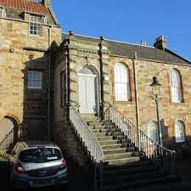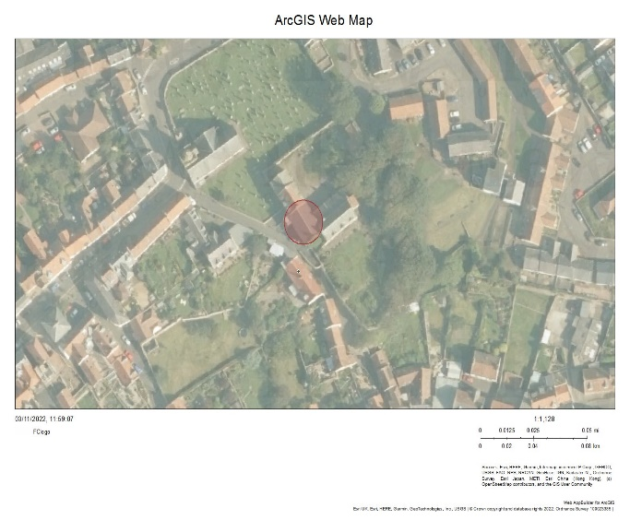
New picture and plan

Disposal Request:
Pittenweem Community Library, Royal Burgh of Pittenweem Arts Festival and East Neuk Model Railway Club (existing tenants) have agreed to enter new lease agreements to regulate their occupation of the property.
Ground Floor – Pittenweem Community Library
The property has been used by the library for the past 5 years .The ground floor library provides café and a library for the local community.
First Floor
The upper floors provide an administration base for the Arts Festival years and the Railway Club and Arts festival for the past 23 years, and provides an administration base for the Arts Festival and a home for Model Railway enthusiasts.
The proposals would be subject to all statutory consents.

Representations:
Anyone may make representations about this request to Fife Council. Representations must be in writing and include the name and address of the person making it. All representations will be published on Fife Direct at www.fifedirect.org.uk/commongood
Representations must be received by Wednesday, 26th April 2023. They should be sent to Zahida Ramzan, Policy Co-ordinator, Fife House, North Street, Glenrothes, KY7 5LT or (Zahida.ramzan@fife.gov.uk).

Date of Notice: 28 February 2023

