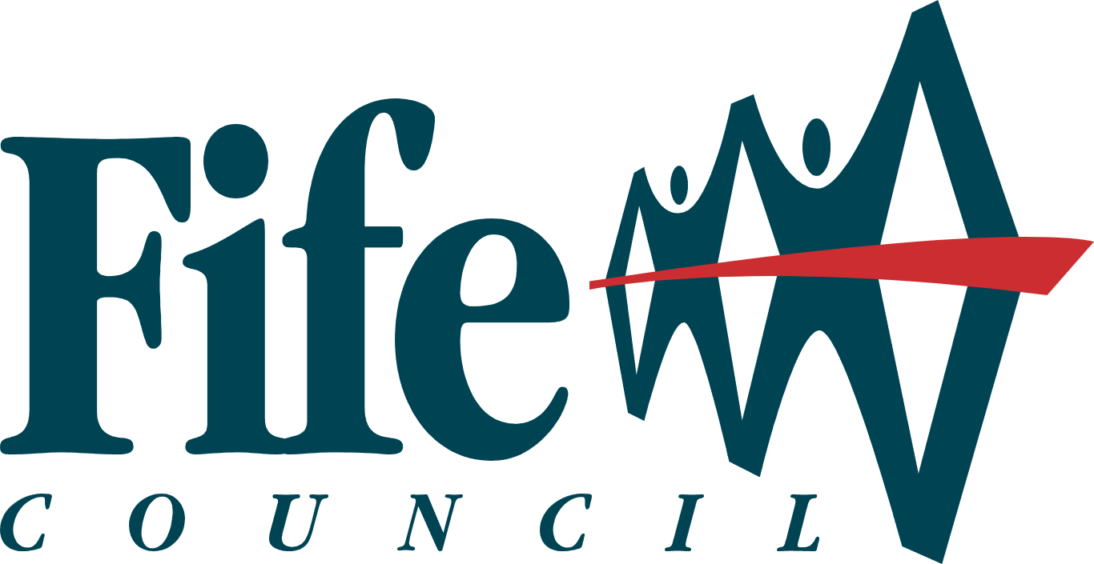
Community Use | Licensed and Unlicensed Functions in Community Use Halls & Centres

For Your Information

Introduction
Fife Council requires all licensed events within venues to comply with the Licensing (Scotland) Act 2005 requirements. For further details please visit Occasional licence | Fife Council. Licensed and unlicensed events within Community Use Halls & Centres require approval from the School Headteacher, Parent Teacher Association and the Head of Service.

Licensed and Unlicensed Functions in Community Use Halls & Centres - Terms & Conditions

- Notice providing basic information about any function will be required to be submitted to the Head of Communities and Neighbourhood Services a minimum of 8 weeks prior to the date of the event.
- Applications for an occasional license must be made a minimum of 6 weeks prior to the date of the event Occasional licence | Fife Council. If it is out with this period, the application cannot be processed by the licensing team.
- The site of the bar (where relevant) must be approved in advance by the Head of Communities and Neighbourhood Services and will not be altered thereafter without his approval.
- Delivery and uplift of alcohol for any licensed or unlicensed function must be agreed by management of the venue.
- All licensed functions must be adequately staffed to ensure acceptable behaviour by all patrons. Entry must be denied to any person attempting to convey alcohol into the venue.
- All licensed functions must adhere strictly at all times to the requirements of the Licensing Board, Fire Regulations and Environmental Health Regulations. In the event of additional facilities/building alterations being required, the Head of Communities & Neighbourhoods must be consulted regarding their feasibility.
- No licensed or unlicensed function should continue beyond 00:00 hours without the prior approval of the Head of Communities and Neighbourhood Services. An additional Public Entertainment License application may be required for events beyond 00:00 hours Apply for a Public Entertainment licence | Fife Council
- On completion of the licensed or unlicensed function, the premises must be left in a condition which is satisfactory to the Head of Communities and Neighbourhood Services.
- A risk assessment is carried out and approved in relation to the function.
- The hirer is responsible for ensuring sufficient stewarding is in place. All nominated stewards must be over the age of 21 and are to be present on the premises for the duration of the event. Stewards must regularly conduct toilet and external perimeter checks.
- The hirer must ensure appropriate stewarding ratio is in place:
- One Steward per 20 adults in attendance (no children)
- One Steward per 12 adults in attendance (children present)
- Licensed stewards may be deemed necessary where facilities are in close proximity to other licensed premises.
- Where possible plastic bottles & glasses should be used. Where glass bottle or glasses are used these must be removed from the premises at the end of the hire.
- All spillages are to be alerted to a member of caretaking/janitorial staff to avoid slipping hazards and to ensure flooring remains undamaged. Any damage to property as a result of spillage may incur additional charge to the hirer.
- The consumption of alcohol outside is strictly prohibited.
- Nominated stewards are responsible for ensuring no alcohol is consumed by anyone under the age of 18 and to ensure no excessive amounts of alcohol is being consumed by any guest.
- Stewards are to ensure no person influenced by too much alcohol gains access to the building. Stewards are to evict anyone displaying sign anti-social behaviour, vandalising the premises, or displaying aggressive behaviour towards other guest or members of Staff.
- Guests who leave the event/premises are not permitted to return and access should not be granted by the nominated stewards.
- All music is to be kept to a reasonable level to ensure there is no disruption or nuisance to neighbouring buildings or residential premises. At the end of the event, noise should be kept to a minimum as guest leave.
- It is the responsibility of the hirer to ensure “Drink-up” is announce 30mins prior to the end of the event.
- The hirer named in this application, must be present throughout the duration of the event.

Licensed / Unlicensed Functions in Community Use Halls & Centres Application Form

Function Organiser/Hirer Details

Community Use Centre: |  |  | Date of Function:
Function: |  | Applicant's Details
Time (Starts and Ends):
Purpose of Function: |  |  |  |  | No’ of Adults: |  |  |  | No’ of U18’s:

Function Details - CONTROLS - Refer to points overleaf

1. Where will the bar be sited?
2. Will the date and times of the function meet the requirements noted overleaf?
If NO - give details
3. When will the alcohol be delivered? | Date |  | Time
4. When will the alcohol be uplifted after the function? | Date |  | Time
5. What staffing arrangements have been made for the function?
6. Who will hold the licence?
7. Will the requirements of Note 7 above be met in full?
8. The event risk assessment is completed and approved?

Comments:

I agree with the terms & conditions overleaf:

Signature of Hirer: |  | Date:

Approved by (Lead Officer): |  | Date:

Approved by (Area Team Manager): |  | Date:

Approved by (Community Manager): |  | Date:

Fife Council Official Use Only

Checks |  |  | Yes |  | No | Document |  |  | Yes | No
Meeting conducted with hirer? |  |  |  |  |  | Risk Assessment agreed & signed by hirer?
License has been applied for (date)? |  |  |  |  |  | License is granted (date)?
Application Approved? |  |  |  | Application reviewed by:
Date |  |  |  | Comments:
Function organiser/hirer informed of decision?

