Standards and Quality Report
Achieving Excellence and Equity

Context
Setting/School Roll (including ELC/ASC) | 802
FME | 149
Attendance (%) 85.5 % (mid term) | Authorised |  | Unauthorised
Exclusion | 28 per 1000 pupils mid term
Attainment Scotland Fund Allocation (PEF and SAC) | £92,809 (PEF allocation for Session 2020 – 2021)

At St Andrew’s RC High we aim to be an inclusive school with happy staff and
young people with the commitment of all staff, pupils, parents and carers in raising
attainment and achievement to the highest standards with community at the centre
of its success.

In St. Andrew’s RC High School we seek to grow together as a community of faith
and learning in which every member feels welcomed, valued and safe. Guided by
the Gospel values of Jesus Christ, our staff will work to provide the highest quality
of education for the young people in our care. In doing so we will help them to
become successful learners, confident individuals, responsible citizens and
effective contributors to our school and to society.

The work of everyone associated with our school is directed by the following aims.

- To enable all to become successful, confident, life-long learners
- To promote a positive, supportive environment for all
- To develop respect and understanding for each other within our school and local communities
- To encourage all to be creative global citizens
- To foster Gospel Values in all that we are, in all that we learn, in all that we do and in how we live with others

Improvement for Recovery Priority Work
Session 2020 - 2021
NIF Priorities: Improvement in Attainment, Literacy and Numeracy, Improvement in Children and Young People’s Health and Wellbeing, Improvement in Employability Skills and Sustained Positive Destinations  NIF Drivers: Teacher Professionalism, School Leadership, School Improvement, Assessment of Children’s Progress | HGIOS 4 Quality Indicators  3.2 Raising Attainment and Achievement  2.3 Learning Teaching and Assessment  3.1 Ensuring Wellbeing, Equality and Inclusion  3.3 Increasing Creativity and Employability
Progress:

Firstly, and importantly, central to progress this session has been the commitment, professionalism and creativity of the St Andrew’s RC HS school staff.

An 18-point action plan was jointly developed between the school and local authority and agreed over a period of time, prior to November 2020 and was very detailed. However, many staff felt that it was difficult to read and understand.

In response, the action plan format was developed using HGIOS 4 and all of the 18 action points were placed under 9 Quality Indicators (QIs), closely linking the action plan to the work and life of the school.

The QIs are linked across the three categories within HGIOS 4 and capture all areas of the work and life of the school. These are:
- Leadership and Management (by all staff): How good is our leadership and approach to improvement? (Blue)
- Learning provision: How good is the quality of care and education we offer? (Orange)
- Successes and Achievements: How good are we at ensuring the best possible outcomes for all our learners? (Green)

As a starter, a group of staff from CDT and Expressive Arts were invited to lead an exercise to engage with learners to refresh and strengthen our school values and to suggest improvements to the learning environment. This work, along with significant investment in the painting and redecoration of large parts of the corridors and common areas within the school building give learners a welcome boost as we set our sights high for the future. Further investment is coming into corridors and classrooms by means of wall display materials in similar calming colours.
Importantly, we are taking this work forward into other areas as we develop approaches to learning & teaching and assessment, our building positive relationships (BPR) policy and attendance, late coming and child protection procedures. Regarding BPR an initial draft policy including exemplifications of staff roles and responsibilities is at a stage to be progressed by the working group during 21/22. Support and advice from our Educational Psychologists were welcome and supported recovery within the school.

We have been taking a closer look at the curriculum within the school, with a particular focus on rationale, design and learner pathways. Some work has been undertaken already around efficiencies, designed to ensure that we can redirect resources into the most needed areas. Work to embed further support for learners with additional support needs is ongoing for session 21/22 and will have a strong focus on sustainability and partnership support. Gordon Wood (DHT – Curriculum) successfully engaged with Education Scotland following their invitation to schools to support in curriculum development.

An exciting piece of work that has been started by the Learning & Teaching working group and will form a key area of focus for the school over the next two to three years is our new Learning Standard.
This is about ensuring that as we move forward on the improvement journey, the quality of experience that learners get within the classroom is of the highest quality, across the whole school.
Further work will take place, at pace, to widen discussion and ensure that we start to develop a shared understanding of what this means – ready to trial and embed during session 21/22.

The Standard centres on a simple three-part model with a focus on:

- ensuring a strong start to the lesson
- learning and teaching that is active and engaging
- plenary/feedback

The graphic includes carefully selected words or phrases as prompts, allowing though for a creative and flexible approach.
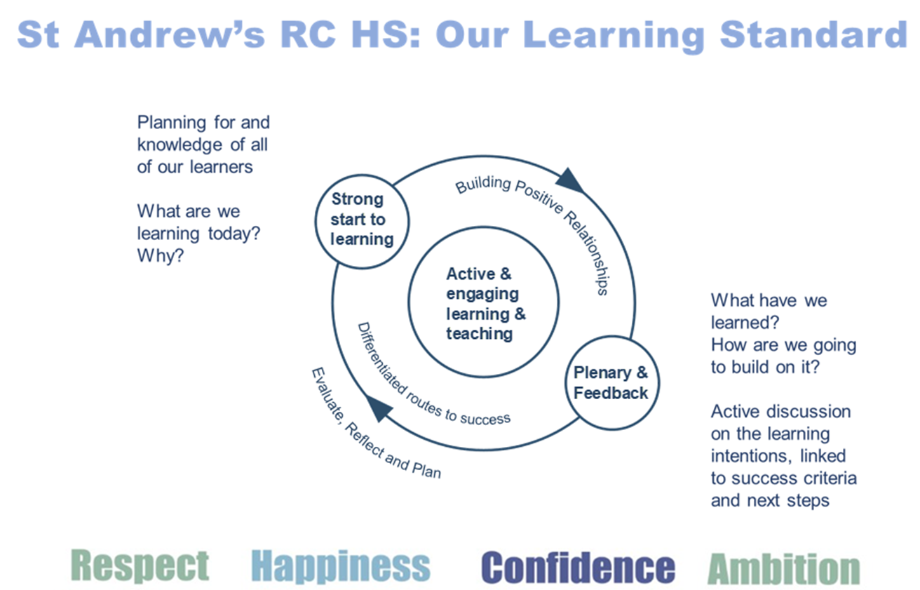

This will be underpinned by an implementation standard for which departments will co-develop.
In addition, clear and accessible support for practitioners will be a focus – through digitally delivered sessions and through planned professional learning opportunities built into the school calendar.

Impact:

All staff have renewed/increased understanding of child wellbeing by engaging in and completing the mandatory E-Learning modules.

The creation of an attendance and late-coming policy has led to the adoption of greater challenge around improving attendance. This links with the creation of a policy for the new Pupil Support Officers with a focus to address pupil absence and improve overall attendance. Policy was implemented post Easter 2021 with potential impact of improved monitoring and action on late coming with overall increased attendance statistics for 2021/22. Early indications from Aug/September (despite cases of pupil isolation) show pupil attendance figures of 89% (w/b 6th September)

Our vulnerable learners have been further highlighted on SEEMiS to improve staff awareness and on-going support.

We have seen the development of House Meeting structures for the Guidance Team to include our PSO staff and an increased focus on pupil attendance.

Aim to have more staff confidence with in-school CP processes.

Curriculum paper in development for consultation. Initial impact:
- Potential efficiency savings have been identified and actioned.
- Ongoing work to build capacity within the curriculum structure for learners who require additional support. Additional staff/capacity for targeted groups engaging in session 2021/22 in an alternative curriculum.

The Learning & Teaching working group has:
- reviewed QI 2.3 in depth to identify the key messages of a shared learning standard;
- analysed feedback from recent school inspections on this area;
- identified key themes for inclusion in the draft St Andrew’s RC HS shared learning standard;
- produced a first draft of a 3-part shared learning and teaching standard.

Staff engaged in an information session and they understand expectations of the learning standard. Impact is at the early stages but consistent implementation across the school will ensure young people receive a high-quality experience across the school.

A draft remit was developed for a Tracking, Monitoring and Reporting policy to allow further work to be completed in the BGE and Senior Phase.
Next Steps:

- Our new Learning Standard will be used across the school with a focus on pupil and staff needs

- Our Curriculum Rationale will be updated to reflect the changing needs of our school community and DYW

- Our Building Positive Relationships Policy will be introduced to support staff and pupil wellbeing

- We will build up our tracking and monitoring systems in the BGE and Senior Phase and enhance communication and understanding of pupil pathways and focus for positive destinations

- New attendance and late-coming policy will be fully implemented to improve our daily pupil attendance

Outcomes for Young People
Full details in attached School Outcome Report highlighting:

- Numeracy and Literacy CFE levels above Fife average in three out of four years.
- Numeracy and Literacy (Leavers) better than Virtual Comparators over four years.
- % Unemployment below Fife and National picture for 2019/2020.
- Increase in both % Higher and Further Education from 2018/2019 to 2019/20.

- Required and planned focus on pupil attendance (89.72 in 16/17 down to 85.5 in 20/21).
- Positive tariff point picture with capacity to focus on deciles below national picture.
- Falling exclusion numbers – Building Positive Relationship policy aims to reduce numbers further.

Evidence of significant wider achievements
- Erasmus Traditional Building Skills Project with Fife College and the Lime Centre developed over last two sessions despite lockdown.

- Development of Alternative Curriculum for new S3 pupils in 2021/22

- Revival of successful Duke of Edinburgh Programme

All of the above have had/will have a positive impact on pupil skill-based learning and skills development.

What have been the success and challenges of school/setting closure period (school/class/playroom isolation, remote learning between January – March 2021)
There has been a recognition of the staff and pupil learning needs following the sharp learning curve for staff and pupils in working on Microsoft Teams as a forum for meetings and posting work for classes.
There has been good monitoring of pupil engagement over the lockdown periods.
Support for our most vulnerable and keyworker children in our “bubbles” has been exceptional.
A number of our families have gained from additional IT support and the delivery of basic equipment to some families was well received. Challenges recognised in the delay in procurement of additional IT devices.
Staff meetings have continued on Teams and we will balance the use of Teams in future sessions with the need/desire for face-to-face meetings.
Acceptance but sad reflection that whole-school activities had to be cancelled.
Guidance staff have been at the forefront in communications with families in responding to requests/concerns. Most parent/carer feedback has been positive with acknowledgement of the work staff are involved in to support our young people.

Impact of Local/National resources to support recovery within your setting (digital devices, additionality of staffing) (primary, special and secondary sector only)
Number of devices provided to support learning at home | 49
Additionality in staffing | 1FTE

We took our full allocation of 49 Scottish Government devices in November 2020 and distributed these to those families in greatest need (via Guidance referrals, parental requests and identified through pupil engagement surveys). We are also aware of four devices distributed to pupils from HAGO and three from BTS stock.

The demand outstripped supply very quickly and so we ordered 80 more Chromebooks to support families with access to devices to work from home on 20/1/21, based on the number of FSM families we have. These have just been delivered (June 2021)

In the meantime, we have lent out a further 39 school devices which is impacting on availability for pupils' access to devices in school and will be more of an issue now that all are back. There are a further 7 requests outstanding for devices.

Lindsay Reston joined our school community in August 2020 as 1 FTE additionality and has been much needed given the fact that two members of our teaching staff have had to shield for the majority of the session (August 2020 until post Easter). All pupils associated with classes she has taken have had a positive impact with her presence and we have also been able to support her in her own subject background of Modern Studies linking her to the Social Subjects Faculty and enabling her to work with groups of young people most in need of her skill base and subject knowledge.

Attainment Scotland Fund Evaluation (PEF/SAC)
Progress:

PEF funding for 2020/21 focused on additional staffing in Learning Support and the addition of two PSOs to our school community.

Impact:

This session the PEF funding has allowed pupil support to employ two members of staff 2.5 days per week. Mrs MacDonald and Mrs Nunes have worked with a number of pupils in school and during lockdown.

Mrs MacDonald worked as a transition teacher, focusing on S1-2 pupils to engage pupils around literacy and numeracy. During this year she has worked with pupils who have a number of barriers in accessing mainstream curriculum, as well as struggling to engage in online learning. She has also extended her support to older year groups to allow them to access learning out with class and to prepare them for assessments. Support and focused work have produced some specific success with pupils, including:

· Two S1 girls who can now do their times tables and feel more confident in their maths class as a result.
· S2 pupils who were struggling to complete any extended writing for questions and can now manage an A4 page of writing.
· Several pupils who can now correctly use grammar including full stops and commas in their writing, who were unable to do so before.
· S2 maths pupils having a breakthrough and achieving a good understanding of fractions and the relationships between these and decimals.
· 41 pupils have had focused work from Mrs MacDonald.

· Pupils who were not able to engage online during lockdown joined Mrs McDonald’s Team where she was able to post out hard copies of work, which was returned to her and marked with feedback. Pupils engagement with this increased dramatically compared to online teams only.

Mrs Nunes has also worked with a large number of pupils on focused programmes of work both during lockdown and in school. Her success with pupils has included.

· Exploring positive relationships and positive body expectations with three S3 pupils, who now have improved self-confidence and relationships with adults.
· Supporting self-regulation strategies with a number of S1/2 pupils who were struggling to accept consequences and engage with staff. These pupils now have early stages of improvement with staff and in their engagement.
· Support with pupils completing S3 literacy work, level of work and attainment improved and staff feedback more positive.
· Supporting individual pupils with self-regulation techniques, developing self-awareness and developing a sensory profile. Impact on pupil being able to regulate emotions and communicate with staff more effectively.
· Sending out weekly work packs to 12 pupils with feedback and online engagement. Increased engagement and contact with parents/carers to feedback.
· Close contact with families of several S1/2 pupils to discuss issues and interests to re-engage pupils who have not worked for some time.
· Supporting English mainstream classes with differentiated work and taking pupils out of class to support them with curricular work to complete assessments

The Pupil Support Officers (PSOs) Anne Murray and Jackie Kelly’s role has become a critical component part of the statutory safeguarding and ensuring wellbeing responsibilities within St Andrew’s RC HS.

Operationally, the PSOs work closely with the school staff and in particular, the Guidance Team, DHT support and admin staff with responsibility for SEEMiS attendance/GroupCall.

The PSO on-call duty is shared where possible, allowing the other to focus on supporting safeguarding duties within the school. Both are available in the event of a serious incident.

Focus for 2 x PSO at St Andrew’s HS

• Visible monitoring duties at start of day, interval, lunch and end of day
• Gathering and sharing information with Named Person/SLT in response to discipline incidents
• Supporting the DHT duty calls, ensuring pupils out of class are triaged
• First Aid on call - one PSO at all times with First Aid responsibility with other holding back up
phone
• LAC/CEC/CP attendance:
• AM/PM openings with a link to SEEMiS & GroupCall support
• LAC/CEC/CP attendance discrepancies with a link to SEEMiS & GroupCall support
• Sharing information with DHT Support/GTs/Teachers as required
• Attend at House Meetings (x3):
• Focus on supporting attendance/CME/communication with harder to reach families
• Feedback on agreed actions to GTs over the week
• Support HLGs:
• Prepare a summary report for Guidance Teachers prior to HLG meetings detailing current
position of attendance concerns previously discussed at House Meetings
• Record keeping – supporting record keeping on SEEMiS using agreed, standardised entries.
• Home visits – as part of the staged approach to absence – directed by SLT/GTs.
• Admin time – Covid PPE stock monitoring (incl. daily pupil masks monitoring/distribution),
emails, HCP admin, medication record checks/updates, first aid stock monitoring and ordering
(termly)

ST ANDREW’S RC HIGH
NIF Quality Indicators (HGIOS 4) School Self- Evaluation
Quality Indicator | 2018 - 2019 | 2019 - 2020 | 2020-2021 | Inspection Evaluation  (within last 3 years)
1.3 Leadership of change | SATISFACTORY | GOOD | GOOD
2.3 Learning, teaching and assessment | SATISFACTORY | SATISFACTORY | SATISFACTORY
3.1 Ensuring wellbeing, equity and inclusion | SATISFACTORY | GOOD | GOOD
3.2 Raising attainment and achievement | GOOD | GOOD | GOOD

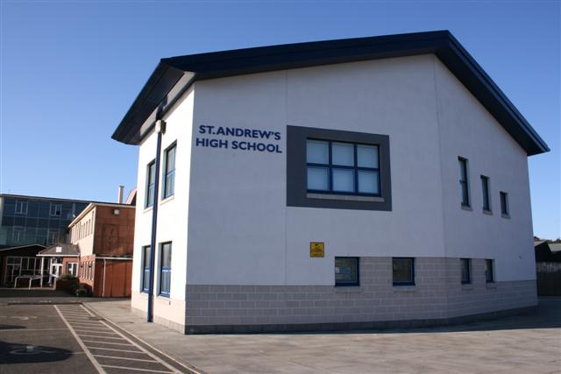

Appendix B

ST ANDREW’S RC HIGH SCHOOL
SCHOOL IMPROVEMENT PLAN
(incorporating: The Catholic School – Developing In Faith, HGIOS4, The National Improvement Framework, Tackling Bureaucracy Guidance and our Pupil Equity Fund)

2021/2022

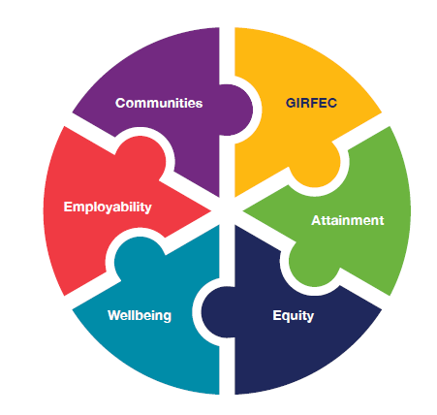

National Improvement Framework Priorities:
- Improvement in attainment, particularly in literacy and numeracy
- Closing the attainment gap between the most and least disadvantaged children and young people
- Improvement in children and young people’s health and wellbeing
- Improvement in employability skills and sustained, positive school-leaver destinations for all young people
Focused Priority: Our new Learning Standard will be used across the school with a focus on pupil and staff needs
HGIOS4 Quality Indicators
1.2 Leadership of Learning  2.3 Learning, Teaching and Assessment  2.4 Personalised Support |  |  | 3.1 Ensuring wellbeing, equality and inclusion (all learners)  3.2 Raising attainment and achievement (all learners)
Expected Impact | Strategic Actions Planned | Responsibilities |  | Measure of Success  (Triangulation of Evidence) | Timescales
Almost all our young people are fully engaged, resilient, highly motivated and interact well during activities. Learners’ experiences are appropriately challenging and enjoyable and well matched to their needs and interests. Learners exercise choice and take increasing responsibility in their learning. They understand the purpose of their learning and have opportunities to lead the learning. We use a wide range of creative teaching approaches. Our explanations and instructions are clear. We observe learners closely to inform future learning. We use feedback effectively to inform and support progress in learning. | Quality Improvement processes led by all teachers in all classrooms that are:  • robust and rigorous  • systematic and continuous  • rely on involvement of colleagues and learners in these processes –  common and shared ambition.  • involve effective discussion on QI 2.3 within and across faculties  (building a collective understanding of QI 2.3)  • effective in leading to change and improved outcomes for learners | All teaching staff to ensure Learning Standard visual is displayed in teaching areas and, together with Support Staff, used as a focus for lessons.  Principal Teachers to discuss faculty task/initial self-evaluation of Learning, Teaching & Assessment and measure progress and impact of this work.  L&T Working group led by Lewis Matthews and Lewis Clelland to develop more detail to sit underneath the graphic to support colleagues.  SLT/MLT to support further professional learning on QA/ Self-Evaluation approaches. |  | Departmental discussions  MLT meetings  SLT on call periods  QI Visits– as per calendar  Pupil feedback  Parent/Carer surveys /feedback | From August 2021  August 2021  September 2021 – January 2022  September 2021 onwards
Ongoing Evaluation
This should be updated as part of on-going cycle of self-evaluation

Focused Priority: Our Curriculum Rationale will be updated to reflect the changing needs of our school community and DYW
HGIOS4 Quality Indicators
2.2 Curriculum  2.4 Personalised Support |  |  | 3.1 Ensuring wellbeing, equality and inclusion (all learners)  3.2 Raising attainment and achievement (all learners)  3.3 Increasing creativity and employability
Expected Impact | Strategic Actions Planned | Responsibilities |  | Measure of Success  (Triangulation of Evidence) | Timescales
Following on from our recent Managing Change Exercise the rationale for our curriculum will be reviewed and communicated to our school community. All stakeholders will have a shared understanding of our rationale.  Our Broad General Education will be furthered developed to ensure all departments have a focus on skills development.  Our senior phase offerings will continue to be reviewed to ensure they meet the needs of all learners and the local, national and international economy and job markets. | Quality Improvement processes led by all teachers in all classrooms that are:  • robust and rigorous  • systematic and continuous  • rely on involvement of colleagues and learners in these processes –  common and shared ambition.  • involve effective discussion on QI 2.2 within and across faculties  (building a collective understanding of QI 2.2)  • effective in leading to change and improved outcomes for learners | All teaching staff to ensure pupils’ skills for learning, work and life are supported and enhanced through subjects in the broad general education.  Principal Teachers to discuss faculty task  around BGE review and measure progress and impact of this work.  Curriculum Working Group led by Diane Turnbull to develop more detail to sit underneath the curriculum rationale to support colleagues.  SLT/MLT to support further professional learning on QA/ Self-Evaluation approaches. |  | Departmental discussions  MLT meetings  SLT on call periods  QI Visits– as per calendar  Pupil feedback  Parent/Carer surveys/feedback  Positive Destination Data | From August 2021  From September 2021  September 2021 – February 2022  From September 2021
Ongoing Evaluation
This should be updated as part of on-going cycle of self-evaluation

Focused Priority: Our Building Positive Relationships Policy will be introduced to support staff and pupil wellbeing
HGIOS4 Quality Indicators
1.2 Leadership of Learning  2.1 Safeguarding and Child Protection |  |  | 3.1 Ensuring wellbeing, equality and inclusion (all learners)  3.2 Raising attainment and achievement (all learners)  3.3 Increasing creativity and employability
Expected Impact | Strategic Actions Planned | Responsibilities |  | Measure of Success  (Triangulation of Evidence) | Timescales
Pupils, staff and the wider school community will have a firm understanding of expectations regarding positive relationships.  Staff at all levels will have ownership of staged interventions. Expected decrease in number of referrals.  Improvement in pupil and staff wellbeing.  Positive in-roads created to becoming a fully restorative and rights respecting school community. | Quality Improvement processes led by all staff in all areas of the school that are:  • robust and rigorous  • systematic and continuous  • rely on involvement of colleagues and learners in these processes –  common and shared ambition.  • involve effective discussion on QI 2.1 within and across faculties  (building a collective understanding of QI 1.2/2.1)  • effective in leading to change and improved outcomes for learners | All staff ensuring the Building Positive Relationships policy is embedded in the day-to-day life of the school and delivering on their particular role.  Principal Teachers to discuss faculty task  around BPR review and measure progress and impact of this work.  BPR Working Group led by Lisa Swanson to develop more detail to sit underneath the policy to support colleagues.  SLT/MLT to support further professional learning on QA/ Self-Evaluation approaches. |  | Departmental /Team discussions  MLT meetings  SLT on call periods  QI Visits– as per calendar  Pupil feedback  Parent/Carer surveys / feedback  Referral/Exclusion Data | From August 2021  September 2021  From September 2021  From October 2021
Ongoing Evaluation
This should be updated as part of on-going cycle of self-evaluation

Focused Priority: We will review and improve our tracking and monitoring in the BGE and Senior Phase and enhance
communication and understanding of pupil pathways and focus for positive destinations
HGIOS4 Quality Indicators
3.2 Raising attainment and achievement (all learners)
3.3 Increasing creativity and employability
Expected Impact | Strategic Actions Planned | Responsibilities |  | Measure of Success  (Triangulation of Evidence) | Timescales
Present tracking procedures developed to focus on post COVID plans with focused groups of learners and individuals, ensuring target levels of attainment achieved.  Improved links with other education providers to improve pupil pathways.  Increase in positive destinations for our young people. | Quality Improvement processes lead by pupil support staff and PTC lead in all areas of the school that are:  • robust and rigorous  • systematic and continuous  • rely on involvement of colleagues and learners in these processes –  common and shared ambition.  • involve effective discussion on QI 3.2 within and across faculties  (building a collective understanding of QI 3.2/3.3)  • effective in leading to change and improved outcomes for learners | Additional staff through PEF (Lindsay Reston/Pat Glacken/Sarah Auchterlonie) used to support targeted groups of pupils as directed by SLT/Pupil Support Team  SLT to support further professional learning on QA/ Self-Evaluation approaches. |  | SLT/ Pupil Support Team discussions  Meetings with/feedback from staff involved.  QA Faculty Review meetings  SLT on call periods  QI Visits– as per calendar  Pupil feedback  Parent/Carer surveys/ feedback  Positive Destination Data | From August 2021  From September 2021
Ongoing Evaluation
This should be updated as part of on-going cycle of self-evaluation

Focused Priority: New attendance and late-coming policy will be fully implemented to improve our daily pupil attendance

HGIOS4 Quality Indicators
2.1 Safeguarding and Child Protection |  |  | 3.1 Ensuring wellbeing, equality and inclusion (all learners)  3.2 Raising attainment and achievement (all learners)  3.3 Increasing creativity and employability
Expected Impact | Strategic Actions Planned | Responsibilities |  | Measure of Success  (Triangulation of Evidence) | Timescales
Improved overall attendance.  Ensure that engagement and attendance is a priority of pupils, parents/carers, staff and other stakeholders to enable pupils to become successful learners, confident individuals, responsible citizens and effective contributors.  Ensure consistency in dealing with all issues relating to attendance, late coming and absence.  Ensure accurate recording of pupils’ attendance, late coming and absence. | Guidance staff are emailed the monthly attendance spreadsheet.  Guidance staff then inform the office staff of any letters/text messages they wish to send to parents.  Termly Attendance report of key pupil groups. (e.g. Casual group reports of LAC, 20% FFA, pupils living in SIMD 1/2)  Pupils with no attendance over a term.  Senior phase pupils with attendance below 90%.  Start of session Attendance spreadsheet with previous session to be created with attendance % noted for all pupils as a reference point.  New S1 intake attendance in P7 to be requested from cluster schools in June/August | As per policy:  Teaching staff  Admin staff  Pupil Support Staff/PSOs  PTs – Team Leaders  SLT |  | At times, it will be helpful to review data linked to the following pupil groups:  - School Stage/ Year Group  - Additional Support Need  - Looked After/Care-Experienced  - SIMD Profile  - Attainment Groups (Furthest from Achievement (FFA)) | - At an early stage in a new term and then periodically through each session  - Faculty meetings where teachers and PTCs look at attendance concerns within classes.  - Guidance House meetings  - SLT meetings at points through the session  - Use of P7 data to establish a baseline for S1  Formal reviews:  September 2021  May 2022
Ongoing Evaluation
This should be updated as part of on-going cycle of self-evaluation

