PUBLIC NOTICE
THE COMMUNITY EMPOWERMENT (SCOTLAND) ACT 2015
NOTICE OF CONSULTATION ON DISPOSAL OR CHANGE OF USE OF COMMON GOOD PROPERTY

Fife Council propose to change the use of a common good property; Raith Lodge at Beveridge Park, Kirkcaldy (the “Lodge”) to education use. Before taking a decision, the Council requires to consult under Section 104 of the Community Empowerment (Scotland) Act 2015.

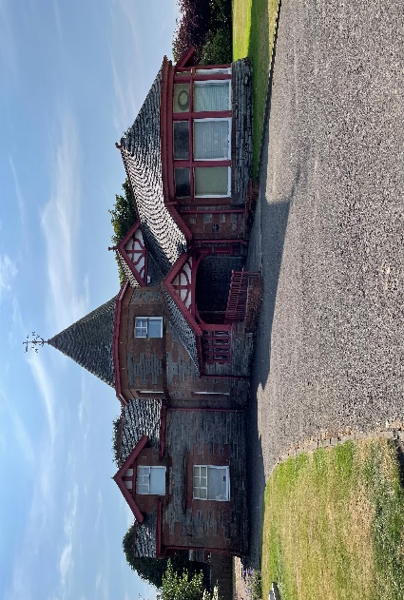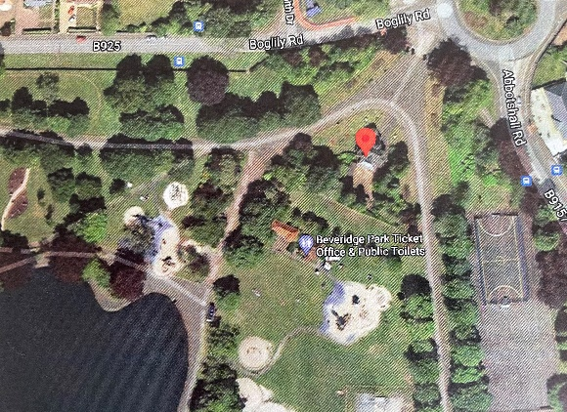

(Above photos) - Raith Lodge location within Beveridge Park
Change of Use Request:
There is a requirement for additional capacity for 3- and 4-year old children within the Kirkcaldy area to access early learning and childcare (ELC). Fife Council propose to use the lodge and grounds as a base from which to operate an outside early learning provision for up to 24 children. The lodge will also be used to accommodate up to 24 children during school term-time between 9.00am to 3.00pm to facilitate early learning and childcare. Therefore, the lodge will provide a facility for up to 48 children based both in the building and using the park over 39 weeks per year to access ELC.
The Lodge will become an early learning and childcare facility to enable learning and development for children aged three and four years. The Lodge will also be the base for those children and practitioners accessing the park on a daily basis and furthermore will be used for storage of equipment, and to provide access to toilets for staff and children. It will be a base for staff to undertake curricular planning and assessment and to liaise with parents about children’s progress.
The Lodge was originally the home of the Senior Park Ranger when it was built, with a tearoom at the front of the building but this closed some time ago. More recently the Lodge has been used by Parks & Open Spaces as office space. Parks & Open Spaces have identified that the office space accessed at the Lodge is surplus to their requirements.
This proposal would be subject to Full Planning and Listed Building Consent, and all other necessary statutory approvals.

Representations:
Anyone may make representations about this request to Fife Council. Representations must be in writing and include the name and address of the person making it. All representations will be published on Fife Direct at www.fifedirect.org.uk/commongood
Representations must be received by 4 November 2021. They should be sent to Zahida Ramzan, Policy Co-ordinator, Rothesay House, Glenrothes, KY7 5PQ or (Zahida.ramzan@fife.gov.uk) or to communityasset.transfer@fife.gov.uk

Date of Notice 3 September 2021

