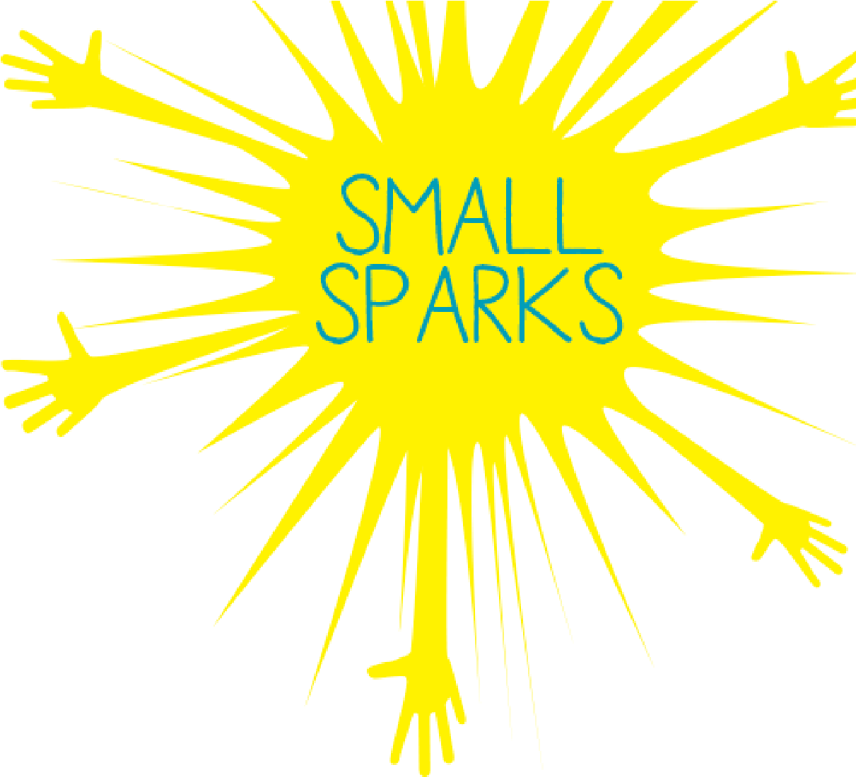
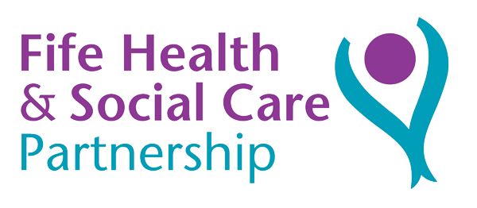

SMALL SPARKS FIFE
APPLICATION FORM 2022/2023

A Catchy Name
A catchy name will get people interested. What name have you chosen for your group/activity/project?

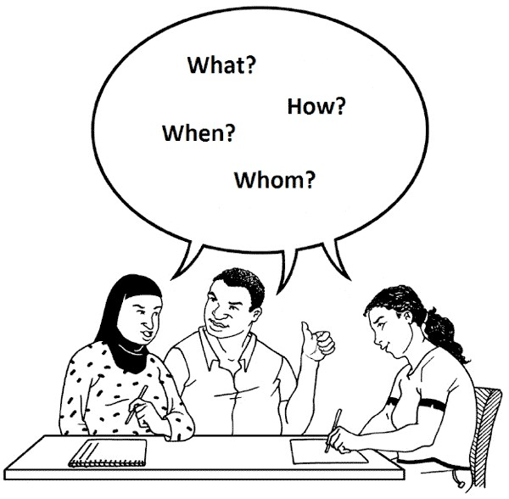 | Project Idea  Tell us about your project/event/group. Where will it take place and when it will it begin?
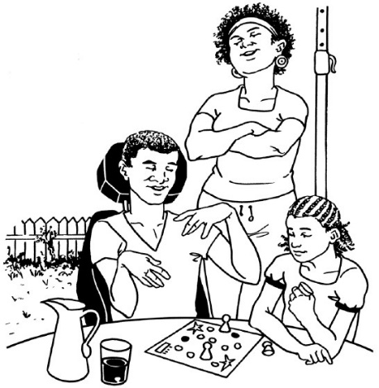 | Involving people  What is your plan to get local people involved in your project/group/event?
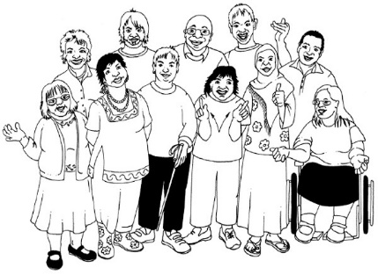 | Who will benefit from your project?  How many people do you hope will get involved?
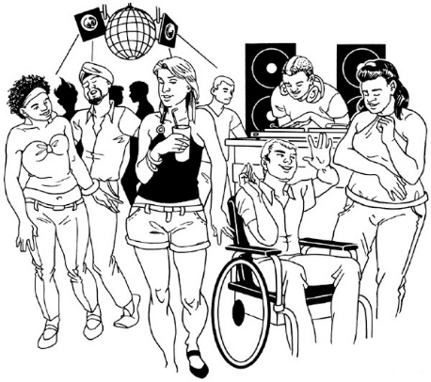 | Community Benefit  What benefits will your project/group/event bring to those involved and the wider community?
Your Contribution
What contribution will you and others make to the project? For example, time, use of equipment or premises, donated goods, or services?

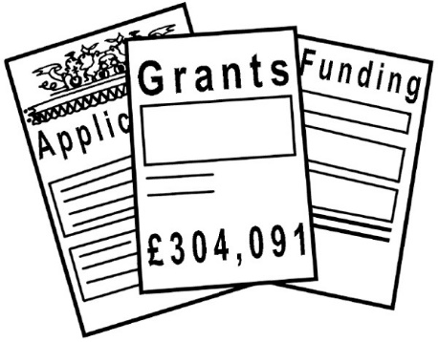 | Money  How much money will you need to get your idea off the ground and what it will be used for? The most you can request is £500.
What happens next?
How do you plan to keep your idea going in the future?

Please use this space to provide us with any other information about your activity, group, event, or project.

We are happy to come along to the Small Sparks Celebration Event in Spring 2023 to share our stories and successes with other projects.

Yes No
Contact Person 1 | Contact Person 2 (if needed)
Address | Address
Telephone | Telephone
Email address | Email address
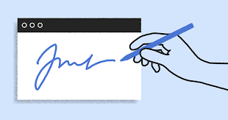  Signature | Signature

A member of the Small Sparks panel will be in touch with you to let you know if your application has been successful.

Post or email your complete application form to:

Geraldine Goldie,
Project Officer
Self Directed Support Team,
6th Floor West,
Fife House,
North Street,
Glenrothes,
Fife.
KY7 5LT

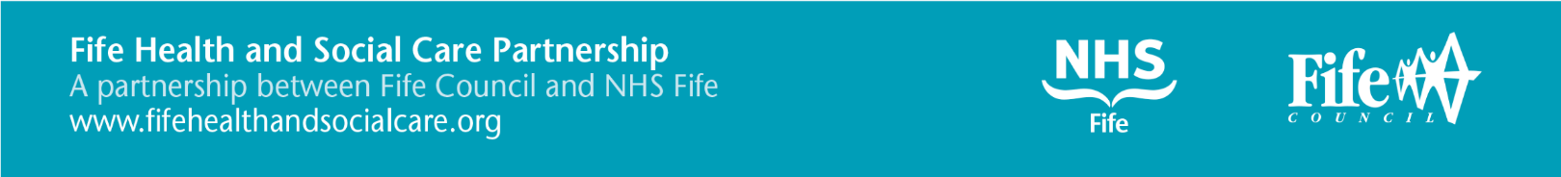
Geraldine.Goldie@fife.gov.uk

