Cowdenbeath Primary School  Standards and Quality Report  Achieving Excellence and Equity |  | 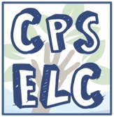

Context
Setting/School Roll (including ELC/ASC) | 204
FME | 38 pupils
Attendance (%) 92.97% | Authorised | 3.43% | Unauthorised | 3.56%
Exclusion (%) | 0.03%
Attainment Scotland Fund Allocation (PEF and SAC) | Allocation for Session 2020 - 2021

Vision Values and Aims
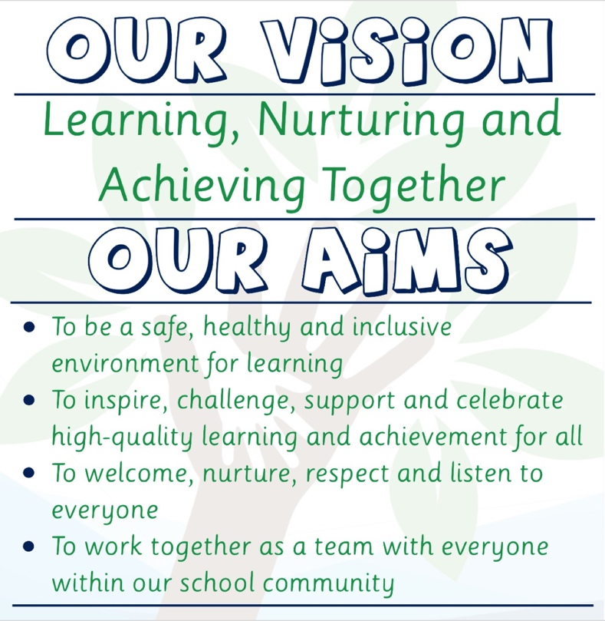 | 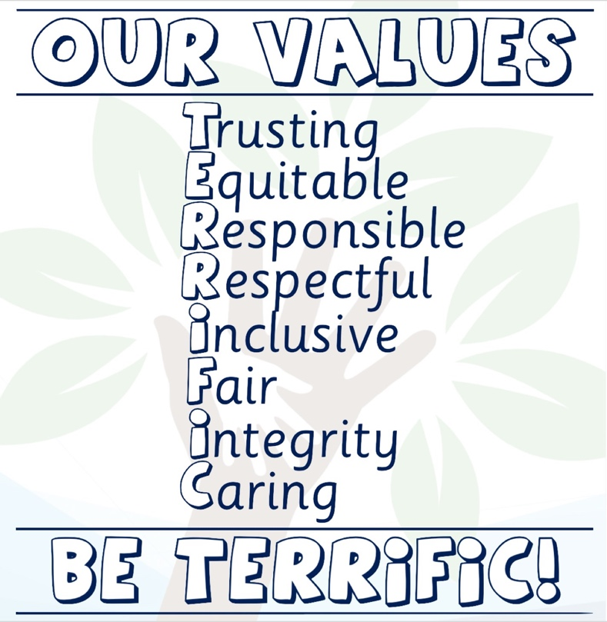
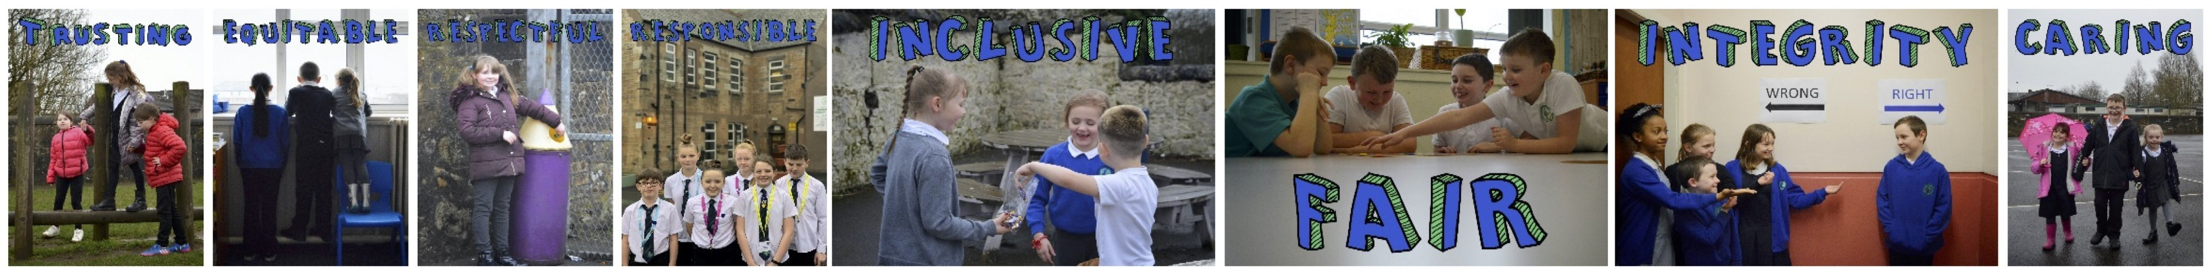

School Improvement for Recovery Priority Work
Session 2020 – 2021
Focused Priority 1: Raising Attainment in Reading
NIF Priority  - Improvement in attainment, particularly in literacy and numeracy  - Closing the attainment gap between the most and least disadvantaged children  NIF Driver  - School Improvement  - Assessment of Children’s Progress  Teacher Professionalism | HGIOS 4 Quality Indicators  - Leadership of Learning  2.2 Curriculum  2.3 Learning, teaching and assessment  3.2 Raising attainment and achievement
Progress:
Support for Learning
- After the first lockdown and the resulting remote learning approach, we recognised that some of our learners would likely require more support upon their return to school this session. Indeed, this was a key factor informing our whole agile action planning as pupils would require support in a wide spectrum of developmental capacities. As such, we used some of our Pupil Equity Fund to ensure we had teaching staff who were not class-committed. This enabled us to form a support for learning team alongside the support for learning teacher. This was intended to give us flexibility and contingency to meet the wide range of educational and academic support needs of our learners. Although this support was not limited to reading, this was a curriculum area that absolutely benefitted from this initiative. The tracking and attainment data we had for the first, second and forth terms in particular showed significant progress was being made by the pupils in receipt of this support. We had returned to a period of remote learning in term three due to Covid and this level of intensive support was herder to implement remotely.
- After creating this ‘support for learning team’, we also developed our termly attainment liaison process. We identified the academic (including reading) support needs across the school and further sorted pupils into three levels of support: Universal, additional and intensive. Universal support encompassed all children in every class. In terms of reading, this related to building consistency in learning, teaching and assessment across the whole school through professional dialogue and use of the available resources. Pupils identified as requiring additional support, typically required additional planning and longer-term targets. These children typically required opportunities for over-learning the fundamentals of reading: phonic recognition, CVC blending, common word recognition and rhyme. The children identified as having the most potential to make the greatest gains in a short time frame, were then in receipt of the intensive support from the support for learning team. As previously mentioned, the tracking and attainment data we had for the first, second and forth terms in particular, showed significant progress was being made by the pupils in receipt of this support. We had returned to a period of remote learning in term three due to Covid and this level of intensive support was herder to implement remotely.

PM Benchmark Reading Assessment
- Through self-evaluation and analysis of attainment data and evidence, we identified Reading as an opportunity for enhancement. In previous years, again through self-evaluation, we had prioritised maths and writing so it was perhaps understandable that we should now focus on building consistency in the planning, teaching and assessment of reading.
- We purchased this resource through PEF as it seemed like the best for our needs in terms of supporting consistent assessment and moderation of reading through formative and summative means.
- All teaching staff completed professional development around the use of the PM Benchmark tool. In particular, the support for learning teachers also explored how this resource could best be used to support our learners .
- Mrs Allan and Mrs Harden also networked with HT’s from other schools to see how they were implementing the PM benchmark resource and how they used the generated data. Unfortunately, due to the second lockdown, progress in agreeing a consistent application across the school was halted so this is an aspect we will pursue in the 2021-22 session.

Chatterbox
- Teaching staff, particularly those with children working within 1st and 2nd level, were encouraged to use the resource, Chatterbox. Through our self-evaluation process, the teaching staff reported that this was a significant resource for engaging children in their reading. The Chatterbox books were a valuable resource to aid reading groups and whole class reading. They provided children with a wider choice in what they could read so that they could engage with texts that provided more reading for enjoyment opportunities and meaningful engagement for discussions, workshop for literacy approaches and literacy circle pedagogies. In addition to wider choice, the use of Chatterbox also enabled less need for larger reading groups to share copies and the titles are constantly updated and added to which makes the reading current. Through our self-evaluation processes, both children and teachers identified these benefits which have been key to use improving our reading attainment this year.
Impact:
- The support for learning team have collected a wide range of formative and summative assessment data throughout the year that has demonstrated immediate, positive gains in reading, particularly for the children in receipt of the intensive support.
- Although the second lockdown in the third term appeared to hamper progress, this was quickly addressed when pupils returned to school after this second period of remote learning. We were able to report that our combined attainment for reading, although undoubtedly affected by consequences of the global pandemic, was above our stretch target for this year and indeed, even surpassed the target for next year. Please see our attainment overview for detail.
- A further positive consequence of our targeted approach to raising attainment was the increased opportunities for moderation. The support for learning, team working across different classes and engaging in increased professional dialogue with the senior leadership and teaching teams, facilitated increased opportunities for moderation. This has undoubtedly informed our shared expectations across the school and has given us a platform to build on for continued success. This was a positive outcome that was identified by almost all our teachers and some pupils through our termly liaisons and through our self-evaluation processes.
Next Steps:
Through our self-evaluation process, the following possible next steps were identified:
- Continue targeted support for pupils in danger of not achieving a level.
- Review use of the Workshop for Literacy approach for consistency as this was not realised as we had hoped. This would be beneficial for all to build a more consistent pedagogy to development of literacy including reading.
- Review existing planning formats to declutter.
- Agree consistent assessment procedures including the use of PM Benchmark.
- Continue to collaborate with parents over seesaw and/or the weekly sway so parents can share in their children’s learning. Parents also need encouragement on how to support their child or an emphasis on how important communication is between us.
Focused Priority 2: Planning for Assessment and Moderation
NIF Priority  - Improvement in attainment, particularly in literacy and numeracy  - Closing the attainment gap between the most and least disadvantaged children  NIF Driver  - School Improvement  - Assessment of Children’s Progress  - Teacher Professionalism | HGIOS 4 Quality Indicators  1.2 Leadership of Learning  2.3 Learning, teaching and assessment  3.2 Raising attainment and achievement
Progress:
- Through our team meetings and interaction with the resources created by last year’s Moderation and Assessment working party, we have continued to develop a more consistent approach to moderation and assessment. The rationale for the Cowdenbeath approach to learning, teaching and assessment is reviewed and updated regularly as a live component of our wider curriculum rationale. This year, this approach was updated to include considerations around assessment opportunities during remote learning. Our approach was highlighted as good practice by the authority and was included in aspects of the Promoting Playful Pedagogy and Pedagogy Team resources that were shared authority-wide.
- In terms of summative assessment, this has become more consistent through the use of key resources and regular assessment intervals across the whole school. In particular, most teachers feel confident carrying these out and agree that they provide consistency throughout the school. They have also enabled new teaching staff in particular to quickly and effectively continue pupils’ learning journeys with minimum lag. In particular the IDL, BIG Writing and BIG Maths resources coupled with the relevant training in their use have facilitated this consistency in assessment and moderation.
- In terms of formative assessment, teaching staff have developed their understanding and use of planning for assessment and assessment evidence opportunities and most report greater confidence in this area. In particular, many of the teaching team have started to use forms assessments to gauge where children are in their learning. Through our termly attainment liaison meetings, it is also clear that the teaching team have also begun to use the literacy and numeracy benchmarks more frequently to make decisions around formative assessment. The teaching team also report increased of assessment matrices to support greater confidence and accuracy in assessment and attainment. The teaching team report that this has led to greater consistency of reporting levels, strengths and areas for development across levels, which also made transitions smoother.
- Our targeted approach to raising attainment through our termly attainment liaisons and targeted support for learning, increased opportunities for moderation across the school and within a range of curriculum areas but with a particular focus on numeracy and literacy. The support for learning, team working across different classes and engaging in increased professional dialogue amongst themselves and with the senior leadership and teaching teams, facilitated increased opportunities for moderation. This has informed our shared expectations across the school and has given us a platform to build on for continued success.
Impact:
- The support for learning team have collected a wide range of formative and summative assessment data throughout the year that has demonstrated consistent, positive gains in numeracy and literacy arising directly from partnership working with pupils and teachers from across classrooms and CfE levels, particularly for the children in receipt of the intensive support.
- Although the second lockdown in the third term appeared to have hampered progress in assessment and moderation, we responded by reviewing our rationale and identifying opportunities to do this accurately as possible by virtual means. We also identified areas that would likely require triangulation upon the pupil’s return to school-based learning. These considerations undoubtedly helped us to minimise the potential negative impact of the second lockdown which is borne out by our combined attainment statistics which are in excess of our literacy and numeracy NIF stretch targets for this year as well as next. Furthermore, through self-evaluation, most of our teachers report increased confidence in maintaining progression even if there are future returns to remote learning. Please see our attainment overview for detail.
- Through our self-evaluation process, most teacher identified that there were a number of successful strategies developed through remote learning that further enhanced learning teaching and assessment during school-based learning. In particular, the use of forms and virtual assessments and the ability to assign work and assessments by virtual means for pupils to complete while the teacher was working with other groups, further enhanced pace and progression in terms of recovery. This is also a factor reflected in our attainment data. Again, these successes have provided us with an efficient platform from which to build on.
Next Steps:
Through our self-evaluation process, the following possible next steps were identified:
- Review existing planning formats to declutter and increase focus on consistent planning for assessment using existing resources (Big Maths, Big Writing, PM Benchmark, IDL)
- Explore ways to develop greater engagement of moderation and assessment from learners and their families.
- Continue to explore greater opportunities to moderate learning and teaching within own school but also seek cluster opportunities.
- Continue with whole school moderation and assessment through PEF support for learning approach linked to termly liaisons.
Focused Priority 3: Better Learning, Better Relationships, Better Behaviour
NIF Priority  - Improvement in attainment,  - Improvement in health and wellbeing  NIF Driver  - Teacher professionalism  - school improvement, parental engagement | HGIOS 4 Quality Indicators  2.2 Curriculum  2.7 Partnerships  3.1 Ensuring wellbeing, equality and inclusion  3.2 Raising Attainment and Achievement
Progress:
After the first lockdown we recognised that some of our learners would likely require more support upon their return to school. Indeed, this was a key factor informing our whole agile action planning as pupils would require support in a wide spectrum of developmental capacities including their emotional and social development. As such, we used some of our Pupil Equity Fund to ensure we had teaching staff who were not class-committed to continue our success with nurture and family support.

Nurture
In addition to reviewing our universal approaches to nurture, we also realised that we would have to have contingency in recognising the children who would benefit from additional nurture support and input as the impact of the global pandemic would likely have affected our pupils and their families in different ways. Following these considerations, the following steps were taken:
- PEF nurture role and nurture groupings and support were reviewed termly and assessed on a needs basis. This was also done in collaboration with pupils’ families and the relevant class teachers.
- Staff professional development was maintained through publication of weekly nurture principles summaries. Further professional development activities taken are detailed below.
- Bank of staff and pupil nurture resources were developed by the Nurture teacher for whole-school use. Some of these were also deployed through remote learning activities.

Professional Development
- Professional reading and dialogue has been provided by Educational Psychologist and Scottish Government. Feedback from staff and children indicates that this has been beneficial to most
- Staff have been given professional reading to complete during Inset days that has helped us to understand the behaviours displayed by pupils and how best to support them.
- We had a big focus on differentiation and student teachers were provided with copies of Sue Cowley’s ‘Ultimate Guide to Differentiation’ book. Staff were guided to read this book and reflect on their own practices to identify opportunities for enhancement.
- Staff took part in the Do Be Mindfulness training. Resource cards were also shared with were shared with staff which were slater hared with children during home learning.

Family Support Officer
We recognised that through supporting our pupils and families this way would enable us to support our pupils most affected by the global pandemic. This enabled us to support a wide a number of our families in a variety of ways. For example:
- Partnership working with local community businesses to create and distribute support parcels.
- Christmas family hampers
- Allocation of home learning devices and 1:1 training on how to set-up and use them
- Mobile SIM distribution to families with no or poor internet connection
- Application for funds for families experiencing financial pressure. Number of families in receipt of this support.
- Partnership with Family Support Services to improve attendance of key pupils – include attendance data.
- Support for families to complete a range of applications for support and entitlements including, young carers, Support and Connect, healthcare referrals and out of hours childcare.
- Termly clothes/essentials drop-ins
- Dedicated phone number for families to use to seek support directly with the team members with the family support role. This was promoted through in the regular school newsletters.
- Partnership working with the Parent Council to raise awareness of available support.
Impact:
Nurture
- Through our self-evaluation processes and staff, pupil and family feedback, our flexble approach to targeted nurture support was positively received by all.

Family Support Officer
- The feedback from our families has been overwhelmingly positive with regards to how approachable and supportive the school is.
- Quotes from family feedback
- We have also been able to directly support significantly more families this year.
- Include numbers of families supported

Professional Development
- Almost all staff indicated that the focus on mindfulness, mental health and wellbeing, particularly at the start of the year and after the second lockdown, were useful. Engagement with the resources published by the Scottish government, Fife Council and in particular, the resources published by the Educational Psychology team, were useful in supporting practice.
- Most staff identifies that they were already using a lot of the differentiation strategies but almost all agreed that this allowed us to think of differentiation from a different perspective and develop more consistent understanding and practice.
- Feedback from the members of the team who engaged with the Do Be Mindful resources and professional development activities was all positive and it was evident that this was valued.
Next Steps:
- Continue to refer to the Sue Cowley book for differentiation ideas and allow time for collaboration between staff on what has worked well.
- Explore creative curriculum approaches to ensure learning is engaging as possible and motivates learners based on their interests and needs.
- Through our self-evaluation and feedback processes, staff indicated that a continued focus on mindfulness would be of beneftit next session for the whole school community.
- Continue the family support structures that were developed effectively last session.

ELC Improvement for Recovery Priority Work
Session 2020 - 2021
Focused Priority 1: Developing Teamwork and Distributed Leadership (Empowered System)
NIF Priority  - School Leadership  NIF Driver | HGIOELC Quality Indicators  1.1 Self-evaluation for self-improvement  1.2 Leadership of Learning  1.3 Leadership of Change
Progress:
- We started the year with whole new teams in each our nurseries. It was important for us to focus on establishing a healthy professional team ethos. We recognised that when there are effective professional relationships within the team, his enables us to meet the needs of our children and families and to provide the best possible service. From the start of the year and throughout, the team focused on developing their understanding and awareness of distributed leadership in the early years and pedagogical leadership. This was achieved through professional reading that was distributed to the whole ELC team. Reflection, team discussions and self-evaluation on these texts informed specific termly action planning.
- The agile, termly action planning was also informed by the professional development opportunities that the team members perused through their own PRD processes. Further opportunities were created for the team to share, cascade and reflect on this wide range of professional learning through the use of a virtual learning space that was created using WhatsApp. When working from home staff shared information about professional development activities, they had engaged with via a space created on One Drive. This helped others to decide if this was something they wanted to do, whist getting feedback on the content from others.
- ELC team members were also able to take on a range of leadership roles to enhance the play and learning provision in the nursery, particularly in the areas of observation and planning, schemas, transitions and outdoor learning.
- We also engaged with the Virtual Nature Schools program this year which similarly created leadership opportunities. Through these leadership roles, the team were able to build richer, more meaningful opportunities for our children to be active participants in their learning.
Impact:
- The success of our efforts to build an effective team through increased understanding of empowerment and distributed leadership is evident through the many adaptions recorded in the termly action planning as well as the nursery planning.
- A range of resources including positive conflict, distributed leadership and empowerment descriptors were developed that will now be integrated into our school rationale.
- Another source of evidence of impact is captured in the pupils PLJs, termly newsletters and Seesaw communications to families.
- Furthermore, we successfully completed the Virtual Nature Schools program and were awarded a certificate in recognition of our progress.
- Finally, the impact towards improving our culture for distributed leadership and empowerment is also recorded in the EYO’s Model for improvement PDSA plans and team self-evaluations, as well as the termly 1:1 meetings with the HT. EYOs consistently gave positive feedback about the team and their role within it with regards to their growing cohesiveness and confidence.
Next Steps:
- Now that new roles and routines have been established, it is important that we build on this with more consistently.
- In particular, further review and fine tuning of communication processes, as well as improved consistency and frequency of quality assurance activities. We will have greater capacity to realise these next steps next session as we will have a full senior leadership team with clearer remits. One of which will be specifically relating to the ELC improvement structures.
Focused Priority 2: Maintaining Links with Families and Partnership Working
NIF Priority  - Parental Engagement  NIF Driver | HGIOELC Quality Indicators  2.5 Family Learning  2.6 Transitions  2.7 Partnerships
Progress:
As stated previously, we started the year with whole new teams in each our nurseries. It was important for us to also focus on establishing a good relationships with families as early as possible to ensure our learners needs were met and the best possible early years provision was realised. This was further complicated by the precautions to minimise the impact of the global pandemic so we had to develop new ways of communicating and collaborating with our families. As such, the following steps were taken:
- Digital versions of PLJs have been sent out via email and see-saw
- Daily learning journal is shared with parents via seesaw on a daily basis.
- Regular parent chats have taken place outdoors and over the phone both planned for formal meetings and incidental informal and frequent as necessary at drop off/ pick up.
- See-saw has also been used to support communication with our families and has helped ensure our interactions are two-way dialogues as much as possible.
- Sharing weekly planning and daily opportunities on seesaw has also given more opportunity to support children’s learning at home, in addition to seeing the learning experiences and opportunities offered to children at home. This dialogue has allowed us to improve our capacity for responding to our families to better meet needs.
- Wherever possible, Key workers ensure they chat with families daily, keeping them Informed of daily achievements and progress.
- Induction checklist were reviewed and updated to ensure consistency in share key information to meet cildren’s needs.
- These were followed up with ‘Settling In’ chats that allowed us to better self-assess whether we were meeting children and families needs to our full potential.
Impact:
- Through our feedback and self-evaluation process, most of our families have indicated that they are happy with the relationship they have with the nursery and the provision they provide for their children.
- In particular, our families indicated that they feel they have a more of a trusting, positive relationship with staff members and have a fuller understanding of their child’s development. Include quotes from feedback.
- Parents have also fed-back to staff that they enjoy looking at the daily learning journal finding out what their child has been learning.
- The steady uptake of Seesaw was also identified by all staff and most families as a positive development.
Next Steps:
- Despite the positive feedback from our families, staff indicated that they would still like to improve approaches to communication as shift patterns and session times can affect effectiveness.
- Through our process of self-evaluation, we also identified further opportunities should be sought for engaging with families in a more collaborative way. Many of our existing approaches are inherently consultation and reporting rather than true partnership working and collaboration.
- Further opportunities to engage families through activities such as workshops, bookbug sessions and PEEP should be explored where possible in the future as these have not been possible as fully though virtual means.
Focused Priority 3: Developing Consistent, High-quality, Early Years Pedagogy
NIF Priority  - Teacher Professionalism  - Assessment of Children’s Progress  NIF Driver | HGIOELC Quality Indicators  2.2 Curriculum  2.3 Learning, Teaching & Assessment  2.4 Personalised Support
Progress:
Progress and Impact:
- The whole ELC team engaged with relevant professional reading and research, in particular, each member of the ELC team were provided with their own hard copies of Realising the Ambition and HGIOELC so they could highlight and annotate as we engaged with the documents
- The ELC team also engaged with the early years pedagogical leadership materials created by Fife Early Years team. This led to reflection and self-evaluation activities that led to actions being recorded on team graffiti walls and our agile action planning processes
- This improvement priority overlapped with our efforts to develop our collective understanding and practice around empowerment and distributed leadership. As such, relevant model for improvement action planning and PDSAs were agreed with responsibilities for all by ELC team in partnership with SLT
- To improve consistency and to cascade professional development learning, we created virtual communication and professional development spaces on WhatsApp and OneDrive that all team members had access to. This improved communication and consistency as all members of the team could engage in professional dialogue regardless of their shift patterns
- All staff indicate that they participate in high-quality individual professional learning which improves outcomes for our children and families. They also agree that there is more of a shared understanding of early years pedagogy within the team over the course of the year.
- As the family meeting space could not be used during the session due to precautions to limit the onward transmission of covid-19, we developed this space so that it could be used for staff professional development activities. In addition to providing a shared spaces to engage in professional dialogue, self-evaluation graffiti walls and similar activities, we also stocked it with a range of professional reading that the team engaged with.
Impact:
- The evidence of our impact in this improvement priority is evident through the many adaptions recorded in the termly action planning as well as the nursery planning.
- Nursery Planning strongly reflects children's interests and ideas and shows how staff respond.
- All staff report that they have a deeper understanding of early years pedagogy and the role of self-evaluation as a result of their engagement with this improvement priority and the linked actions.
- Other sources of evidence of impact can be observed in the children’s PLJ’s, Seesaw communications, records of reporting to families, newsletters and nursery displays.
- Each of the ELC team, in addition to sharing their own professional development with each other, have also kept personal professional development records, which have highlighted their ‘take-home learning’, resulting actions and evaluations.
- Finally, the impact towards to realising this improvement priority, is also recorded in the EYO’s Model for improvement PDSA plans and team self-evaluations, as well as the termly 1:1 meetings with the HT. EYOs consistently gave positive feedback about the professional development journeys and understanding of pedagogical leadership with regards to their growing confidence.
Next Steps:
- All staff feel that communication within the team has improved to create a more consistent approach to early years pedagogy. This this should continued to be developed further next session including the use of self-evaluation graffiti walls, virtual learning and dialogue spaces and the use of PDSA cycles.
- We will have greater capacity to build on our successes next session as we will have a full senior leadership team with clearer remits.

Attainment of Children and Young People (Early Learning, Primary and Special)
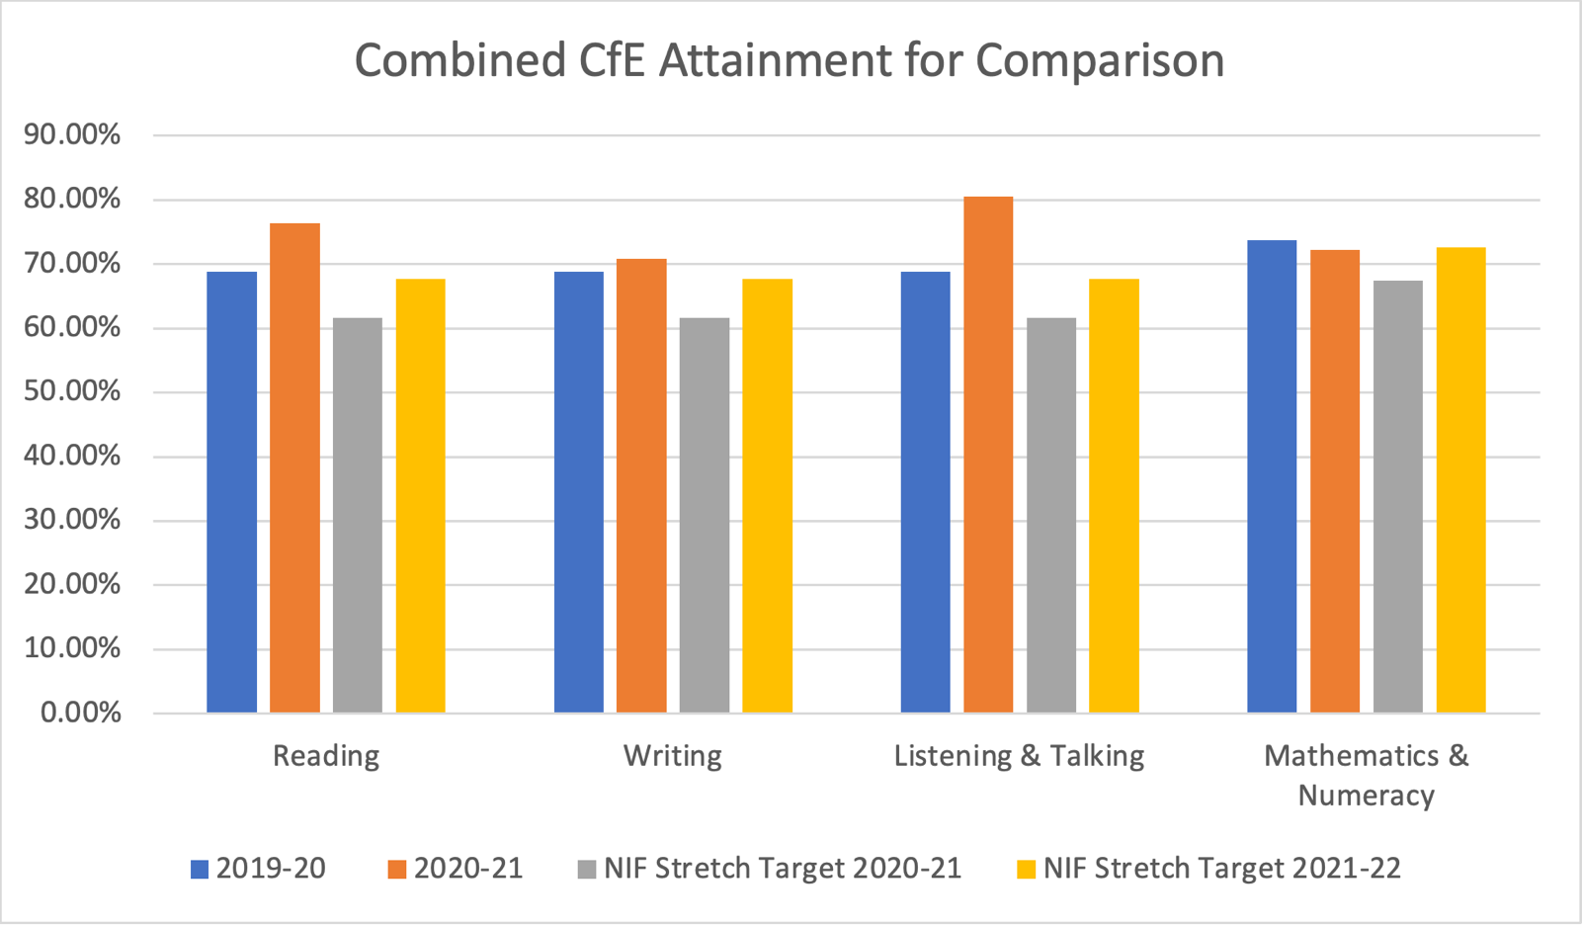
The graph below shows our 2019-20 reported CfE levels alongside the 2020-21 levels. This demonstrates an improvement in attainment and supersedes our current stretch targets in all literacy and numeracy areas. Furthermore, our current reported CfE levels also exceed that of our stretch target for the next session which we will of course be aiming to further improve upon.

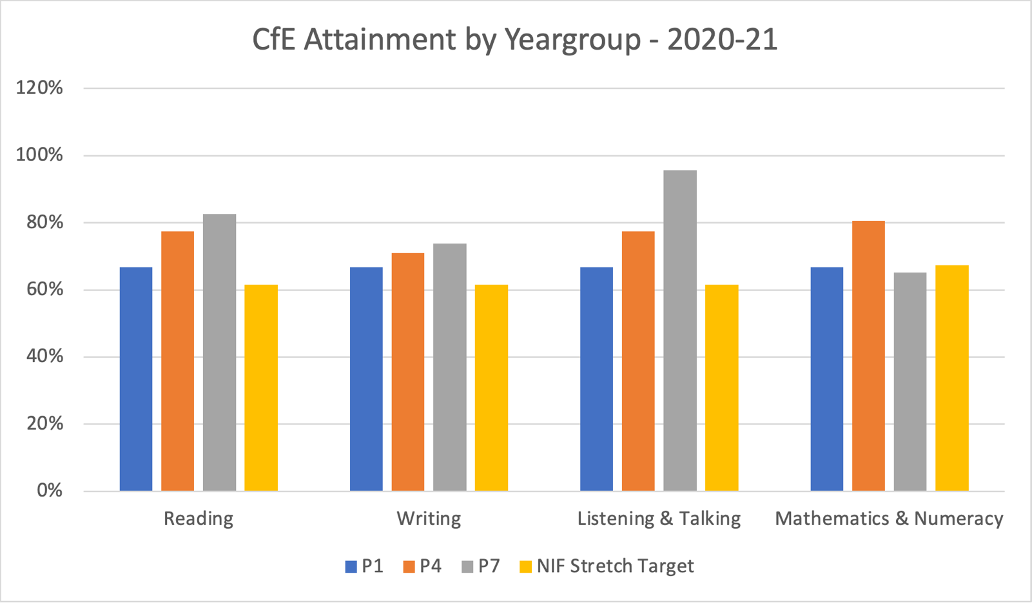
This graph shows our reported CfE attainment for this session by key stage. For all areas of literacy, we are reporting CfE levels that exceed our current stretch target. Our P4 attainment also exceeds our current stretch target for maths and numeracy while our P1 and P7 attainment is just below. We have focused in particular on Literacy this session which may account for some of this discrepancy. This data suggests that we may need to look closer at raising attainment in maths and numeracy next session.

Evidence of significant wider achievements
Achievements should be linked to skills and not be a list of events/activities from in school/setting or during remote learning
What have been the success and challenges of school/setting closure period (school/class/playroom isolation, remote learning between January – March 2021)
During the lockdown from January 2021 – March 2021, remote learning activities were made available for all pupils. The pupils were given a minimum of three learning tasks to complete each day. These tasks comprised of one literacy, one numeracy and one from another curriculum area. Teachers had to ensure that there was balance across the additional curriculum areas. Tasks were differentiated and supported through a range of approaches including direct instruction, video links and live interactions. Each teacher provided a daily live interaction opportunity for pupils to receive instruction or support and to socialise with their teacher and peers. There was a frequently and deliberate focus on positive mental and emotional wellbeing during these sessions. In addition to these remote learning considerations, we also had approximately 25% of our school students being taught in school, in bubbles, and number remained fairly consistent through out this period of lockdown.

Our initial engagement in the first week was low, approximately 60%. By the end of the second week onwards, due to the deployment of home learning devices and phone calls to families to support engagement, this number increased to approximately 80%. We conducted further analysis on not only engagement but the depth of engagement and the quality and frequency of returned work and found that this figure was approximately 60% across the school. We then set key children small incremental targets to increase their depth of engagement and we began to see progress but our data was skewed due to the February break and then the severe weather closures. Shortly after, we had a partial return to school for our younger classes but despite these changes, the data we were able to gather indicated that deep engagement was approximately 68% and increasing.

We audited pupils and families regularly throughout the lockdown and the feedback was almost all positive. Teachers identified improvements in engagement and quality of returned work, particularly in comparison to the first lockdown in 2020. We attributed this to greater confidence of teachers, pupils and families in using digital and virtual technologies brought about through familiarity of use.

This increased confidence in using digital technologies to enhance learning has been carried through into the classroom and we have seen an increased in effective use. Teachers are more confident to provide individuals and groups with virtual tasks and instruction while the work directly with other groups and most teachers report that this has improved their efficiency and pace.

It is our aim now to widen our distribution of home learning devices so that learning can be continued in the home where necessary by many more of our learners. This is an aspect we intend to develop next session.
Impact of Local/National resources to support recovery within your setting (digital devices, additionality of staffing) (primary, special and secondary sector only)
Number of devices provided to support learning at home | We allocated 20 devices during lockdown.
Additionality in staffing | We had 0.7 fte additional staffing.

The deployment of home working devices to pupils, to support home learning during the second lockdown, improved the engagement and participation of most of those pupils. We were also able to safely accommodate approximately 25% of the school population in learning bubbles within the school. These factors undoubtedly contributed positively to our engagement levels and minimised the potential of negative impact on learning.

With our 0.7 additional staffing, we were able to better support a wide range of pupils. The targeted deployment of this resource was reviewed on a termly basis and undoubtedly contributed positively on our reported attainment.

Attainment Scotland Fund Evaluation (PEF/SAC) (primary, special and secondary sector only)
Progress:
We used our Pupil Equity Fund to help us realise a number of goals in closing the poverty -related attainment gap and to improve pupil equity:
- Funding for additional teachers to work intensively with groups of children. These pupils were identified and reviewed on a termly basis with corresponding action plans and timetables designed around needs.
- Additional PSA allocation to further support learning with key pupils
- Nurture Teacher to continue designing bespoke programs for key pupils as well as supporting team professional development. This role was particularly challenging this year due to covid-19 safety precautions and the impact the global pandemic was having on a number of our learners emotional health and readiness to learn.
- Family Support Officer to respond to our families in the greatest need of support. This involved a range of activities and coordination of different resources and services.
- Purchased a range of digital and concrete learning resources to support literacy in particular.
Impact:
Intensive Pupil Support (additional teachers and PSAs)
- Almost all children identified as being at risk of being off-pace who received the additional intensive support, met their identified targets.

Nurture
- All teachers report that the regular professional development updates and resources have improved practice across the school to better meet the needs of learners.

Family Support
- The feedback from our families has been overwhelmingly positive with regards to how approachable and supportive the school is.
- Quotes from family feedback
- We have also been able to directly support significantly more families this year.
- Include numbers of families supported

Learning and Teaching Resource Purchasing
- Our main focus was raising attainment in literacy and we achieved this through the purchased of relevant resources and through our additional staffing and intensive support programs. This is evident in our attainment data which shows an improvement on the previous year. This improvement is also in spite of covid-19 precautions including the second lockdown.
- Our attainment is not yet back to where it was pre-Covid-19 but we are in almost all instances, exceeding our stretch aims.

School/Setting Name: Cowdenbeath Primary School
NIF Quality Indicators (HGIOS 4) School Self- Evaluation
Quality Indicator | 2018 - 2019 | 2019 - 2020 | 2020-2021 | Inspection Evaluation  (within last 3 years)
1.3 Leadership of change | Good | Good | Very Good
2.3 Learning, teaching and assessment | Good | Good | Good
3.1 Ensuring wellbeing, equity and inclusion | Good | Good | Very Good
3.2 Raising attainment and achievement | Good | Good | Good

NIF Quality Indicators (HGIOS ELC) Early Years Self- Evaluation (Nursery)
Quality Indicator | 2018 - 2019 | 2019 - 2020 | 2020-2021 | Inspection Evaluation  (within last 3 years)
1.3 Leadership of change | Good | Good | Good
2.3 Learning, teaching and assessment | Good | Good | Very Good
3.1 Ensuring wellbeing, equity and inclusion | Good | Good | Very Good
3.2 Securing children’s progress | Good | Good | Good

Care Inspectorate (within last 3 years) | Grade (if applicable)
 | 2018 - 2019 | 2019 - 2020 | 2020-2021
Quality of care and support | N/A | 5 | N/A
Quality of environment | N/A | N/A | N/A
Quality of staffing | N/A | N/A | N/A
Quality of leadership and management | N/A | 5 | N/A

Appendix B
Session 2021 -2022 Improvement Plan
National Improvement Framework Priority: relevant links made
Focused Priority: (aim/outcome – who will change?, what will change? and how will it change?)
HGIOS4 Quality Indicators |  |  | HGIOELC Quality Indicators
Linked to all relevant QIs as well as key QIs |  |  | Linked to all relevant QIs as well as key QIs
Expected Impact | Strategic Actions Planned | Responsibilities |  | Measure of Success  (Triangulation of Evidence) | Timescales
What are we trying to improve?  Is this focused on children and young people and making a difference to their outcomes?  Is it for all learners or a group of learners? | Will these actions improve outcomes for all or some of the school’s/setting’s children and young people? | Is responsibility shared and devolved?  Does this allow for and demonstrate leadership at all levels? |  | How will evidence be gathered – data, views, direct observations? | Are these linked to Working Time Agreement?  Are timescales realistic?
Ongoing Evaluation
This should be updated as part of on-going cycle of self-evaluation

Appendix C Session 2021 -2022 Improvement Plan – PEF Plan
Attainment Fund Rationale |  | Amount of Fund
What is the rationale behind your identified actions?
What are your gaps?
Expected Impact | Interventions Planned |  | Measure of Success  (Triangulation of Evidence) | Impact on learners  Ongoing evaluation
Intervention 1  What are we trying to improve?  Your aims should be specific and targeted i.e. increase x to y by Z. | Max 200 words. How does this intervention tie in with your rationale? |  | How will evidence be gathered – data, views, direct observations? | What has been the impact?

Appendix D – Pupil Equity Financial Plan Session 2021 - 2022

Allocated Amount:

