School Improvement Plan Session 2021 - 2022
Priority 1 – Learning, Teaching, Assessment and Moderation
National Improvement Framework Priority: | - Improvement in attainment, particularly in Literacy and Numeracy.  - Improvement in children and young people’s Health and Wellbeing.  - Closing the Attainment Gap between the most and least disadvantaged children – PEF.  - Improvement in employability skills and sustained, positive school leaver destinations for all young people.
HGIOS 4 Q.I. | 1.1 / 1.2 / 1.3 | 2.2 / 2.3 | 3.2 / 3.3 | NIF Drivers | School Leadership, Teacher Professionalism, Parental Engagement, Assessment of Children’s Progress, School Improvement and Performance Information.
Focused Priority: Learning and Teaching
Learning, Teaching, Assessment and Moderation
Aim: Children will have clarity about what they are learning (LI), how they will be successful (SC), have their learning assessed and receive regular feedback.
Outcome: By June 2022, all teacher’s will consistently be implementing the 4 - part model.
Assessment will be an integral part of the planning cycle.
Expected Impact | Strategic Action Plans | Responsibilities | Measures of Success (Triangulation of Evidence) | Timescales
Consistent implementation of our 4-part model.  Almost all children are involved in co-creating LI/SC and understand what they are learning  All children are actively involved in reflecting on their learning as a result of feedback  Almost all children are aware of the varied teaching strategies used and why  Almost all children engage with a variety of types of feedback (peer, self, teacher)  Almost all children can link their learning to the world of Work | Learning and Teaching  Implementation of 4-Part Model  Professional Learning to support staff in specific areas, e.g. questioning, feedback and DYW  Involvement of learners in the 4-part model – learning conversations  Opportunities to support and challenge making it clearer to identify Differentiation  Professional Learning follow up beyond Cluster Collaborative Groups using core texts:  Hattie & Clarke – Visible Learning Feedback  Shirley Clarke – Enriching Feedback  EEF – Feedback recommendations.  Assessment  Assessment calendar established and shared which ensures ongoing assessment throughout the academic year (standardised assessment, diagnostic, daily formative assessments). | Lyn Meeks – HT  Alix Rolland – DHT  Joanne McGill - DHT  All staff  Feedback  Rachael Aitken - CT  Nicola Leslie – CT  Louise Wilson - CT  World of Work – Ross Farmer  Literacy – Helen Thomson PT / Lyn Meeks – HT  Numeracy - Joanne McGill - DHT  All staff | Evidence of feedback in jotters  Children can talk about their feedback  Learning Walks  Learning Partnership Visit  Pupil evidence  Teacher feedback  Dialogue in Progress Meetings | In-set Day 3 - Nov in-set day  Staff collegiate sessions – see annual overview.  Termly Progress Meetings

Focused Priority: Moderation
Aim: Children will experience equity of opportunity as a result of a shift in focus from planning activities to planning for learning which is influenced by moderation findings
Children will benefit from staff having a greater understanding of the national standard at each level.

Outcome: By June 2022, all staff will have a clear understanding of the literacy / numeracy benchmarks.
Expected Impact | Strategic Action Plans | Responsibilities | Measures of Success (Triangulation of Evidence) | Timescales
Consistency of Literacy and Numeracy assessment standards.  Declared outcomes in literacy and numeracy will be consistent across all stages, | Planned opportunities for professional learning related to Moderation.  Cluster focus Writing.  Opportunities to share writing standards out with school – Cluster (4 sessions)  Learning Partnership Focus Reading.  School Focus Numeracy. | Megan Lindsay – PT  Helen Thomson – PT  Jennifer Fowle - CT  All staff | Analysis of Assessment Evidence used to be discussed at Progress Meetings  Validity of teacher judgements is supported using a as a result of moderation activities impacting positively on pupil outcomes | Staff collegiate sessions – see annual overview.  Cluster Collegiate Sessions
What are we trying to improve?  Is this focused on children and young people and making a difference to their outcomes?  Is it for all learners or a group of learners? | Will these actions improve outcomes for all or some of the school’s/setting’s children and young people? | Is responsibility shared and devolved?  Does this allow for and demonstrate leadership at all levels? | How will evidence be gathered – data, views, direct observations? | Are these linked to Working Time Agreement?  Are timescales realistic?

Ongoing Evaluation
 | Learning and Teaching | Assessment | Moderation
Progress
Impact
Next Steps

Priority 2 - Curriculum - Literacy
National Improvement Framework Priority: | - Improvement in attainment, particularly in Literacy and Numeracy.  - Improvement in children and young people’s Health and Wellbeing.  - Closing the Attainment Gap between the most and least disadvantaged children – PEF.  - Improvement in employability skills and sustained, positive school leaver destinations for all young people.
HGIOS 4 Q.I. | 1.1 / 1.2 / 1.3 | 2.2 / 2.3 | 3.2 / 3.3 | NIF Drivers | School Leadership, Teacher Professionalism, Parental Engagement, Assessment of Children’s Progress, School Improvement and Performance Information.
Focused Priority: Curriculum – Literacy
Aim: To introduce new planning formats and undertake staff professional learning to support their knowledge of the teaching of reading.

Outcome: By June 2022 staff will consistently plan to meet the needs of all children’s literacy needs and use appropriate teaching strategies to support children’s literacy development. Pupils baseline phonics / spelling levels will have improved.
Expected Impact | Strategic Action Plans | Responsibilities | Measures of Success (Triangulation of Evidence) | Timescales
The teachers knowledge of the teaching of reading skills, including phonics will improve.  Attainment in reading will improve. | Implement new planning / tracking progress format  Jolly Phonics / Jolly Grammar on-line modules  Staff professional dialogue following each module.  Review the Teaching of Reading  Update SWAY with changes to practice. | Helen Thomson – Sfl PT  Lyn Meeks - HT | Start / End of the year staff feedback.  Learning Walks  Peer Discussions during collegiate sessions - Mentimetre Feedback  Pupil Assessment | Collegiate Sessions – see annual overview.
What are we trying to improve?  Is this focused on children and young people and making a difference to their outcomes?  Is it for all learners or a group of learners? | Will these actions improve outcomes for all or some of the school’s/setting’s children and young people? | Is responsibility shared and devolved?  Does this allow for and demonstrate leadership at all levels? | How will evidence be gathered – data, views, direct observations? | Are these linked to Working Time Agreement?  Are timescales realistic?

Ongoing Evaluation
 | Jolly Phonics / Jolly Grammar | Teaching of Reading | Teaching of Writing / Moderation
Progress
Impact
Next Steps

Priority 3 - Digital Schools
National Improvement Framework Priority: | - Improvement in attainment, particularly in Literacy and Numeracy.  - Improvement in children and young people’s Health and Wellbeing.  - Closing the Attainment Gap between the most and least disadvantaged children – PEF.  - Improvement in employability skills and sustained, positive school leaver destinations for all young people.
HGIOS 4 Q.I. | 1.1 / 1.2 / 1.3 | 2.2 / 2.3 | 3.2 / 3.3 | NIF Drivers | School Leadership, Teacher Professionalism, Parental Engagement, Assessment of Children’s Progress, School Improvement and Performance Information.
Focused Priority: Digital Schools
Aim:
Almost all learners will benefit from an increase in staff confidence in using digital technologies
Almost all learners will benefit from being taught ICT skills
Almost all learners will have an increased awareness of the variety of Digital Technologies available to them and how they may impact on their learning, life and work

Outcome:
By June 2022 Methilhill Primary will be a Digital School
Expected Impact | Strategic Action Plans | Responsibilities | Measures of Success (Triangulation of Evidence) | Timescales
Improved awareness and use of IT throughout the curriculum with a focus on skill-based learning.  Transferable skills for learning, life and work. | Digital Schools (DS)  All staff to use PICT II documentation to support skills planning for IT  Further Professional Learning opportunities to support staff knowledge and understanding of digital tools  Apply for our Digital Schools Scotland Award  Upskilling children to use devices to support learning at home | Digital School Leaders  Alix Rolland – DHT  Helen Thomson - PT  Louise Wilson – CT  Steph Close – CT | Feedback from Staff about the Impact of Professional Learning  Pupil Forms – baseline assessment Sept / Oct 2021 and follow up May 2022  Analysis of home use of devices | Collegiate Sessions  8.9.21  10.11.21  8.12.21
What are we trying to improve?  Is this focused on children and young people and making a difference to their outcomes?  Is it for all learners or a group of learners? | Will these actions improve outcomes for all or some of the school’s/setting’s children and young people? | Is responsibility shared and devolved?  Does this allow for and demonstrate leadership at all levels? | How will evidence be gathered – data, views, direct observations? | Are these linked to Working Time Agreement?  Are timescales realistic?

Ongoing Evaluation – Digital School
 | Term 1 and 2 | Term 3 | Term 4
Progress
Impact
Next Steps
On-going actions from next steps identified in SQR - 2020 - 2021

- Vision and Values – Launch, implement through start of term plan and embed.

- Playful Pedagogy – On-going involvement in Fife PPP programme – Roll out to ensure planned opportunities for play are available P1 – P3

- HWB – Continue to update planning with additional resources.

- 1+2 – National Audit, Sharing of Professional Learning Opportunities

School Improvement Plan Session 2021 – 2022 – Pupil Equity Fund
Attainment Fund Rationale | Amount of Fund | £235,238
What is the rationale behind your identified actions?  Raising Attainment and Closing the Gap in Literacy and Numeracy will forever be a feature in our PEF planning due to the nature of our context. All targeted interventions will be based on  HWB / Nurturing Approaches  An on-going theme and focus at MPS is our need to promote Positive Relationships and Nurturing approaches. Many of our children continually try to break relationships as a result of the lifestyles they lead and this is particularly evident after an extended period of time at home.  Attendance / Engagement in Home Learning  Engagement levels for many during lockdown have highlighted the barriers many of our children face. Establishing an accurate picture of each learner alongside identifying ways to support them will be key this session.  What are your gaps?  Attainment  - Update Fife Data and Stretch Targets when available  - Class / Stage Analysis for session 21 – 22  Attendance / Lateness  - Use Annual Summary  Readiness to Learn | 15% Top Up | £35,286
 | Less 2.5% Top Slice | £6,763
 | Amount  available | £263,761

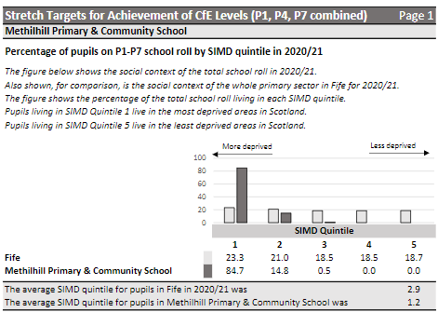
Methilhill SIMD Data Profile

Literacy
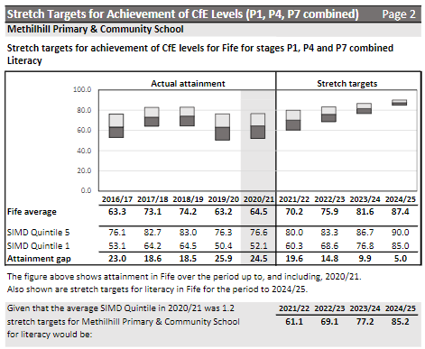

Literacy
Expected Impact | Interventions Planned | Measures of Success  (Triangulation of Evidence) | Impact on Learners  On-going evaluation
Attainment in Reading at P1, P4 and P7 will reach 61%  Attainment in Writing at P1, P4 and P7 will reach 61 %  Attainment in Listening and Talking at P1, P4 and P7 will reach 61 % | Consistent and continual analysis of Data to inform targeted interventions.  Continue to share expectations of the teaching of Reading and Writing skills at Methilhill  Creating opportunities for collaborative planning and co-operative teaching  Planned and targeted usage of Rapid Reader, GLOW (Teams) and SEESAW app to support learning at home and school.  Use of Model for Improvement methodology to track individual pupils’ attainment.  Get Writing – Read Write Inc. - PSA  Targeted co-operative teaching of writing – P1 - 3  P1 Music Transition Programme – Focus on Rhyme

Numeracy
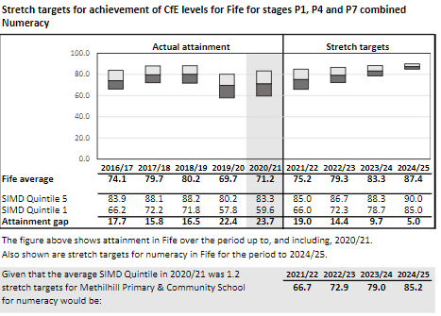

Numeracy
Expected Impact | Interventions Planned | Measures of Success  (Triangulation of Evidence) | Impact on Learners  On-going evaluation
Attainment in Numeracy at P1, P4 and P7 will reach 67% | Numeracy  Continue to share expectations of the teaching of Numeracy/Maths skills at Methilhill  Creating opportunities for collaborative planning and co-operative teaching  Planned and targeted usage of Sumdog, GLOW (Teams) and SEESAW app to support learning at home and school.  Use of Model for Improvement methodology to track individual pupils’ attainment.  Consistent and continual analysis of Data to inform targeted interventions.

HWB
Expected Impact | Interventions Planned | Measures of Success  (Triangulation of Evidence) | Impact on Learners  On-going evaluation
A few children will be supported daily to be ready to learn alongside peers in the classroom.  A few children will be supported to attend school more than 80% of the time by February 2022. | Promoting Positive Relationships and Nurturing Approaches  Share the updated SWAY on relationships and classroom management  Focus on Re-connection with Pupils  Implement staff professional learning on KIT Bag / Mindfulness  Review Demand Avoidance with all staff with a particular focus on the use of 5 Point Scale  Input on Inset 2 and 3  Termly Collegiate  Attendance  - Cluster Attendance Project. | Staff questionnaire  DEN Pupil focus groups  Learning Walks | All children and staff will be aware of a range of strategies to support children to make safe choices and resolve difficulties.  Positive relationships between almost all children and a school member of staff.
Intervention 1  What are we trying to improve?  Your aims should be specific and targeted i.e increase x to y by Z. | Max 200 words. How does this intervention tie in with your rationale? | How will evidence be gathered – data, views, direct observations? | What has been the impact?

Pupil Equity Financial Plan Session 2021 - 2022

- See Spreadsheet Summary

Attendance / Lateness
- Use Annual Summary from Power BI

Fife’s Recovery & Reform - Using data to target improvement work
Rationale
- We know the pandemic and its economic and emotional fall out has taken its toll on families. We know that school closures have widened the attainment gap.
- Led by Angela Logue, Fife’s Recovery and Reform programme aims to increase attainment for all our learners whilst closing the poverty related attainment gap. In order to achieve Fife’s overall attainment aims we need to make improvements across our system at school, class and individual level.
- A data report is available (from Stuart Booker) clearly laying out the contribution needed by each school to deliver Fife’s Recovery and Reform Stretch Aims.
- We appreciate the enormity of the challenge ahead and we wish to offer practical training and support to schools to maximise efforts and accelerate improvements.
- Having taken a deep dive with three schools using their report, Head Teachers have found the process beneficial in identifying specific areas for improvement. They feel this process has supported them to hone in on what aspect they need to focus on in order to deliver the greatest impact.
- We would therefore like to support you to analyse and understand your school data report; what the data is telling you, and for this to inform your school improvement priorities and improvement activity during 2021/22.
Offer
- We will support you to establish an improvement team, involving key members (2-4 staff) that are best placed to lead improvement work aligned to emerging priorities.
- The improvement team will have the opportunity to take up Quality Improvement training and support.
Training
- Our training is based on an experiential learning model, with minimal focus on theory but providing coaching support to apply Quality Improvement tools to your own context and improvement challenges. Teams will apply a range of QI tools and techniques to their work to understand their systems, gather and organise information, understand variation and identify and test change ideas with rigor to support implementation, spread and scale. Learning gathered will be fed into Fife’s Recovery and Reform Programme.
- Staff would need to commit to:
- 1 Full Day’s Training
- 6 x 2hour Twilight Sessions
- Touchpoints sessions led by your school improvement lead (for schools that don’t currently have a Fife QI Leader, coaching support will be provided).
Expectations
- In order to deliver improvement within your school and contribute to Fife’s Strategic Recovery and Reform Agenda, this training would need to be a strategic priority within your school and have your senior leadership team’s full commitment and support. The programme will require participants to have time and space to be able to regularly connect as a team, enabling them to integrate and progress improvement activity as part of their daily work therefore you will require to create this capacity to ensure your improvement is delivered.
- For those who do not have a Fife QI Leader within their establishment, a member of the senior leadership team will be required to attend all the training sessions and provide the team strategic support back in school. You will also be assigned a QI coach / mentor.
Learning Objectives:
This process is designed to support schools to:
- Use their school data to inform their School Improvement Planning and subsequent improvement activity during session 21/22.
- Understand Quality Improvement Methodology as a roadmap for improvement projects.
- Develop, test and implement changes identified as high-leverage change ideas.
- Become skilled in how to use data for improvement, including how to use run charts, and other key quality improvement tools.
- Be able to demonstrate impact of changes introduced.
- On completion of the programme, continue the team approach to improvement and share learning systematically to scale up projects that deliver impact.
- Leave with a specific plan of how you will continue to embed Quality Improvement approaches within your establishment and inform future school improvement planning.
- Contribute to Fife’s Recovery and Reform Programme – improving outcomes, sharing learning and supporting peers to make the changes that lead to sustainable improvements.

As of 28.6.21

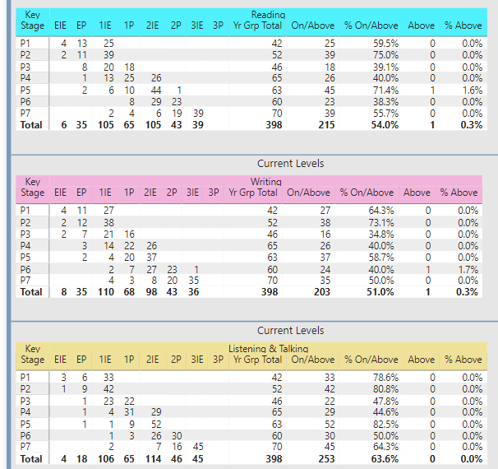
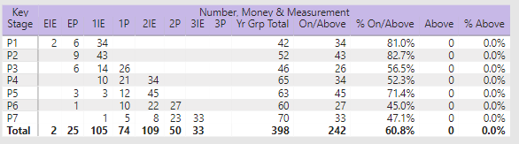

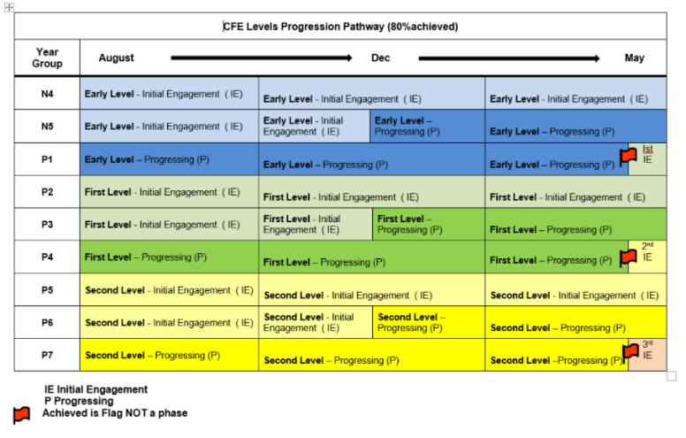

Data from each stage / class – starting point – August 2021

Reading |  |  |  | Writing
Stage | On Track | Not yet achieving |  | Stage | On Track | Not yet achieving
P2 | 60% | 40% |  | P2 | 59% | 41%
P3 | 75% | 25% |  | P3 | 73% | 27%
P4 | 39% | 61% |  | P4 | 35% | 65%
P5A | 41% | 59% |  | P5A | 44% | 56%
P5B | 39% | 61% |  | P5B | 36% | 64%
P6A | 63% | 38% |  | P6A | 56% | 44%
P6B | 81% | 19% |  | P6B | 61% | 39%
P7A | 60% | 40% |  | P7A | 63% | 37%
P7B | 20% | 80% |  | P7B | 23% | 77%
Listening and Talking |  |  |  | Numeracy and Maths
Stage | On Track | Not yet achieving |  | Stage | On Track | Not yet achieving
P2 | 78% | 22% |  | P2 | 80% | 20%
P3 | 78% | 22% |  | P3 | 83% | 17%
P4 | 43% | 57% |  | P4 | 61% | 39%
P5A | 50% | 50% |  | P5A | 49% | 51%
P5B | 39% | 61% |  | P5B | 55% | 45%
P6A | 78% | 23% |  | P6A | 63% | 38%
P6B | 87% | 13% |  | P6B | 81% | 19%
P7A | 77% | 23% |  | P7A | 63% | 37%
P7B | 30% | 70% |  | P7B | 27% | 73%

