What are Seagull Proof Sacks?
- Seagull Proof sacks are strong reusable bags which are used when collecting household waste sacks.
- They help protect your waste sacks from gulls, foxes, vermin and the elements.

Image of a Seagull Sack
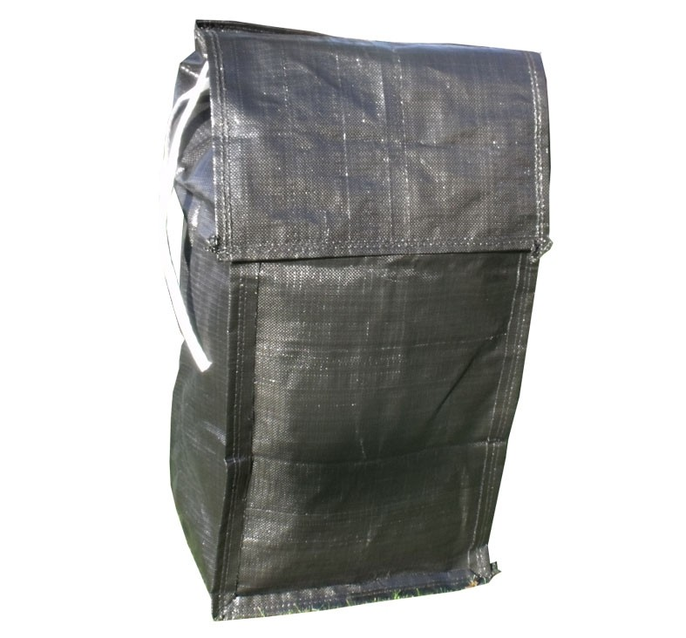

*Address

*Uplift Day

How to use Seagull Proof Sack

- Place your Household waste sacks in the Seagull proof sack, ensure lid is closed and put on kerbside for collection.
- Only put your seagull proof sack (and contained household sacks) out on collection day – i.e. Tuesday
- Sacks should be out by 6am on collection day and left out no later than 9pm (or when emptied)
- Clearly display your address on your seagull proof sack.
- Seagull proof sacks must be removed from the street after collection

