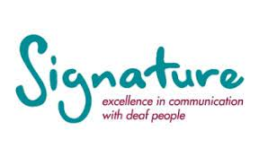
British Sign Language Level 2

Every Thursday from 9th September 2021
1.30pm – 4.30pm (until June 2022)

Held at Town House, Wemyssfield,
Kirkcaldy, KY1 1XW

The cost is £350

Register your interest at https://forms.office.com/r/0w58jRa8pq
Or use your phone by scanning the QR code 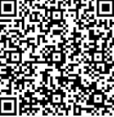

Closing Date: 13th August 2021
