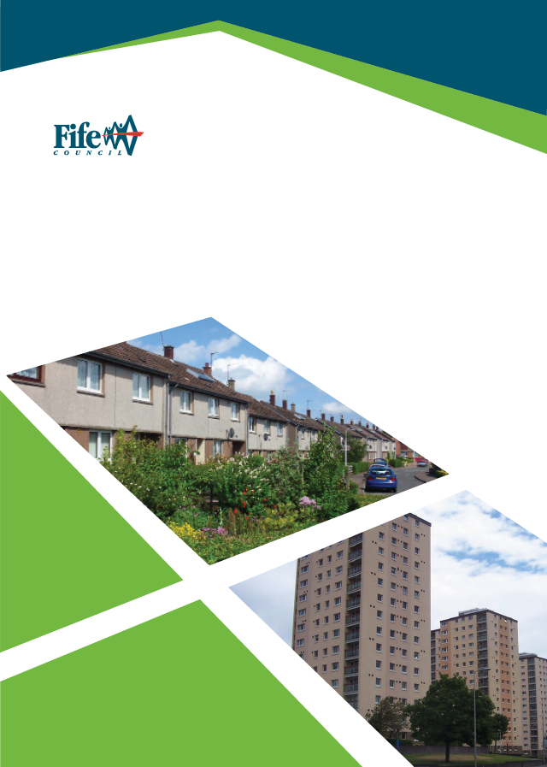
Introduction

Domestic Property Acquisition Policy
(Revised October 2020)

Housing Services recognises that under the Right to Buy Scheme which was active between 1980 – 2016 many properties were sold; this policy seeks to purchase properties back in the areas of greatest demand to assist those in the greatest need of housing.
The focus will be for these to be former Local Authority properties however, in certain circumstances properties that are not former Local Authority may be considered.
The purchase of these properties will support the Affordable Housing programme (AHP) and link in with Fife’s Rapid Re-Housing Transition Plan (RRTP).

Aim

The aim of the Property Acquisition Policy is to meet a range of specific housing needs by purchasing properties from the open market and directly from owners to support the AHP & RRTP.
All properties that are purchased will be improved to meet the Scottish Housing Quality Standard (SHQS) & Energy Efficiency Standard for Scottish Social Housing (EESSSH).

Objectives

- Meet demand in the areas of most need as reported in the Housing Needs and Demand Assessment (HNDA).
- Assist in the delivery of the Fife Rapid Rehousing Transition Plan.
- Identify properties on the open market or through speculative requests from owners.
- Assist Fife in delivering the Affordable Housing programme.
- Prioritise allocating properties to homeless applicants to support Fife’s RRTP.
- Raise the standard of housing in Fife by improving all properties to meet SHQS & EESSSH.
- Work alongside Fife Council’s Empty Homes team to identify potential properties to acquire to bring back into use.

Criteria

A property will be considered under the process where it meets at least one of the
following criteria:

- Resolve a Homeless Situation / Prevent Homelessness
- To help meet housing need where there are significant pressures and limited opportunities to build new homes
- To facilitate Estate Action or Regeneration Schemes
- To facilitate New Build Schemes
- To meet specific needs
- To meet specific tenant’s’ housing needs for more appropriately sized or adapted properties by adopting a transfer-led approach to maximise housing opportunities

1. To Resolve a Homeless Situation / Prevent Homelessness

The Council may consider purchasing properties from the open market to resolve a homeless situation and/or prevent homelessness, the focus will be to purchase larger properties (3 bed and above) to reduce the time that families with children spend in temporary accommodation.

It is proposed that the Council may purchase properties to resolve / prevent homelessness where:

- The Service has identified a suitably sized property on the open market, the properties will be purchased with vacant possession.
- The application to the Scottish Government through mortgage to rent is successful (see www.mygov.scot/home-owners-support-fund/).

2. To help meet housing need where there are significant pressures and limited opportunities to build new homes

Significant Housing need will be determined by reference to the HNDA and cross-referenced with the AHP. Typically, repurchase will take place where:
- The AHP is likely to deliver less than 50% of the total HNDA requirement for affordable housing
- The property is a former local authority property
- The house size and type are under-represented in the local housing stock mix and demand exists
- Demand will be demonstrated through the Fife Housing Register (FHR)
The property will be purchased with vacant possession.

3. To facilitate Estate Action or Regeneration Schemes

It may be necessary to repurchase former Local Authority properties to ensure successful outcomes in terms of place-making and sustainable communities.

These will include:

- Properties in blocks of flats where the owners are unable to meet the costs of improving the block. The property can be purchased with vacant possession or the current owner-occupier may be offered a secure tenancy.
- Properties in blocks of flats where purchasing the property would give Fife Council majority ownership in the block. The property can be purchased with vacant possession or in exceptional circumstances the owner may be offered a secure tenancy.
- Properties in schemes where the proposal is to demolish the existing properties and build new ones. The property will be purchased with vacant possession.
Properties will generally be former Local Authority properties but may include other properties if included in the boundaries of a formal Estate Action or Regeneration Scheme.

4. To facilitate New Build Schemes

It may be necessary to purchase properties to gain appropriate site access or make satisfactory infrastructure works to a new build scheme.
Properties may or may not be former Local Authority properties. Normally, the property will be purchased with vacant possession for demolition. However, it may be that the site objectives can be achieved by using part of the garden ground, in which case Fife Council will only seek to purchase the land required.

- To meet specific needs

The Council may purchase properties to be used for specific needs applicants where no suitable Council property exists, taking account of the costs to provide adaptations or alterations. The Council may also purchase a private rented property which has been specifically substantially adapted in a major permanent way (i.e. does not have temporary adaptations for example stair lifts or ramps) where:

- The property should normally be purchased with vacant possession
- In exceptional circumstances where there is a sitting tenant who requires the adaptations in the property the Council may look to purchase the property and offer the tenant a secure tenancy.
The tenant should have a live Fife Housing Register application and there is no suitable Council house to meet the needs of the sitting tenant locally (including consideration of the costs of adapting the property).

- To meet specific tenant’s needs for more appropriately sized or adapted properties

It is recognised that there is a need to ensure that council tenants have the opportunity to up or downsize, or move to more suitably adapted or adaptable properties, particularly where the council new housing programme does not deliver in some areas the required number of housing options for our tenants.

It is proposed that the council seek to purchase properties to satisfy transfer needs following discussion between the Area Housing Manager and the Lead Officer (Affordable Housing).

Cost and Value for Money (VFM)

Purchase cost will be as assessed by an appropriately qualified surveying company or the District Valuer. The price paid by the Council will not exceed the valuation unless in exceptional circumstances. A pre-requisite for agreement to purchase will be that an estimate of repairs and improvements costs to meet the SHQS and the EESSSH will be obtained through a condition survey. These costs plus the purchase price should not normally exceed the valuation and / or new build benchmark costs for the property type.

Process

The full process is available on FISH process management:

Fife Council Main Menu – Communities Menu – Housing Services Menu – Managing Properties, Property Acquisition Process

Lead Officer (Affordable Housing & Regeneration) should complete the Property Acquisition request form and forward it to the Housing Manager to consult with the area team, this should be signed by the HM and returned to the Lead Officer.

The property will be subject to an internal SQHS & EESSSH survey, external valuation and VFM assessment.

In all cases the Housing Management Executive and elected members for the ward in which the property is located must be consulted, and provided with a summary on offer price, costs of meetings SHQS and ESSHH1 and the likely housing subsidy for each property.

The final decision to purchase will be taken in conjunction with the Executive Director (Communities) in accordance with the Fife Council Scheme of Delegation.

Fife Council will not look to purchase properties through a private sale with Fife Council employees.

Budget

The Head of Housing Services is responsible for the HRA Capital Budget to finance purchases of private properties. The budget for the Scheme is set as part of the HRA budget each financial year. The Lead Officer (Affordable Housing & Regeneration) will maintain a budget monitor.

Resources

Staff resources to support the Scheme will be drawn from Housing, Estates, Legal, Finance and Building Services.

Equal Opportunities

We will ensure that no individual is discriminated against on grounds of gender or marital status, on racial grounds, or on grounds of disability, age, sexual orientation, language or social origin, or other personal attributes, including beliefs, or opinions, such as religious beliefs or political opinions. We will ensure the promotion of equal opportunities by translating information and documentation and providing other formats such as large print, CD and Braille, as required.

Contact

Email – property.acquisitions@fife.gov.uk

How to make a comment or complaint

You can do this in any of the following ways:

- Go online at https://www.fife.gov.uk/kb/docs/articles/have-your-say2/make-a-complaint
- Phone our general enquiries line: 03451 55 00 00 (8am-8pm Monday to Friday)
- BT Text Direct for the Deaf: 18001 01592 55 11 91
- Visit us at any Council office and speak to a member of staff
- Write to us at: Freepost RTBZ-BBJT-BBYC, Comments and Complaints, Fife Council, Fife House, Glenrothes, KY7 5LT
- If you are deaf and have registered for the Council’s SMS text service, please send your correspondence to the number given when you registered.

It is easier for us to resolve complaints if you make them quickly and directly to the service concerned. So please talk to Housing Services’ staff and they can try to resolve any problems on the spot.

If you are contacting us, tell us:
- Your full name and address
- As much detail as you can
- What has gone wrong or right
- If something has gone wrong, how you want us to resolve the matter.

Review

The Domestic Property Acquisitions Policy will be reviewed in 2022.
