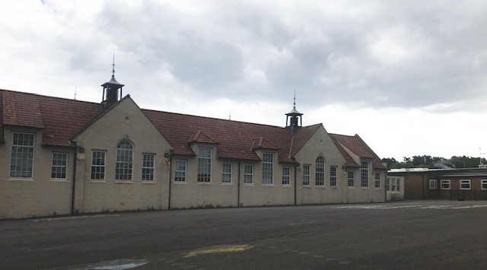

2019/20
Denend Primary School and Nursery
Improvement Plan 2021-22

National Improvement Framework Priority: Improvement in children’s and young people’s health and wellbeing
Focused Priority 1: Improved pupil, parent and staff wellbeing (Cluster and Denend Priority)
HGIOS4 Quality Indicators |  |  | HGIOELC Quality Indicators
3.1 Ensuring wellbeing, Equality and inclusion  2.6 Transitions  1.2 Leadership of Learning  1.5 Management of resources to promote equity  2.4 Personalised support  2.5 Family Learning  2.7 Partnerships |  |  | 3.1. Ensuring wellbeing, Equality and inclusion  2.6 Transitions  1.2 Leadership of Learning  1.5 Management of resources to promote equity  2.4 Personalised support  2.5 Family Learning  2.7 Partnerships
Expected Impact | Strategic Actions Planned | Responsibilities |  | Measure of Success  (Triangulation of Evidence) | Timescales
Improved pupil emotional wellbeing P6-S6.  Improved confidence in PSAs knowledge and skills in supporting emotional wellbeing particularly children suffering with poor mental health.  Improved confidence in team work and leadership skills at P6/7 stage and improved transition to S1 – August 2022 | Baseline in schools at stages P6/7 and S1 using resilience tool kit with all learners? - monthly updates collated  Targeted support through kit bag, seasons for growth, nurture groups led by LS teaching staff and PSAs.  Tree of Knowledge training and online supports to be introduced at Denend for P5-7 pupils and shared with families  20 PSAs across the cluster (2 from Denend plus LS teacher) to receive 2 full days training in supporting children’s emotional wellbeing and mental health through nurturing approaches.  Pedagogy Team training  OMM training – Louise Stean  P6 pupils across cluster to be supported by Active Schools and current Junior Leaders (Lochgelly South and Denend) to be trained as Junior Leaders and to lead on this in their own school. | P6/7 teaching staff and LS teachers  LS teacher (Barbara Gow), PSAs and P6/7 teaching staff  PT trained to introduce to staff/parents -Gail Thomson  LS teachers network to collaborate and lead on in own settings  Janet Cunningham  Rachel Hill  P6 and P7 teaching staff  Simon Warren  Mick McMillan  Andrea McDonald |  | Improvements in feelings of pupil wellbeing  Improvements in engagement data (Levens scale)  Shine data  Wellbeing webs and Shine data  Parent and pupil surveys  Pre course survey completed by PSAs  Second survey completed  Pupil survey data (before and after training)  Direct observations in playgrounds | Start Term1 and monthly data gathering  Begin September 21 and reviewed after 6 weeks – review 29 October 21  Inset day 1  February inset day (Inset 4)  Inset day 17th August (Inset day 2)  Inset day 12th November 21 (Inset day 3)  By February so P6 pupils can have an impact in their own school for the rest of session 2021/22
Ongoing Evaluation

National Improvement Framework Priority: Improvements in attainment, particularly in literacy and numeracy.

Focused Priority: Raising attainment and confidence in numeracy and maths across nursery/school.
HGIOS 4 Quality Indicators |  |  | HGIOELC Quality Indicators
- Self evaluation for Self-improvement  - Leadership of Change  2.2 Curriculum  2.3 Learning, teaching and Assessment  - Raising attainment and achievement  1.5 Management of resources to promote equity |  |  | 1.1Self evaluation for Self-improvement  1.2Leadership of Change  2.2 Curriculum  2.3 Learning, teaching and Assessment  3.2 Securing Children’s progress  1.5 Management of resources to promote equity
Expected Impact | Strategic Actions Planned | Responsibilities |  | Measure of success | Timescales
Attainment at P1,4 and P7 to  Aligned and consistent planning and assessment documents (RFU) and consistent support on learning walls  Very good use of Early Level progression planner in new PLJ document  Improved staff confidence in maths pedagogy and use of resources  Improvements in mental calculation at P4-6 stage | Audit of current practices and staff confidence in teaching and assessing numeracy and maths  Targeted support and team teaching  Set up TLC model to reflect and plan for improvements in maths teaching.  Professional reading on Differentiation - Sue Cowley -Ultimate guide to Differentiation  Introduce new Maths teaching resources  Introduce mental calculation weekly programme | Gail Thomson (newly appointed PT)  Suzanne Black  Mara Sweeney  Claire Wyatt  .  NCC teacher (Lorna Young) |  | Base data at P1  SNSA data at P4 and P7  Attainment data  Teacher survey  Classroom observations  Peer observations | Term 1  Term 1 and 2  Term 1
Ongoing Evaluation
National Improvement Framework Priority – Creating an Autism Friendly environment in school and nursery

Focused Priority: Creating and Autism friendly environment in school and nursery
HGIOS 4 Quality Indicators |  |  | HGIOELC Quality Indicators
3.1 Ensuring wellbeing, equality and inclusion  2.4 Personalised support |  |  | 3.1 Ensuring wellbeing, equality and inclusion  2.4 Personalised support
Expected Impact | Strategic Actions Planned | Responsibilities |  | Measure of success | Timescales
Children with ASD/on AAP pathway and with social, language and communication difficulties to make good progress in learning  Children to experience less anxiety in school and nursery through a more predictable routine and daily timetable  Consistency in Boardmaker usage across school and nursery (visual timetables, lanyards – visuals for Now/Next) | Professional learning from Educational Psychologist and ASIST  Staff to set up classrooms according to autism friendly environment suggestions  Staff to plan for and conduct a small test of change and to capture progress through measuring data | Pauline Davidson  Claire Wyatt  Sharon Mclean  Lindsey Campbell  Caroline Kane  Barbara Gow  All teaching staff  All EYOs  PSAs |  | Staff to plan to measure succcess in their own room with own learners i.e. less interruptions in learning or more engagement in group tasks  Direct observations from peers, SLT and LS teacher | Inset Day 2 and 2 x twilights in term 1/2  Term 1 and 2
Ongoing Evaluation

