Our Improvement Plan 2021~2022

As a team, we have identified ensuring the children experience a broad, balanced and progressive curriculum rooted in our rich local area as a priority. We have already begun to embed new planning and tracking processes this term and look forward to driving this forward. Of those parents that returned their parental questionnaire – we also recognise that wellbeing remains a priority for families in these difficult times.

The children have made great progress in their use of technology, building their skills using platforms such as Teams during Lockdown. We aim to look closely at our resourcing, as well as our planned experiences, to ensure that we continue to build on the progress already made. It will be exciting to look at new technologies to support the development of, for example, coding skills with the children.

This session our priorities are:

1. Ensure children experience a broad and coherent Broad General Education with a focus during the recovery phase on literacy, numeracy and health & wellbeing across learning. Effective tracking and monitoring will support pupil progress.
2. Increase pupil and staff engagement in digital technologies to support the development of digital skills for learning, life and work.

We look forward to working with you on these priorities over the coming session.

A New Chapter

I have thoroughly enjoyed getting to know the children, the staff, the school and starting to get to know you as parents and carers. I would like to thank Tamsin for her hard work over the past two sessions and look forward to building on the progress already made. I hope this summary gives you a sense of the areas the school was working on last session and the progress made. We will aim to provide a Sway to share how we are progressing with our improvement priorities each term. If you think you can help us in any way, please do not hesitate to get in touch.

Many thanks,

Lesley O’Brien

Headteacher

Pitlessie Primary School

Standards and Quality Report Summary 2020~2021

and

School Improvement Plan 2021~2022

**“Learn, Achieve, Succeed!”**

**Honesty**

**Kindness**

**Respect**

**Positivity**

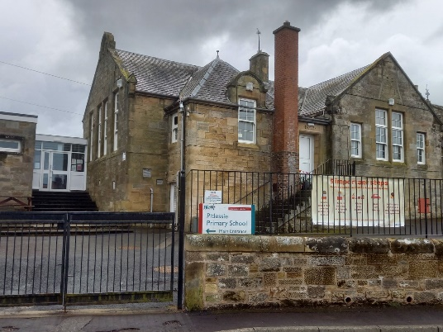



What improvements were made?

* Planners were created using How Good is OUR school, focussing on the evaluative language and questions when teaching the topics.
* Planners were created detailing each of the SHANARRI, wellbeing indicators. These had resources and activities linked to each indicator.
* Almost all children appear to be more resilient. We recognise that the second lockdown appears to have had a greater impact on our older learners.

Evidence of Significant Wider Achievement

* Both schools have a woodwork bench in their younger class. The P1-3 children have learned how to use saws, hammers, clamps, etc, independently and are confident with using tools and making an end product.
* Both sets of P4-7 pupils have had their Bikeability training.
* P6 and P7 pupils had an outdoor experience led by Ardroy in June.
* All children have participated in growing and eating the fruits of their labour.
* All children are participating in French Fun for Families – family engagement programme in French.
* All children are now confident with navigating around Microsoft Teams, GLOW, Sumdog, Teaching Monsters to Read, Reading Eggs, Big Maths. Mathletics, etc
* P6 took part in the Euroquiz for the first time.
* The children in Pitlessie learned BSL and signed songs which were filmed for a Christmas experience for their families. There was also Scottish Country Dancing and creative dancing, again filmed, so that parents had an alternative Christmas service to watch at home.
* Groups of early years pupils in Pitlessie have been part of enrichment groups and have taken part in activities such as baking each week ~ which has supported the numeracy learning in class.

This is a summary of Tamsin’s Standards and Quality report from last session. You can find a full copy on our school website.

What has been the outcome and impact of our 2020~2021 Improvement Priorities?

1. **Improvement in attainment for all, particularly in Literacy**

What we did:

* We focussed on Writing and Spelling
* Pobble was introduced as a Writing resource and as a way of sharing this area of work with parents and families.
* Staff had online training and Mark Pitblado, a Senior Teacher from last year’s Learning Partnership, spent a day with each teacher in their class.
* Classes published work on Pobble where they had been given permission to do so.
* A collegiate working party over both schools, developed draft Writing planners and a progression, for each level.
* A collegiate working party developed planners, a progression and policy for Spelling using the resource Alpha to Omega.
* This was shared and piloted across both schools. It has been identified as a resource that we will use to support children that benefit from additional support to develop their skills.

What improvements were made?

* All children are engaging in Writing and it is being taught in class more frequently.
* Parents could see their children’s writing on the Pobble online platform.
* Teachers can see examples of good writing on Pobble and can share this with their class when the class are constructing Learning Intentions and Success Criteria.

1. **Improvement in children and young people’s health & wellbeing**

What we did:

* We focussed on the Emotional wellbeing of our pupils upon our return to school.
* Planners were shared across both schools.
* Our non-class contact teacher focussed on the wellbeing indicators for her lessons.