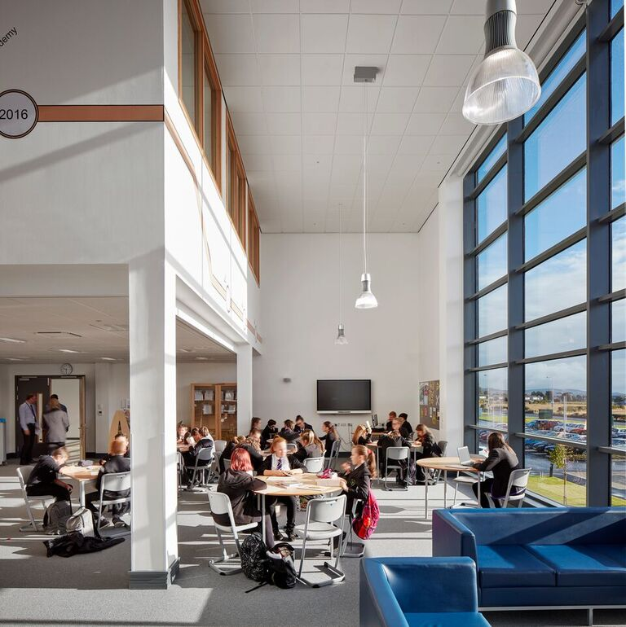
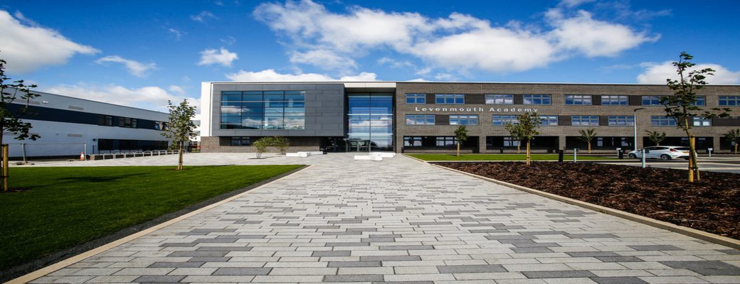
THE LEVENMOUTH ACADEMY SCHOOL IMPROVEMENT PLAN 2021 - 2022

The Levenmouth Academy SIP is a progressive programme of improvement, based on evaluation of impact and progress in sessions 2019 – 2020 - 2021. We are committed to excellence and equity for all in line with our vision for 2024 with a continued focus on improving outcomes.

Our school. Our values. TRUST RESPECT AMBITION TEAMWORK RESPONSIBILITY
Learning to Achieve your Personal Best

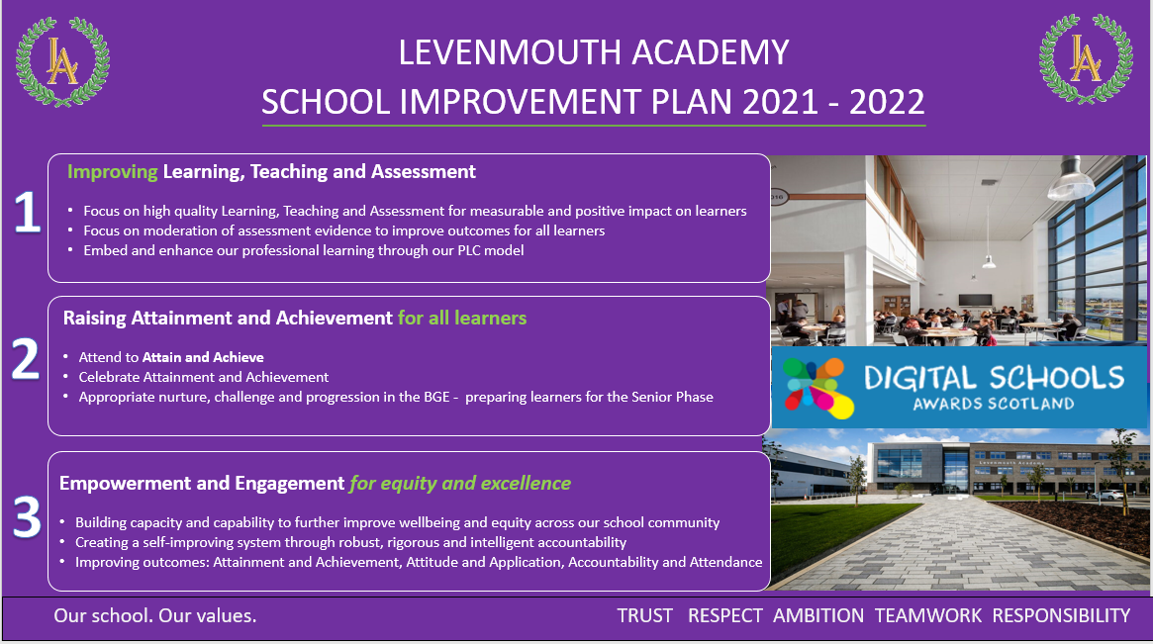
Agile Recovery Information
Continuing into 2021 – 2022, Levenmouth Academy is committed to work to support recovery from the Covid-19 pandemic, with sharp focus on mental health and wellbeing, and targeted work to improve equity. This underpins our continued focus on improvement.
Our plan is driven by an ambitious improvement plan, following on from the challenging times for our whole community during COVID-19 and will:

- Support the school in responding to the immediate demands arising from the Covid-19 pandemic;
- Provide a basis for learning in relation to the school’s pandemic response, including areas where different ways of working, required as a consequence of the pandemic, have proved beneficial both to families and staff;
- Allow us to seek to include the experience of young people, families, staff and partners of Levenmouth Academy;
- Support Levenmouth Academy in working towards its longer-term strategic goals, continuing to embed our vison and values;
- Pupil wellbeing remains at the core of our agile response and ongoing planning for improvement – for equity and excellence.
OUR SCHOOL, OUR VALUES OUR CONTEXT
Levenmouth Academy is one of the largest merged campuses in Europe. Formed of ten associate primary schools, we have a strong cluster who work together towards a shared vision, with shared values and aspirations for our young people.
We currently have 1583 young people. Our roll is forecast to increase to around 1650 in August 2021. This is reflective of significantly fewer external placing requests to other secondaries and reflects an increase of around 60 young people in this year’s S1 cohort.
Working in an area of significant socio-economic deprivation, our young people benefit from around £320k per annum of Pupil Equity Funding from The Scottish Government, aimed at reducing the poverty-related attainment gap. We have 76% of our school roll residing in SIMD 1-3 with an FMR of 29%.
112.3 teaching staff 20 single status staff
Extended Leadership Team
Senior Leadership Team – HT, BM 5x DHTs
16 PTs Curriculum
14 PTs Pupil Support
4 PTs Raising Attainment
PT DYW/STEM
PT Equity and Excellence
PT Curriculum
PT Digital Technologies
PT Learning, Teaching and Assessment
28 Pupil Support Staff, including: 23 Pupil Support Assistants, 3 Pupil Support Officers, 1 Attendance Support Worker, 1 Apex/ReSet

National Improvement Framework Priority: Available here

Improvement in attainment, particularly literacy and numeracy
Closing the attainment gap between the most and least disadvantaged young people
Improvements in employability skills and sustained, PSLD for all young people

HGIOS4 Quality Indicators |  | Learning Teaching and Assessment |  |  | NIF Drivers – Colour coded to driver diagram
QI 1.1 Self-evaluation for self-improvement  QI 1.2 Leadership of Learning  QI 1.3 Leadership of change (learning)  QI 2.3 Learning, teaching and assessment  QI 2.2 Curriculum  QI 3.1 Improving wellbeing, equality and inclusion  QI 3.2 Raising attainment and achievement |  |  |  |  | Our priorities – School Improvement  School Leadership  Teacher Professionalism  Assessment of Learner’s progress
Expected Impact | Strategic Actions Planned |  | Responsibilities | Measure of Success  (Triangulation of Evidence) |  | Timescales
High quality Learning and Teaching | Embedding and enhancing Levenmouth Learning Standard.  Class Visits and Quality Assurance focused specifically around high quality learning, teaching and assessment.  Identify and share effective practice across school.  Professional Learning Communities (PLCs) model with a focus on improving Learning, Teaching and Assessment. |  | DHT (Learning and Teaching)  PT (Learning and Teaching)  DHT Faculty Links  PTs Curriculum  All Teaching Staff | High quality learning evidenced through observation.  Positive feedback from young people via pupil voice.  Young people that are engaged in learning – improving trends in Depts.  Feedback from practitioners around improvements in engagement of young people/successes in Departments (also linked to SQR) |  | Continual evaluation/observation by DHTs/PTs
Improving learning progression in Numeracy from P6-P7 to S1.  Meeting all learners’ needs in Mathematics via appropriate pace and challenge in Numeracy.  Increased expectations of all young people – greater understanding of levels by young people, parents/carers and stakeholders. Evidenced through QI evidence processes | Strategic initiative for 2021-2023. Year 1 – Small test of change involving associate primary schools  Levenmouth Cluster Moderation Project (P6-7/S1) – specific CLPL focus on understanding of standards, alignment and progression – strategic improvement planning (Y1) being expanded in Y2.  Levenmouth Cluster Moderation Project (P6-7/S1) to build capacity in Mathematics Teachers  Launch of improved BGE tracker in Mathematics to ensure more effective progression and tracking value added. |  | DHT (Attainment – N Haddow)  DHT (Curriculum)  PT BGE Maths/Numeracy in liaison with PTC Maths  CTs (Mathematics)  P6-7 Class Teachers  HT (Methilhill PS) and Joleen McCool (Improvement Officer) – led by N Haddow DHT | Teacher feedback (P6-7 + S1)  Learner feedback – experiences in Mathematics and Numeracy  Improvements in S1 performance for almost all learners – assessment data evidence  Tracking Mathematics and Numeracy outcomes |  | Session 2021-2022  Cluster discussion/launch – Term 1  Review in Terms 3 and 4 and agree future actions/interventions
Improving learning progression in Literacy from P7 to S1.  Meeting all learners’ needs in English with appropriate pace and challenge in S1 Curriculum  Increased expectations for young people – greater understanding of levels and benchmarks. | Cluster Moderation (Literacy) Project (P7-S1)  Focus on embedding and reviewing previous project work (pre-pandemic)  Embed BGE tracking in English and Literacy. |  | DHT (School Improvement)  DHT (Curriculum)  PT BGE English/Literacy in liaison with PTC English  CTs (English)  P6-7 Class Teacher  PT Learning, Teaching and Assessment | More curricular progression and alignment – evidence in young people’s outcomes.  Improved L3+ CfE declarations by S3 of up to 5%  Specifically;  Listening at Level 3+ from 71% to 74%  Reading at Level 3+ from 65% to 68%  Writing at Level 3+ from 64% to 67% |  | Term 1 – Virtual Cluster meeting  Term 2 – Material Sharing/CLPL and Moderating the Standard  Term 3 – Moderation and planning for S1 Curriculum
Ongoing Evaluation

National Improvement Framework Priority: Available here  Improvement in employability skills and sustained positive SLD for all young people  Improvement in attainment, particularly in literacy and numeracy  Improvement in young people’s health and well-being |  |  |  | Fife Priorities/Local Plan Priorities  Levenmouth Area Plan  Opportunities for All 2.2.1, 2.2.2, 2.2.3 available here
QI (HGIOS 4) |  | Raising Attainment and Achievement for all learners |  |  |  | NIF Drivers
QI 1.1 Self-evaluation for self-improvement  QI 1.2 Leadership of Learning  QI 1.3 Leadership of change (learning)  QI 2.3 Learning, teaching and assessment  QI 3.1 Improving wellbeing, equality and inclusion  QI 3.2 Raising attainment and achievement  QI 3.3 Employability and Creativity Skills |  |  |  |  |  | Our priorities – School Improvement  School Leadership  Teacher Professionalism  Assessment of Learner’s progress
Expected Impact | Strategic Actions Planned |  | Responsibilities |  | Measure of Success  (Triangulation of Evidence) |  | Timescales
Improvements in Attendance  Improvement in attendance levels across all stages – focus on “attend to achieve” – aiming to be in line with Fife average for attendance.  Improvements in all attainment and achievement measures – tracked against improvements in attendance.  Universal Provision that engages all young people in an appropriate curriculum, tailored to meet their needs.  Clearer understanding of HNIOS across all stakeholders. | Cluster focus on Attendance. DHT Pupil Support, Education Manager and 4 Associate Primaries focusing on attendance improvement model.  Levenmouth Academy Small Test of Change group (S1s) - bespoke T/T and curriculum to support improvements in attendance and engagement.  S1 targeted groups of young people to address historical attainment and engagement challenges. Identified collaboratively with Associate Primaries.  Pupil focus groups to explore reasons for gaps in attendance with appropriate interventions thereafter.  Strategic approach to improving inclusive practice – supported by PTs Pupil Support (ASN) |  | DHT Pupil Support, Cluster HT and Ed. Manager  Daily – Pupil Support Officers – reducing learner non-engagement and period truancy  Daily – Attendance Support Worker  Weekly - SLT Meeting – Attendance item  Fortnightly – House Meetings.  Monthly – SLT data |  | Improved attendance % for young people – focus at House Meetings.  Greater engagement of target groups – impact of success from pupil voice, percentage attendance and parental engagement improvement.  Tracking of targeted groups shows a reduction in the attainment gap over the course of S1.  KPIs – improvements against VC and Fife/National average linked to attendance improvements.  Attendance Sub Group supporting enhanced role clarity as part of strategic work. |  | Cluster Attendance project ongoing 2021-2022  PSO Support – daily  ASW Support – daily  SLT Attendance focus – weekly  House Meeting Attendance focus – fortnightly  DHT RAA data sharing on attendance - monthly
Expected Impact | Strategic Actions Planned |  | Responsibilities |  | Measure of Success  (Triangulation of Evidence) |  | Timescales
Improvements in Performance  Improvements in performance in S3 at Third Level Achieved (CfE Declarations) data for Numeracy and Literacy.  Numeracy increase at Level 3+ of 10%. Increase from 74% to 84%  Literacy increase at Level 3+ of 3% overall. Specifically;  Listening at Level 3+ from 71% to 74%  Reading at Level 3+ from 65% to 68%  Writing at Level 3+ from 64% to 67%  Almost all young people recording achievements in Literacy and Numeracy via Skills Framework and Achievements recording. | Embed and review revised Instruments of Assessments for Literacy and Numeracy, leading to improved outcomes for almost all young people.  Regular and robust tracking of all young people to ensure targets are met throughout the Broad General Education. Intelligent accountability.  Specific focus on SNSA data to better plan for the needs of all learners through teacher/departmental intervention for targeted improvement.  SNSA training for English and Mathematics Department – to shape, implement and drive improvements.  Implementation of combined whole school tracker to include all attainment, achievement and 9 key characteristics data |  | DHT School Improvement (Numeracy + Maths)  DHT Curriculum (English)  PT BGE English/Literacy  PT BGE Maths/Numeracy  Class Teachers (Lit/Num)  DHT Raising Attainment (Skills Framework/ Achievement)  PT Learning, Teaching and Assessment  PTs Raising Attainment  Pupil Support Assistants |  | Level 3 Assessments to ascertain levels.  Ongoing evidence gathering and recording via Literacy and Numeracy ongoing assessments.  Observation of Numeracy Starter and plenary tasks and Numeracy-specific lessons show alignment to appropriate CfE level with pace and challenge to further extend numeracy focus and improvement  Evidence of learners better prepared for the Senior Phase and National Qualifications, evidenced through improved outcomes for young people.  Ongoing tracking and minutes of robust liaison between DHTs + PTs – success indication - performance increase of 10% in Numeracy |  | Focused Literacy and Numeracy assessment items/lessons from Term 1  Progress check Feb 2022 (Action Findings)  Analysis in November 2021 (initial projection and intervention)  February 2022 (continued strategic improvement)  April 2022 – (final stage checks and focus group targeted interventions)  Achievement Certification Points – October 2021 + June 2022
Improvements in Performance  Improvements in performance in Senior Phase Key Performance Indicators for 2021 – 2022, leading to improved outcomes for young people.  Impact: Almost all young people attaining appropriate levels and a few exceeding these.  Positive and improving attainment trend – value added for young people demonstrated via tracking evidence.  Increase in KPIs  5 @ 3 Increase 5%  5 @ 4 Increase 5%  5 @ 5 Increase 5%  1 @ 6 Increase 5% | Rigorous and robust process around effective Curriculum Pathways process  Robust and rigorous SQA reviews/analysis and agreed Raising Attainment Plan by PT with Dept Teams Shared with DHT. Focus on outcomes.  Regular, robust DHT/PT monitoring of live tracking data to monitor performance via ASM process – with early intervention of ‘at risk’ candidates with intelligent accountability.  Whole School approach to Learner Conversations as an intervention strategy alongside data tracking.  All staff will confidently use tracking and attainment data to effectively prognosticate and estimate. |  | DHT (Curriculum)  PTs Curriculum  PTs Pupil Support  DHT/House Teams |  | Triangulated evidence gained through Pupil Self-Evaluation of progress and Identification of next steps.  Measurable positive impact – value added for almost all learners – based on tracking and monitoring of ‘value added’ via BGE and SP tracking.  Evidence of success and progression in the 4 “Arenas of participation” and recording development against Levenmouth Skills Framework – young people and staff having the confidence to link to attainment strategy |  | Quality Improvement File inc ASM meetings, and Quality Improvement Calendar.  Initial SQA Reviews meeting Aug/Sp  Attainment Scrutiny Meetings throughout session in line with QA Calendar.

Improvements in Use of Data  Data informing learning, teaching and assessment. Intelligent accountability driving improvements in performance. Leading to improved outcomes for young people.  Tracking and monitoring systems are well understood by all staff and used effectively to secure improved outcomes for learners.  Strategic approach to targeted intervention – focus on Literacy Improvements in BGE.  Strategic approach to targeted intervention – focus on Numeracy Improvement in BGE.  Appropriate Learner Pathways in place – underpinned by intelligent use of data and attention to specific pupil aspiration and skillset. | Embedding Broad General Education whole school tracking system, incorporating baseline P7 data.  Further use of SNSA data across the curriculum to plan next steps in young people’s learning.  Attainment Scrutiny Meetings leading to more rigorous monitoring, tracking and effective intervention – promoting impact-driven ongoing improvement.  Literacy Intervention Programme (Fresh Start) for identified S1 and S2 pupils.  Numeracy Improvement Plan – 1 year implementation plan. Embedding, reviewing and enhancing numeracy delivery across the Dept. of Maths.  Raising Attainment and Achievement Plan (under constant review). | DHT Raising Attainment and Achievement  PTs Raising Attainment  DHT/PT (Faculties)  DHT/PTs (House/Support)  PT English  PT BGE English + Literacy  PT Maths  PT BGE Maths + Numeracy | Evidence of improved outcomes – measurement of school against Key Performance Indicators (KPI)  Improved data in INSIGHT and PowerBI  SQA Presentations 2021 – 2022  Improvements in performance and increase in %A-C and %A-D in all areas.  Improvement data for individual department.  Evidence of Value Added for individual young people  Improvements in performance in KPIs against Fife, RIC, VC and National measures.  Pupil and practitioner voice through evidenced learner conversations | Quality Improvement File inc ASM meetings, and Quality Improvement Calendar.
Improvements in Transitions  Improvements in Positive Sustained Destinations for almost all leavers to be in line with Virtual Comparator  2017/2018 – 90.48% VC 92.72%  2018/2019 – 90.94% VC 93.37%  2019/2020 – 83.46% VC 90.08%  Average LA over 3 years – 88.30%  Average VC over 3 years – 92.05%  Appropriate curricular pathways, focus on multi-modal study, including partners such as Fife College.  Better school/college partnership working to take account of labour market information/data  Improved understand of/evidence of The Career Education Standard (CES) being embedded. The majority of young people will be aware of the CES by end session 2022. | Appointment of an Employability Worker  DHT on Strategic Working Group for Local Authority focused on best practice and improving outcomes for young people post school  Curricular review completed 2020/2021. Embed and review and continue to review throughout 2021.  Alternative Curriculum Focus 2020 – 2022 (ongoing due to impact of COVID-19)  Career Education Standard- focus on 2020 – 2022 (ongoing due to impact of COVID-19)  Cohort group engagement plan promotes increased measures in CIAG performance reports and increased 1:1 support for young people in course choices and CMS assessments.  Enhanced and targeted support group identification increases engagement opportunities for all risk groups. | DHT Raising Attainment  Employability Worker  PT STEM/DYW  PTs Pupil Support *  * Discussion at House Team Meetings – PTs PS and DHTs discuss standing item of Leavers’ Information  “Responsibility of all” area (CES)– all staff to focus on this National Improvement Framework Priority.  DHT Raising Attainment  PT’s Pupil Support  SDS Partnership | Measurable impact – improvement in SLDR data/PSD for all young people.  SLDR data to show comparison to Virtual Comparator Data – 92.05% or above  Evidenced in House Minutes  Improvements in school/college partnership evidenced through SLDR data – increase in % of young people accessing college as PSD.  Enhanced PSDs for all young people – evidenced through INSIGHT, benchmarked against Fife, National and VC measures.  Evidence through enhanced partnership working – QI 2.7 triangulated through pupil, parent and partner voice. Evidence via LA Skills Framework – recording positive skill development.  CIAG Performance Summary data shows progress in monthly reports. | Curriculum Working Group – ongoing  CIAG Performance Summary data  House Meeting Attendance focus – fortnightly
Ongoing Evaluation
- Transitions discussions with PTs ASN + Cluster HTs – Oct/Nov 2021 – transitions improvement planning

National Improvement Framework Priority  Closing the attainment gap between the most and least disadvantaged young people  Improvement in employability skills and sustained SLD for young people |  |  |  | Levenmouth Area Plan  Opportunities for All 2.2.1, 2.2.2, 2.2.3 available here
QI (HGIOS 4) Colour coded to HGIOS?4 |  | Engagement and Empowerment for Excellence and Equity |  |  |  | NIF Drivers – Colour coded to NIF Driver Diagram
QI 1.1 Self-evaluation for self-improvement  QI 1.3 Leadership of change  QI 2.5 Family Learning  QI 2.6 Transitions  QI 2.7 Partnerships  QI 3.3 Increasing creativity and employability |  |  |  |  |  | Our priorities  School improvement  School leadership  Parental engagement
Expected Impact | Strategic Actions Planned |  | Responsibilities |  | Measure of Success  (Triangulation of Evidence) |  | Timescales
All young people having equitable access to the curriculum through appropriate, learner driven requirements.  Levenmouth Academy to be a fully ‘poverty-proofed’ environment.  Access to care and welfare services for all young people – improved wellbeing in a nurturing environment with highly skilled practitioners.  Improved attendance at school and in classes.  Higher degree of learner engagement. | Poverty Proofing Baseline Audit of all Departments – ensure all curricular areas and activities are Poverty Proofed.  Equity to be a focus on all Departmental Improvement Plans – strategic consideration around poverty proofing, improving operational provision.  Community Engagement around Poverty Proofing  All young people to have access to:  - Re-fresh (showering and washing)  - Re-plenish (free sanitary products)  - Re-stock (clothing bank)  - Re-energise (toiletries for families)  - Required resources and support |  | DHT (School Improvement)  PT Equity and Excellence  Equity and Excellence WG  ELT  All Classroom Teachers  All single status staff |  | Data from Poverty Proofing Self-Evaluation Tool – comparison to Education Scotland/HNIOS  Benchmarking against Education Scotland Documentation  Parental Feedback  Pupil Feedback  Staff feedback  Improvements in attendance % for those in SIMD 1-3  Continued development of Mental Health First Aider programme – tracking by PT Health and Wellbeing  Enhanced confidence and capacity of staff around Mental Health and wellbeing, evidenced through pupil voice. |  | Full Audit by September 2021  Focus on Digital Equity – ongoing  Focus on accessibility – ongoing and proactive
Enhanced learner/family engagement through eradication of Digital Exclusion.  Improved Digital Engagement across Cluster led by Levenmouth Academy, Digital Schools Excellence Award winner.  Systems level leadership of change – supporting Cluster Primary Schools and Secondary Schools in Clackmannanshire, Fife, Perth and Angus with developments in digital technology as a national mentor school. Impact – looking outwards for examples of best practice/idea sharing with wide group of establishments. | Fife Council 1:1 Device Strategy rollout to ensure Digital Equity to all S3 pupils by end 2021.  ‘Test of change’ attendance group – ICT for Family Learning funded by SCVO Scotland – aiming to improve digital engagement.  Cluster Digital Improvement Project – Cluster Digital Schools Scotland project with 6 associate primary schools. ICT provision for Cluster families – aiming to improve ongoing family engagement, learning and digital engagement with Levenmouth Cluster. |  | DHT School Improvement  PT Digital Technologies  Technicians/Support Team  DHT Pupil Support  PT ASN  DHT School Improvement  Primary HTs/DHT |  | Impact of evidence – pupil voice, parent voice and attendance improvements triangulating impact. |  | 1:1 Device Strategy by end 2021 (ongoing from 2020 due to global supply issues with ICT following COVID-19 pandemic)  1:1 Device Strategy – monitoring ongoing throughout 2021 – 2022.  Test of Change Attendance Group – ICT rollout June 2021  Cluster Digital Improvement Project:  Launch September 2021  Review January 2022
Ongoing Evaluation
Evaluation: June 2021
Headteacher in discussion with Head of Facilities Management (Tariq Ditta) around the provision of FSM for all young people at Levenmouth Academy. This is directly linked to our improvement area of SIP 3 (Equity and Excellence) and would support out drive to improve HWB for all – this would also have an impact on the Cost of The School Day (CTSD) directive

