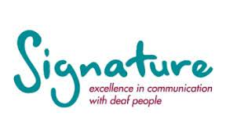
British Sign Language Level 1

Every Tuesday from 7th September 2021
10am – 12 noon (until June 2022)

Held at Town House, Wemyssfield,
Kirkcaldy, KY1 1XW

The cost is £300

Register your interest at https://forms.office.com/r/0w58jRa8pq

Or use your phone by scanning the QR code 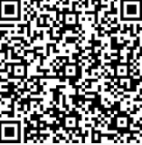

Closing Date: 13th August 2021
