PUBLIC NOTICE
THE COMMUNITY EMPOWERMENT (SCOTLAND) ACT 2015
NOTICE OF CONSULTATION ON DISPOSAL OR CHANGE OF USE OF COMMON GOOD PROPERTY

Fife Council has received a request for a lease and change the use of a common good property Former Change Pavilion, Ravenscraig Park, Kirkcaldy. Before taking a decision, the Council requires to consult under Section 104 of the Community Empowerment (Scotland) Act 2015.
Pavilion and Location with Ravenscraig Park
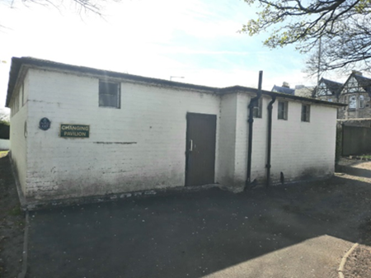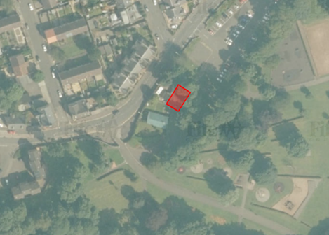

Lease Request
A lease request has been made by Kirkcaldy and District Men’s Shed a Scottish Registered Charity (Number SC048357). They have requested a 1 year lease of the former change pavilion at Ravenscraig Park, and any further lease or disposal will have a separate consultation (see location plan above).

Change of Use Request:
Kirkcaldy Men’s Shed have requested a lease of the pavilion as a base to replace their existing facility at Ravenscraig Walled Garden which does not provide sufficient security. The Pavilion will be used for men to connect, create, and converse.
The pavilion will be used for men to pursue practical interests, to practice skills and enjoy making and mending, and to provide an opportunity for social connections and friendship building, sharing skills and knowledge. The pavilion will also provide storage for equipment and to provide access to toilets for Shedders .
The pavilion has been used as a football change pavilion over the past 20 years. The pavilion has not been used for the benefit of the community for some time and has now been declared surplus to Operational Requirements by the Council.
The proposals would be subject to planning and all other statutory consents.

Representations:
Anyone may make representations about this request to Fife Council. Representations must be in writing and include the name and address of the person making it. All representations will be published on Fife Direct at www.fifedirect.org.uk/commongood
Representations must be received by Friday, 25th June 2021. They should be sent to Zahida.ramzan@fife.gov.uk

Date of Notice: Friday, 30th April 2021

