**PUBLIC NOTICE**

**THE COMMUNITY EMPOWERMENT (SCOTLAND) ACT 2015**

**NOTICE OF CONSULTATION ON**

**PROPOSED DISPOSAL BY LEASE &**

**CHANGE OF USE**

**COMMON GOOD PROPERTY**

Fife Council propose to grant a lease and permit a change of use of part of Common Good land at **East Sands Beach, East Sands, St Andrews**. Before taking a decision, Fife Council requires to consult under Section 104 of the Community Empowerment (Scotland) Act 2015.

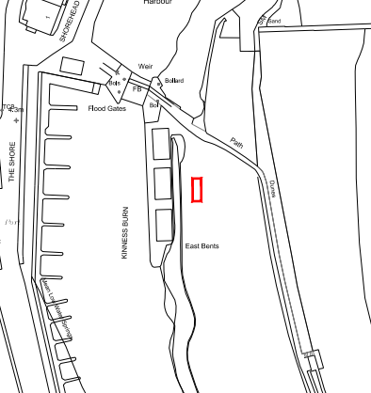

The land to be let on the former putting green at East Sands Beach is shown above outlined in red.

**Background**

The land to be let comprises part of the former putting green at East Sands Beach, East Sands, St Andrews extending to 10 square metres or thereby.

Planning permission (ref: 24/00383/FULL) has been granted for the siting of a mobile sauna unit.

**Disposal by lease & change of use**

It is proposed to grant a 5 year lease of the area shown above as a site for a mobile sauna unit.

**Representations**

Anyone may make representations to Fife Council in respect of this proposed disposal by lease and change of use. Representations must be in writing and include the name and address of the person making it. All representations will be published on www.fife.gov.uk at <https://www.fife.gov.uk/kb/docs/articles/council-and-democracy/land-and-property/common-good/previous-consultations> .

Representations must be received **by 13th November 2024.** Representations should be sent to either [Zahida.ramzan@fife.gov.uk](mailto:Zahida.ramzan@fife.gov.uk) or [communityasset.transfer@fife.gov.uk](mailto:communityasset.transfer@fife.gov.uk)

or by post to Zahida Ramzan, Communities and Neighbourhood Service, Fife Council, Fife House, North Street, Glenrothes, KY7 5LT.

**Date 18th September 2024**