Community Led Services

Thematic Report

August 2019

Focus: Improve data and knowledge management and provide tools to help understand, measure and manage demand

What we are doing now?

We have established the KnowFife Partnership Hub and are now working to merge this with the KnowFife Dataset to create a more engaging and useful resource for anyone who needs to access the latest knowledge about Fife. A Fife Council demand analytics programme is being implemented to look at ways of better predicting, analysing and influencing demand for services. A State of Fife Index is being developed in consultation with partners. When published in spring 2020, the State of Fife Report will prompt a process to review progress to date against Plan for Fife ambitions and three-year actions.

What’s missing?

Key gaps in this area include the need for the better use of intelligence in evidence-based decision making and for increasing research and analytical skills across the Fife Partnership. We also need to promote a more co-ordinated approach to research and the production and use of intelligence across Fife Partnership.

What will we do next?

- Commence the demand analytics programme in August 2019;
- Merge the Dataset and Hub to create a cloud-based KnowFife, test site for piloting throughout the summer, prior to a launch in November 2019;
- Create and consult on the State of Fife indicators to provide key metrics for the Plan for Fife, and update the strategic assessment.

Data & Knowledge Management
16 | Demand reviews identified to date
8 | Organisations collaborating in the Researchers Alliance to make best use of research capability across the Fife Partnership

Focus: Decentralise and devolve responsibility to improve responsiveness, access and integration

What are we doing now?

A key focus over the past two years has been the strengthening of local community planning arrangements across Fife’s seven local community planning areas. Following publication of the Plan for Fife in 2017, Fife’s seven local community plans have been revised and strengthened in line with the Plan. The seven plans now reflect the ambitions and outcomes of the Plan for Fife, while at the same time reflecting key local priorities. The plans are supported by local community planning groups in each of the seven areas, and progress in delivering the plans is being scrutinised by seven area committees.

Current work is also focused on identifying budgets that lend themselves to greater decentralisation of decision making, for example, parks and open spaces, car parking, local assets and community provision. Plans have been agreed to start to mainstream participatory budgeting, and a ‘test of change’ is underway in relation to subsidised passenger transport.

What’s missing?

There is evidence across partners and services of the need for:

- Greater clarity and common purpose around decentralisation in Fife and how these structures and approaches will support integrated and responsive service delivery;
- Stronger area leadership arrangements across the seven local community plan areas.

What will we do next?

- Implement a delivery plan for devolving further areas of expenditure;
- Undertake a programme of meetings with service managers across partners to consider how we can further decentralise services and ways of working;
- Complete ‘tests of change’ which are being undertaken in Kirkcaldy and Levenmouth and use these to further develop the area leadership model.

Decentralisation
72.6% | 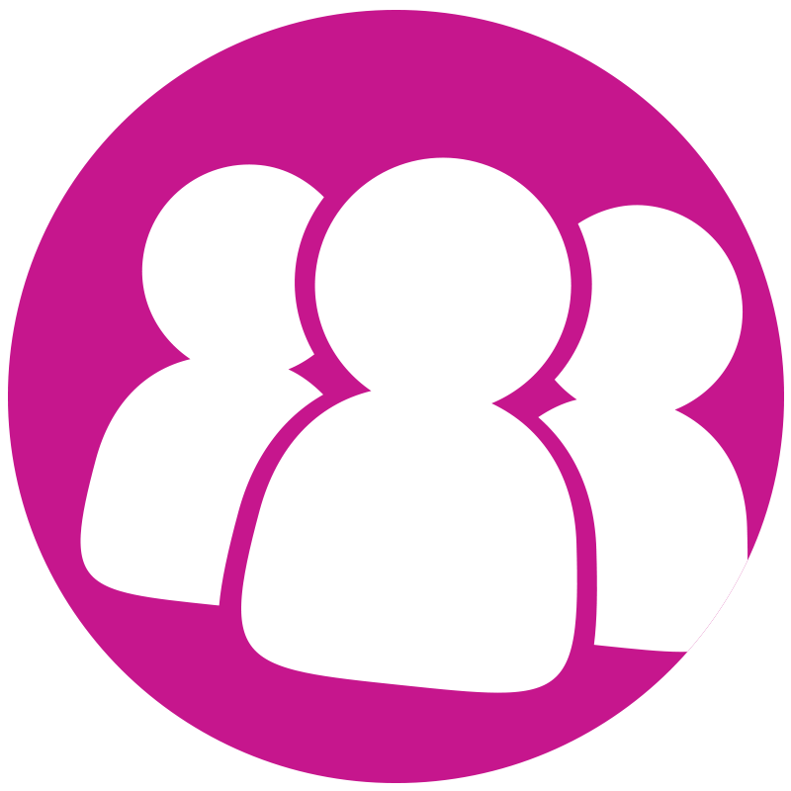  of Fifers agree that the Council is addressing issues affecting quality of life in their local areas, an increase from 68.5% compared with the previous year
43.3% | of people agree that they can influence decision making, a slight rise from 41.07% in 2016/17
£900k | value of projects subject to PB to date

Focus: Foster innovation and collaboration through a focus on culture change and an engaged workforce

What are we doing now?

The Plan for Fife and the preceding Fairness Matters report both stress the importance of organisational culture to the achievement of better outcomes and a fairer Fife. There has been an increased focus on culture over the last few years, as evidenced, for example, by Fife Council’s work on ‘unwritten ground rules’ and the use of iMatters in the Health and Social Care Partnership. The Fairer Fife Innovation and Learning Network provides a forum for reflection and discussion around organisational development (OD) across partners. There has also been additional investment in training to support new ways of working. Fairer Fife funding has been provided to Fife Voluntary Action to co-produce an event in January 2020, which will aim to consider how the voluntary sector can help take forward community led services.

Building on the findings of the Fairness Matter report, we have delivered poverty awareness training to front line and professional staff across the Partnership.

A cohort of staff has also been trained in dialogue and deliberation – the communication practices and facilitation skills needed to achieve a shift in local democracy – and further training is planned.

A multi-agency group is co-ordinating work to build trauma informed services across Fife, so that we can provide better, more effective responses to people who have experienced psychological trauma - preventing further harm and improving outcomes.

NHS Fife is rolling out a ‘personal outcomes and good conversations’ approach across Fife. The aim is to promote a shift in culture to focus on ‘what matters to people’ rather than ‘what is the matter with them’, the strengths and assets they already bring and the power of small improvements.

What’s missing?

There is a need for partners to:
- Learn from successful partnership models of training to inform better co-ordination of organisational development (OD) resources and to provide greater innovation and support in this key area of work;
- Strengthen collaborative leadership approaches at an area level.

What will we do next?

- Establish a partnership group to co-ordinate OD approaches across the partnership, including the work of the Innovation and Learning Network;
- Continue to roll out anti-poverty awareness training across the Partnership;
- Support the development of collaborative area leadership approaches, building on two ‘tests of change’, which are currently underway in Kirkcaldy and Levenmouth.
- Further develop the role of the Fife Partnership Learning and Innovation Network to look at culture change, and what needs to change to enable services to work more innovatively and collaboratively across the Partnership.

Culture Change
217 | people have been trained in the ‘Personal Outcomes and Good Conversations’ approach over the past year, with a further 81 attending an awareness session. This brings the total number now trained in Fife to 740.

Focus: Make better use of digital opportunities to improve service responsiveness, support independent living and better connect communities and individuals

What are we doing now?

The overall aim of our work in this area is to shift the focus from technology to digital services and engagement. Fife Council is focusing on improving its digital infrastructure, creating a new website and customer portal with web chat and links to social media.. Across the Partnership, we are extending the use of digital tools in our community learning and development work, and using www.digitalfife.com as a tool to increase digital skills in the community. We are also working with a Fife residents Digital Panel to test new digital developments and options for channel shift.

A new community portal is being developed to provide better access to information and community services, including local community plans, participatory budgeting initiatives and community development resources.

A Fife Partnership workshop on Fife’s Digital Future was held on 20th June to inform the development of work to promote digital opportunities in Fife.

What’s missing?

Digital is a cross-cutting issue across all Plan forFife themes, and we now need to develop a better overview of action and opportunities across the Plan. We also need a shared vision and coordinated programme of work, with buy-in from all sectors. This will require new governance and delivery reporting arrangements for the Partnership. We also need to develop a better understanding of digital participation issues, and, specifically, why some people are being left behind in terms digital opportunities.
What will we do next?

Building on the workshop on Fife’s Digital Future, we will:

- Develop a draft strategic framework on promoting digital opportunities for wider discussion ahead of the Fife Partnership Board meeting in November;
- Establish a Fife’s Digital Future strategic group to oversee cross-cutting work in this area;
- Take forward the development of a community portal as part of the new Fife.gov website;
- Develop a Fife version of the CONSUL digital platform to support community engagement and participatory budget approaches.
- Promote wider community involvement in Fife’s Digital Panel.

Digital Opportunities
629 | Number of adults supported to improve their digital literacy skills. A decrease of 52 on previous year and below the 890 people target.
305 | Number of community group websites in the Digital Fife online community. A decrease of 14 on previous year and below the 347 group target.
48k | Number of Fife Council Twitter followers, an increase of 3.8% on the previous year.
36k | Number of Fife Council Facebook fans, an increase of 5.2% on the previous year.

Focus: Invest in community capacity to get involved and develop confidence

What are we doing now?

We are working to promote greater community involvement in the planning and delivery of services by:

- Helping to build capacity within community organisations;
- Enabling community management and ownership of assets through community asset transfer (CAT);
- Making it easier for groups become involved in managing services and assets via subsidised leases or the ownership of assets;
- Providing extra support, and simplifying processes, for planning and approving l community events;
- Supporting community food initiatives by developing new allotments;
- Enabling the use of participation requests by community groups.

We are developing the CONSUL digital platform to enable communities to become more involved in decision making, for example, through participatory budgeting (PB). We are also exploring how digital opportunities can support better community engagement. This is part of a wider project looking at how we support community groups and citizens who want to make things happen. Fairer Fife funding has been provided to Fife Voluntary Action to support community engagement activity, including training f on engagement methods or staff and community councils.

A Community Learning and Development (CLD) delivery plan has been produced to co-ordinate the delivery of community capacity building and learning approaches across Fife. There are many good examples where communities are leading the way, with partnership staff playing a supportive and enabling role. Examples include the People’s Pantry in Leven, led by a team of 14 volunteers, some with experience of food insecurity, and a programme of participatory action research that was conducted by volunteers in North East Fife, which has led directly to the creation of a North East Fife Rural Poverty Action Plan.

What’s missing?

We need to:

- Further develop front-line and professional skills in community engagement and community led approaches across the Partnership;
- Simplify processes to better support communities in areas such as advice and information, grants and funding, events; leases and community asset transfer (CAT).

What will we do next?

- Develop a skills and capacity building programme for staff across the Partnership;
- Promote use of the CONSUL digital platform;

Community Capacity Building
51 | Community asset transfer enquiries have been supported: 39 Stage 1 applications: 13 Stage 2 applications; 3 completed CAT transfers.

Focus: Improve community involvement in local community planning and land use planning

What are we doing now?

Fife’s seven local community plans provide a clear context for greater community engagement in the planning and delivery of services, and will support further work on ‘planning for place’ across Fife. As well as the seven local plans, 21 neighbourhood (or locality) plans will be developed over the next three years as well as a growing number community led action plans. Neighbourhood plans will provide a focus for the development of local ‘place plans’, which will give communities further opportunities to influence local land use planning decisions.

Fife Voluntary Action has established a multi-agency group to lead on the development of a new volunteering strategy for Fife with the aim of promoting further volunteering across the Partnership.

The Place Standard is being widely used across Fife, with training provided for 45 practitioners. It has been used in numerous community engagement exercises, most recently in Glenwood High School and Cowdenbeath. Work is also underway to develop joint approaches across community planning and land use planning, including joint CPD sessions.

What’s missing?

We need to do more to join up community engagement work across the Partnership and across services to ensure that communities aren’t consulted multiple times on a range of issues.

What will we do next?

- Strengthen area leadership arrangements to ensure effective service and partner engagement in delivering and reporting on local community plans;
- Develop 21 neighbourhood plans by 2021;.
- Support the development of local ‘place plans’, to give local communities a greater say in local land use planning;
- Promote further volunteering across the Fife Partnership.

Local Community/Land Use Planning
7 | Local community plans approved by area committees
21 | Neighbourhood plans being developed in partnership with communities (2018-2021)

Ambition: Our Public Services are more joined up and act ‘one step sooner’

Key Actions | Expected Outcome Status  Aug 2018 Aug 2019
Roll out demand management review tools across services areas.
Develop metrics that allow us to measure progress.
Enhance the role of data hubs and invest in research.
Invest in decentralised delivery, service integration, workforce development and collaboration. | NB. Covered in other actions – subject to change control
Review barriers and identify opportunities for devolved decision making across services.
Identify and further devolve budget to the local level.
Make local community planning and neighbourhoods central to community planning delivery arrangements.
Review the role of partnership groups and strengthen the focus on prevention and innovation.
Create a focus on culture change in the partnership and across partner organisations.
Promote more collaborative working and learning.
Promote and encourage information sharing among local front-line staff
Develop community digital opportunities to improve networking and knowledge sharing.
Use social media and online tools as part of a wider programme to improve community provision.
Jointly invest in digital opportunities to improve access, information and knowledge, and build community capacity
Ambition: Fife’s communities and individuals are more involved in local
decision making and in helping to plan and deliver local services

Key Actions | Expected Outcome Status  Aug 2018 Aug 2019
Support community asset transfer.
Strengthen the capacity of community groups to get involved.
Extend and further develop the use of participatory budgeting to involve local people in decision making on the allocation of mainstream partner resources and in designing services.
Community planning partners will review their current approaches to encouraging and supporting volunteering.
Introduce integrated and community based design requirements for future changes to services by partners.
Support the development of local plans, neighbourhood plans and community led action plans.
Promote the use of a range of engagement approaches, such as the Place Standard and charrettes, to promote effective community engagement, in line with the National Standards for Community Engagement.
Key |  | No clear delivery plan, lack of activity |  | Work initiated |  | Delivery plan in place and on target

