**Fife Council Educational Psychology Service**

**Standards and Quality Report**

**2022-23**



**Aims**

Fife Council Educational Psychology Service (FCEPS) works at a strategic, school and individual level to make a significant impact on achieving positive outcomes for children and young people in Fife, particularly those most at risk of poor educational and social outcomes.

The Service’s work is based on the principles of the most effective, least intrusive intervention which makes a difference. Educational psychologists (EPs) work with schools to build the capacity of staff to meet the learning needs of all pupils, with a specific focus on breaking the cycle of disadvantage for those most at risk. This contributes to the equity, effectiveness and inclusiveness of all schools in Fife and minimises the need for specialist and more costly outwith Fife placements.

**Meet the FCEPS team**

Fife Council Educational Psychology Service is split into 3 areas, and we work on a Blended Working model. When fully staffed, we have 20 FTE staff delivering our Core Offer to schools. Our Principal Psychologist and two Depute Principals (Strategic) oversee the strategic leadership and direction of the service. Three Operational Depute Principal Psychologists each oversee the staff and operational management of one of our local area teams. All EPs within our service have a casework allocation, including those in management positions, taking responsibility for delivering educational psychology to a range schools. In Fife the average school population covered by a full time EP is 4091, based on the 2023 national staffing survey. This number ranges across Scotland from 2171 to 5827.

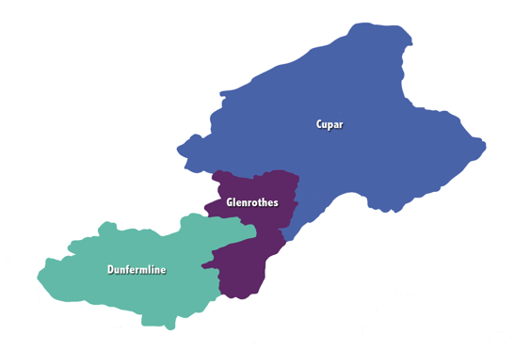

Our Central team, which covers Glenrothes and Kirkcaldy, have office space in Fife House in Glenrothes, our Dunfermline team, which covers the West Fife villages, Dunfermline, Cowdenbeath and Lochgelly, are based in King’s Road Primary School in Rosyth and our Cupar team, which covers North-East Fife and Levenmouth are based in County Buildings in Cupar. A full list of EPs and which schools they cover can be found on the FCEPS website through the link ‘School EP contacts for practitioners’ [Educational Psychology Service | Fife Council](https://www.fife.gov.uk/kb/docs/articles/education2/supporting-children-in-school/educational-psychology-service).

**Purpose of our service**

Our service purpose is ‘Sharing psychology to improve educational outcomes for those who need it most’.

The intention of our Standards and Quality report (SQR) is to report annually on the work we do and the actions we take to help us fulfil our service purpose.

This is based on how we meet the needs of our service users, how we deliver our Core Offer to schools, and how we are progressing on our key Service Improvement Priorities.

**Structure of our SQR**

We evaluate our work through our Service Evaluation Framework, which is structured around the overall question ‘What is Fife Council Educational Psychology Service’s capacity for continuous improvement?’

The Framework is based on How Good is our School, and aims to provide data to answer three key questions:

1. How good is our leadership and approach to improvement?
2. How good is the quality of our service delivery?
3. How good is the impact of our work, above and beyond the Core Offer to schools?

**How good is our leadership and approach to improvement?**

**EPS Staffwise Survey data**

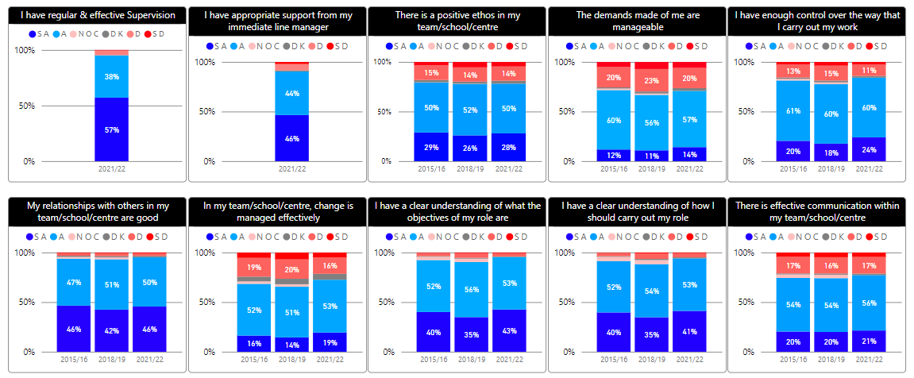

Service feedback on the Staffwise Survey areas is generally positive. However, we chose the four areas where we had the most headroom for improvement and did a specific survey to follow up on these areas and ask EPs what they felt would help us to improve. The results are below.

**EP survey responses on specific areas of Leadership and Approach to Improvement**

The areas in which there was most headroom for improvement were:

* In our service, change is managed effectively
* The demands made of me are manageable
* I have enough control over the way I carry out my work
* There is effective communication within our service.

We used a Forms survey to ask all staff to rate each of these on a scale of 1-10, and importantly, to provide improvement ideas about what we could do individually and as a service to take these forward. The ratings are in the graph below:

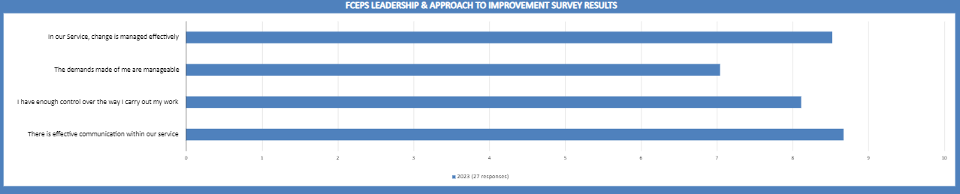

The improvement ideas were collated into the following themes, and specific ideas for change are being considered further by the Management Team and relevant groups within the service.

|  |  |
| --- | --- |
| **Staffwise area for improvement** | **Themes from specific EP survey** |
| Manage change more effectively | Make timescales explicit, and communicate these ​ |
|  | When change occurs outwith control, follow-up is planned (through discussion and support)​ |
|  |  |
| Making demands more manageable | Demands from external sources, such as tribunals – implications for workload |
|  | LA and EPS procedures/guidance where schools are advised to contact EP for support or to answer questions ​ |
|  | Clear on demands and timescales with regards to reports/tribunals (using task tracker to prioritise)​ |
|  | Reflection time together for learning and support​ |
|  |  |
| I have enough control over the way I manage my work | Professional autonomy valued​ |
|  |  |
| How could we improve communication | Protected time for group discussion essential​ |
|  | Try new ideas e.g., technology, and evaluate how they work for us |

**EPs’ and Management Team feedback through 1:1s – actions planned:**

During the summer in 2023, Operational Deputes carried out 1:1s with EPs in their teams; the Principal Psychologist carried out similar 1:1s with all members of the Management Team. The themes which emerged have been turned into actions, set out below:

Review our blended working approach across teams using headings from ‘optimal working environment’ journal article.

**Action – Staff Wellbeing Network**

Identify areas of ASN Tribunal work for which parameters can be set.

**Action –** **ASL Strategy Team**

Identify points of learning from previous ASN Tribunals.

**Action – ASL Strategy Team**

Review our blended working approach across teams using headings from ‘optimal working environment’ journal article.

**Action – Staff Wellbeing Network**

Develop annual mechanism in teams to share individual PMR targets, and network group/service level tasks.

**Action – Staff Wellbeing Network**

Streamline links with Business Manager and Business Support for budget and staffing tasks.

**Action – Viv Sutherland on behalf of PPs team**

Identify service-level Business Support tasks, and shortfall in provision.

Termly link with Business Support Officer to review what is working and troubleshoot issues.

**Action – Viv Sutherland on behalf of PPs team**

Identify team-level Business Support tasks which would best support EPs’ work, to ensure consistency in provision.

Regular link with team Business Support staff to review what is working and trouble-shoot issues.

**Action – Depute Ops**

Develop regular links in each team with EMs for local schools

**Action – Depute Ops**

Develop regular links in each team with local Children and Families SW Leads/Teams.

**Action – Depute Ops**

**Inductees****’, Probationer and Trainee Educational Psychologists’ (TEP) feedback on induction process,** **supervision and support**

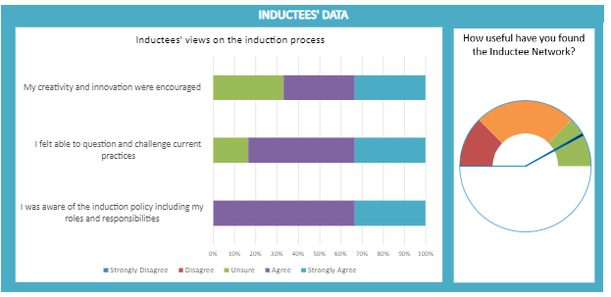

We generally have two Y1 Trainee EPs (TEPs), two Y2 TEPs and two Y3 Educational Psychologists in Training, as well as a number of new members of staff. They all automatically become members of our Inductees’ Network, which is run by relatively new EPs. The Inductees’ Network carries out this survey every year.

This tells us that feedback is generally positive, but we have more to do on encouraging members’ creativity and innovation, and to support them to question and challenge our current practice.

**Collated EP feedback on Development Days**

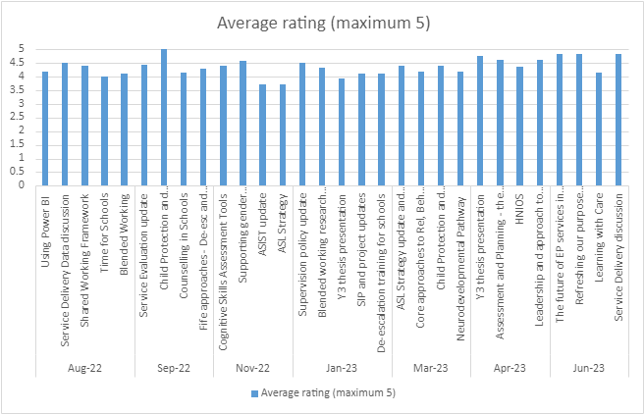

We have seven whole-service Development Days each year. Our internal Planning Professional Development Group plans these, using national, Education Service and our own Service Improvement Plan priorities to identify relevant content. This group also seeks feedback from EPs after each Development Day.

Next steps are to link the themes from individual EPs’ Professional Management Review targets into Development Day planning, and to analyse EP feedback on what would improve Development Days further.

**Themes of conferences or training attended by EPs in 2022-23**

|  |
| --- |
| Adolescent neglect |
| Trauma-informed practice |
| CSAT (Cognitive Skills Assessment Toolkit) |
| SCERTS (Social Communication, Emotional Regulation and Transactional Support) |
| Sexual behaviour in children |
| Dynamic assessment |
| Extended support continuum |
| EFQM self-evaluation |
| Relationships & behaviour, teaching & learning policy development |
| FASD (Foetal Alcohol Syndrome Disorder) |
| Child bereavement by suicide |
| Commercial sexual exploitation |
| EP National Conference |
| ASD (Autism Spectrum Disorder) (Barry Prizant) |
| Exploring racial harm in Educational Psychology |
| Being ASD trauma informed |
| Practice Development session |

**How good is the quality of our service delivery?**

**Our Core Offer to schools:**

**‘No-name’ Consultation – Child Wellbeing Pathway Stage 1: Universal Level**

Through consultation, EPs will provide advice and indirect support to stakeholders to help them problem-solve issues of concern. This will not involve an EP becoming directly involved with a child, young person or family.

**Priority Casework – Child Wellbeing Pathway Stage 2: Additional/Intensive Level**

EPs will provide advice and direct support to assess, identify, plan for, and review children/young people and families with significant additional support/wellbeing needs.

**School Development**

Advice and support to improve the capacity of a school to more effectively meet the needs of its pupils, linked to:

* The school’s Improvement Plan
* HGIOS 4 quality indicators 2.4 Personalised Support & 3.1 Ensuring Wellbeing, Equality and Inclusion – NOT as a quality assurance activity
* Evidence based development work, including how to close the poverty related attainment gap.

**Key Priority casework data:**

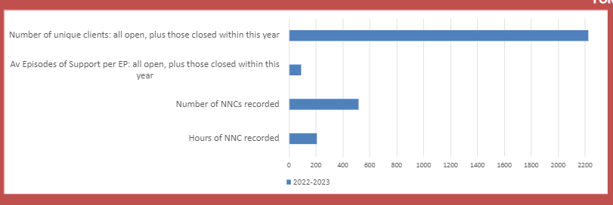

Through our record keeping system, FORT, we know that between 1st August 2022 - 31st July 2023:

* Our service had 2223 priority cases across Fife, where we were directly involved in supporting young people, families and schools
* Each EP had an average of 90 episodes of support throughout this year
* These figures have increased year on year since we started using FORT in 2019-20
* EPs recorded 518 No Names Consultations, which amounted to 208 hours of EP time.

Feedback from HTs tells us that No Names Consultations are under-recorded by EPs on FORT, most likely because they are not always individual, separate events, but happen through interactions with school staff and other professional partners.

**Percentage of Episodes of Support closed with a satisfactory outcome this school session:**

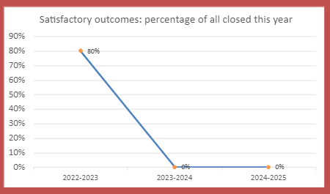

80% of episodes of support which were closed, had ‘Satisfactory Outcome’ noted as the reason. In our previous three-year reporting cycle this figure was 75% (2019-20), 58% (2020-21) and 67% 21-22). These previous figures include the Covid-lockdown period. The figures for 23-24 and 24-25 will be added in due course to continue to identify trends and any actions required.

**Breakdown of unique clients (Priority Cases) by Scottish Index of Multiple Deprivation (SIMD) deciles:**

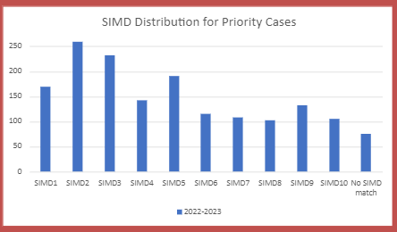

The balance of our priority casework is within SIMD 1-5, reflecting our service purpose statement ‘sharing psychology to improve educational outcomes for those young people who need us most’ – highlighted here by a focus on those who are at more risk of negative educational outcomes due to social deprivation.

**Number of Traumatic Incidents supported by EPs for pre-school, primary, secondary, and additional support needs settings:**

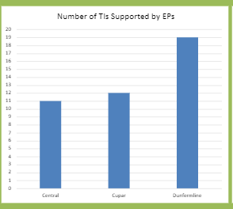

Supporting Traumatic Incidents in schools is an increasing area of work for EPs, across all sectors.

**HT survey data:**

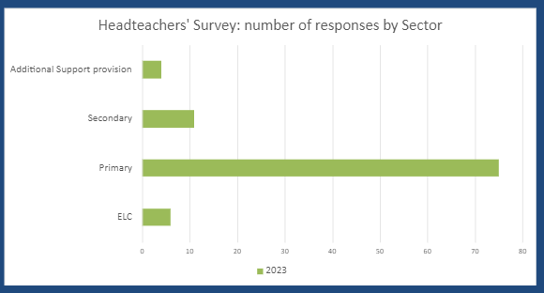

We had 96 responses to the HT survey, representing approximately 53%. While this is our best survey return rate to date, there is room for improvement here in our reach.

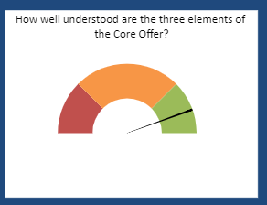

The vast majority of our schools understand the three elements of our Core Offer to schools.

**How is EP time in school shared across the three elements of the Core Offer?**

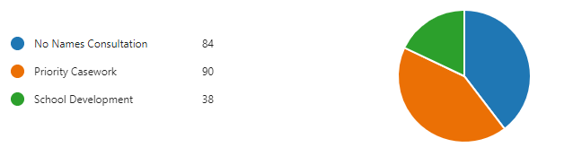

HTs report that Priority casework is the most frequently used element of our Core Offer to schools, closely followed by No Names Consultation. School development is less well used.

**On a scale of 1-10, how valuable was your contact with the EP Service over this school session?**

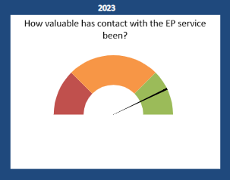

HTs report that they find the contact with their EP valuable, with an average rating of 8.52 out of 10.

**What did you value most about the contact with the EP over the past school session?**

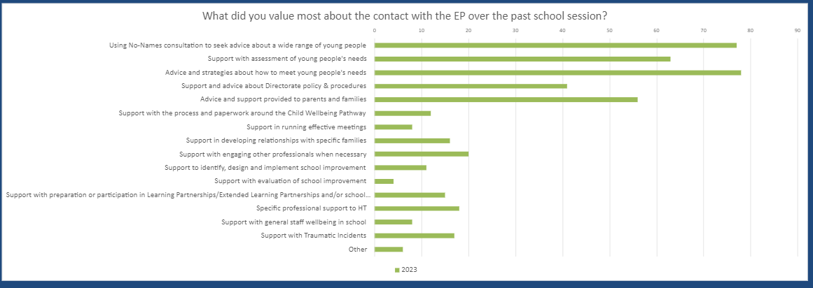

When asked what they valued most, HTs most frequently mentioned:

* Advice and strategies about how to meet young people’s needs
* Using No Names Consultation to seek advice about a wide range of young people
* Advice and support provided to parents and families
* Support with assessment of young people’s needs.

**In your view, on a scale of 1-10, to what extent did EP involvement in priority casework improve outcomes for young people?**

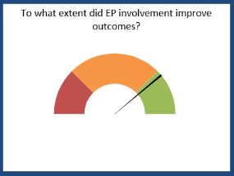

HTs reported that they did feel EP involvement improved outcomes for young people, with an average rating of 7.73 out of 10.

**What types of better outcomes could you give as examples?**

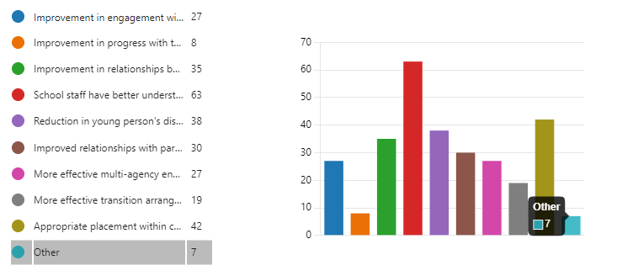

The most frequently mentioned outcomes were:

* School staff have a better understanding of the young person’s needs
* Appropriate placement within the continuum of provision
* Reduction in the young person’s distressed and/or challenging behaviour
* Improvements in relationships between young person and school staff.

**How do you think the work of the EP Service and/or Core Offer could be improved?**

The following themes were collated from an analysis of HTs’ responses to this question:

* Schools value the relationship with their EP (41)​
* They want more EP time (32)​
* Specific EP behaviour valued * (20)​
* Want consistency of EP (16)​
* Happy with EP support (15)​
* Increased level of need and increase in services not matching this (11)​
* Bureaucracy of paperwork overwhelming (RfA and health pathways) (10)​.

The specific behaviours valued by HTs included:

* Like and value flexibility of EP support (being contactable)
* Ideally want to use EPs for earlier intervention
* Prefer it when EP sticks to agreed plans for visits/meetings
* Building in planned time for consultation
* Practical advice provided by EP, which is easy to understand how to implement
* EP supporting supervision model
* Would like more 1:1 meetings between EP and young people.

**Number of schools which have had staff training from their EP:**

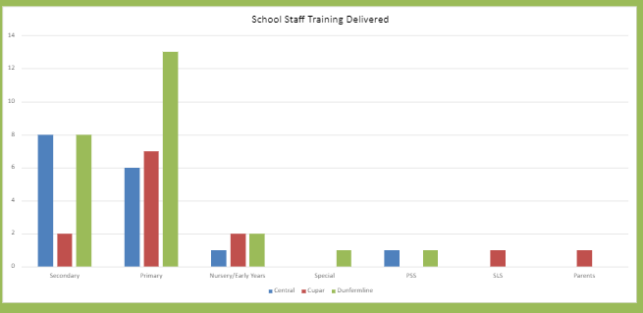

All sectors engaged with staff training from the Educational Psychology Service.

Themes in staff training negotiated between EPs and HTs for staff training and school development:

* ASD effective intervention
* De-escalation
* Planning curriculum to meet learners’ needs
* Trauma-informed Practice.

**Feedback from schools about staff training:**

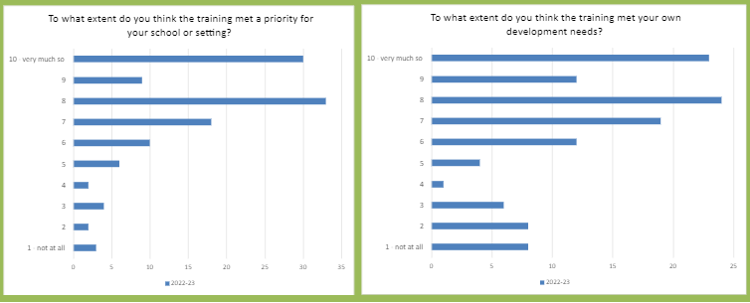

**Feedback from schools about staff training through a three month follow up survey:**

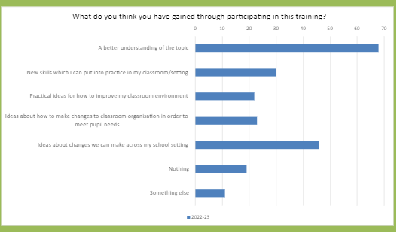

Surveys are sent out to schools which receive training from EPs; immediately after the training and then again as a three-month follow up. These indicate that generally it is felt that training met the priority need in their school, and met their own development needs, but there are a range of responses. These will help us to negotiate even more specifically with school leadership to ensure that training is tailored to what is needed (sometimes more so than what is wanted).

**In terms of the Directorate Core Relationships, Wellbeing and Behaviour offer (Trauma-informed Practice or De-escalation), did you seek support from your EP to develop this work in your school?**

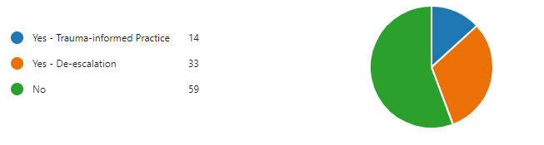

**What kind of support did you seek from your EP in relation to the Core Relationships, Wellbeing and Behaviour offer in Trauma-informed Practice, or De-escalation?**

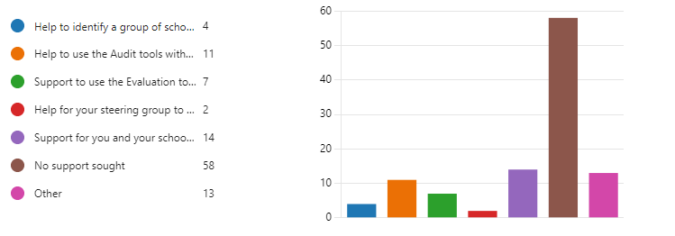

Most schools responding reported that they did not seek support from their EP for the Core RWB during the 2022-23 school session. There could be several reasons for this, including that many schools already had their school improvement plan priorities and their Shared Working Framework planning with the EP completed before they engaged with the Core Offer.

**What kind of support do you plan to seek from your link EP in terms of the Core Relationships, Wellbeing and Behaviour offer (Trauma-informed Practice or De-escalation) in the 2023-24 school session?**

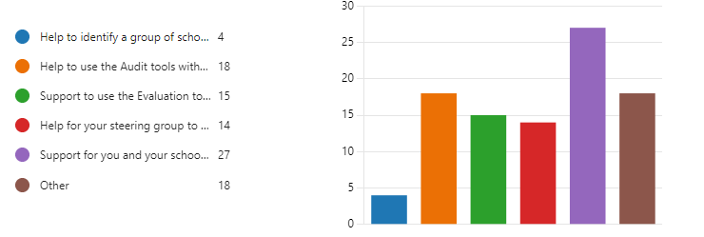

Planning ahead for the 2023-24 school session, the most frequently reported areas were:

* Support for you and your school to implement your action plan
* Help to use the Audit Tools with staff in your school
* Support to use the Evaluation Tools to help develop an evaluation structure
* Help for your Steering Group to put together an action plan
* Where ‘other’ was selected, it was generally noted that they did not plan to seek support from their EP for this work.

**EP survey data**

**How confident do you feel explaining the service delivery model/Core Offer to schools?**

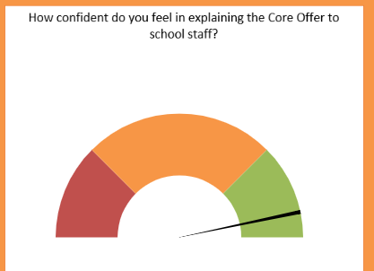

EPs generally feel confident in explaining the Core Offer to school staff.

**To what extent do schools use No Names Consultation?**

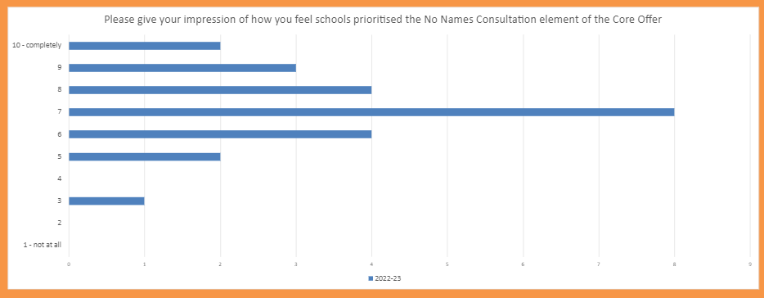

**To what extent do you feel schools prioritised Priority casework?**

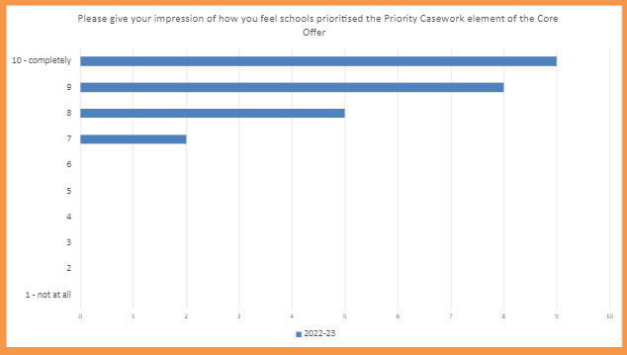

**To what extent did schools prioritise staff/school development work?**

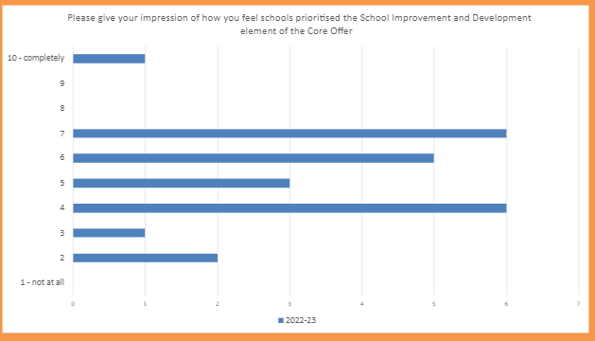

This data reflects the HT survey data, in that Priority Casework is the most frequently used element of the Core Offer, followed by No Names Consultation, and then School Development work.

**Parent survey data:**

**How helpful has it been to have the involvement of the EP service?**

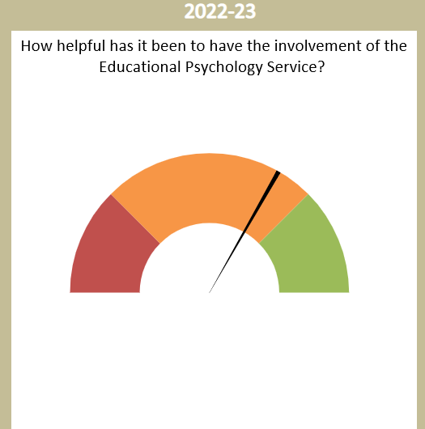

**What led to EP involvement with your child?**

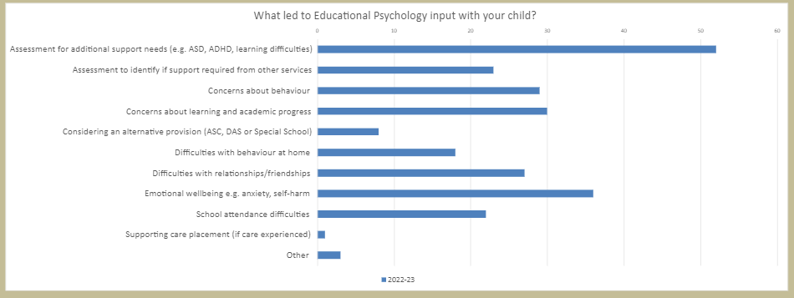

**What has been better for you or your child** **as a result of having the EP service involved?**

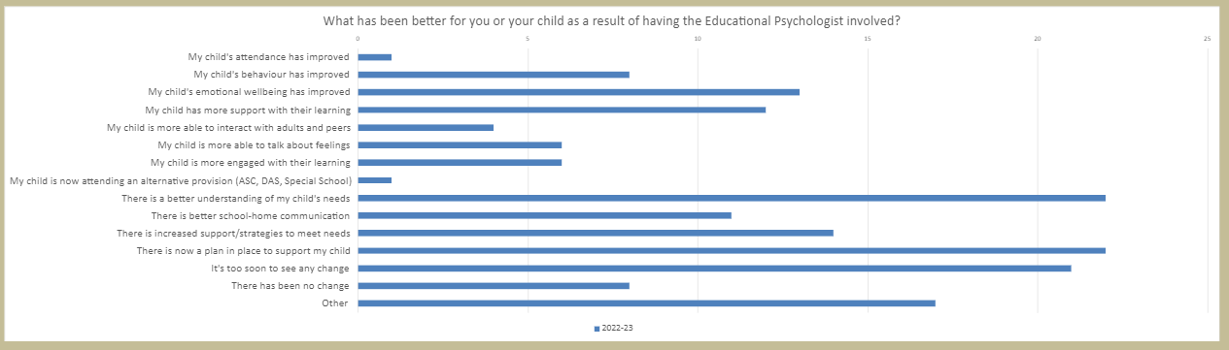

This is the first year in which we have carried out a large-scale survey of all parents who have a child or young person who is a current Priority Case, or who has been closed as a Priority Case during this year.

We had 91 responses, 76 of whom competed a Forms survey and 15 who indicated a preference to complete the survey by phone.

We plan to continue to survey parents through this methodology for the 2023-24 and 2024-25 school sessions, with a focus on increasing the numbers of parents who respond.

Key learning from this first survey includes:

* The need for us to have clearer information for parents, at the point where schools raise our involvement, explaining the role of our service and what parents can expect from the EP
* Further focus on clarifying what parents hope for through the involvement of the EP, and agreeing shared goals between the parent, school and EP.

**How good is the impact of our work,** **above and beyond the core offer to schools?**

**Our Core Offer to the E&CS Directorate:**

**Strategic Work**

The EPS supports the E&CS Directorate and Children’s Services Partnership to develop, implement and evaluate policies and guidance, and provides a range of training, all focused on improving experiences and outcomes for staff, children/young people and families. We also do local research on local issues, and translate this and national research evidence into practical resources for schools.

**Commissioned project work:**

The service currently has additional funding for commissioned project work in four areas, allowing us to do specific tasks over and above our Core Offer to schools and to the Directorate.

* FTE to support tasks associated with the Additional Support for Learning Strategy.
* FTE to support the integration of Counselling in Schools into the wider continuum of emotional wellbeing support.
* FTE (temporary) to support the development and implementation of the Neuro-developmental Pathway.
* 0.6 FTE (temporary) to support better outcomes for Fife Care Experienced young people through the Learning with Care project.

These projects, and other Service Improvement Plan targets from 2021-22 are reported on in Appendix 1.

**External research scrutiny**

**Number and themes of external research requests processed by the EP Service External Research Scrutiny Group:**

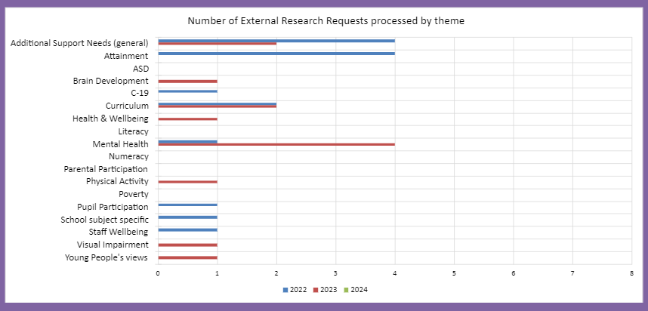

There is a scrutiny process, designed and implemented by a subgroup of our Planning Professional Development Group, to which all external requests to do research involving Fife schools, education staff, children and young people are subject.

The workload fluctuates across the year. Liaison with researchers and gathering sufficient information to be able to make a recommendation about approval or refusal is time consuming. The benefit to the Education Service is to have up to date research carried out in Fife, which we can then use to improve learning and teaching.

Being provided with outcome reports from researchers is challenging, and this is an area for development.

**Number and type of requests for involvement in Directorate and/or Education Service strategic and policy work:**

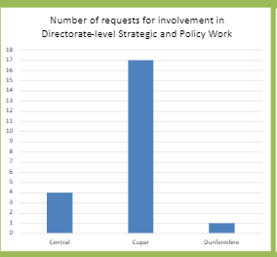

We keep track of the type of requests for EP Service involvement from the Directorate. Analysis of these requests identify the following themes, from most frequently requested to least:

* Join Education Service or Directorate strategic/working group
* Deliver training
* Present to Committee
* Provide strategic staff wellbeing advice
* Input to Directorate Leadership Group
* Take on a role in relation to evaluation of a task or project.

**Number of potential (near miss) and actual ASN Tribunals involving EPs:**

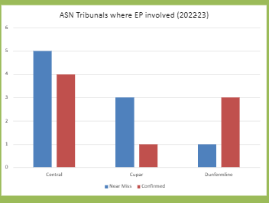

Involvement in ASN Tribunals is an increasing area of work for EPs, and the numbers of parents making Placing Requests (PR) for independent provisions, or additional support provisions within Fife, are increasing, with an increasing number also exercising their right to appeal refusal of a PR through the ASN Tribunals process.

This has significant workload for EPs, over and above their Core Offer to schools. Our focus has been on identifying early the cases which could potentially go to ASN Tribunal i.e., those in which a parent and school are in disagreement about how their child’s ASN are being met, where there is a parental complaint about the school relating to ASN, where the parent has mentioned the possibility of putting in a PR to an independent provision or Fife ASN provision, and where a PR has been submitted. We categorised these as ‘Near Misses’ until such point as a reference was actually received for an ASN Tribunal, at which we categorised them as ‘Confirmed’.

As this graph shows, there has been success in diverting a high number of ‘Near Misses’. However, the numbers of PRs being received and the additional workload this requires not only for the EP involved, but also Operational Deputes in supporting the EP through this process, means that we will now focus on working with the Education Manager for ASL and the ASL Solicitor to:

* streamline processes for all involved, including EPs
* identify how to manage workload around specific areas of work e.g., Witness Statements, EP reports
* set parameters around the workload for EPs, to make this manageable without withdrawing from our Core Offer.

These tasks will be reflected in our 2023-26 Service Improvement Plan.

**Appendix 1 – evaluation of 2021-22 Service Improvement Plan priorities, including Commissioned Project Work**

|  |  |  |  |
| --- | --- | --- | --- |
| New Priority | Tasks and Timescales | Evidence of achievement | Status |
| Supporting implementation of Counselling in Schools within a spectrum of EWB support in secondary school.  Service Lead:  Jo Lawson. | By Summer 2022, there will be an overview of Universal, Additional and Intensive Supports in Secondary schools across Fife (using information gathered from Secondary schools and partners).  By Summer 2022, data which could be used to evaluate the efficacy of supports will be gathered and any gaps identified. | An overview document of EWB supports and identified gaps.  An overview document of potential sources of evaluation data and gaps. | Done. |
| *Action Enquiry project:*  *Service lead: Viv Sutherland*  To develop a model of making online learning a sustainable element of the education offer for pupils not attending fulltime, with a specific additional focus on our ASD learners.  To improve the engagement in learning for pupils with very limited attendance, with online learning as an element of a bespoke learning package.    To develop a better understanding of the supports and barriers to education that existed for ASD pupils during the pandemic. Summarise findings to inform how we better support those who encounter barriers to full-time school attendance going forward. | Gather info from two high schools - staff, young people and parents to inform a Fife-wide survey for all high schools to review case successes to identify systemic gaps and resource limitations.  Develop format for reporting.    By March 2022, we will have gathered and analysed information (from EPs, school reps and ASIST) about the supports and barriers that existed for young people with Autism accessing education during the pandemic and produced an interim report. By Summer 2022 we will have produced a full report of findings. | Data available showing key themes emerging.  Fife-wide survey results available.  Skeleton report available.  A full report, which will be submitted to Education Scotland, as part of the Action Enquiry Project.  Feedback summary of findings to Fife Directorate Leadership Team. | Done.  Done.  Done. |
| Evaluate the usage of the FCEPS Effective Implementation Toolkit, refresh and promote the tool.  Service Lead: Viv Sutherland. | By end of February 2022, have:   * Developed an evaluation questionnaire to gather feedback data from EPs who have used the tool * Considered gathering feedback data from schools * Reviewed the sections and identified any missing info.   By Easter 2022 have collated EP feedback re usage,  reviewed each section for readability and brevity, and drafted any missing sections (including incorporation of EP feedback).  By Summer 2022 have:   * identified plan for future maintenance and evaluation * identified a partner to support us in developing a more visual format.   By October 2022 have:   * agreed a launch and communication strategy for refreshed Toolkit * established a refresher course in usage for inductee/new EPs etc. | Refreshed, more visual Toolkit available and easily accessible to staff across the Directorate. | Done.  Done.  In process.  In process. |
| Neurodevelopmental Pathway Pilot to support the effective implementation of the West Fife pilot of the Neurodevelopmental Assessment Pathway.  Service Lead: Adam Brown. | Develop a remit for funded ND EP support - by end of Jan 2022.  Be a point of reference for the service – ongoing.  Support for schools to develop their early assessment, signposting and intervention processes alongside CWP processes to improve the ‘offer’ to children and families impacted by ND conditions at an early stage – Oct 2021 – end of the pilot.  Liaison with Health which will include the Oversight Steering Group (ASD), ASD Management Group and ASD Education Network to support planning and strategic developments – ongoing.  Lead evaluation role both implementation overview plus reporting on the West Fife Pilot – ongoing. | Evaluative data gathered, gaps and training needs identified, and used to develop and refine professional learning materials / strategy developed.    Feedback and updates on outcomes and impact provided to the Directorate Leadership Team (DLG) and Fife Council Elected Members, as appropriate.    Reporting to ASD oversight group and periodically updating Scrutiny Committee alongside ES colleagues plus internal processes. | Done.  Done.  Done. |
| Development of the ASL Strategy, and an implementation plan.  Service Lead: Malcolm McGovern. | Take a lead role, alongside the ASL Strategy Group, to develop a clear and coherent ASL Strategy - by August 2022  Key tasks will include:   * Robust consultation process – by Summer 2022 * Review of resource allocation models for ASL/ASN - underway by December 2022 * Development of concise ASN data dashboard – by Summer 2022. | The ASL Strategy will be published and shared with all relevant stakeholders.  The current models of resource allocation will be under review.  AN ASN data dashboard will be established, with a clear purpose and functionality. | In process.  In process.  Assigned to different group. |
| Learning With Care.  Service Lead:  Jane Messer | Work with the wider Learning with Care Team to identify clear tasks for the EP service to support improving outcomes for Fife Care Experienced Young People. | Develop and implement a quality assurance checklist for young people in secure provision.  Research project to focus on exclusion of CE young people in Fife. | Done.  Done. |