www.fife.gov.uk/supplierguidance

Invoice Payments Guide
We try to process supplier invoices as quickly as possible. Whichever part of Fife Council, or
associated Trust/ Arm’s Length Organisation you do business with, take these steps to avoid delays:
- Get an official purchase order (PO) – see example below. Do not provide any goods or services without one!
- Send a costed delivery note/work confirmation to the contact named on the PO so they can confirm receipt / completion before the invoice is submitted.
- There are several invoicing options available, we can work with you to choose the best option for processing your invoices.

Invoicing Methods
- Send your invoices directly to Accounts Payable at:
- invoices.accountspayable@fife.gov.uk
- or PO BOX 18078, Glenrothes, Fife KY7 9DY
*Please send each invoice as an individual file. We accept Word, Excel, and PDF documents.
- Invoicing via the Supplier Portal - using this method you create and submit an invoice in the Fife Council Supplier Portal, the benefits to using this method is that the invoices are matched to a purchase order at point of creation, therefore the invoice when submitted goes directly into the Payables system with no user intervention required.
- E-invoicing - the facility to submit your invoice in an electronic format.
- Self-billing - where we automatically pay you for the goods/services provided, without the need for you to submit an invoice.
Invoices that are cleared for payment
- Are addressed to the purchasing organisation that is identified on the PO. E.g., if the PO has been issued by a Trust the invoice must be addressed to them and not Fife Council.
- State the full 10-digit PO number (starting P0...). If you receive a new PO for the next financial year, make sure you change this on your invoice.
- For each invoice line, state the PO line number and item/service description it refers to.
- For each invoice line, state the quantity, unit price (for goods) and total value being billed. These cannot be higher than shown on the PO. If a PO is incorrect, contact the person named on it to get it amended.
- Use a unique alpha numeric invoice number containing no slashes/dashes or special characters.

Spot revised orders so you do not duplicate supply.
Our PO numbers have 10 digits. Revised orders will show a revision number, which will increase by 1 each time the PO is amended. Only POs (Purchase Order) with no revision number should be treated as a new order.
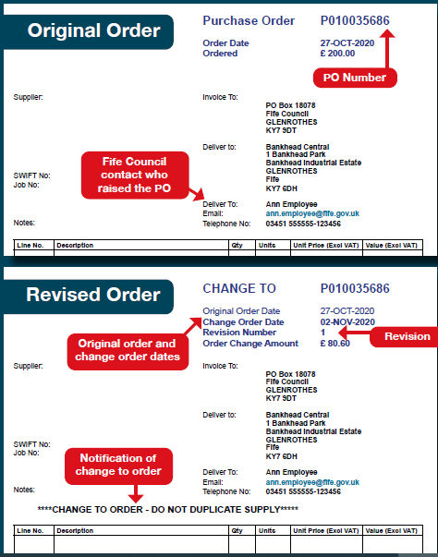
Contact us
- Queries about specific POs & invoices:
use the email address provided to contact the employee named in the ‘Deliver to’ section of the PO.
- General queries about invoice payment:
erp.accounts-payable@fife.gov.uk
- Set up options, or purchasing enquiries:
enquiry.procurement@fife.gov.uk

updated November 2021

