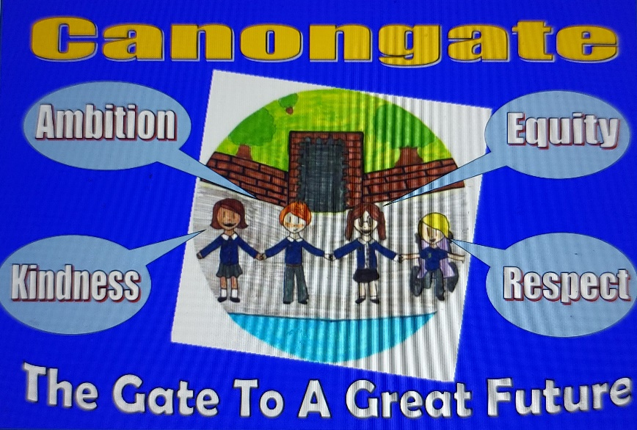

Session 21-22
Improvement Plan

National Improvement Framework Priority: Closing the Attainment Gap and Improving the Health and Wellbeing of our children
Focused Priority: Continuing to Implement a whole school Nurture Approach
 |  |  | HGIOELC Quality Indicators
HGIOS4 3.1 ensuring wellbeing, equality and inclusion 3.2 raising attainment and achievement 2..4 personalised support. 1.3 Leadership of change |  |  | 1-3 3.1
Expected Impact | Strategic Actions Planned | Responsibilities |  | Measure of Success  (Triangulation of Evidence) | Timescales
Improved health and wellbeing will lead to increased access to the curriculum for individuals and target groups.  All staff will be knowledgeable and feel confident in using nurturing approaches across the school  For specific individuals we expect to have evidence of improved engagement, achievement and attainment. Attainment will be tracked on these children. Comparing – Ipsative assessment.  Whole school will benefit from nurturing approaches / child to child- adult to child- adult to adult. | - Gather information from May 20-21 GMWP questionnaire but repeat in late Aug/ Early September for confirm target groups/ individuals due to possible new starts or changes in responses.  - Once analysis completed F Dearle (lead) will deliver input on targeted interventions to teaching staff.  - Each teacher from P2 onwards will carry out a small test of change with either an individual or a small group identified. Also to be used by nurture base to measure impact.  - Input on 6 principles of nurture for all - tackling entrenched belief systems staff eg terminology used / use of voice (shouting). Readings on window of tolerance, self regulation, resilience, de-escalation and restorative conversations.  - Development of child friendly language through range of approaches eg. Assemblies, posters, class charters/ nurture lanyards.  - Training from PMHW - Understanding and Managing Anxiety and Setting up a listening Service for PSAs  - Approach parents for extra meeting that focus on learning – not making families feel uncomfortable or inadequate.  - Access questionnaires for staff from ‘applying nurture as a whole school approach’ to establish baseline and compare to track progress.  - SLT engaged in Education Scotland focus work on reducing exclusion | Expectation all staff will participate.  Inputs led by F Dearle as Nurture Leading Learner  Supported by D Bates, R. Faragher and L Hodgkinson. |  | How will evidence be gathered – data from online forms  -direct observation  Tracking table for test of change  Discussion with focus groups  Engagement levels tracked and attendance. | Child questionnaire to be done by late August.  Beginning of September collegiate input from F Dearle on Interventions relating to data.  Baseline staff questionnaire completed early September 21  Mid September – input from Group on nurture principles and use of language etc.  Between Mid September – Christmas ongoing test of change – review – plan for rest of year – are the same children continuing – are there changes needed?  Nurture collegiate time – check in January.  Review will determine rest of school year.

National Improvement Framework Priority: Closing the Attainment Gap, improvement in attainment; particularly in Literacy
Focused Priority: Improvement in attainment in Reading and Writing. To nurture a love of reading and writing in school.
HGIOS4 Quality Indicators - 2.3 Learning, Teaching and Assessment  3.2 raising attainment and achievement |  |  | HGIOELC Quality Indicators
Expected Impact | Strategic Actions Planned | Responsibilities |  | Measure of Success  (Triangulation of Evidence) | Timescales
Improvement in attainment in both reading and writing - especially P7 group identified.  Focused writing pieces to extend in quality and quantity  Primary 1 and 2 focus – Covid funding PSA – building on ELIPs and Base assessment data  Increase the love of reading for enjoyment in our learners- increasing fluency and vocabulary. (See ‘We love reading discussion paper created by staff). | Use of exemplars/WAGOLL in all focused writing lessons.  Sharing of good practice through planned moderation sessions using QAMSO’s for support - cross cluster  Feedback Focus in writing  PSA is a trained SALT and will use Base data and ELIPs to target interventions (Covid funded)  Use feedback from children’s questionnaires on their preferences for reading. (consultation with parents and children carried out June 21)  Purchase of new reading materials to increase engagement including graphic novels, First News, comics, shorter comprehension pieces for second level.  Reinstate school library in a Covid friendly way – update  Staff develop a ‘reading progression ladder’ which we have for writing as a guide to progression in reading skills and expectations from Nursery – P7  Novels at 3-4 level need to be purchased and further resources for high interest/ low reading level.  To be confirmed  (School have applied to participate in Fife Council improving writing programme and have applied but awaiting for information on whether we have been acceepted. This may be in place of ‘some of above’. If accepted this would be targeted in Primary 7. | Mags and QAMSO support team Fife  All staff  H Maclaren/ E Lawson  P1-2 tracking  L Armstrong helping purchasing.  Target group of children choosing resources  If allowed parents involved in set up.  All staff audit own classroom and contribute to organisation of library.  Progression Reading Ladder – J Smith will be working at home – already led on reading skills. |  | Microsoft Forms  Examples of work  Review meeting- discussions with children and parents.  Reading ages for target children will be tracked.  Observations | 3 planned sessions from collegiate time. Terms 2-3 and 4  Purchase of resources in Term 2  6 weekly review with parents of target children focusing on reading and writing (not behaviours or other)  From Term 2
Ongoing Evaluation

Session 2021 -2022 Improvement Plan – PEF Plan
Attainment Fund Rationale - of money will be used for PSA support to enable us to implement our nurture plans including time to talk (see above), PSA training, time to talk and Seasons for Growth input for children who have suffered bereavements / separations. |  | Amount of Fund TBC - £56,00  Administration charges and some costs from March to June to be removed.
Linked to literacy plan and nurture– special focus on closing attainment gap reading and writing at second level.
Projected writing target for Primary 7 next year is 56.8% but we wish to increase this to ‘most children’ - over 75 percent.
However we need children to be ‘ready to learn’ and are looking holistically at this.
Expected Impact | Interventions Planned |  | Measure of Success  (Triangulation of Evidence) | Impact on learners  Ongoing evaluation
Intervention 1  Reducing anxiety for individuals  Intervention 2  Primary 7 writing levels to improve by approximately 15 percent (not including ASC).  Intervention 3  Nurture Base | Time to talk and reducing anxiety – PSA availability for children to book into ‘listening service’. Strong focus on P5-7.  Focused support on writing editing/ personal targets to ensure improvement.  Success shared and celebrated with children and parents.  PSA to support this – copies/ communication but also will give teacher more time to support targeted pupils.  Focused intervention for individual pupils - see reading plan  Further fund this resource due to impact shown during 20-21 in reducing exclusions and allow further access. Support pupils to be more fully included with their class. PSA  Additional hours for training for PSAs in nurture and all above.  Seasons for Growth inputs for children particularly affected by separations / bereavements etc. |  | Questionaires/ Focus groups/ Analysis of work samples/  Number of referrals should reduce? Information gathered – insights.  Attendance figures for target pupils.  Evidence of engagement and work.

