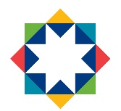

Sunflower Family Nurture Centre
and
Sunflower Annex

STANDARDS AND QUALITY REPORT

2020/2021

Achieving Excellence and Equality

Sunflower Family Nurture Centre
Standards and Quality Report
Achieving Excellence and Equity

CONTEXT
Setting Roll (Including Sunflower FNC and Sunflower Annex) | 99 (3-5 year olds)  22 (2 year olds)

Our vision, values and aims were revised in September 2017.
Vision
Together we dream, believe and achieve
Values
We will provide a responsive service based on
Honesty – Inclusion – Respect - Equality
Aims
- We aim to play an active role in nurturing our children and their families within a caring, safe, secure and happy environment.
- We aim to work together as a team to ensure the best possible outcomes for children and families.
- Through play, we aim to provide opportunities for all children to develop their skills for life and learning.

Sunflower Family Nurture Centre and Sunflower Annex provides Early Education and Care to children in their ante pre-school and pre-school year. We also have the capacity to provide extended day places for children with an identified social, emotional or educational need. During session 2020-2021 a total of 99 children, aged 3-5 years, attended the nursery. We also provide Early Entrant provision for up to 30 children aged 2-3 years.
As a Family Nurture Centre we are open for 52 weeks a year. During holiday periods we continue to support children and families by providing a variety of services. We offer places to children from across the locality, and numbers accessing this service are continuing to increase.

During session 20-21 Sunflower Annex staff and children operated out of Sunflower Family Nurture Centre as the new build was delayed opening as a result of the Covid19 Pandemic. A total of 49 children, aged 3-5 years have attended the Annex this session. We still await confirmation of the new build Annex opening date.

We provide excellent Family Learning opportunities, including both targeted and universal groups. We work in partnership with a number of local agencies and have strong links with the local community.
We offer a welcoming, safe place for families who may be experiencing a range of challenges in their home lives. As a result of Covid19, this session support has been offered through using our outdoor spaces. We are a food bank voucher holder and also support our families through use of the Fairshare scheme in partnership with TESCO. We signpost families who are in financial crisis and do what we can to make life a little easier, for example, taking part in charity schemes that support our families very well (e.g. Cash for Kids Christmas Appeal etc).

Currently 28% of our children and families come from SIMD 1 and 2. 35% sit within the SIMD 3 bracket. We currently have no children on the Child Protection Register and 6 children who are currently care experienced.
We continue to experience increasing numbers of children with language delay and have a number of different strategies to address this, including, Communication High 5 and eLips.

We work in close partnership with Clentry Nursery in Kelty and are jointly managed by a shared Headteacher. Our extended management team now includes 2 Depute Head of Centre, a Principal Teacher, a Senior Family Worker and 4 senior EYOs. A number of staff work across the 2 settings and this allows for the effective sharing of knowledge and experience.

We work closely with our partners within the Beath locality. The Local Improvement Forum is a platform for education partners across the locality to share practice and engage in improvement priorities together. This has continued virtually this session. Sunflower Family Nurture Centre work closely with the Area Early Years Principal Teacher and provide regular opportunities for Early Years Officers from across the locality to come together for a range of professional learning opportunities, thus influencing early years practice.

We have adapted our procedures and practices in light of COVID19. As a staff team we are commmitted to ensuring that our children continue to have access to high quality learning experiences. We have creatively adapted our Enterprise projects, for example Café de Flores now takes place as a take away! This has ensured that learners are still developing key skills.

Engagement with families continues to be a key priority. It has been essential to adapt how we support this. Garden Visits, phone calls and TEAMS meetings have all ensured a high level of communication. Newsletters, daily Facebook posts and using our You Tube Channel is also supporting this. We continue to gather views from our families, albeit in a different way. Our ‘Wall of Wishes’ has taken the place of our Big Breakfast as a new way of gathering parental feedback. Our Parent Learning sessions named ‘The Importance of Play’ was used to support parents with play in the home on the back of the lockdown periods.

RATIONALE FOR CHANGE
The 3 areas for Improvement for session 2021-2022 have been identified through a full and robust process of self-evaluation. Priorities have been planned in consultation with staff, parents and partners. The COVID19 pandemic and the turnover of staff that continues as a result of the embedding of 1140hrs are 2 key drivers for change within Sunflower FNC and Sunflower Annex.

A strong focus on relationships and the emotional wellbeing of all continues to be high priority This includes our children, their immediate and wider family networks, our staff and our partners. We have ensured that all staff will have access to high quality, well timed professional learning to ensure they have the tools and strategies to support our families as the pandemic continues. Our engagement data during lockdown tells us that our families need access to regular, ongoing supportive conversations. Families like to know where they can access supports when needed.

The evidence we gathered over the course of session 2020-2021 highlights the need to continue our work towards supporting children to co-regulate and ultimately be able to self-regulate with support. This session we have observed children joining us with far lower levels of skill in areas such as socialisation and independence. This is as a result of the more limited experiences they have had in the year prior to starting Nursery. They are finding sharing and playing, as part of a group, more challenging. In session 2021-2022 we will continue to have a focus on Emotional Wellbeing and regulation. Emotionworks will continue to be used and we will enhance the use of this by focusing on further cogs such as body sensations and emotion triggers. We will be supported by Educational Psychology colleagues and the Infant Mental Health team to ensure all staff are highly skilled in supporting individual children needs.

We know from our eLIPS data that children continue to join us with lower than desired levels of language and communication. Language and Communication needs to continue to be a priority. In session 2021-2022 we will continue to ensure a Total Communication Environment which will support the work carried out so far. All staff (new and returning) will understand the need for this and how this is effectively used within the playroom. We will continue to work closely with SALT. We will use the Expressive Arts to further suppport this work with a real focus on Music and in particular, Kodaly. Songs and rhymes will be a focus and all staff will have the opportunity to work with YMI professionals to upskill in these areas.

We will continue to use BASE Primary 1 data to identify gaps and address these. Last sessions BASE data will be used to support the professional learning of staff in relation to Mathematics. This will carry on from the work carried out in this area this session.

At Sunflower FNC and Annex we are striving to ensure the correct levels of pace and challenge for our children. We have high aspiration for all our children and families. We know that our returning staff are highly skilled and take ownership of their professional learning. New staff to the setting will be supported through the professional learning plan this year. Opportunities are in place to support upskilling in key areas across the curriculum to ensure consistently that experiences planned for are appropriately challenging and meeting the needs of all.

Staff have been fully involved in the self-evaluation process throughout the session. This takes place through; weekly room planning meetings, fortnightly full team meetings and INSET development days. They are skilled at critically analysing practice and planning for next steps and developments. Our Critical Friends approach has supported this during session 2020-2021. We aim to continue this robust system in session 21-22.

We work closely with our partners and involve them fully in the improvement process. Our plan for 21-22 has been developed with support from SALT, Educational Psychology, Infant Mental Health Team and our Early Years Area PT. With their specialised input we have ensured improvement priorites will have sustained impact on outcomes for children.
Our parents and families have regular opportunities to support our self-evaluation process. We ensure that their views are gathered throughout the year on specific areas of improvement. The use of Microsoft FORMS has supported this process this year and we have been able to regularly gather views and analyse these quicky and effectively.

We work closely with our locality education colleagues. Our drop in virtual Early Years Development Hub in partnership with SALT, OT, Physiotherapy and Health Visiting Service was highy effective during session 20-21. Colleagues across the locality have benefitted from having regular access to professionals. This opportunity for colleagues to take part in high quality professional dialogue is having a positive impact on practice across the locality. We aim to continue to run the Development Hub in session 21-22. The Hub is now open to Health Professioanls to attend and so has become a real cross services collaboration.

School Improvement Priority Work Session 2020 – 2021
Improvement Outcome 1
Recovery - Learners will be supported as they transition back into the Early Learning environment, ensuring a strong focus on self regulation, emotional wellbeing and using trauma informed principles to support our planning
NIF Priorities  - Closing the attainment gap between the most and least disadvantaged children and young people  - Improvement in children and young people’s health and wellbeing  - Delivering Improvement | HGIOS 4 Quality Indicators  2.5 Family Learning  2.6 Transitions  2.7 Partnerships  3.1 Ensuring Wellbeing, Equality and Inclusion  3.2 Securing Children’s Progress
Progress:
- This outcome has been met in full.
- All practitioners (including those new to the service) received appropriate professional learning around the recovery curriculum prior to our children returning in August. Staff explored the 5 losses and 5 levers for recovery.
- All practitioners attended professional learning provided by our Educational Psychologists; ‘Supporting the return to School – using a trauma-informed approach’.
- ‘Wall of Wishes’ evaluation system and Microsoft FORMS were used to enable us to reflect and react to parental feedback on an ongoing basis.
- Critical Friends were set up for staff to ensure they could have ongoing professional dialogue around their practice and the new procedures put in place to safeguard against Covid19.
- Staff have re-visited the key principles of Solihull supported by our area Early Years Principal Teacher. The Solihull approach is embedded in practice. Practitioners have explored the ‘Relationship Matters’ professional Learning.
- We have had a focus on Self-regulation and Executive Function, supported by our Occupational Therapy colleague Tracey Ratcliffe.
- Emotionworks was re-visited and is now being used consistently by practitioners and children to name emotions.
Impact:
- As a result of practitioners being knowledgeable and skilled around the areas of recovery curriculum and trauma-informed approaches, children have been well supported, nurtured and ready to learn within the ELC setting.
- Almost all children have transitioned into ELC happily and confidently. Practitioners have felt confident and skilled when supporting children and families.
- Practitioners know and understand their children very well. They have a clear understanding of what every child’s lockdown experiences looked like and they use this information to support an individualised approach.
- All practitioners understand the key principles of Solihull and brain development. They have used this knowledge to support and nurture all children’s emotional wellbeing within the setting. As a result, when a child shows signs of distress or upset staff are able to intervene quickly to ensure the child is supported and nurtured back into their learning.
- Almost all children have been emotionally ready to learn. Observations evidence that they have settled quickly into their ELC environment and have made very good progress across the curriculum.
- Practitioners are able to quickly identify children who may require more intensive individualised support. No time is wasted and where appropriate partners and external agencies are accessed quickly to ensure that appropriate targets and strategies are in place.
- Feedback from our parents through our ‘Wall of Wishes’ and Microsoft Forms suggests that almost all parents were very satisfied with the level of support they received as their child transitioned back into ELC after lockdown. We received comments such as;
‘Treating the kids as individuals and the support they receive is fantastic’
‘Happy with everything and making sure kids are safe’
‘Meeting individual needs of every child’
- Emotionworks is used consistently across the setting. As a result of 1140hours we had a significant turnover of staff and for this reason Emotionworks was re-visited. Our Emotionworks champions delivered virtual training. This approach has ensured we continue to have a consistent approach for all children and that all staff feel confident when supporting children to name their feelings and emotions. This was even more crucial this year as we observed children transitioning into ELC with lower levels of social skill than we would normally see (children had not attended play dates or been out in the community during lockdown). Emotionworks has supported children within the playroom. We observe children using this to co-regulate with the support of an adult and quickly identify and name emotions, all of which is supporting the quality of play experiences within the playroom.
Next Steps:
- A focus on children’s Emotional Wellbeing to ensure our children feel safe, secure and are in the best possible place to achieve their potential at the Early Level. We will focus on the following area;
Brain development and Attachment
The importance of healthy food/nutrition and how we ensure a high quality snack/lunch experience within the setting
Sleep – Many of our children do not get the recommended 10-13hours sleep. How can we provide appropriate spaces for naps as children move to full days?
Emotionworks – Consistently use the Body Sensations and Emotion Triggers cogs across the setting
Yogido – all staff will have training for and access to Yogido resources – consideration to the balance of the day for full day children.
- UNCR – The Rights of the Child – The Promise – take a closer look at the rights to ensure children have a real life understanding of these. Involve our families and partners.

Achievement of Children and Young People:
- All children have had a successful transition into Nursery.
- Almost all children are on track and making very good progress through the Health and Wellbeing Early Level Curriculum. For those who are not meeting their milestones an individualised plan is in place.
- Observational data evidences children are appropriately supported in their learning environment and are making very good progress.
Improvement Outcome 2
Learners will experience high quality play pedagogy
NIF Priorities  - Improvement in attainment, particularly in literacy and numeracy  - Closing the attainment gap between the most and least disadvantaged children and young people  - Improvement in children and young people’s health and wellbeing  - Delivering improvement  NIF Drivers | HGIOS 4 Quality Indicators  1.2 Leadership of Learning  1.3 Leadership of Change  2.2 Curriculum  2.3 Learning, teaching and assessment  2.4 Personalised Support  2.5 Family Learning  3.2 Securing Children’s Progress  3.3 Developing Creativity and skills for life and learning
Progress:
- This outcome has been partially met.
- SLT have met with all feeder primary schools to analyse the Primary 1 Base Data. Trends have been identified. Areas where Primary 1 pupils have performed less well have been highlighted and Professional Learning for Early Years Officers developed around these areas. Following this Professional Learning a support pack of ideas for learning experiences which will support progress in these areas has been compiled and is available in all playrooms.
- eLIPS data continues to be used to identify trends in levels of language and communication. Targeted intervention ensures low levels of language and communication are acknowledged quickly and an appropriate plan put in place.
- All staff (returning and new) have received high quality professional learning on quality observations to ensure they are confident when making observations of children’s progress – what they are mastering and what they still need supported with in order to achieve.
- Tracking systems have been developed further to ensure practitioners are confident about where a child is in their learning and what their next steps are at any one time.
- All staff have been supported to have a clear understanding of high quality child centred planning. There is an appropriate balance of responsive and intentional planning ensuring that suitable experiences are provided that connect with and extend children’s interests and motivations.
- We have focused on interactions, experiences and spaces ensuring high quality facilitation of learning.
- A focus on Playful Literacy has ensured that talking, listening, reading and writing are skilfully attached to children’s own interests. Practitioners have focused on the Core Provision to ensure that opportunities for children to explore Literacy are available across the curriculum.
- We have re-visited the Communication High 5 supported by Gwen Bell (SALT). We also took a closer look at speech sound development, children’s styles of interaction and the communication pyramid.
- As a result of the Covid19 lockdown we have not fulfilled our work planned for Playful Numeracy development and Digital Technologies – this work will form part of our SIP 2021-2022.
- We had a significant number of new staff join us in August 21as a result of the 1140hrs expansion. As a result of this we have taken a flexible approach to staff Professional Learning. Although we had our 2020-2021plan in place quality assurance monitoring highlighted there were some key areas we needed to look at as a priority to ensure that all staff were consistently providing high quality ELC. The lockdown period supported this extra Professional Learning. Areas explored included; supporting a high quality core provision including; arts and crafts, home corner and doll’s house, sand and water, small world and story corner. Staff also took a closer look at Schema.
- Parent Learning sessions have been provided. The sessions named ‘The Importance of Play’ were developed as a result of Key Workers reporting a real eagerness from parents to learn more about play during the lockdown period. We surveyed our parents and developed learning for them to support children’s development through play in the home.
Impact:
- Almost all practitioners are now confident when making high quality observations of children. For those who find this more challenging a specific plan is in place to ensure they are supported. As a result, practitioners are very clear about the progress a child is making and their next steps in learning. We can confidently state that a child is ‘on track’, for those who are not a clear plan is in place.
- PLJs consistently evidence high quality observations which are based on skills and learning.
- Planning evidences a balance of responsive and intentional planning. As a result, children are experiencing learning that is tailored to their interests and motivations. Children’s learning is extended to ensure very good progress is being made. Next steps are identified and supported in a timely manner to ensure that no opportunity for learning is missed.
- Nurturing and supportive interactions can be observed throughout the setting, as a result, almost all children are in a very good place to engage with learning and therefore they are making excellent progress.
- All areas of Core Provision are high quality. This excites children, motivating them to learn through play. Core Provision is carefully tailored to ensure it takes account of children’s interests. Observations evidence children engaging for sustained periods of time in their learning through the Core Provision. As a result almost all children are making very good progress.
- Literacy is fully embedded across all areas of the setting. Practitioners are highly skilled and almost all are able to confidently support children’s literacy development through well timed, warm and nurturing interactions. Where this is not the case a plan is in place. All practitioners are consistently using the Communication High 5. This is resulting in higher levels of to and fro conversations between peers and staff. Interactions are of a high quality.
- 94% of our children are ‘on track’ as they make their way through the Early Level Literacy curriculum. A clear plan is in place for the 6% who are not.
- Parents have been supported to understand the importance of play through ongoing Facebook Posts and the creation of Parent Learning sessions. For those parents who engaged in this offering they are more knowledgeable about the importance of play and are more able to support play in the home.
Next Steps:
- Our commitment towards high quality play pedagogy remains a priority.
- We will ensure high quality Playful Numeracy and Mathematical Development opportunities are provided, linking this to STEM.
- Digital Technologies will be developed across the curriculum.
- A focus on Music and Kodaly will support levels of language and communication for all children – universal and targeted.
Achievement of Children and Young People:
- PLJ monitoring, Learning Conversations and tracking evidences that almost all children are making very good progress across the Early Level curriculum. In Literacy and Numeracy 94% of children were on track, an individualised plan is in place for the 6% who require extra support to meat their milestones.
- eLIPS data suggests that high quality interactions and a focus on Language and Communication is having a positive impact on our children’s levels of language and communication as they transition into school.
Improvement Outcome 3
Learners will continue to access a high quality ELC setting during a time of significant change and challenge - primarily the very high turnover of staff.
NIF Priorities  - Improvement in attainment, particularly in literacy and numeracy  - Closing the attainment gap between the most and least disadvantaged children and young people  - Improvement in children and young people’s health and wellbeing  - Delivering improvement  NIF Drivers | HGIOS 4 Quality Indicators  1.3 Leadership of Change
Progress:
- This priority has been met in full.
- We welcomed 17 new staff to our service in August 21. As a result, it was crucial that work was carried out to ensure a shared vision was established very quickly. This was imperative to ensure the high standards and expectations embedded within Sunflower. Our Vision, Values and Aims have been shared and modelled throughout the session.
- All staff have explored the Our Minds Matter Framework and 5 Ways to Wellbeing. Time has been prioritised for this on INSET Days and we have re-visited it through staff meetings and PRDs.
- Critical Friends have been set up. A culture of support and challenge exists.
- Our quality assurance processes and procedures have been carried out throughout the session. Some activities have had to be modified as a result of Covid19 regulations. Our monitoring and moderation processes continue to be robust and ensure consistency and quality.
- A full programme of professional learning has been delivered throughout the session. This has been crucial in light of the high turnover of staff this session. Our yearly plan of Professional Learning has gone ahead. We also made best use of the lockdown in January 2021 and provided additional learning, focusing mainly around the Core Provision.
Impact:
- Clearly setting out the Sunflower vision has resulted in a shared understanding of the expectations and standards. Leadership at all levels has empowered practitioners to take ownership. As a result, children are making very good progress in a stimulating, nurturing, high quality environment.
- The Our Minds Matter Framework has encouraged staff to take ownership of their wellbeing and utilise supports that are in place. Staff feeling supported during a particularly challenging year has ensured that our children are learning within a positive ethos of fun, enjoyment, laughter and learning.
- Our Critical Friends system has ensured that a culture of support and challenge exists. This element of challenge continues to ensure that children experience a high quality provision and are supported by highly skilled practitioners.
- Our robust quality assurance systems continue to ensure that high standards are maintained. All practitioners are supported through these systems, for example, PLJ monitoring/Learning Conversations. Children are experiencing a quality provision and are highly engaged in their learning.
- All staff have been supported through a full programme of high quality professional learning. This was especially critical this year as we had a very high number of new staff coming to us with varying levels of experience. Through our fortnightly learning programme we feel we have achieved a high level of consistency across rooms and also across settings (Sunflower FNC/Sunflower Annex and Clentry). Standards are high and children are motivated and engaged in their learning. Very good progress is evidenced.
Next Steps:
- Staff professional learning is a high priority. We know that high quality interactions and highly skilled staff results in very good progress for our children. Our programme of Professional Learning for next session will ensure that staff learning is focused and links to our School Improvement Plan.
- The new PLJ tracking system will be introduced. Staff are familiar with the tracking pages as these have been used to support planning and next steps in the past 2 years. We will ensure staff feel confident about using these within the PLJ and that these are having a positive impact on identifying next steps for children.
- Staff wellbeing remains a priority. We will focus on the work of Bruce Perry and the 5 principles. This work will sit alongside The 5 Ways to Wellbeing.

Achievement of Children and Young People:
- This year of challenge resulting from the move to 1140 hours and the Covid19 pandemic has not impacted on the high quality experience offered to our children. Staff commitment and skill has ensured that all children have achieved their potential and that specific individualised plans are in place for children and families who require these.
Evidence of significant wider achievements
- In session 2020-2021 we have received our full STEM Nation award. We fulfilled all 5 elements of the award; Family Learning, Partnership Working, Curriculum and Pathways, Equity and Equality. The children have been fully involved in these experiences; talking to visitors about their learning, documenting their learning in the daily planning and planning for their learning in the STEM subjects.
- We presented our STEM Nation award as part of the Education Scotland Early Years STEM webinars. This was warmly received by colleagues from across Scotland.
- We used our STEM funding to support one of our locality feeder primary schools. This took place in a COVID secure way and involved our STEM ambassadors working alongside Primary 1 staff. This woodwork project resulted in all children in the Primary 1 class using their skills to make high quality wooden gifts to be sold at their online virtual Christmas Fayre. This collaboration has upskilled staff to ensure that there is a seamless progression of skills when children move into Primary 1.
- A full programme of virtual family groups has been running successfully this session. Families are provided with all the resources they will need prior to the session and they have engaged well with the Family Learning offer.
- Our children and families engagement levels over the lockdown period were very high and we were thrilled with the uptake we got around the key aspects of the programme we offered (see below – successes of lockdown Jan-March).
- We worked alongside the Pedagogy Team to support the ‘Learning in the Outdoors’ webinar. Staff presented a workshop on the interesting and motivational outdoor practice that takes place at Sunflower. As a result Sunflower featured in the Climate Change and Learning for Sustainability paper.
- Throughout the session we have ensured that a child attending Sunflower this year has the same high quality experience a child would have who attends during more normal times. We have been committed to ensure that all experiences throughout the year go ahead, although in a very different, Covid19 secure way.
- Our high quality Professional Learning programme has significantly upskilled staff and ensured a consistent approach across playrooms and settings (Clentry/Sunflower FNC and Sunflower Annex). As a result we have a highly skilled team who are meeting the needs of all children ensuring that their potential is met.
- Our online Parent Learning sessions – ‘The Importance of Play’ has acknowledged that if our families have a good knowledge of the benefits of learning through play this will support the child’s progress. We provided these sessions at different times of the day to ensure the needs of all parents were catered for (including evening sessions).

.

What have been the success and challenges of setting closure period
(playroom isolation, remote learning between January – March 2021)
Successes
We have identified 5 key areas of success during the January-March lockdown Period;
- Learning Content of our Offering
- Support for children and families Wellbeing
- Communication
- Using data to inform Remote Learning Strategy
- Organisation of Staffing

- Learning content of our offering
We feel our overall Remote Learning Offering provided breadth of the curriculum. It catered for families experiencing a variety of circumstances and challenges.

In Lockdown 2 (January-March 2021) the key elements of our offer were;
Daily Facebook Challenges - Make it Monday, Talking Tuesday, Wake up Wednesday, Thinking Thursday, Family Fun Friday. In the first lockdown we discovered that Facebook was a very effective way of engaging with our families. Almost all families had access to our Facebook page. The daily challenges were planned around themes emerging from children’s prior learning. Staff shared a video in the morning of them taking part in the challenge. We then collated responses throughout the day and shared the learning during the afternoon. Our Facebook page reached the wider community and we found that groups within the community also became involved in our daily challenges; nurses at the local health centre, community police etc.
Bedtime Stories – We shared a bedtime story every night. All staff took turns in reading a story. We also reached out to the wider community to support us with this, for example, a Primary 1 teacher from a feeder primary school read a story one evening.
Home Learning Packs – every Monday we sent out a learning pack to families by email. Contained within this pack were play ideas for Literacy/Numeracy and Health and Wellbeing. These packs were well received. We did receive some feedback that our first couple of packs were too detailed for some families. From this feedback we then included a summary version of the pack for those who were looking for something less detailed.
Activity Bags – Activity bags were planned around the learning for the week. Within the bag were all the resources a family would need to complete an activity. A new bag was available every Friday and then left out for families during the following week.
Weekly Phone Calls – Key Workers made contact with their families weekly. These calls were split into 2 sections (Health and Wellbeing/Learning through Play). Staff were supported with these calls by using provided key questions which had been discussed at a professional learning session. These calls were critical to our remote learning strategy. They quickly indicated if there were any care issues relating to a family that needed to be addressed. The phone calls were also our main way of assessing engagement levels with play at home.
Learning Live – Learning Live was introduced during Lockdown 2 as we felt introducing a ‘Live’ element would be advantageous for our families. Our first Learning Live took place for the whole setting. This involved rhymes and stories. We then gathered feedback from our families and developed the session for the following week. The main points we fed back to our families about developments were as follows;
Learning Live will now take place for individual rooms. The feedback we received was that smaller groupings would be better. We also know that it would be beneficial for children to see familiar faces and the other children that attend Nursery with them.
· Singing and Interactive Sessions will be led by your child’s room staff. We want children to see and hear the staff they are familiar with from their own rooms.
· For the first 5-10 minutes of the session, only 1 member of staff will be present. This is to allow children time to see as many children as possible on their screens. The less staff in the meeting, the more children you will see on screen. This time can be spent waving to their friends, microphones can be on for this section.
· Microphones will be muted for most of the session. To ensure that there is no feedback noise and that all children can hear the songs and activity we will keep all microphones muted apart from the member of staff who is leading the group. We will unmute the microphones at set times when this is appropriate.
· Sessions will be more interactive. We know how challenging it is to keep your child’s interest when we are using virtual means. Your feedback told us that a wee interactive activity might help with this. This week’s session will include a Scottish themed interactive activity as well as Tap Tap box songs.

- Support for Families Wellbeing
- Through Key Worker phone calls we were able to quickly offer support to families when needed. This took many forms and was individualised to meet the needs of the family.
- Nappies and food were supplied to families as required. This was through working with the Foodbank and Amazon.
- Individual TEAMS chats were set up for families who required a more in-depth conversation – Family Workers facilitated these.
- We shared locality information through our Facebook Page to support Mental Health.

- Communication
Children and Families
We ensured during the lockdown period that we had ongoing communication with our families. We used phone, Facebook Messenger, email and weekly newsletters to ensure that families felt supported and were clear about our remote learning strategy. Learning Live TEAMS meetings were supportive in allowing families a ‘live’ opportunity to ask any questions they may have.
Staff
We scheduled a staff meeting weekly to ensure staff were kept abreast of most up to date guidance and were supported around remote learning for their key worker children. SLT meetings took place throughout the week to ensure all members understood their delegated tasks and had opportunities to discuss these and share ideas.

- Using Data to inform Strategy
- Our engagement spreadsheet supported us to identify any children and families that were finding engaging in learning through play more challenging. We were then able to quickly put in place an individualised support package. We used a traffic light system to do this.

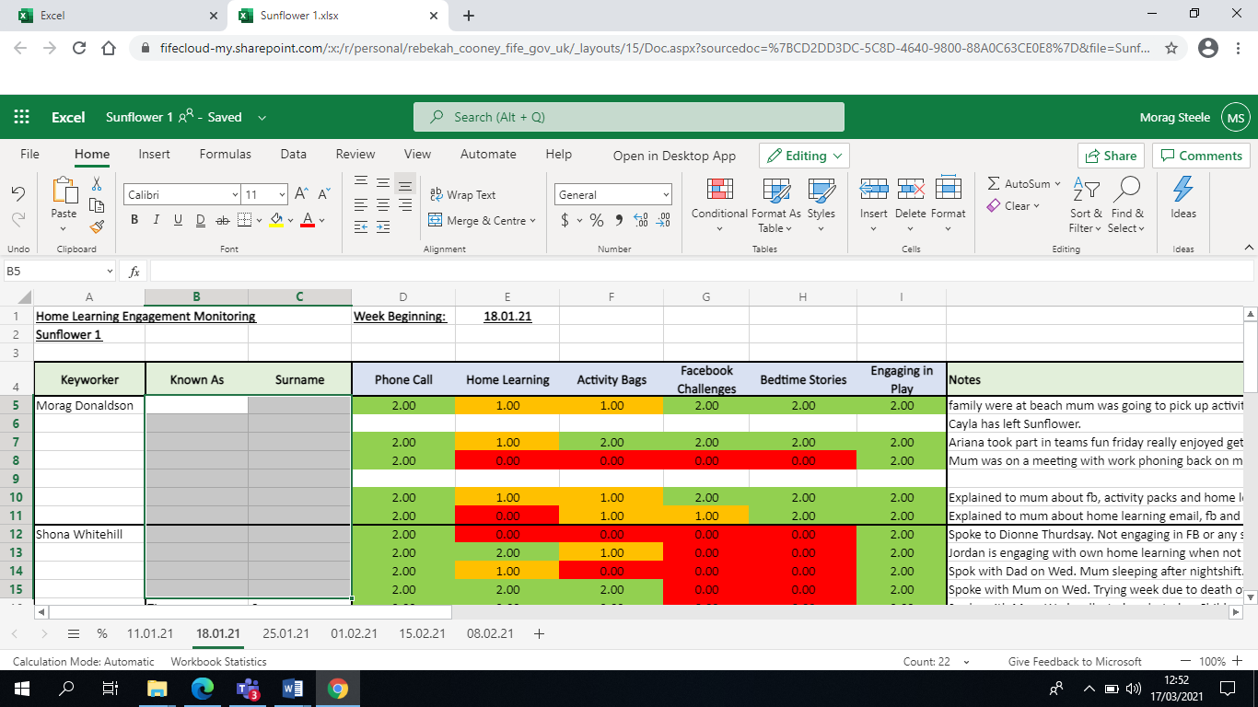

- PLJ Monitoring has been ongoing and Learning Conversations are supporting us to ensure children continue to make progress and we are aware of their Next Steps.
- Our ASN meetings continued during the Lockdown period. Targets for individual children were reviewed and set. TEAMS was used to facilitate these. It has proven easier to include all professionals in these meetings virtually.
- We used our Wall of Wishes to gather views prior to Lockdown 2.
- We used Microsoft Forms to collect data regularly from our families. The results of these were used to develop our remote learning practice. Since returning we have carried out a thorough analysis of our remote learning offer.

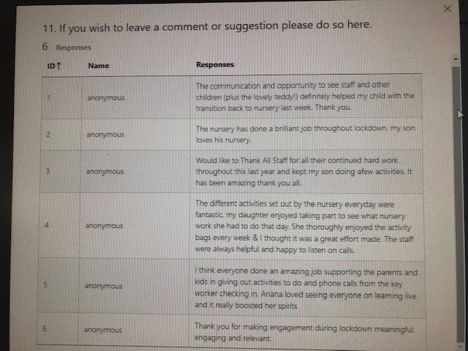
All comments left were positive and highlighted that the remote learning strategy had been effective from our parents perspective.
“Thank you for making engagement during lockdown meaningful, engaging and relevant”

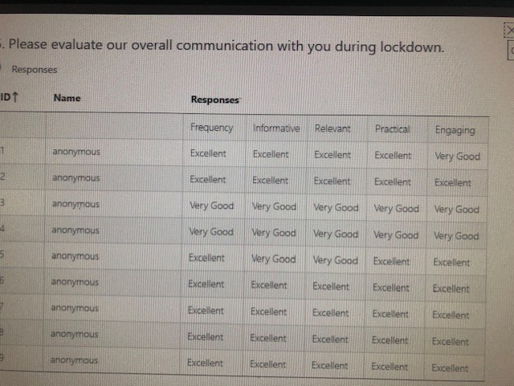
All parents reported that they felt we were Excellent or Very Good under the following headings when evaluating our overall communication;
Frequency
Informative
Relevant
Practical
Engaging

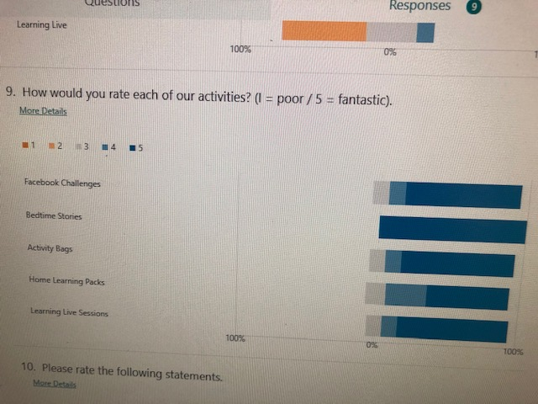
We asked parents to rate how they felt about each area of our remote learning content.

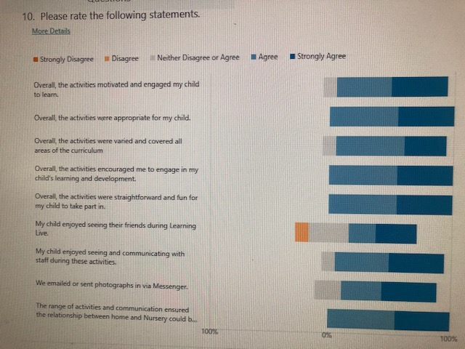
We asked parents to rate a number of statements about their child’s remote learning experience, e.g.,
‘the activities motivated and engaged my child to learn’

‘the activities encouraged me to engage in my child’s learning and development’
- Organisation of Staffing
During the 2nd Lockdown (January – March 2021) we coordinated the staffing in a more focused way to ensure the most effective use of staff time and skills. Our Senior Leadership Team was split into 3 core sections;
- Team 1 – Support for Vulnerable/Key Worker children – In Setting Learning
- Team 2 – Support for children at home – At Home Learning
- Team 3 – Support for staff – Professional Learning
This proved to be a very effective way of organising the 3 key areas. Our staff had access to weekly high quality professional learning opportunities as well as being well supported when providing ELC to children in the setting and those learning at home.
Challenges
- With such a large staff team it was not easy to pick up on staff wellbeing challenges remotely. We addressed this by having weekly staff meetings and catch ups with staff. We really missed the informal conversations we would have on an ongoing basis with staff.
- Our Engagement Spreadsheet was an excellent shared tool to ensure families were well supported and that they were engaging in some form of play at home. For those who did not engage in play experiences in the home it was a real challenge to support this virtually with no face to face groups being available. We ensured a very bespoke package of support was available where we felt a parent was finding playing in the home a challenge.

Quality Indicator | 2018 - 2019 | 2019- 2020 | 2020-2021 | Inspection Evaluation  (within last 3 years)
1.3 Leadership of change | 5 - Very Good | 5 – Very Good | 5 - Very Good | n/a
2.3 Learning, teaching and assessment | 5 – Very Good | 6 - Excellent | 5 – Very Good | n/a
3.1 Ensuring wellbeing, equity and inclusion | 5 – Very Good | 5 – Very Good | 5 – Very Good | n/a
3.2 Securing children’s progress | 5 – Very Good | 5 – Very Good | 5 – Very Good | n/a

Care Inspectorate (within last 3 years) | Grade (if applicable)
 | 2018 – 2019 | 2019- 2020 | 2020-2021  Key Q5 Covid Inspection
Quality of care and support | 6 – Excellent  (Feb 2019) |  | - V G  - VG  - VG
Quality of environment | Not Assessed
Quality of staffing | Not Assessed
Quality of leadership and management | 6 - Excellent  (Feb 2019)

