**Standards & Audit Committee**

14 June, 2018.   
Agenda Item No. 10

|  |
| --- |
| **Complaints Update** |
| Report by: Diarmuid Cotter, Customer Service Delivery Manager |
| Wards Affected: All |

**Purpose**

To provide a brief update on complaints closed between 1 April 2017 and 31 March 2018 (performance and information)

**Recommendation(s)**

That the Committee:

* comment on the complaint performance detailed in this report

**Resource Implications**

There are no direct resource implications arising from this report.

**Legal & Risk Implications**

There are no direct legal and risk implications arising from this report.

**Impact Assessment**

An EqIA has not been completed and is not necessary as the report does not propose a change or revision to existing policies and practices.

**Consultation**

No specific consultation has been carried out in relation to this report however there is continuous consultation with Services through quarterly and ad hoc performance reports.

**1.0 Background**

1.1 It should be recognised that the proportion of complaints made to the Council are very small given that the organisation responds to around 7 million contacts from customers across Fife every year. Where customers do have cause to complain, we aim to resolve these quickly and learn from them to improve future services.

1.2 Reports on customer complaints made to the Council are presented twice a year to Standards and Audit Committee. We also publically report complaints performance information quarterly through Fife Direct and benchmark with other local authorities. In September 2017, Standards & Audit received their 6 monthly update (reflecting year 2016/17) and this report now provides the latest full year picture.

1.3 The main areas highlighted for improvement from the September 17 report included:

* Continue to maintain current performance levels
* Work to improve stage 2 complaint responsiveness rates
* Learning and improving from complaints received (better corrective actions leading to revised processes or service provision)

**2.0 Performance and Issues Arising from Complaints**

**Volume & Responsiveness**

2.1 From the 2,329 complaints received from 1st April 2017 to 31st March 2018 (in period), 2,128 of these were closed (the remainder were still open, withdrawn or pending an allocation decision). This is an 11% decrease on last year when 2,626 complaints were received. This reduction can be attributed to our enhanced ability to separate complaints from service requests and avoid duplication utilising the Escalation & Resolution Team who manage a proportion of the complaints received (all those submitted online, letters, forms and direct emails).

2.2 To improve customer satisfaction and reduce costs, we aim to complete 80% of complaints at Stage 1, and within 5 working days and the remaining 20% at Stage 2, within 20 working days. 83% of complaints were successfully handled at stage 1 in period, 88.3% of which were handled in timescale.

Table 1

|  |  |  |  |
| --- | --- | --- | --- |
| **Stage** | **Total No. of complaints closed** | **No. closed in target timescales** | **% closed in target timescales** |
|  | 2,128 | 1,873 | 88.0% |
| Stage 1 (5 days) | 1,770 (83%) | 1,563 | 88.3% |
| Stage 2 (20 days) | 358 (17%) | 310 | 86.6% |

2.3 The graphs below show our performance over the last 9 years. The overall responsiveness graph highlights a slight dip in performance which coincided with the introduction of the current procedure. The graphs demonstrate that we are making a return to previous performance levels and increasingly resolving complaints more quickly.



2.4 The percentage of complaints resolved in overall target timescales has improved since 2013/14 and work continues to continually improve this across all Services. There has however been a slight decline in our performance with stage 1 (5 working day deadline) complaints completed in timescale. The biggest impact to the Council figure overall has come from Education & Children’s Services (see Table 2). Removing these Services would see the Council 5 day responsiveness at 91%. Arguably stage 1 complaints for these Services can be more complicated thus taking extra time to resolve.

2.5 The following graph shows the average working days to close a complaint and that since 2012 we have generally become quicker at responding to all complaints. Speed in receiving a response remains important as this is a key driver of customer satisfaction. This period does however highlight an increase in the average working days to respond at stage 1. Again this can partly be attributed to Education & Children’s Services performance where their average working days to resolve stage 1 cases was over 11 working days. Their results also impacted upon the overall timescale where Education took on average 29.8 working days on stage 2 cases and Children & Families took 26.1 working days.

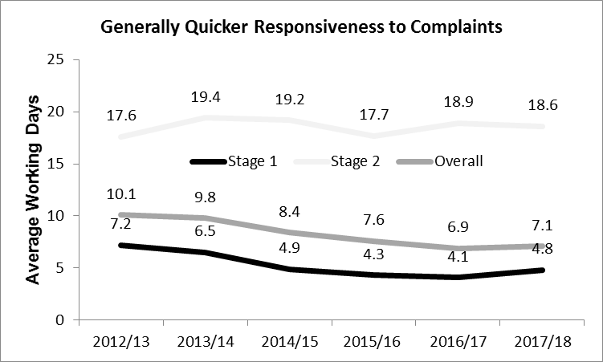

2.6 The following table provides a breakdown of the average working days at stage 1 and stage 2 complaints by respective Services relative to the number of complaints they closed in the period. The table is ordered by average working days to close at stage 1 from highest to lowest.

Table 2



**\*Note:**  Some Education complaints will naturally run into additional working days as due to SPSO guidelines, working days is calculated as calendar working days and not term time (complaints received at the end of a school term may not be addressed until matters can be investigated upon staff return).

2.7 Complaints that necessarily run into extra time are counted as having not met timescale, yet we can separate these out for reporting purposes. The procedure allows for an extension to be applied with an agreed process for doing so that includes keeping customers informed in the event an extension becomes strictly necessary. Some 20 cases ran over timescale at stage 2 where an extension was agreed with the customer, (42% of stage 2, out of timescale cases). This means that overall 92% of stage 2 cases could be considered as resolved within agreed, just not target, timescales.

2.8 Table 3 shows complaint responsiveness by Services. Ordered by % all in timescale worst to best. Please note that 25.4% of Building Services’ complaints were attributed to 3rd parties (77 out of the total of 303). Housing Service recorded 19 complaints that involved an external contractor.



2.9 Table 3 shows that Education & Children Services have experienced reduced performance throughout 2017/18 and have affected the Fife overall figure (highlighted as a consequence of this volume impacting performance). This can be attributed to a number of factors and has been highlighted to the Senior Management Team. The Directorate has recognised the issues and are working closely with Escalation & Resolution team to develop a number of strategies to improve the performance and ultimately the customer service. See paragraph 4.5

2.10 Other Services have also impacted on performance when compared with the previous year. Building Services, Area Services and Parks were in decline and received, like Education & Children’s Services, sufficient volume to affect overall performance. Again this has been highlighted to the respective Services and appropriate action is being taken.

2.11 The Council overall result has reduced slightly, however Customer Service Improvement and Escalation & Resolution continue to do a number of activities in an attempt to raise quality and improve upon performance throughout the reporting year. These activities included:

* Team members have a portfolio of Service areas and have built relationships with complaint handlers in best efforts to improve performance and provide expert support in the process and procedure.
* The frequency and enhanced content of performance reporting continued, facilitating Services to identify any problem areas earlier.
* Extensive quality and quantitative checks were made as well as checks on complaint timescales being met and the administration of complaint closure.
* Additional complaints and system training provided
* Poor performance in terms of system administration highlighted (poor system administration) and improvements made

**Qualitative Checks**

2.12 Additionally the Escalation & Resolution Team completed qualitative checks on responses to complaints and called customers back to survey their satisfaction with the overall complaint process.

2.13 The team completed 50 call backs in period, where 25 (50%) of customers reported that they were entirely satisfied with the way their complaint had been handled. These calls were made to customers in receipt of the full range of decisions, including 42% where their complaint was not upheld. This suggests that customers can be generally satisfied with the handling, even where the Council has disagreed with their complaint.

2.14 There were both positive and negative comments received from the calls:

**Positive Comments:**

* Glad we were doing follow-ups to feedback to Services
* Very happy as officer offered unrelated additional advice
* Delighted with speed of result

**Negative Comments:**

* Unhappy with not being kept up to date on the progress.
* Felt issues were swept under the carpet
* Feel like I was unfairly treated

2.15 The following table 4 provides the details of complaint decisions across Fife:



2.16 Escalation & Resolution also regularly check the quality of written responses and these are marked against a scoring matrix. The matrix details the SPSO’s expectations in composing a resolution letter of sufficient quality. Services scored well in their correspondence and there is evidence that this has improved from last year.

2.17 Qualitative checks will be completed using a different methodology into 2018/19 with no call backs being made, mostly as a consequence of resourcing issues. See section 3 Customer Satisfaction Surveys, and paragraphs 3.2-3.6

**Other Customer Issues**

2.18 The SPSO complaints’ procedure includes a clear definition of a complaint which means that some issues are recorded as fault reports or requests for service rather than as complaints. Some of these customer issues may have been recorded as complaints prior to the revised definition as the Council definition at the time allowed issues to be considered as a ‘complaint’ where a customer requested this.

2.19 These “softer” complaints that are considered outside of the definition include reports around dog mess, pot holes, noise issues, etc. The numbers of enquiries received from these issues are detailed in the following table 5.



**Note:** The table is an extract from our CMS providing the volume of enquiries logged against an enquiry type. Services may express enquiry volumes differently

**\***15/16 volumes were for 6 months only and the 16/17 figure and beyond represents better accuracy of data than any assumption of the issue worsening over time

2.20 Provision of this sort of data continues to be developed for future reports, in order to provide Committee members a fuller picture of matters raised. No further comment is offered on the changing volumes over time as any interpretation could be flawed as often changes are made to how such requests are made and recorded therefore influencing an extract from the database.

**Area Comparison**

2.21 The following table 6 provides the latest comparison of the volume of main Service complaints by area (presented as per 1,000 of the population, then results have been multiplied by 1,000 to provide better readability). Note that complaints made anonymously or from outside of Fife are not attributed to any Area Committee (therefore the grand total will not sum to 2,128 complaints). Population information sourced from the KnowFife dataset.

| **Area Committee** | **Dunfermline** | **Cowdenbeath** | **Glenrothes** | **Kirkcaldy** | **Levenmouth** | **North East Fife** | **South West Fife** |
| --- | --- | --- | --- | --- | --- | --- | --- |
| Population Volume | 56,832 | 41,288 | 50,257 | 60,214 | 37,288 | 74,674 | 49,777 |
| Service Complaints by 1,000 Population **(x1,000 for clarity)** | Per 1,000 | Per 1,000 | Per 1,000 | Per 1,000 | Per 1,000 | Per 1,000 | Per 1,000 |
| Area Services | 176 | 97 | 73 | 145 | 73 | 121 | 24 |
| Bereavement Services | 123 | 170 | 73 | 121 | 145 | 24 | 24 |
| Building Services | **669** | **1,090** | **1,211** | **1,308** | **630** | 702 | **533** |
| Catering Cleaning Facilities Management | 53 | 24 | 97 | 121 | 97 | 145 | 73 |
| Children & Families | 123 | 315 | 194 | 291 | 218 | 170 | 291 |
| Contact Centre | 158 | 194 | 194 | 266 | 242 | 194 | 194 |
| Criminal Justice | 70 | 0 | 48 | 73 | 0 | 48 | 48 |
| Customer Service Improvement | 35 | 0 | 0 | 73 | 0 | 0 | 0 |
| Education | 405 | 315 | 412 | 678 | 242 | **727** | 460 |
| Environment | **1,003** | **993** | **1,163** | **1,308** | **702** | **1,429** | **1,163** |
| Housing | **1,179** | **1,284** | **1,066** | **2,858** | **799** | **727** | **557** |
| Local Office | 35 | 48 | 48 | 194 | 48 | 170 | 24 |
| Parks Open Spaces | 211 | 97 | 242 | 194 | 170 | 194 | 145 |
| Planning | 18 | 145 | 121 | 97 | 24 | 242 | 121 |
| Protective Services | 70 | 48 | 48 | 24 | 48 | 48 | 24 |
| Revenue & Shared Services | 229 | 242 | 412 | 484 | 242 | 509 | 436 |
| Sustainability | 35 | 24 | 24 | 48 | 24 | 73 | 0 |
| Transportation | 457 | 630 | 315 | 388 | 242 | 654 | 315 |
| Welfare Fund | 0 | 0 | 24 | 48 | 24 | 0 | 0 |
| **TOTAL** | **5,226** | **5,837** | **4,756** | **5,995** | **4,479** | **3,602** | **3,737** |
| **TOTAL VOLUME** | **297** | **241** | **239** | **361** | **167** | **269** | **186** |

2.22 The table identifies in bold the top 3 Area complaints received by Service. Housing (Poor communications including lack of notice, consultation & engagement), Environmental Services (Bin issues) and Building Services (poor quality of workmanship / tenant unhappy at work) are in the top 3 for complaints received in all areas. The exception were Education complaints replacing Building Services (dissatisfaction with current delivery arrangements) in North East Fife.

2.23 There is some variation in area responsiveness to complaints. This ranges from 85.6% (down from 87% in 2016/17) of all complaints responded to in timescale in the Levenmouth area to 91.7% (down from 93.5% in 2016/17) of all complaints in the Cowdenbeath area. Work continues to explore the nature of the variation and offer support where required. Levenmouth area had poorer responsiveness from Education and Children & Families.

2.24 The majority of complaints increasingly come in via FifeDirect and then by Contact Centre calls, the table displays an obvious shift over time away from traditional methods of complaint to our best value channels.



**3.0 Customer Satisfaction**

3.1 A new council wide approach to measuring customer satisfaction was launched in 2017. A link to a short online survey is emailed automatically to all customers that we hold an email address for, 4 weeks after their case is logged on our customer management system (Lagan). Some of the transaction types selected for the survey include:

* Repairs i.e. housing
* Reporting faults i.e. potholes, street lighting
* Environmental i.e. domestic waste

3.2 The satisfaction survey methodology has us ask customers how much they agree or disagree with the following statements 4 weeks after they have completed a range of transactions:

* I got everything I needed from the service
* I was happy with the time taken to deal with my request or enquiry
* I got all the information I needed
* I was happy with the way I was treated

3.3 The automated distribution of this new, short customer satisfaction survey to high volumes of customers has generated a high level of responses where we have seen as high as an 18% return rate. By linking up to Lagan, feedback is based on real transactions and gives us a comprehensive picture of customer satisfaction with the services provided.

3.4 The expectation is for Services to consider the customer feedback, particularly the comments, following up by contacting customers where required, with the aim of improving service delivery. Customer Service Improvement are leading this project, conducting all necessary admin and coordinating reports. There are no resource implications for Services in the gathering of this feedback. They are simply asked to consider the content (the dissatisfaction with certain transaction types and our customer’s comments) with the aim of improving service delivery, introducing corrective action to mitigate repeat circumstances that cause dissatisfaction.

3.5 A process has developed whereby if a customer expresses strong disagreement with a survey statement and provides a comment then this feedback is transferred to a new Lagan queue. This enables Customer Service Improvement to assess and decide whether immediate action is required or whether the comments can wait for the quarterly reports. Immediate action can include logging negative feedback as a corporate complaint or instantly taking corrective steps to fix any issues encountered.

3.6 From May 2018 complaints will be surveyed in this manner and therefore replace the current resource intensive call backs.

**Recent Results**

3.7 The latest results from this survey come from feedback received into quarter 4 of 17/18. The Fife Council overall result has 63% of those surveyed (69% in Q3 1718) agree with the satisfaction statements (see 3.2), graph as shown:

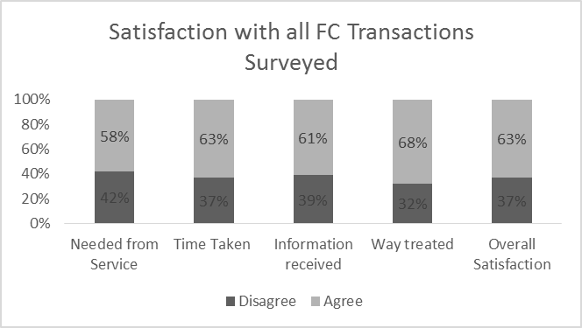

3.8 Overall satisfaction with grouped transactions in Q4 17/18 ranged from 44% agreeing with the statements against Building Services transactions to 100% agreeing in reference to both Blue Badge and registrar transactions. Full results for Q4 1718 shown in table 7.



**4.0 Learning from Complaints**

4.1 One key element of handling complaints is using customer feedback to rectify or improve upon the service provided. It has previously been reported that the improvements introduced allowed for more and better corrective actions to be captured.

4.2 Every upheld or partially upheld complaint presents an opportunity for the Council to address the failings identified, and this is also a requirement of the complaints procedure. Previous complaint update reports to this Committee have described gaps in the volume and quality of corrective actions however this report notes a marked improvement. There are very few instances this period of no statements being recorded.

4.3 A few instances remain where corrective action statements refer simply to the outcome of the complaint, rather than specific actions that would potentially prevent future reoccurrence however these are far fewer than in previous years.

4.4 There are particularly good examples when the Council gets this right and listens to customer feedback and makes improvements. Some from this reporting period included:

* Following complaints about repairs and repair timescales and appointments, Building Services in partnership with Housing Services and the Contact Centre have worked over the last few years to improve customer experience with a range of initiatives. Systems have been developed and implemented (Mobile Working, Repair by Appointment) to improve working arrangements and engagement with customers to make it easier to report repairs and agree time and date that suit their needs.
* A complaint concerning perceived lack of action with bullying claims identified a learning opportunity of increased supervision of pupils, particularly during specified activities and communication between a head teacher and parents to be improved.
* Communication revised so that customers requesting an uplift of bulky refuse are aware that the items may be broken down kerbside so that they can fit in the lorry.
* Following a complaint concerning a pupil being injured the school’s policy changed to allow parents and guardians to be informed and decide upon the best course of action (remain at school or seek medical attention).
* Administration of NEC cards revised and improved following a complaint that a customer had received letters not intended for them causing confusion.
* Following a complaint about unkempt areas the weeding schedule was revised so that the problem area was addressed before becoming an issue.
* Following a complaint about failure to collect bins in a particular area consideration is being given to providing customers with large communal bins in replacement for the current arrangements for the landfill type.
* The Blue Badge process was revised where staff would alert applicants in the event of missing documentation following a complaint of a delay in processing that had resulted from missing verification paperwork.

4.5 A leadership team review within Education & Children’s Services has recognised the importance of a focus on the ‘customer experience’ and the learning from areas such as complaints. The result is the allocation of this area within the strategic responsibilities of an Education Manager.

4.6 One of the reasons for creating the new Communities Directorate was to increase customer responsiveness and this included setting up the Escalation and Resolution team.

4.7 As was reported in the September 2017 annual update report, staffing levels enabled Escalation & Resolution to transition the complaint case management for all Services. The team were therefore able to focus on key aims, including:

* Improving upon current responsiveness rates, such as targeting poorer performing Services (more effective queue management and professional administrational support).
* Improving the standard of customer communication, by increasing the volume of qualitative checks and supporting Services by peer review of resolution letters / emails.
* Improving upon and suggesting alternative corrective actions in response to upheld complaints, to really challenge Services to learn and improve from complaints received, and to follow up to ensure implementation.

4.8 Escalation & Resolution also recorded contact with MP’s & MSP’s in conjunction with the Support Assistant in the Chief Executive’s Office, and there have been 479 enquiries (all politician enquiries, including elected members) in period.

4.9 Unfortunately during 2017/18 the team were affected by staff turnover and mostly operated with 3 permanent and 1 temporary member of staff and a team leader. The beginning of 2018/19 sees the team again affected in this manner and in the interim will operate with 2 permanent staff, 1 temporary member, a seconded staff member, and no team leader. The staff shortages did and will continue to impact upon performance and the ability of the Council to learn and improve from complaints received.

4.10 The future size and scope of the Escalation & Resolution team is currently being reviewed and subsequently the team are focusing on maintaining the current performance levels.

**5.0 Conclusions**

5.1 The overall number of complaints responded to in timescale continues to generally improve and is likely attributable to the improvement activity of the Escalation & Resolution Team and the account management approach adopted throughout the period. This trend remains positive and heading towards performance levels prior to the introduction of the SPSO model complaint handling procedure.

5.2 Some Services performance has dipped from last year particularly in responding to stage 1 cases in timescale. This impacted upon the average working days for a customer to receive a response. Work continues with specific Services to improve performance.

5.3 Generally the quality of written responses are good, and continually improving, as Services use the guidance available. Customer feedback suggests that they can be satisfied with complaint handling, even where their substantive matter wasn’t upheld.

5.4 Customer insight has been enhanced this period with an improved ability to consider “softer complaint” volumes and our ability to quickly identify transactions that have caused dissatisfaction by using the customer satisfaction survey.

5.5 There was some improvement this period with the Council’s ability to learn and improve from complaints received and this was evidenced by better quality and an improved volume of corrective action statements recorded.

5.6 The scale of improvement activity and therefore performance may be negatively impacted as a consequence of current resources in the Escalation & Resolution Team.

**List of Appendices**

1. Appendix 1: Complaint type summary by Service
2. Appendix 2: Summary graph & table of SPSO cases

**Background Papers**

The following papers were relied on in the preparation of this report in terms of the Local Government (Scotland) Act, 1973:

1. Annual Customer Report (Community & Housing Services Committee) August 2017 [click here](https://www.fifedirect.org.uk/news/index.cfm?fuseaction=committee.event&evntid=4E715709-A8EA-CA75-6A32B38FD68E48E7)
2. Standards & Audit Complaints Update Report from September 2017 [click here](http://publications.fifedirect.org.uk/c64_PDF-SA-210917.pdf)

**Report Contacts**

Rab Lindsay, Customer Service Experience Manager

1 Floor Fife House, Glenrothes

Telephone: 03451 55 55 55 + 480222, Email [rab.lindsay@fife.gov.uk](mailto:rab.lindsay@fife.gov.uk)

Dave Thomson, Customer Experience Lead Officer / SPSO Liaison Officer

1 Floor Fife House, Glenrothes

Telephone: 03451 55 55 55 + 444449, Email: [david.thomson-crm@fife.gov.uk](mailto:david.thomson-crm@fife.gov.uk)

**Appendix 1: Complaint Examples Received by the Top 6 (accounts for >75% of complaints handled by Fife Council)**

| **Service type** | **Summary data** | **Complaint & compliment examples, including detail of any learning (all from upheld complaints)** |
| --- | --- | --- |
| **Building Services** | **Received:** 14% of complaints  **Main categories:** Standard of workmanship - tenant unhappy with work | **Complaint Examples**  Without protecting the property by covering furniture, floors or walkways, they removed the old windows. This created a lot of mess, some of which was left behind such as rubble and broken glass on the ground floor bay window roof. They then proceeded to fit the windows. The level of workmanship is not to the customer's satisfaction; three windows are squint. The customer reports that the window fitters when talking amongst themselves were using bad language. When the customer pointed out that a piece of rubble had fallen into a wax burner and caused the wax to splash onto the walls, she was told it wasn't the workman's fault and the rubble must already have been there.  **Outcome**  Apology offered and poor work redone. Corrective actions included all trades were reminded of the Service and customer’s expectations regarding quality and operatives involved were placed on close monitor for 6 months.  **Compliments**  Customer called to say that the glazier that attended to repair his door was very well mannered and did an excellent job. He is pleased with the short time taken to repair and quality of work. |
| **Education** | **Received:** 9% of complaints  **Main categories:** Dissatisfaction with policy current arrangements | **Complaint Examples**  Yesterday my p1 son came home from school and told me he couldn't go to London as there had been another attack. I asked him what he meant and he couldn't explain it further. My p2 daughter then told me they had a minute silence for the people of London. At that point I then told my kids what had happened, previous to the minutes silence at school they didn't know. After the silence at school they were confused and unsettled. After speaking to other mums I found out that the school had also had a silence for Manchester. This 1 perhaps being where my son got the word 'attack' from. I'm hugely alarmed that my 5 and 6 year old children are being informed of this nature of events without my knowledge. As such, I'm not being given the opportunity to chat to them, clear issues up, reassure them. I understand that via social media, television, papers that many older students may be aware of current events. I also understand that kids chat at school, but my kids were not aware of the tragic London events.  **Outcome**  Complaint upheld with an apology offered. Corrective action now in place that parents and guardians will be made aware of these sorts of events so that pupils can be supported in the home environment too.  **Compliments**  “I have found the school and the staff to be nothing short of exceptional. Open evening tonight was a brilliant idea. My daughter got to show off her own work to us and we got an insight into her week which was brilliant. Her teacher is amazing and very approachable. This school and those who work in it should be commended not only for its excellent educational standards but its overall involvement with its families and the community.” |
| **Environment** | **Received:** 19% of complaints  **Main categories:** Failure to collect or empty bins | **Complaint Examples**  Customer wishes to complain that each time his bin is missed from TOR assisted collection, his missed bin report is never resolved within the advised 5 working-day timescale (his bin is not emptied, and he receives no contact from Environmental Services. Customer says his bin is only ever collected on its next scheduled date.  **Outcome**  Apology offered and bin serviced without the wait. Corrective action involved adding the customer’s address to the close monitor list  **Compliments**  “My bins have been repaired many thanks to your guy for the work he was so helpful and customer focused a credit to the organisation please pass these comments on.” |
| **Housing** | **Received:** 20% of complaints  **Main categories:** Poor communications including lack of notice, consultation & engagement | **Complaint Examples**  To whom it may concern, ***staff member*** is the most incompetent person I have ever had the displeasure of speaking with on the phone. I have been dealing with my father's housing application and needs for the last x months as he is currently in unsuitable accommodation and we have some relevant parties involved in helping him. I finally (only took me around three weeks) got a hold of ***staff member***, the housing officer in charge of my father's application, today. She has never spoken to my father and I have ALWAYS had authority on his account/application as he is so unwell, well, dying! Today I called and requested either a meeting or to make changes to my father's areas as he has decided to include more areas that have a higher turnover in housing. She stonewalled me by telling me I have no authority to make those changes. I have always had authority. My father has 2 main medical condition that prevent him helping himself. She has been an incompetent force since I first spoke to her. I am absolutely livid! I hope she can be dealt with in an appropriate manner as this is unacceptable.  **Outcome**  Apology offered and efforts made to accommodate request. The corrective action included that the entire team concerned were trained again in Data Protection issues to prevent this type of reoccurrence.  **Compliments**  Customer (details removed) attended a homeless interview with ***staff member***. He called back into the office afterwards to thank her for all the help, advice and encouragement he had been given. Said he was impressed by how professional and understanding she was and advised she has helped him to move forward and address his ex-tenancy arrears. |
| **Revenue & Shared Service** | **Received: 6%**  **Main categories:** Lack of / Incorrect information | **Complaint Examples**  Call received from XXXX, Trade Union on behalf of his member ***staff member***. ***Staff member*** received a call from ***staff member 2*** in relation to rent arrears. XXXX stated that ***staff member*** was threatened with disciplinary action in relation to non-payment of rent. XXXX wanted to escalate this to an appropriate manager as deemed the employee did not act in accordance with Fife Council policy.  **Outcome**  Complaint partially upheld with appropriate apology offered. The Service has retrained staff members as well as procedure for rent collection being reviewed by way of corrective action.  **Compliments**  “Thank-you to ***staff member*** absolutely great customer service” |
| **Transportation** | **Received:** 8% of complaints  **Main categories:** Dissatisfaction with gritting / snow clearing response e.g. delayed response, poor performance, ineffective etc. | **Complaint Examples**  I know the roads have been horrendous and the council have been out day and night trying to make them safe. They have also used the company ***sub-contractor*** to help them. My parents are pensioners and my mum is disabled. Went over this morning to take them out and was unable to access their disabled bay as they've dumped all the snow in the disabled parking bay. This was done by ***sub-contractor***. You can see that it is clearly marked a disabled bay with the pole and sign. Now I appreciate all the work that has been done to clear the roads but this is just unbelievable. Went to the council offices and showed the lady in the office the picture. Waiting on a call back. Phoned ***sub-contractor*** and they have said there is nothing they can do until they hear from the council. This is just shocking.  **Outcome**  Complaint upheld with apology offered however it is unclear what corrective action was completed as this was not recorded.  **Compliments**  "Just wanted to pass on my thanks to the team of gritters who have been keeping Fife moving. The main roads are perfect." |

**Appendix 2 – Summary Graph & Table of SPSO Cases**

A2.1 The final stage for complainants is the Scottish Public Services Ombudsman (SPSO) and the following graph and table presents the decisions communicated to Council Services by the SPSO over 2017/18. It is worth noting that only a small percentage (12%) of complaint decisions are partially or fully upheld and some of those will have been previously upheld by the Council.

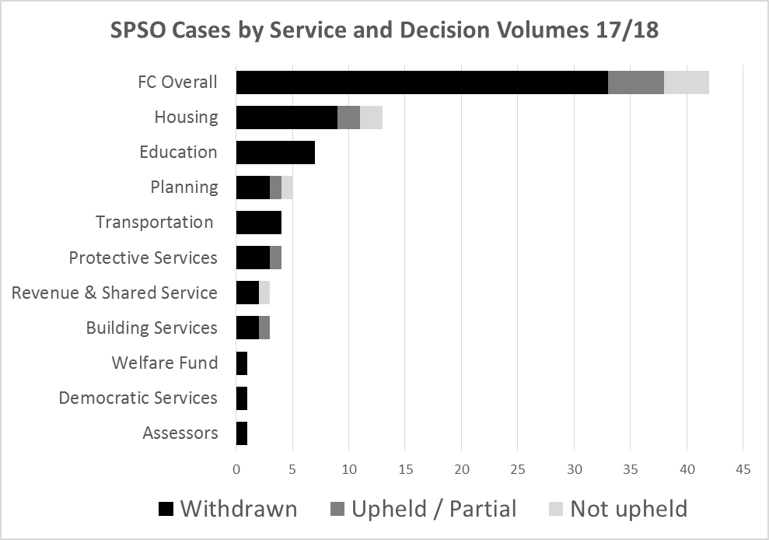



**Note:** Withdrawn (by SPSO) typically means complaints that are out of their jurisdiction or the complainants’ outcome is unachievable. The SPSO remain obliged to alert the Council of these cases under their governing Act.