Asset and Corporate Services sub-Committe

29 October 2020.
Agenda Item No.
Enterprise and Environment Directorate Section/Service Performance Reports
Report by: Keith Winter, Executive Director, Enterprise and Environment
Wards Affected: All
Purpose
To present the performance scorecard for Property Services, Facilities Management, Building Services & Fleet Operations for 2019/20
Recommendations
Members are asked to:
- Consider the Property Services, Facilities Management, Building Service & Fleet Operations performance information presented at appendix 1, 2 & 3;
- Consider if any further review work or scrutiny is required and the scope of that review.
- Note the arrangements set out in section 1 to fulfil the Council’s obligation to comply with Audit Scotland’s 2018 SPI Direction.
- Note the information regarding the workforce profile at appendix 4.
- \note the information regarding workforce data at appendix 5.
Resource Implications
None
Legal & Risk Implications
None
Impact Assessment
An EqIA is not required because the report does not propose a change or revision to existing policies and practices.
Consultation

None required
1.0 Background
  - Audit Scotland published the Statutory Performance Direction in December 2015. 2018/19 is the final year to which that direction applies. The Council is required to report a range of information setting out:

- Its performance in improving local public services, provided by both (i) the council itself and (ii) by the council in conjunction with its partners and communities.
- Its progress against the desired outcomes agreed with its partners and communities.
- Its performance in comparison (i) over time and (ii) with other similar bodies including information drawn down from LGBF in particular and from other benchmarking activities.
- Its assessment of how it is performing against its duty of Best Value, and how it plans to improve against this assessment.

  - The first requirement, to report the Council’s performance in improving local public services (including with partners) will be satisfied by the series of reports (of which this is one) that will be presented to the Council covering the whole of the Council’s performance for 2019/20. Where possible, comparative performance is given for the Scottish average, top quartile, and peer group averages.

  - The other requirements of the Statutory Performance Direction will be satisfied by a combination of

- Update reports to the Fife Partnership regarding progress against the Plan for Fife, with reports also going to Policy and Co-ordination Committee.

- public performance reporting, assurance statements and governance arrangements.

- Reviewing the external Audit Annual Report for it’s view on our Best Value performance and any action plans thereafter.

- Carry out a Best Value self Assessment using the updated Audit Scotland Guidance in conjunction with the Council’s Corporate Governance Statements.

1.4. Taken together, these reports will cover the whole of the Local Government Benchmarking Framework, plus selected service performance indicators that give a balanced picture of Council performance.

  - The appendices to this report are presented in the form of a balanced scorecard covering the areas of Customer, People, Responsiveness and Cost results. This is consistent with the format used for the 2018/19 Public Performance Report and mirrors the approach used for internal management reporting throughout the year.

- Workforce Profile/data

2.1 It was agreed by CET in December 2019 that to streamline performance reporting, workforce Profiles and Data shall be incorporated into Annual Service Reports to eliminate the need for separate reporting.

- Conclusions

3.1 This report is part of a series covering the whole of the Council’s performance against key indicators, including the Local Government Benchmarking framework.

3.2 The overall performance of Property Services, Facilities Management and Building Services & Fleet Operations Services is positive; areas for improvement focus are identified in appendices 1, 2 & 3

List of Appendices

Appendix 1 – Property Services Performance Report 2019/20
Appendix 2 – Facilities Management Performance Report 2019/20
Appendix 3 – Building Services & Fleet Operations Performance Report 2019/20
Appendix 4 – Workforce Profile
Appendix 5 - Workforce data

Report Contacts
Robert Norrie
Corporate Development Officer
Communities Directorate
Robert.norrie@fife.gov.uk

Anne-Marie Fleming
Corporate Development Officer
Communities Directorate
Anne-marie.fleming@fife.gov.uk

Property Services
Performance Report 2019/20
This report provides a strategic overview of performance against key indicators. We continue to work hard to maintain and improve performance, and this year has seen several important achievements for Property Services:  - 6% reduction in energy use across the council estate  - £71m of capital projects delivered (328 projects)  - £1.77m of revenue savings delivered through Building Value Programme  - £11.75m of capital receipts delivered  - Significant programme in place to deliver nursery places across Fife (1140 programme)  - 324 houses delivered via AHP (Affordable Housing Programme)  - Implementation of fire alarm upgrades programme across 50 schools  - Continued high level of satisfaction with services provided by Property Services  - Property Services continue to maintain a low level of absence  - Bereavement Services absence rates are improving  - Improving cemetery safety through a rolling programme of headstone inspections and £1.3m commitment to date to cemetery wall improvements | However, we continue to face significant challenges:  Property  - Potential rising construction costs due to COVID and Brexit over the next couple of years  - COVID affecting the demand for commercial properties impacting on potential income sale/lease  - Reducing Co2 by design, resulting in potential budget conflicts  Bereavement  - Aging workforce and budget realignment require the service to investigate a revision of the structure  - Need for continued input for service improvement through better digital solutions for administration and functional requirements  - Pressure of demand for identification and development of new burial grounds throughout Fife  COVID19  - Increased utility costs owing to increased water safety requirements during low occupation rates  - Conflict between maintaining good ventilation and the heating buildings during the cooler months  - Limited access to operational buildings for non-essential construction works

Customer
Performance | Progress
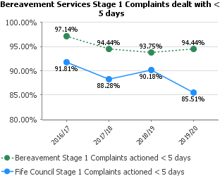 | Bereavement services continues to demonstrate a high level of customer responsiveness.
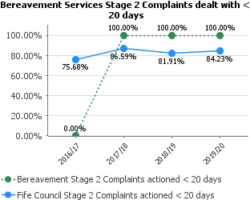
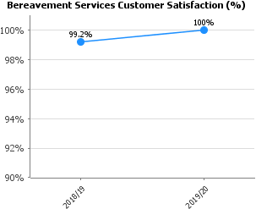 | The service continues to work hard to collect as much customer information as possible to facilitate improved service performance and reputation. Any comments identified within the feedback are used to improve processes and customer experience.
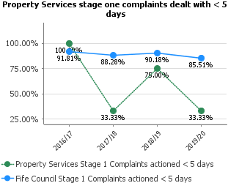 | The service takes complaints seriously and over the next year will be reviewing the handling of these issues. However, owing to the small number of complaints received (5) any issues/delays in the process make a significate difference to the performance indicator.
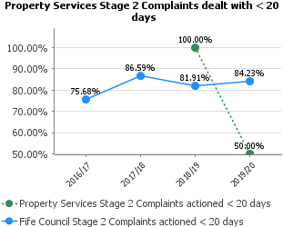
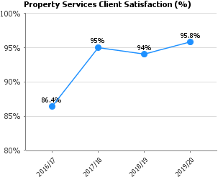 | Customer feedback is essential to develop changes to current practices, such as repairs and maintenance activity and estates transactions.

People
Performance | Progress
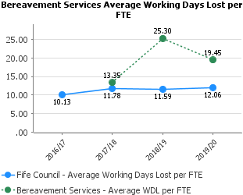 | Physical and mental health has historically been a problem, this could be attributed to the nature of the service.  Last year shows improvement reflecting the Services focus.
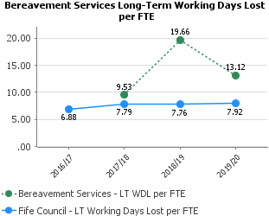
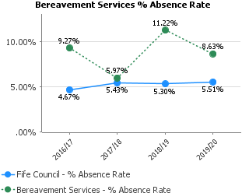
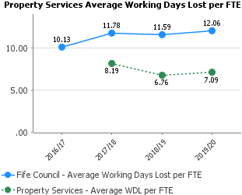 | Attendance levels within Property Services remain high and we continue to improve our figures for Working Days Lost, with a rate significantly lower than the average across Fife Council
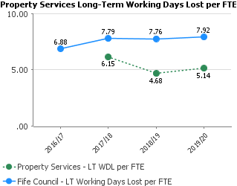
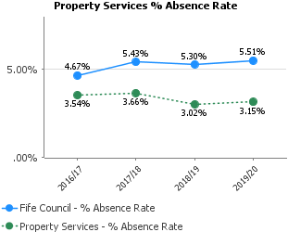
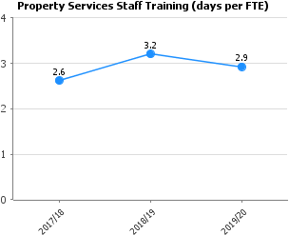 | The development of staff remains important to the service, especially within areas of H&S, building and design compliance, etc.

Responsiveness
Performance | Progress
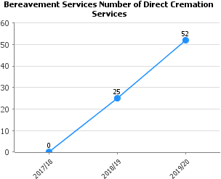 | The offer of direct funerals began in 2018 as part of an initiative to support the provision of more affordable funeral options for Fifers.
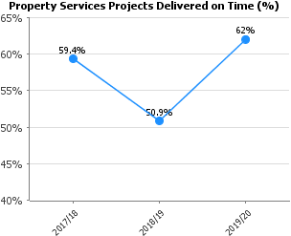 | The service continues to work with clients to improve the delivery time of projects and (as shown below) the number of projects delivered on budget.  Early customer engagement allows us to align expectation in relation to timescales and budgets and enables an early realistic reference point for each project.
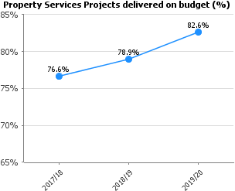
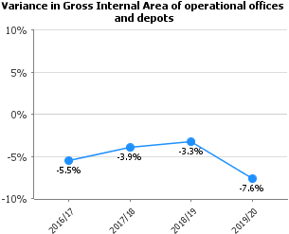 | Continued reduction in Gross Internal Area across offices and depots primarily with the realisation of depot rationalisation within the Dunfermline area, mothballing Elgin street, Milesmark and Bellyeoman Depots and relocating the functions to Halbeath depot.
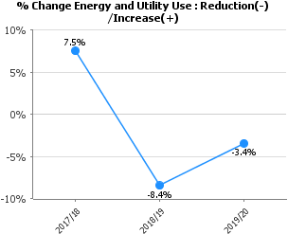 | We are continuing the scrutiny of mechanical and electrical systems to gain performance in line with operational/building requirements.
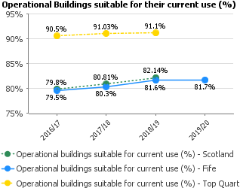 | In line with the Scottish average, we continue to improve the suitability and condition of the estate through investment in new buildings and disposal of premises that are no longer fit for purpose.
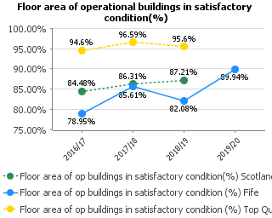 | The increase indicates that as part of the Council’s capital programme we are providing new and upgraded facilities.

Cost
Performance | Progress
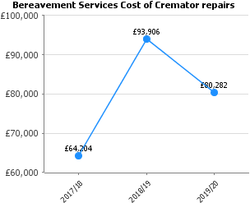 | Four out of five of the cremators are scheduled to be replaced at the beginning of November 2020. The successful supplier is also providing a 10-year maintenance programme for an agreed sum which should reduce future maintenance costs.
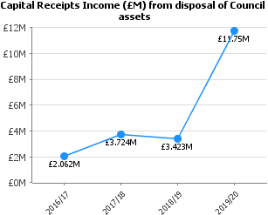 | Capital receipts in 2019/20 included an £8.1m receipt for Madras College, St Andrews.
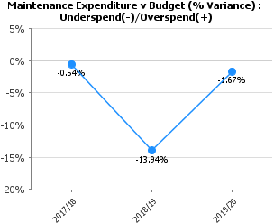 | Tight budget management in 2019/20 allowed the service to deliver planned maintenance spend within 2% of budget.

Facilities Management Services

Performance Report 2019/20
This report provides a strategic overview of performance against key indicators. The service has worked hard to maintain and improve performance, and this year has seen several important achievements for Facilities Management Services (FMS):  It is pleasing to see that long-term staff absences are continuing the downward trend from a high of 9.07days in 2017 and now showing 8.28 days. This positive trend will continue as managers are taking positive remedial action and understand the high financial impact of this resource leakage.  Similarly, with short term staff absence there is a similar downward trend which is to be welcomed and FMS is now only listing 0.5% above the Fife Council average  Manual handling training is now standing at 56.45% which is welcomed but needs further improvement. This will ensure the safety and wellbeing of co-workers and reduce the risk of staff avoidable sickness.  The Meals on Wheels service has been undertaking various promotional activities and consulting with Social Care and the service will see an increase in take-up for 2020/21. | However, the service continues to face significant challenges in the debilitating effect of falling sales in the following 3 areas of the FMS:  Primary school meal take up continues a downward trend sitting 53%. This represents a decrease of approximately a 2% reduction on the previous year (55.4%). This mirrors the national worsening trend across Scotland where primary meals take up is falling.  P1 – P3 Universal free school meals is now down to 72.2% which is following the trend since 2016/17. Further analysis work will be undertaken to understand the reasons for this downward trend  Primary free school meals are showing at 71% and, again, this is a downward trend since 2016/17 where the service was at 80%. It is perplexing to understand the reasons for this downward trend as families benefit by £400 pounds per year per child in taking up Free School Meals.  High school free school meals have had a welcome slight increase since last year and is now at 43% however the service needs to do a lot better by improving marketing and improve uptake to combat off site sales.

Customer
Performance | Progress
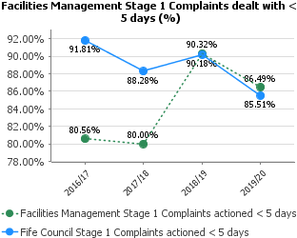 | A small drop of 5% over the previous year but the service will continue to encourage managers to respond promptly.
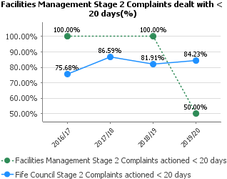 | Only one stage 2 complaint was received in 2018/19. During 2019/20 the service had only two complaints, but will need to examine the reason for not complying with the normal timescales. Often it is that more time is required to ascertain the facts and to respond.
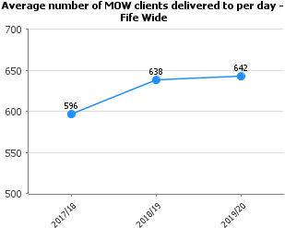 | Meals on wheels service trend continues a very slight increase to 642. Promotional work was undertaken 2017/18 and 2018/19, including tasting sessions with the social workers who will agree care packages with service users and a flyer campaign in offices, day care centres etc. For 2020/21 we expect a substantial increase in users of this valuable service.
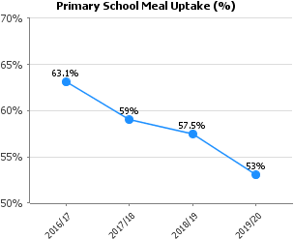 | Increased school meals pricing is making them less attractive for families particularly with more than one child.  Aggressive advertising and promotional work by supermarkets is thought to be a factor together with cheap unhealthy products.
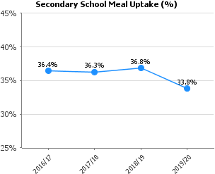
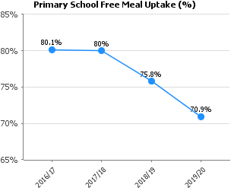 | The service is not certain of the reason for the reduction of primary schools’ free meals take up. The annual reduction of approximately 3% since 2017/18 appears to correlate closely to the meals take up. Menus have not changed significantly and in most cases the lunchtime experience is unaffected. The decline in uptake of universal free meals will affect this indicator.
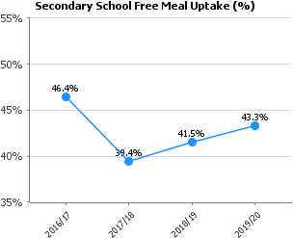 | High schools are showing a marginal increase, but more promotional work and new product foods will be done to offset the attraction of external suppliers (e.g. fast-food outlets).
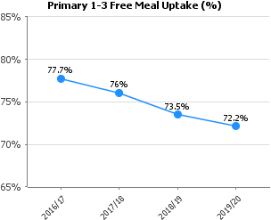 | This is the universal free school meal and again more analysis is needed to understand this trend. Again, this appears to mirror the trend across other Scotland local authorities.

People
Performance | Progress
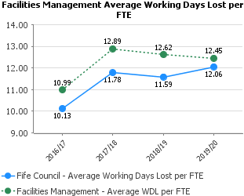 | FMS has very much an older profile workforce and together with repetitive manual work results in higher incidence of sickness.  The continued decline for FMS compared to the overall increase for the council confirms the continuing good work by FMS managers in conjunction with HR should keep the KPI trends going in the preferred direction.
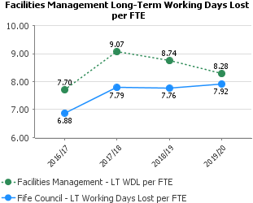
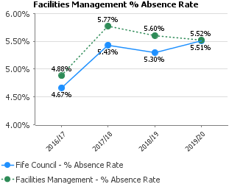
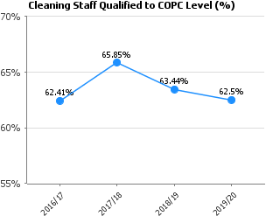 | There have been some issues with accessing training over the last few years, however increased resources from within FMS should show improvement moving forward. Although the difficulties in delivering this training to a large dispersed workforce should not be underestimated  Cleaning staff training under the COPC (cleaning operatives’ cleaning qualification) will need to improve to ensure better service standards and reduce accidents and repetitive strain injuries.  Similarly, this applies to Manual Handling training but covers cleaning, janitorial and catering staff.
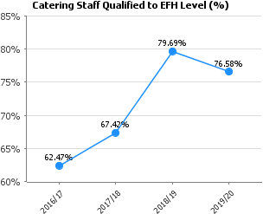
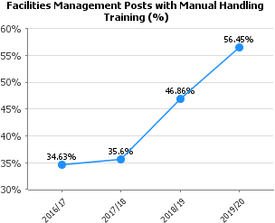
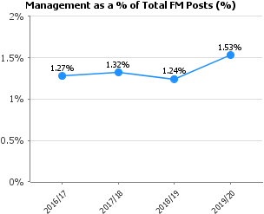 | Funding was obtained to recruit a further two part time staff to the area team, and this explains most of the increase.  The service ratio is very low compared to other Fife Council services and is the lowest ratio in all Scottish authorities. It may be that the decline in some KPI is directly correlated to this low managerial ratio.

Cost
Performance | Progress
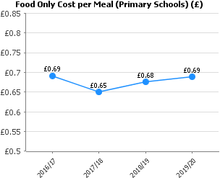 | Per meal cost have largely been stable over the last few years however in future years we will have to increase the quality and variety of menu options and this might result in food ingredient costs increasing to 75p.
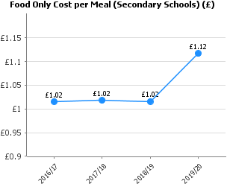 | For High schools there has been increase due to menu changes to offer more popular items to pupils and often these items have a lower margin.
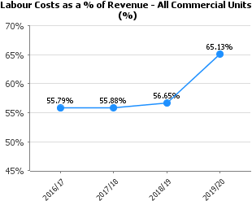 | Sales volumes have reduced, and this percentage has increased accordingly. If sales volumes increase, then this percentage will decrease.
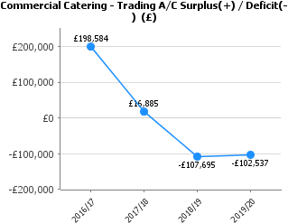 | Achieving the budgeted surplus in commercial catering is proving to be extremely challenging with the service offering being mainly snack based with small margins for profit  The surplus reduction from earlier years is largely attributable to policy changes stopping “hospitality” expenditure within the Council.  .

Building Services & Fleet Operations

Performance Report 2019/20
This report provides a strategic overview of performance against key indicators.  Building Services and Fleet Operations continue to explore and introduce smarter working opportunities and process improvements.  2019/20 has seen performance in these frontline services largely maintained or improved upon with only a few areas for particular focus going forward. | Future challenges include:  Demand growth will be managed through smarter working where possible, increase in mixed economy activity and recruitment of additional staff where workloads are sustainable.  COVID impact recovery will take time and private sector procurement will be reduced to keep all in-house staff fully engaged until a business as usual position is reached.  The uncertainty around the scale of future reductions in client budgets is a major barrier to forward planning. However, a rebalancing of the mixed economy and expansion in to external revenue generating activities may be part of the mitigating solution.

Customer
Performance | Progress
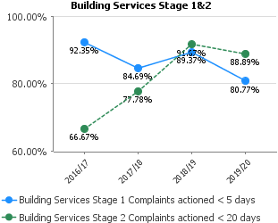 | Building Services remain committed to resolving complaints within timescales. Often the complexity requires additional time to ensure the complaint is resolved satisfactorily. Whilst there has been a general drop in performance Building Services have worked to maintain that decline particularly near the financial year end where staffing was disrupted unexpectedly by government guidelines in the workplace.
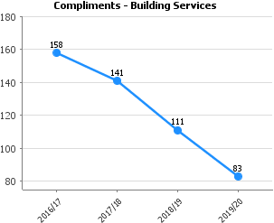 | Building services will review the way they interact with the public over the coming year. A drop is not unexpected considering the events of the last quarter of the year in the UK  It should be noted that tenants now use handheld technology for customer satisfaction returns, when the repair is delivered. This means that it is inevitable there will be a decline in additional written compliments received.
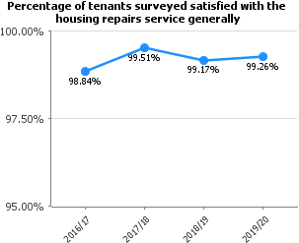 | The year return overall reflects the continuing high satisfaction rate from customers.

People
Performance | Progress
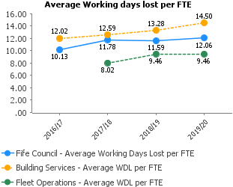 | Building Services will be looking at ways to improve attendance level as the current epidemic restrictions begin to ease and as guidelines change.
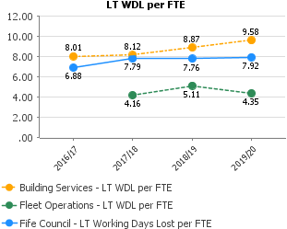
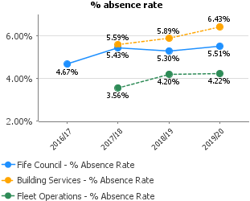
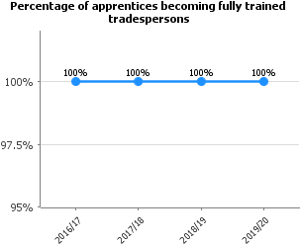 | The apprenticeship scheme remains a national exemplar of good training practice in the construction industry. The continued 100% pass-out rate reflects the quality of the recruitment process and the dedicated support provided throughout the 4-year training period.
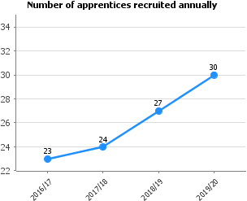 | Recruitment numbers are increasing as displaced apprentices from the private sector are recruited and successfully complete their training.

Responsiveness
Performance | Progress
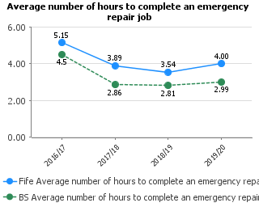 | As current COVID guidelines remain in place, the service will be striving to maintain current performances in line with regulatory targets.
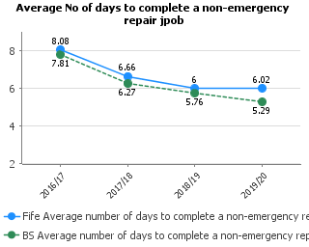
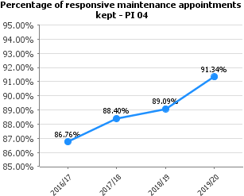
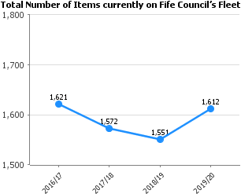 | The number of vehicles increased slightly in 2019/20 because of new vehicles being added and a delay in the auction of old vehicles.  However, the total number of Council Fleet items continues to decrease. A number of vehicles are now electric or hybrid which will help contribute to lowering carbon emissions. Fleet numbers have decreased consistently over the last few years demonstrating that Fleet Services is working closely with customers to ensure service delivery is still met but reductions are made where possible to keep within the Capital budget.
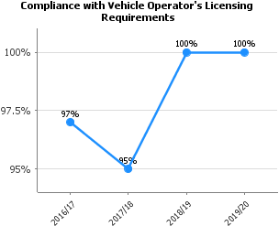 | The implementation of a focused strategic approach in previous years continues to achieve licensing compliance. HGV first time pass rate to the end of March 2020 was 100%.

Cost
Performance | Progress
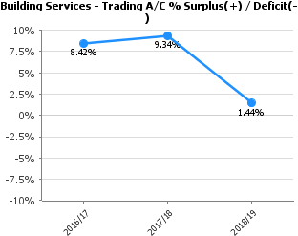 | The Trading account surplus targets continue to be achieved. The 2019/20 is 2.07%, the graph will be updated when the presentation issue is resolved.

