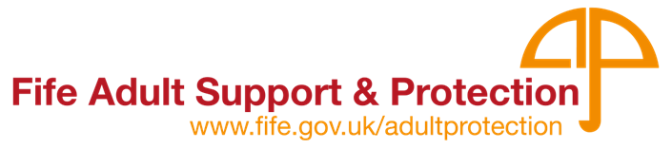

Support with
my rights!

Support to make
decisions!

Help me understand
choices &
decision

Updated October 2022
Advocacy
and
Adult Support and Protection

What is advocacy?

I’m not being
Listened to

Advocacy is about your voice being heard.

What is an Advocate?
How do you feel?

- An advocate is a person who will support you to have your views heard.

- An advocate is matched with you by the advocacy organisation.

- An adult might want/require an advocate because they would like support to look after themselves or the things they own.

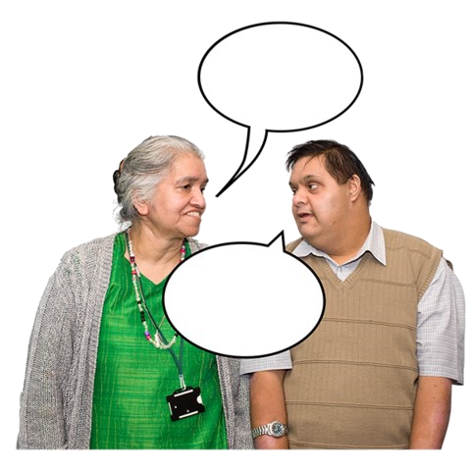
Can you
help?

I’ll call
them

- You can ask for an advocate yourself or someone can support you to do this.

What does an advocate do?

Help to
decide

It’s what
she wants

An advocate can support you to:
- Understand what is happening

- Understand your choices and help you to make your own decisions

- Tell others your views, feelings and what you want

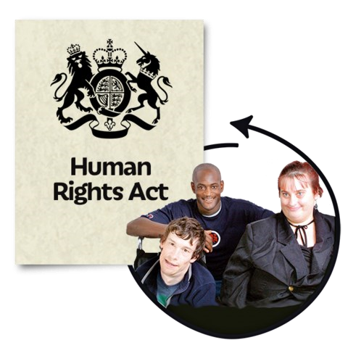

- Understand your rights

An advocate won’t tell anyone else what you have said unless:
- You want them to
- They are worried about your safety
- They are worried about other people’s safety or
- The law is being broken or is going to be broken.
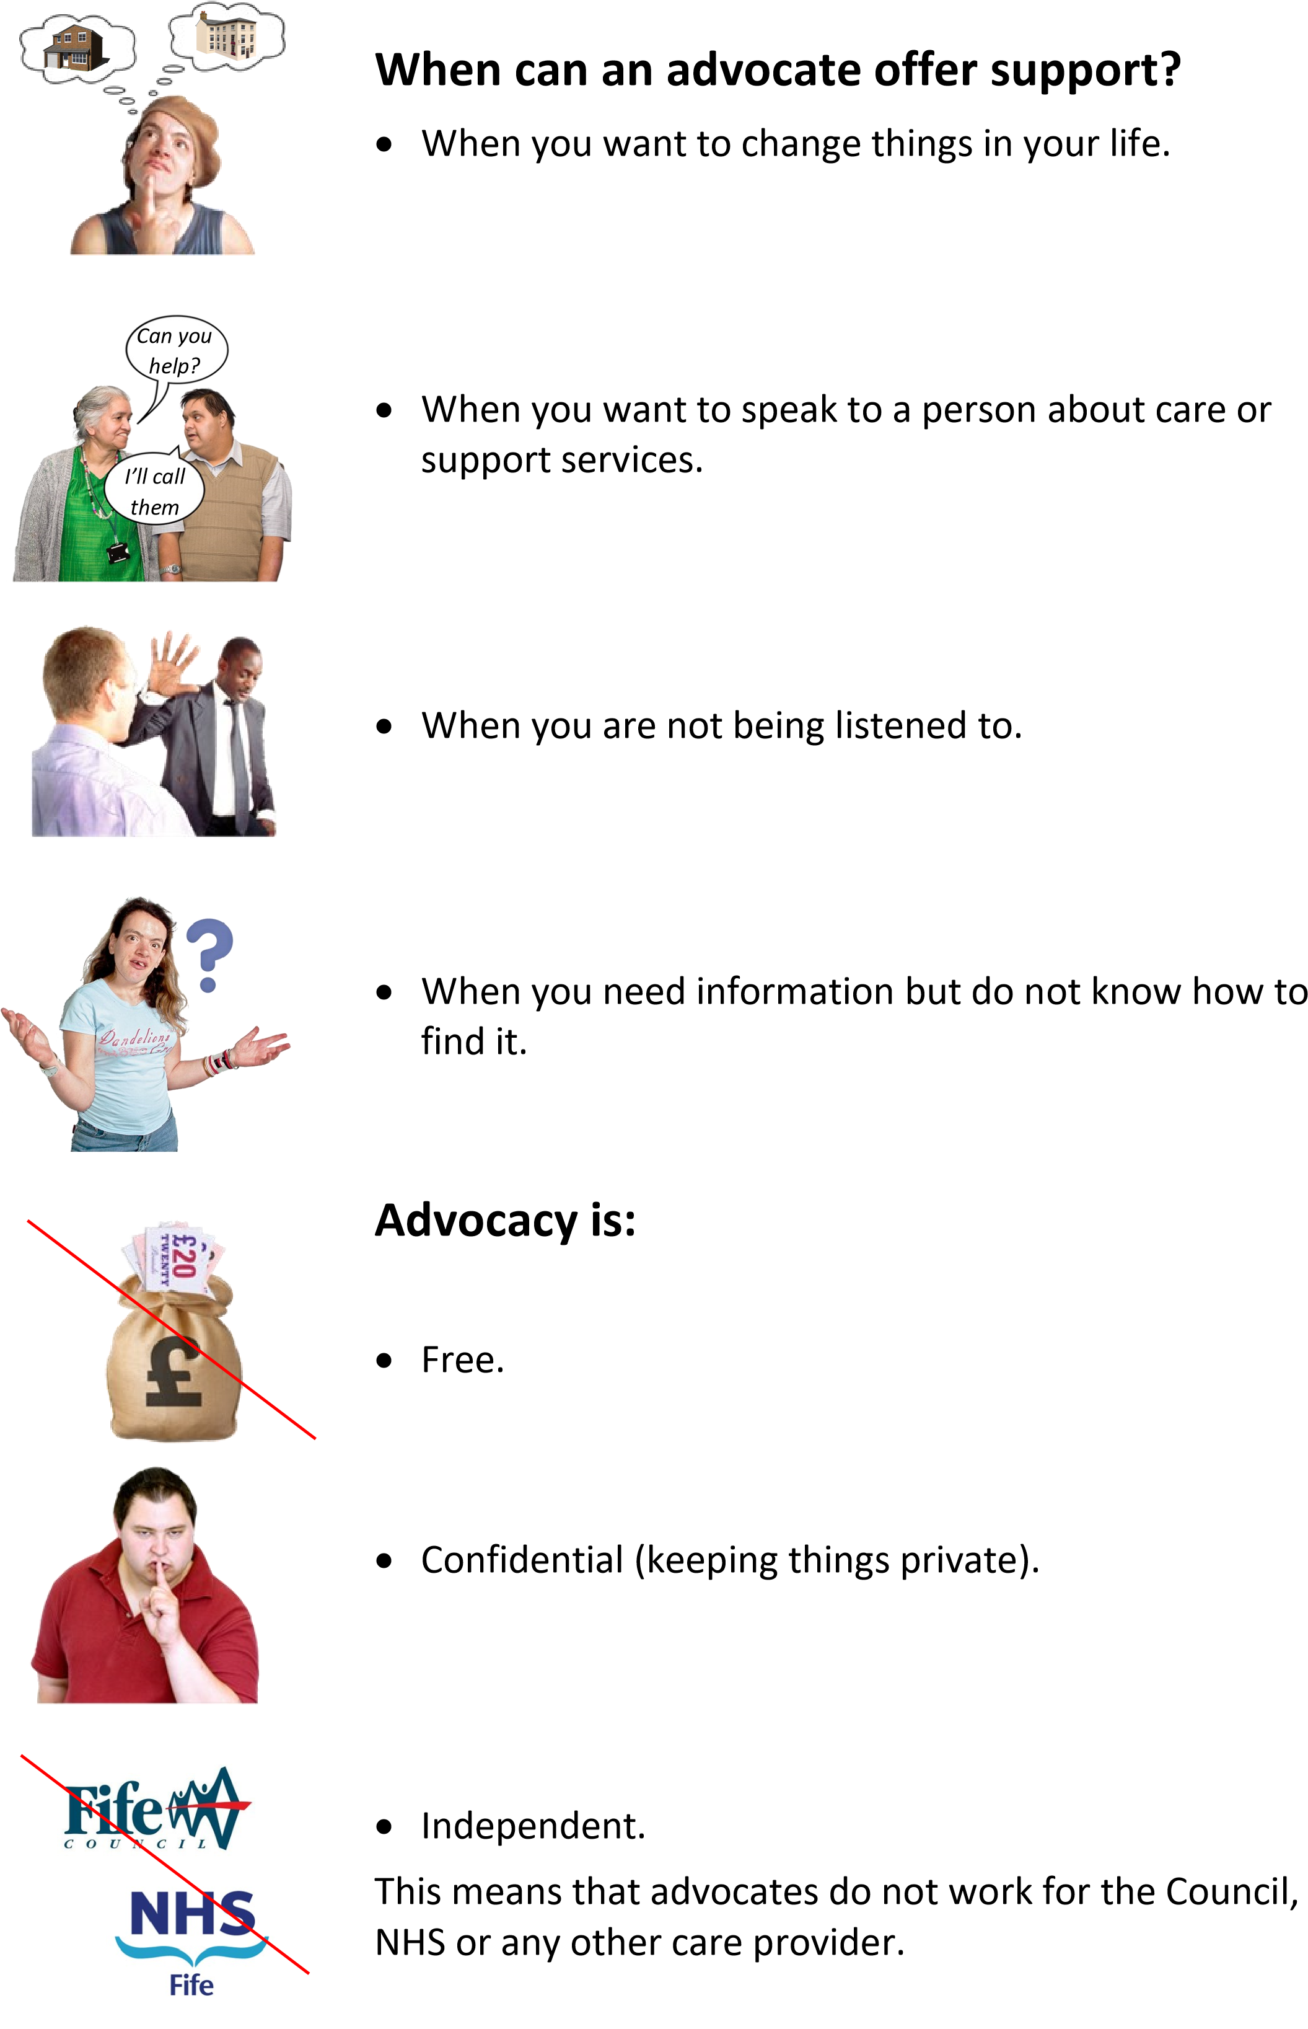
Who can get an advocate?

Fife’s population is rising and the need for advocacy services is high.
This makes them very busy, putting pressure on organisations to prioritise who is eligible to receive advocacy support.

Priority will be given to:
- Adults (age 16 or older) can get an advocate if they have a disability or serious illness.
- Frail older people including those with
dementia/learning disability.
- People with long term conditions.
- Unpaid carers.
- Adults who meet the criteria in the Adult Support and Protection (Scotland) Act 2007.

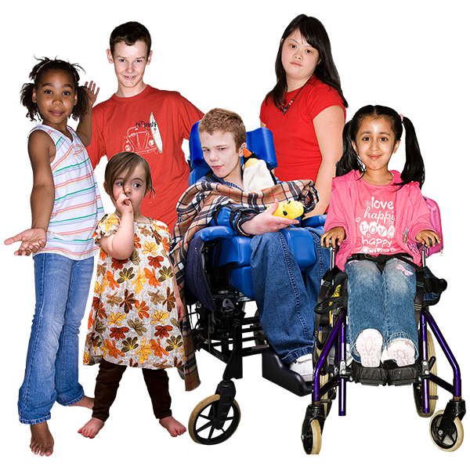
Children and Young People (under 18) can get an advocate if:
- They are a ’looked after’ child. This means they are in care.
- They are between 5 and 18 and supported by Child Protection.
- They have a mental health issue and/or a learning disability.
- They are a young carer.

What kind of advocacy is the right one for me?

There are different kinds of advocacy.

The rest of this booklet explains what they are and how to get in touch with the organisations that can get you an advocate.

PROFESSIONAL (ISSUE BASED) ADVOCACY

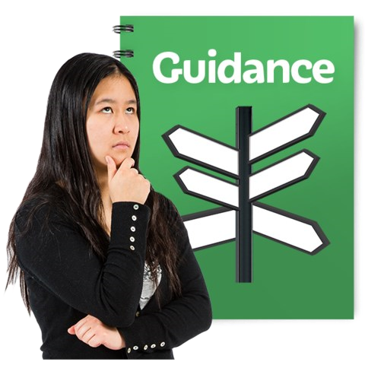
A professional advocate will help you with a difficult issue, when you need an advocate straightaway.

The advocate will support you to:
- Understand what choices you have and who can help
Can you
help?

I’ll call
them

- Express your views at meetings

- Talk to Fife Council or NHS Fife staff

- Deal with formal meetings, for example a Mental Health Tribunal or Child Protection Conference.

When you no longer need an advocate, contact with the advocate will end.
The advocate will support you to contact other organisations if you need to.
You can ask for support from a professional advocate again if you need to.

PROFESSIONAL ADVOCACY ORGANISATION
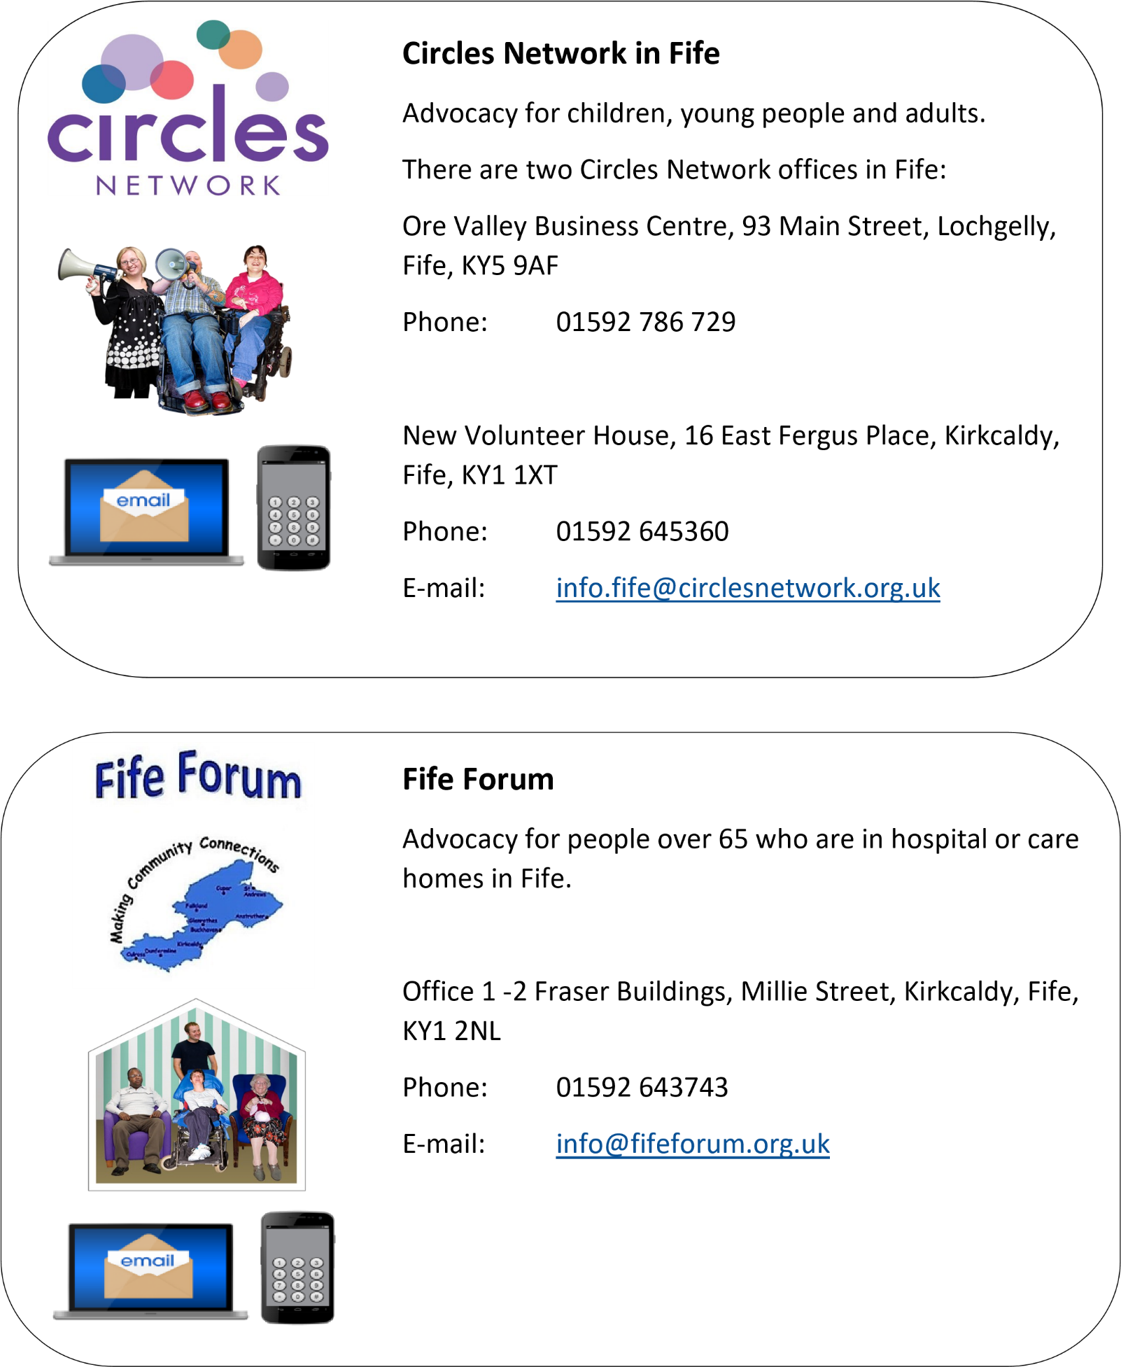
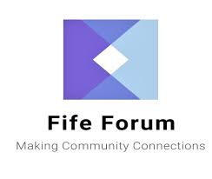

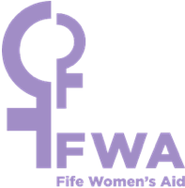

Fife Women’s Aid

Advocacy for women who are experiencing, or have experienced,
domestic abuse.

Domestic abuse is when you are hurt, bullied, or frightened by your
husband, wife, girlfriend, boyfriend, or ex someone who used to be
your partner.

Suite 1, First Floor,
Saltire House, Pentland Park, Glenrothes, Fife,
KY6 2AL

Phone:

0808 802 5555

E
-
mail
:

info@fifewomensaid.org.uk

Kindred (Fife)

Advocacy for parents and carers of children
with additional support
needs
.

No drop-in service but can write to: Unit 11, Dunfermline Business Centre, Izatt Avenue, Dunfermline, KY11 3BZ.

Phone:

01383 871 844

E
-
mail
:

Fifeenquiries@kindred
-
scotland.org

CITIZEN ADVOCACY
How can

I help?

A Citizen Advocate is someone who:
- Builds a trusting relationship with you
- Helps you understand what is happening to you
- Helps you speak up about how you feel
- Can support you for a long time
- Can support you for a short time for one issue

There are three Citizen Advocacy organisations in Fife.

Choose the one that is nearest to where you live.

Dunfermline Advocacy (Dunfermline and West Fife)
Phone: 01383 624382
E-mail: enquiries@dunfermlineadvocacy.org
Website: www.dunfermlineadvocacy.org

Equal Voice (Kirkcaldy & Central Fife)

Phone:

01592 653754

E
-
mail
:

info@equal
-
voice.org.uk

Website:

www.equalvoice.org.u
k

IncludeME! (North East Fife)

Phone:

Telephone 07487 566 442 (Mon-Wed)
07487 566 937 (Tue- Thu)

E-mail
:
contact@includeme.org.uk

Website:

www.includeme.org.uk

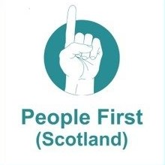
GROUP ADVOCACY
Group advocacy helps people:
- Support each other
- Work together on things that are important to them
- Campaign to make things better for people with learning disabilities

In Fife group advocacy is provided by People First (Scotland).
This is run by and for those with learning disabilities.

There are People First groups all over Fife including a women only group, a men’s only group and a group for people who stay in Mayfield and Lynebank.

The People First team will find the right group for you.

People First (Scotland)
Dunfermline Business Centre, Scotland KY11 3BZ, Scotland, United Kingdom

Contact number: 0131 478 7707

Email: admin@peoplefirstscotland.org
Website: www.peoplefirstscotland.org

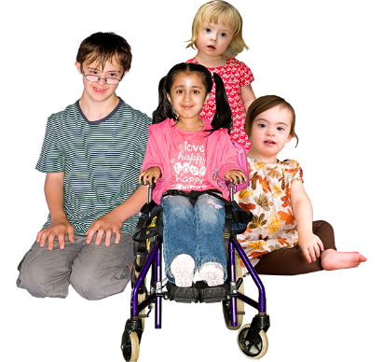
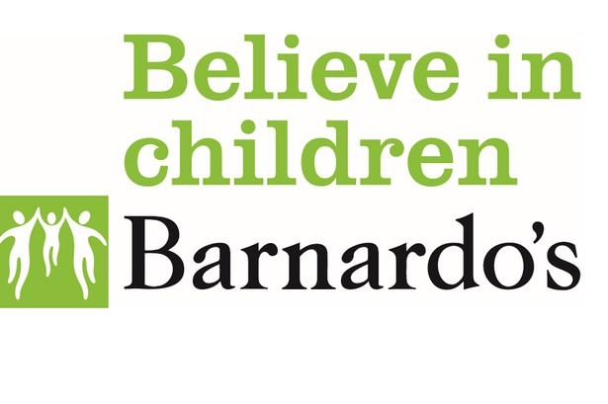
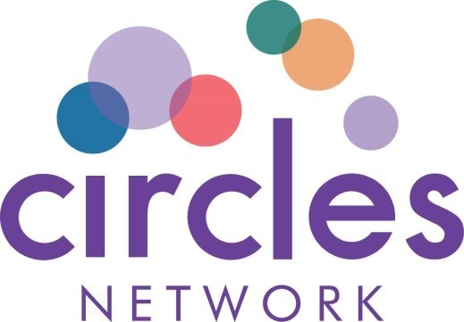

ADVOCACY FOR CHILDREN & YOUNG
PEOPLE

Children and young people can contact one of these organisations,
or someone involved in their care can do this for them.
.
.

Barnardo’s Children’s Rights and Advocacy
Service, Fife.

For children and young people (up to 18).

Phone:

01592 651482

E
-
mail

:

fifeservices@barnardos.org.uk

Who Cares?

Advocacy for young people (up to 25) who live, or have
lived in Fife’s residential homes.

Phone:

07712
872096

E
-
mail:

rdearden@whocaresscotland.org

Circles Network in Fife

Advocacy for children subject to compulsory measures
under the Mental Health (Care and Treatment) (Scotland) Act 2013.

Phone:

01592 645360

E
-
mail:
info.fife@circlesnetwork.org.uk

ADVOCACY FOR UNPAID CARERS
Carers in Fife play an increasing role in our communities.
Some carers need help and these two organisations can provide specialist support to help carers meet their personal support needs.

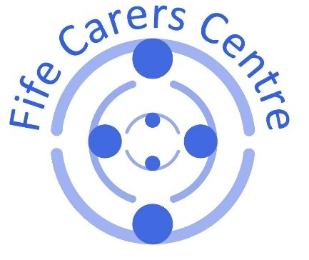

Fife Carers Centre

Fife Carers Centre offers support, including advocacy, to
support carers in their unpaid caring role. They give
information and the means to use it to carers on a w
ide
range of topics from applying for benefits to learning
more about the condition affecting the person they
care for.

Fife Carers Centre, 157 Commercial Street, Kirkcaldy,
Fife, KY1 2NS

Phone:

01592 205472

E
-
mail
:

centre@fifecarers.co.uk

Website
:

www.fifecarerscentre.org

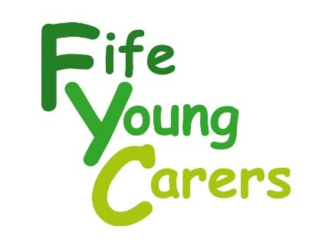

Fife Young Carers

Support to children and
young people (up to 25) who
carers
.

Ore Valley Business Centre, 93 Main Street, Lochgelly,
Fife, KY5 9AF

Phone:

01592 786717

E
-
mail
:

admin@fifeyoungcarers.co.uk

Website
:

www.fifeyoungcarers.co.uk

