MADRAS COLLEGE
Standards and Quality Report
Achieving Excellence and Equity
Context
Setting/School Roll (including ELC/ASC) | 1338
FME | 8.7%
Attendance (%) 91.72% | Authorised | 4.65% | Unauthorised | 3.62%
Exclusion (%) | 0.45%
Attainment Scotland Fund Allocation (PEF and SAC) | £68138

There was not an existing vision, values and aims for Madras College but the school’s motto since 1833 “Pro Rege et Grege” – For King and People. Therefore, as part of our 2020-21 SIP we undertook the task of creating a new Vision, Values and Aims with all stakeholders.
New Vision, Values and Aims
In August 2020 we spent the first two terms asking the views of all pupils, parents/ carers, staff and partners about what our school’s new Vision statement and values ought to be for moving together into the new school at Bell Brae. This formed part of our school improvement plan. We will of course retain our history from 1833 in the form of our school badge and our motto “Pro Rege et Grege” translated as “For King and People.” Firstly, we surveyed all stakeholders to seek opinion on what the most important values are to our school community.
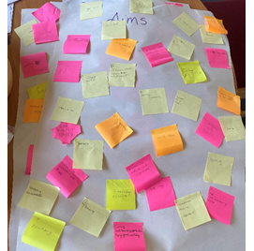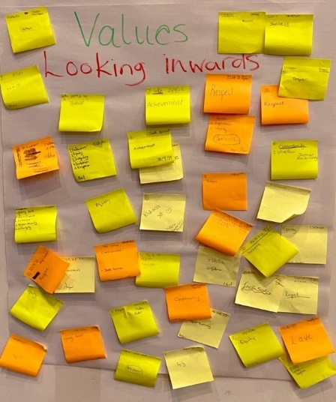

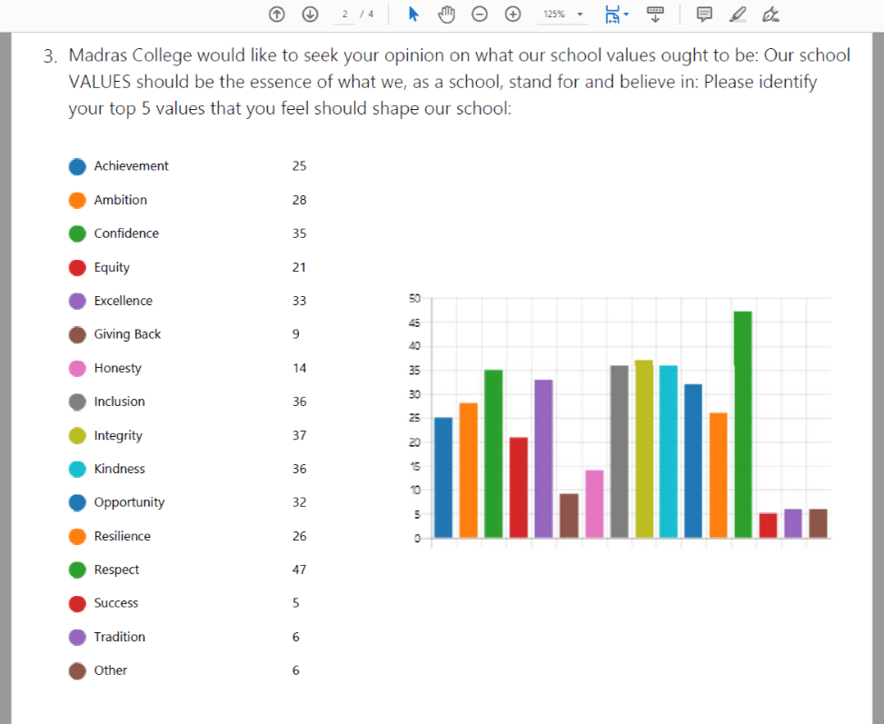

Few pupils from across S1-6 formed a pupil led Vision, values and aims group. They collated the most popular values led by Head Person - Maisie Russell. The group created the vision statement: We are MADRAS.

They then decided that each letter of MADRAS should reflect the most important values:

M – Mindful
A – Achieving
D- Diverse
R – Respectful
A – Ambitious
S – Successful

The pupil led vision, values and aims group have documented this in the following video which can be found on our website:

https://www.madras.fife.sch.uk/Visions-Values-Aims/

Learners ran a competition to create a logo to reflect our values. The winning design below was created by Samantha Kennovin in S2. She has done an outstanding job of designing a crest to reflect our new values. This will be placed in our new school building.
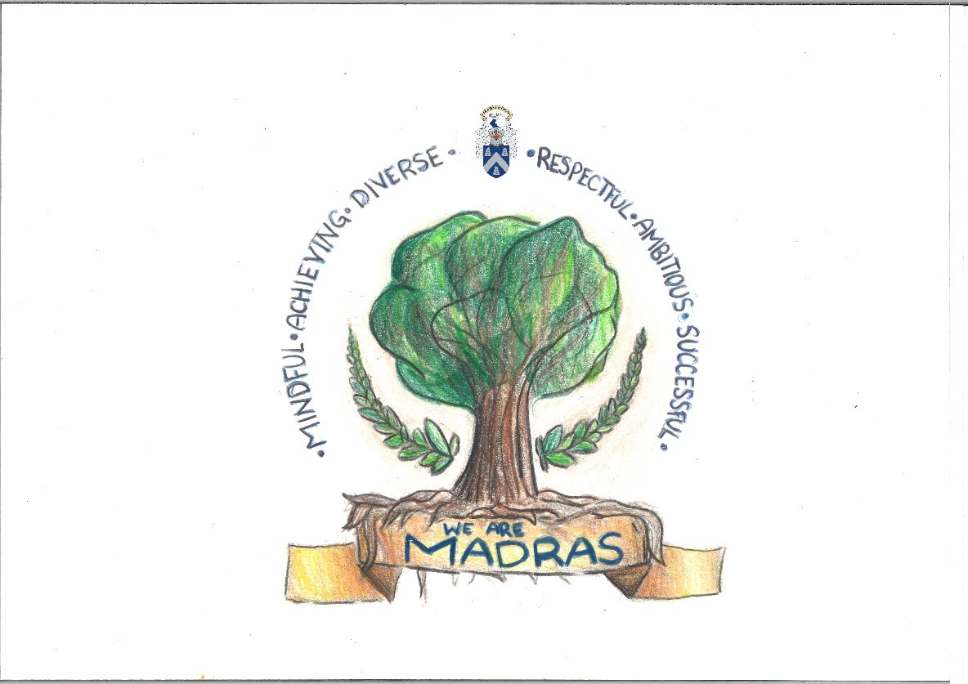
This work correlates with SIP Key Priority 3 – Transition to new school and creating a vision, values and aims for Madras College
Rag status of this priority below:
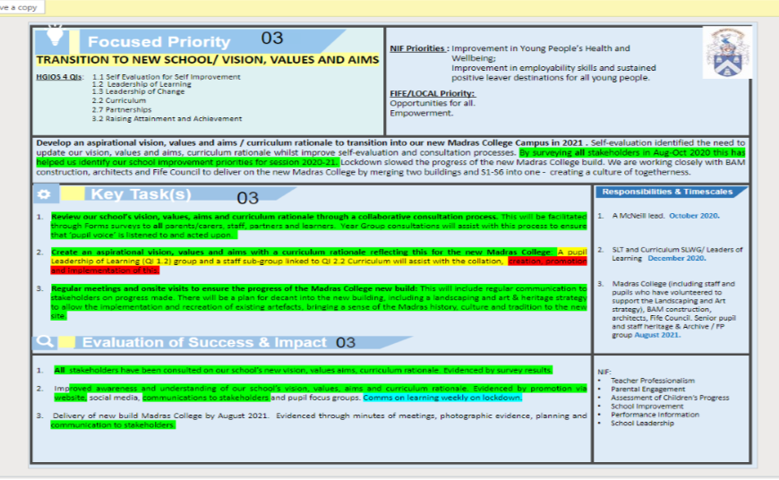

Progress and Impact – key priority 3
Above illustrates the progress and impact of transition to new school and the creation of our vision, values and aims.
Key priority 3 Next steps:
- Implement our school vision, values, aims to improve overall ethos, diversity and respect for all. Stakeholders should live and breathe the values.
- Implement our curriculum rationale and review our curriculum to meet the needs of all learners and correlate with positive destinations and employment.

Improvement for Recovery Priority Work
Session 2020 - 2021
NIF Priority  - Improvement in Young People’s Health and Wellbeing;  - Closing the Attainment Gap.  NIF Driver  - Teacher Professionalism  - Parental Engagement  - Assessment of Children’s Progress  - School Improvement  - Performance Information  - School Leadership | HGIOS 4 Quality Indicators  - 2.1 Safeguarding and Child Protection  - 2.3 Learning, Teaching and Assessment  - 2.4 Personalised Support  - 3.1 Ensuring Wellbeing, Equality & Inclusion  - 3.2 Raising Attainment and Achievement
Progress:
In August 2020 all stakeholders (staff, parents/ carers, pupils and partners) were surveyed to seek their views on our new vision, values, aims, school improvement priorities for session 2020-21, and our curriculum rationale drivers. This survey was repeated in May 2020 to assist with our self-evaluation and SIP/ SQR and PEF planning for session 2021-22.
Focused Priority 1 - Renew our Madras College Health & Wellbeing (HWB) focus for learners, staff, and families in our school community.
Our rationale for this priority was a response to lockdown and the impact of COVID-19 on our school community. Baseline evidence from Health and Wellbeing (HWB)/ Staffwise & Staff HWB surveys (main themes arising are isolation, communication, and leadership opportunities), HWB pupil triage interviews (on return to school in August 2020) were used to address concerns, anxiety, and target support.
Self-evaluation 2019-20 identified a review required of Support for Learners at Madras College. Create an action plan/ workstream for improving consistency of expectation from learners, improving relationships, and addressing low level interruption from a few learners.
- Continue to review our school’s Recovery Plan and Risk Assessment:

Regular reviews of the Madras College risk assessment and recovery plan took place each term to quickly adapt to changes in National Guidance from Scottish Government in relation to schools and COVID-19.

- The headteacher, business manager, janitorial staff and professional associations representing teachers and support staff met termly to review and update the school’s Risk Assessment and planning processes.
- Clear communication to parents / pupils and staff on website, through groupcall when a positive case was identified. This included acting on feedback from Parent Council to ensure that parents/carers being asked to self-isolate their child responded to the groupcall text message, ensuring no learners came to school who were required to self-isolate.
- Public Health praised the school’s approach to seating plans, minimising the numbers of pupils required to isolate when required.
- The Health and Safety Executive looked at our school’s approaches to mitigate risk and agreed positive actions were in place at Madras College.
- Review Support Structure for new school site in 2021.

Key Task 2
Progress and Impact

We evaluated our existing Intensive, Targeted and Universal support provision at Madras College. The aim was to create a Nurture provision and review use of teaching spaces and curricular delivery/ planning for at risk learners. This was for both the current and future provision in the new school. Plans to implement Boxall profiling for a few targeted / at risk learners in session 2020-21 with a view to train staff and extend this.
We undertook a SWOT analysis in the guidance team across the S1-S3 guidance teachers to get an initial indication of where the guidance team were in terms of self-evaluation. All guidance staff in the S1-S3 team completed an individual return.
SWOT ANALYSIS GUIDANCE TEAM OVERVIEW
Strengths  Know caseloads well.  Strong problem-solving skills.  Strong cohesion across the team.  Open door policy.  Positive and prominent profile across the school.  Strong partnerships.  Strong communication skills.  Prioritisation skills. | Weaknesses  Time constraints within teaching timetable.  Keeping records up to date and in the right place.  Duplication of paperwork.  Issues with curriculum when pupils want to leave a subject.  Year team system – too many guidance teacher changes for pupils.  Most of our work is re-active.
Opportunities  Opportunities to share good practice with colleagues in both departments.  There have been valuable professional learning opportunities this year.  More regular meetings between the year teams and partners.  Development of more accessible courses for those who are not academic.  Overhaul of social education programme.  Improvements in knowledge of wellbeing Indicators across the school.  An opportunity to discuss the way forward for Guidance and how that will look in the new school. | Threats  Timetable commitments make the balance between guidance and subject challenging at times.  Time and resources.  Finding time to improve personal skills.

Guidance Team Improvements and Evaluation
- We have implemented full guidance team meetings and created an initial draft Quality Assurance calendar for the faculty to be updated and full implemented in session 2021/22.
- The Guidance team have been allocated sufficient time in their working week to support their caseloads (timetable 2021-2022), this was not previously equitable.
- We have taken feedback from parents/ carers, and pupils through Forms regarding the ideal universal support structure moving forward. Pupils and parents felt that it would be beneficial to maintain the same guidance teacher as a young person moves through the school.

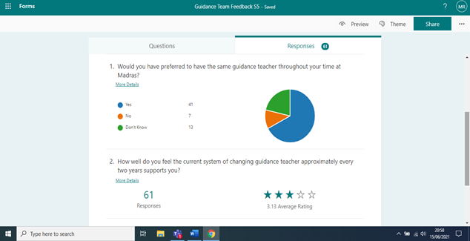
We have implemented an initial professional learning programme this session with CAHMS and other partners. Almost all guidance staff attended the sessions. In addition, we have gathered data from all guidance staff and the PTC support regarding the sessions and what professional learning that staff feel would be beneficial.

How helpful have the CAMHS sessions been? | Has it been useful having different services attend our meetings? | Is there a particular service that you would like me to invite along? | What do you think has been the most effective professional learning you have undertaken this session? | What areas of professional learning would you like addressed moving forward? | How confident do you feel in dealing with the requirements of your role? | Please add any further comments below:

Support Structure
We created a Madras College Support Structure Vision to evaluate our Intensive, Targeted and Universal support provision. The group consisted of a comprehensive and diverse group of partners, staff and other invested parties. The meeting highlighted some key priorities for moving forward including: inclusion, empowerment, communication of information about pupils and roles and responsibilities of staff linked to pupil wellbeing.
Review of the support space in the new school. Changes made to incorporate a Nurture room and teaching areas to meet the needs of the faculty. Agreement reached and put forward in relation to the security of the Department of Additional Support and the facilities required to ensure all young people feel included and valued in the new building.
We have created a Nurture provision and reviewed the use of teaching spaces for the new session and new building. We have used our PEF funding to fund a PT Nurture role to embed nurture across the school in session 2021/2022. Our PT Nurture has undertaken Nurture training with Nurture UK and has begun to undertake Boxall profiling for a few targeted/at risk learners. This has also led to creative and bespoke timetable being offered for a few targeted/at risk learners.
Inclusion
Almost all PTCs and PTs attended an initial session to introduce them to the CIRCLE resource for a session titled ‘The Inclusive Classroom’. The session was delivered by A. Robertson, A. Bracken and H. Thomson (Educational Psychology Team) and A. Massie (PTC Support). The session was used to highlight the roles and responsibilities of staff to meet the needs of all learners in the classroom. A Forms was issued to all staff to determine confidence levels in meeting the needs of the young people at Madras College and the results from this will be used to determine the professional learning sessions offered in session 2021/22.
All staff in the support faculty have been trained on the CIRCLE resource and how to undertake observations as part of the contextualized assessment process.
- Observation and self-evaluation of existing support structures and provision including the support faculty, rooming, planning, and Guidance structure highlighted the need to clarify roles, responsibilities, facilities, and guidance caseloads.
- Resources have been identified to create a Nurture Provision currently and more fully in the new school provision. This meant existing plans for the Support faculty in the new build were updated to create a more inclusive provision. A sensory room and Nurture provision with all requisite resources have been identified and ordered.
- In August 2020, the bullying module was not being used to record concerns/ incidents, not all Guidance staff had been Respect Me trained and there was not a way for learners to confidentially contact Guidance staff without face-to-face contact.
Key Task 3
Continue to develop differentiation strategies to provide appropriate support for young people facing barriers to learning and maximise progress of lower achieving learners:
Priority
Gathering and training on the use of baseline evidence and data including the data linked to young people with additional support needs. Tracking data made available to all staff to support professional judgement and to identify a few targeted learners who required support as they were our furthest from achievement group. Analysis of Insight data identified issues in Literacy for leavers in S4 particularly for boys. To support this the Hackney Literacy programme and the Accelerated Reader programme has been purchased for use in the English and Support faculties.
The Support Faculty and S4 team have forensically analysed the S4 data and created and implemented action plans for young people who were at risk of not achieving their qualifications.
Impact:
RAG STATUS EVALUATION OF PRIORITY 1 - HEALTH, WELLBEING AND RECOVERY
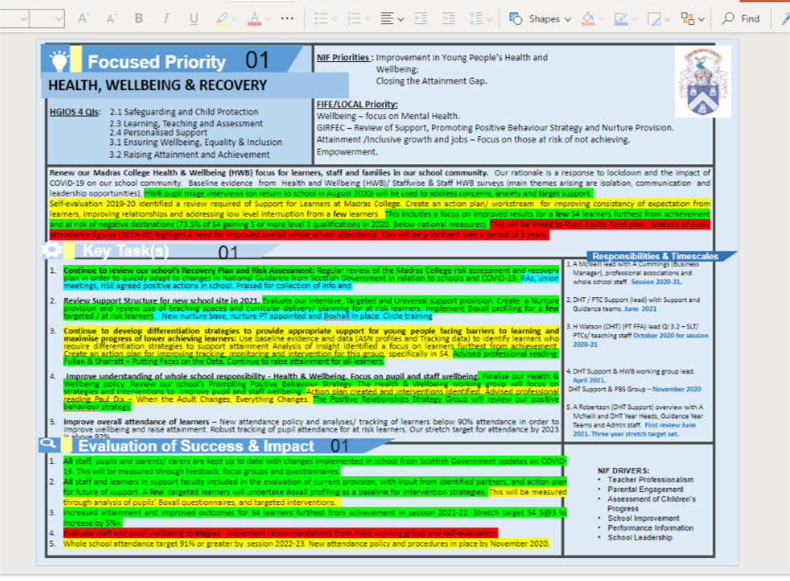
- Continue to review our school’s Recovery Plan and Risk Assessment:

Impact
- All updated Risk Assessments and government guidance issued via weekly update and stored in a centralised location shared with all staff.
- Our new website, school app and groupcall were used successfully to ensure information about COVID updates, changes and testing kits were available to all parents/ carers. All pupils were able to access this information on year group teams.
- Few positive COVID cases has meant less disruption to face-to-face learning when in school. This reflects the measures in place to support pupils and staff.
- On undertaking the protocol linked to positive Covid tests the school was praised by the local authority for the collection of information and the practice in place across the school.
- All staff, pupils and parents/carers are kept up to date with changes implemented in school as a result of changes to Scottish Government guidelines through the weekly What’s On communication.

- Review Support Structure for new school site in 2021.

Impact

In August 2020 almost all S1-S3 pupils had a one-to-one post lockdown triage interview:

- All staff and learners in support faculty included in the evaluation of current provision, with input from identified partners, and action plan for future of support.
- A few targeted learners undertook Boxall profiling as a baseline for intervention strategies. This will be measured through analysis of pupils’ Boxall questionnaires, and targeted interventions.
- All staff in the support faculty have received training on the using of Boxall profiling.
- Almost all PTCs and PTs attended an initial session to introduce them to the CIRCLE resource for a session titled ‘The Inclusive Classroom’.
- Professional learning has been instituted with a focus on support, inclusion, and nurture. All support staff have been trained by the DHT Support in delivery of reading for understanding, phonics, and comprehension to consistently support learners in the faculty to access literacy skills. Professional reading underpinned this: Alex Quigley – Closing the Vocabulary Gap. Additional texts to add in as staff have been given professional reading tasks – Getting into Words Shira Lubliner and Bringing Words to Life Isabel L. Beck, Margaret G. McKeown and Linda Kucan.
- All support staff have attended The Circle training with Educational Psychologists.
- All Guidance staff have completed Respect Me training.
- A few Support teachers have been trained in Boxhall profiling and Nurture UK.
- New dedicated nurture base and identified caseload of young people at the top end of universal/beginning of additional support to be supported by the PT Nurture.
- CIRCLE training and full implementation

Key Task 3 - Continue to develop differentiation strategies to provide appropriate support for young people facing barriers to learning and maximise progress of lower achieving learners:

Impact
All staff were given professional reading to support this area through access to specific areas of Fullan & Sharratt – Putting Faces on the Data. Continue to raise attainment for all learners.
Support Faculty Targeted Attainment
The support faculty took on the role of supporting S3 and S4 learners furthest from achievement. Impact is illustrated below:

Session 19/20
S3: 5 pupils
S4: 1 pupil
18 qualifications - average 3
By comparison in Session 20/21
S3: 35 pupils with 123 qualifications. Average 3.5 qualifications
S4/5: 41 pupils with 241 qualifications. Average 5.9 each

- Increased attainment and improved outcomes for S4 learners furthest from achievement in session 2021-22. Stretch target S4 5@3 to increase by 5%+. This has been attained.

Key Task 4 - Improve understanding of whole school responsibility - Health & Wellbeing. Focus on pupil and staff wellbeing.

Impact
- The promoting positive behaviour strategy has just been finalised and is subject to review in the new school and next session.
- All staff who requested support or raised issues were spoken to by A McNeill.
- On return to school all young people in the BGE had a return to school triage interview to identify any significant health and wellbeing concerns. We also began a further check in at the end of the year before the school building closed again. During the school closure we worked closely to carry out phone calls to all young people with frequency of calls being determined by the needs of the young person. Positive feedback via parents and parent council.
- Almost all young people in the BGE have been taught the wellbeing indicators and have carried out a final self-evaluation before breaking off for the summer break. Any pupil who rates themselves as a three or below is spoken to by their guidance teacher to determine if support is required.

Key Task 5 - Improve overall attendance of learners:
Impact
- New attendance policy and analyses/ tracking of learners below 90% attendance in order to improve wellbeing and raise attainment. Robust tracking of pupil attendance for at risk learners.
- Introduction of a protocol for our vulnerable pupils. Data shared and discussed at year team meetings – attendance policy followed.

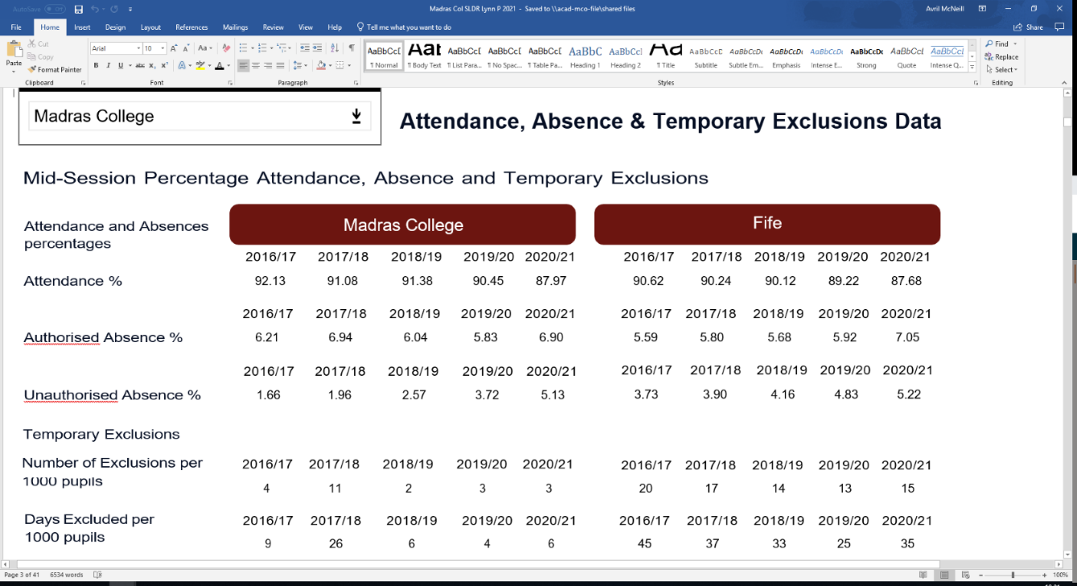
Next Steps:
Key Task 1 - Next Steps

- All staff to engage with the changes to the risk assessments as and when changes are made. Staff to be clear of the best practice protocols being used in schools across the local authority.

- Continue to review practice and evaluate the effectiveness of the current methods for the prevention and limiting of spreading the Covid 19.

Key Task 2 - Next Steps
- The proposed new Support and Guidance structure requires to be finalised by October 2021 in line with LNCT13.
- Create, implement, and evaluate professional learning related to the identified priorities linked to inclusion and meeting the needs of all learners.
- Create, implement, and evaluate professional learning opportunities as identified by the guidance staff in their recent professional learning questionnaire feedback.
- Professional learning of Principles of Nurture and the role of the PT Nurture to be shared with all staff

Key Task 3 - Next Steps
- Continue to identify the most at risk learners and work with them to ensure that they are achieving a full suite of qualifications.
- Curriculum overhaul to ensure we are meeting the needs of all learners.
- Professional learning programme for support faculty

Key Task 4 - Next Steps

- Implement Positive Behaviour and Relationship Strategy in the new school and evaluate its effectiveness after the initial settling in period.
- Continue to offer professional learning to staff regarding positive relationships.
- Implement Restorative Schools training for staff to ensure they are confident in restoring relationships.
- Continue to develop staff wellbeing opportunities.
- Share the How We Are Matters Toolkit for staff in session 2021/22

Key Task 5 - Next Steps

- Introduction of system for those with late coming issues – to be fully implemented and evaluated in session 2021/22. Review safeguarding around attendance and track groups closely.
- Meet stretch target of over 92% by 2023.

Outcomes for Young People
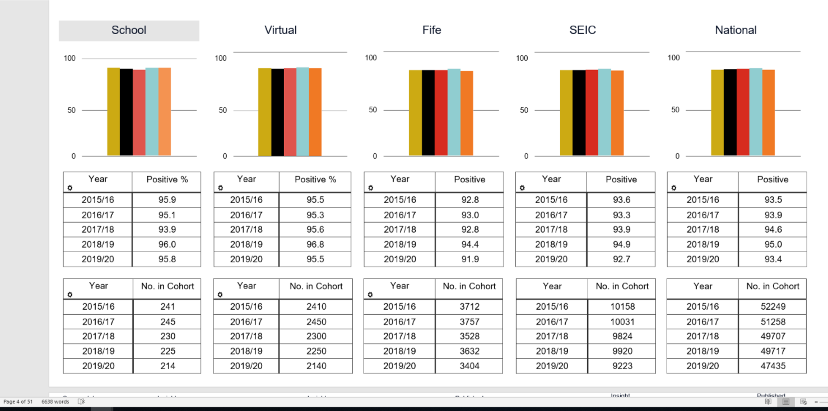
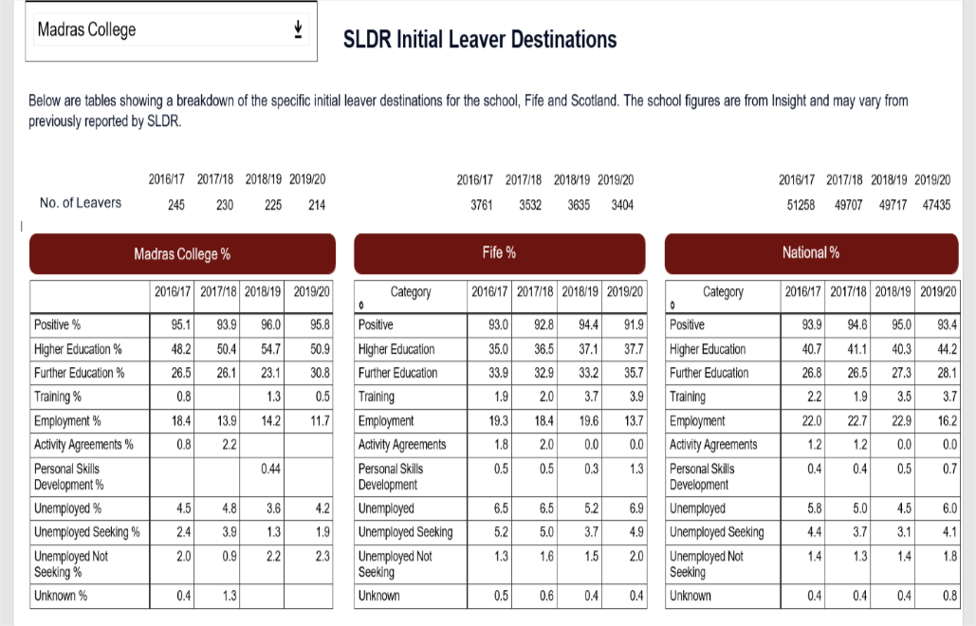
- Almost all young people achieve a positive destination at Madras College. This is above the National Average. Many of our students almost 82% of our cohort move onto Further or Higher Education. We are just under the National Average for those going into employment due to so many taking up places in FE and HE institutions. Those unemployed and not seeking employment is higher than the National Average.
- Successes- here are some of the areas that worked well despite lockdowns from our annual DYW Report:

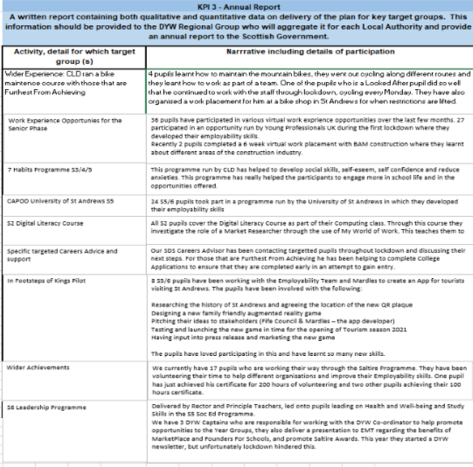
- Next Steps:

- Early intervention is key and often linked to mental health issues. Early support with mental health will support this i.e. referrals to DAPL, Clued-Up and CAMHS Furthermore, the re-introduction of face-to-face work experience and the newly established links with Fife College supporting Skills for Work and NPAs with work experience should support this.
- Again, early in-school interventions will support this such as introducing Nat 3s in S3 for those showing signs of being “at risk”. The embedding of MyWOW and through the auspices of SDS will help pupils to identify employment opportunities and pathways. More timely interventions such as 16+/Works Coach to help support those school refusers or at risk of negative destinations.
- CLD have also provided work experience opportunities which gave some of our FFA pupils skills and qualities for applications for college and work. The reintroduction of face-to-face experiences in Activities time including FAs, TEFL, Academic Skills, Barista Training as well as courses in construction and land based activities will build confidence develop knowledge and skills an prepare young people for the world of work.

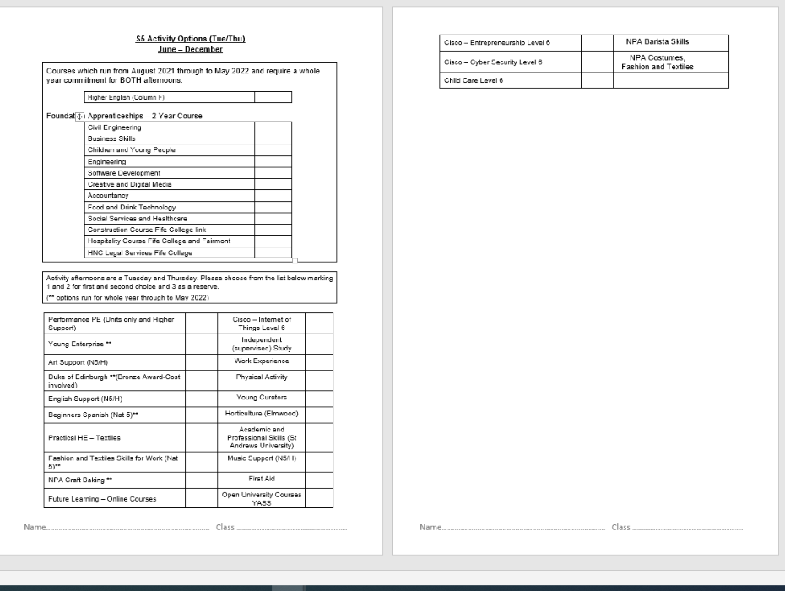
- CFE Declarations across and within levels/ subjects have not been reported on or recorded in the BGE at Madras for the past 7 years. This is a critical improvement priority moving forward. Therefore, this will be a priority for session 2021-22 including the implementation of tracking, recording and moderation of CFE levels within and across all subjects.

- In terms of bridging the poverty related attainment gap – evidence suggests this gap has widened in recent years between the total/ complementary tariff scores for those in deciles 1-3 compared to SIMD 8-10. In 2019-20 the gap between SIMD decile 1 was 68 (National 652) and 1361 in decile 10 (1369 National) total tariff.

- A focus on improved results for a few S4 learners furthest from achievement and at risk of negative destinations (73.5% of S4 gaining 5 or more level 3 qualifications in 2020. Below national measures).

Attainment in Literacy and Numeracy (Theme 1 QI 3.2) – aim to raise attainment in literacy over time.
Insight data for Literacy:
83.18% of leavers from Madras attained Level 5 Literacy in 2020 against 88.79% for our virtual comparator. A gap of over 5%. This gap has grown over the past three years. We were above our virtual comparator in 2017: 85.71% compared to 85.31%. So, while our virtual comparator has improved over the past four years, our results have gone the other way.

92.99% of leavers attained Level 4 Literacy at Madras in 2020 against 96.50% for our virtual comparator. A smaller gap than for Level 5 but one that has increased over the past four years. In 2017 Madras leavers were less than 0.5 % behind our virtual comparator, but since then our percentage has dropped while our virtual comparator has remained broadly the same.

Performance in Literacy at Level 5 in 2020 is highlighted as significantly lower than our virtual comparator in Insight.
If we look specifically at the literacy of S4 leavers a cohort which averages 26 over the past five years last session 37.50% of Madras S4 leavers achieved level 5 while our virtual comparator achieved 49.69% on the same measure. This is a significant gap and again one that has increased over the last four years. In 2017 40.00% of Madras S4 leavers achieved Level 5 compared to 43.33% for our virtual comparator.

At level four we overtook our virtual comparator in 2017, but since then the percentage of our S4 leavers achieving this level has declined while our virtual comparator has remained consistently around or above 80%.
If we look at the information available from the Scottish National Standardised Assessments (SNSAs) which pupils sit in P7. This provides us with a baseline measure for Reading on entry to S1.
Current S1 627
Current S2 639
Current S3 613

Insight Data for Numeracy:
74.30% of leavers from Madras attained Level 5 Numeracy against 78.22% for our virtual comparator. Over the past four years we have been above our virtual comparator twice and below twice. The gap between us and our virtual comparator has developed and widened on this measure over the past two years.

92.52% of leavers attained Level 4 Numeracy at Madras in 2020 against 94.49% for our virtual comparator. Last year we closed the gap with our virtual comparator and we are closer once again to our usual position within 2% of our virtual comparator.

Focussing specifically on S4 Leavers, 31.25% of our leavers achieved National 5 Numeracy compared with 32.19% for our virtual comparator. The gap which opened up in 2019 is closing once again on this measure.
At National 4 Numeracy our S4 leavers overtook our virtual comparator. 84.38% achieving this award against 79.06% for our virtual comparator. After 2019, where we were behind our virtual comparator for the first time in this measure we were once again ahead in session 2020.
Evidence of significant wider achievements
Wider Achievement from Last Session
Prior to this academic session, the school did not have a Wider Achievement policy, overview or tracking system.

Wider Achievement Update – Session 2020/21
In line with HGIOS 4, 3.2 Raising attainment and achievement – overall quality of learner achievement - this year, a temporary position was created. The position – PT Wider Achievement – was introduced in order to audit the current WAOs, set up a database to track future success and engagement with WAOs, introduce new WAOs and create a system which encourages pupils, parents and staff to share information regarding WA involvement with the school.

New Wider Achievement Policy
A policy has now been created which centres around three key principles. They focus on the need to encourage young people to take part in experiences and opportunities beyond their formal education, to record these achievements and to recognise and celebrate individual success.
- Principle 1: Encouraging young people to engage with opportunities beyond formal education.
- Madras College will offer a robust Wider Achievement programme which will be available to all pupils within the school. This programme will have various opportunities, both targeted and universal, to ensure that every young person is given a fair chance to participate.
- The importance of these skills will be communicated regularly throughout the school and success will be celebrated to encourage engagement.
- A DYW steering Group is being set up to encourage and promote wider opportunities within subject areas beyond the classroom.

- Principle 2: Recording achievement in the Wider Achievement Database.
- A Wider Achievement database will be created to record all young people’s engagements, success and achievement both in and outside of the school.
- Communication with all educational stakeholders, including parents and clubs within the local authority, will increase the data available to be inputted into the system.
- If a young person has been accredited with a qualification outside of school, any successes can be shared with us via the Wider Achievement e-mail address:
MCO.WiderAchievement@fife.gov.uk

- Principle 3: Recognising and celebrating success.
- In SOC Ed, pupils will be encouraged to record their success and engagement with Wider Achievement Opportunities using the My World of Work profile provided by Skills Development Scotland. This will allow pupils to keep track of their successes throughout, and beyond, their formal education.
- Achievements will be recorded in the Wider Achievement Database which will be used by Guidance teams when helping young people reach positive destinations.
- The school will reward individual success using commendations, achievement awards and dates ties. Success will be communicated via the school’s social media platforms when appropriate. Success will also be communicated through the daily sheet, assemblies and end of term rewards evenings.

Microsoft Sway Listing Current WAOs
Information on the current Wider Achievement Opportunities offered at Madras can be found here: Madras College Wider Achievement Opportunities

SCQF Ambassador Programme
The school has also signed up to become an SCQF Ambassador School. The SCQF Ambassador programme helps recognise wider achievement, develop Senior Phase learning pathways in line with the Developing the Young Workforce strategy and give equality between vocational and academic qualifications. DYW Ambassadors from the pupil body can play a key role in this.

SQA Leadership Award
Next session, linking with our partners at the university of St Andrews, we will be running the SQA Leadership Award with our S6 cohort. With this award, we aim to encourage more pupils to take active roles in leading opportunities as well as positively recognising those in the year who are already working in committees and groups both in and outside of school.

My WOW Ambassador
Next session, the school will introduce a new leadership opportunity for pupils. This will revolve around My World of Work. The role will involve sharing the benefits of using My WOW and encouraging young people to interact with it regularly. Ambassadors will also encourage pupils to take ownership of their achievements by tracking their experiences in the CV builder. In S6 DYW Captains will support the DYW agenda with our stakeholders.

Remote Learning Experiences – Virtual Work Experience
Throughout lockdown, pupils have been encouraged to sign up for virtual work experience opportunities through the My WOW marketplace. Any engagement with these opportunities will be tracked in the WA Database.

Career Ready, Foundation Apprenticeships
Next session the school will continue to recruit to the programmes listed above, targeting pupils to build confidence and their employability skills with practical experiences.

Leadership Committees
Currently, we have recruited Captains to lead 16 Committees, from Heritage to Health and Well-being: from to Equalities to STEM, as well as DYW Captains. These posts will build their skills and qualities for the next step in their career. The Eco Club and our Equalities Committees will be working with our local community.

S6 Peer Mentoring
Next session on one site, we are instituting a buddy programme whereby senior pupils can mentor pupils in the BGE both inside the classroom and extra curricular.

Developing New Programmes
SQA Barista training, SQA Costumes Fashion and Textiles Fashion, NPAs in P.E.
Fife College we are hoping to run a Hospitality Course at the Fairmont with Madras College pupils. While Fife College are delivering with a construction course.

What have been the success and challenges of school/setting closure period (school/class/playroom isolation, remote learning between January – March 2021)
Key task 1:
Build a more consistent and simplified approach to Blended Learning across Madras College : A working group will be established to lead the development of a whole-school policy and action plan. This priority will be reflected in all Departmental/ Faculty Improvement Plans. Time has been allocated to In-Service, Collegiate meetings and in our Working Time Agreement to reflect the need for a blended learning approach as required.

A working group was established to discuss a whole school approach to Blended/Digital Learning. This group met at various times through the Autumn and Winter terms before the second lockdown came into force in December 2020. The working group produced a draft digital learning policy and action plan which has been shared on the school website at the following address:
https://www.madras.fife.sch.uk/Digital-Learning-Draft/
- All faculties were given time in the Working Time Agreement to develop their use of Blended/Digital Learning. Time was spent in collegiate sessions and during Inservice days developing departmental capabilities.
- All faculties used MS Teams to organise their Blended/Digital Learning offerings following feedback from a parental survey that requested a consistent approach across the school.
- All staff also made use of MS Teams to organise their class’ Blended/Digital Learning provision.
- School staff identified all pupils who required support with ICT (including providing laptops as required) and assisted them in accessing digital learning. A bid was accepted by Connecting Scotland and Madras College has 15 Chromebooks to distribute to families who lack a suitable device for accessing the digital world.

Key Task 2:
Raise staff confidence in the use of Blended Learning approaches at Madras College: Microsoft Teams will be used to create an online hub for tutorial videos. This is an opportunity to embed a culture of Blended/Digital learning. Professional reading folder created for all staff to access includes “Flipped Learning/ Classrooms”. Improve the Professional Reading library for staff.

The Blended/Digital Learning working group produced a MS Team that was dedicated to providing support to staff using MS Teams to deliver digital learning.

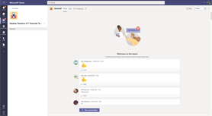

ALL members of staff had access to this resource and a MINORITY of them accessed it regularly.
Dedicated tutorial videos were produced and accessed through this MS Team. A variety of staff members were responsible for producing these short tutorials.

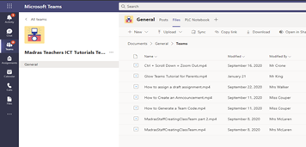

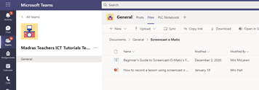

A minority of staff engaged regularly with this platform and offered questions to their colleagues. These questions stopped in February 2021. The inference drawn is that staff were comfortable with the platform being used and so did not require the same support from their colleagues as they had done in the early weeks of lockdown 2.

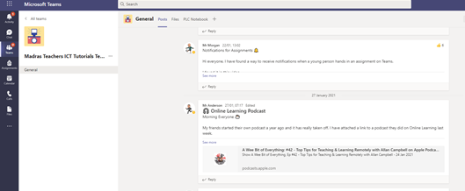

Live video tutorials were also offered through this platform and these were attended by a majority of staff (exact percentage is unknown as a result of how these were organised – drop-ins - but based on the number of staff who signalled an interest through Teams it is estimated approx. 50%-60% attended one of these). One of the drop-in sessions was recorded and the film placed in the ICT Tutorial Team for any staff member to access.

A professional reading folder was created on the Staff server and was populated with a wide range of materials – including materials on Blended/Digital Learning:

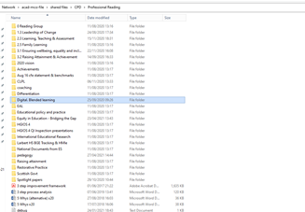

In addition to this the school librarian has created a physical library with a range of professional reading titles available to all staff:

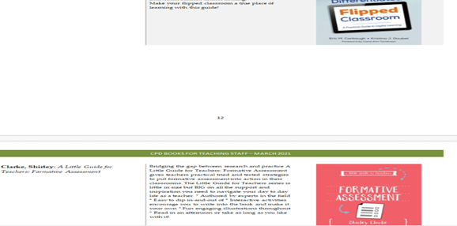
Engagement statistics gathered during the second lockdown demonstrate that more pupils engaged with digital learning during lockdown two than did during lockdown 1. In some areas engagement figures were fewer than 30% during lockdown 1. As the chart below shows, ALL year groups showed engagement figures greater than 30%. Indeed engagement ranged from just above 60% to almost 90%. The majority of pupils engaged with digital learning suggests an improvement in both their confidence and the offering they received from teaching staff.
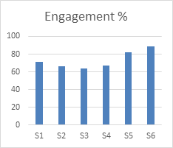
This table was taken from figures collected by SLT for return to Fife Council and the Scottish Government.

Next Steps
- As we move into the new school there is much scope to develop how Madras College staff utilise digital technology to improve learning and teaching, raise attainment and tackle the poverty related attainment and achievement gap. Work must be undertaken to change the culture surrounding learning and teaching in order that staff can make use of the new opportunities afforded by the new school and the technical advances present therein.

Key Task 3
Devise our new communications and positive achievements strategy at Madras College: Create and implement a communications strategy/ action plan to include the build of a new website and App for our school, social media strategy, weekly updates to parents/ carers and staff. Devise a positive achievement strategy to trial and implement focused on celebrating the successes of learners and staff. This will be aligned to our communications strategy.

A new website has been created in collaboration with Greenhouse School Websites. This can be accessed at: https://www.madras.fife.sch.uk/

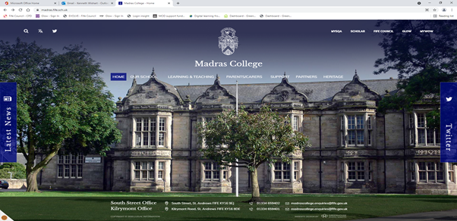

Since January 2021 there have been 19494 unique visitors to the site with over 1.3 million individual hits (a hit is any request for a file – PDF, image, document). This indicates that site is very well used and is visited regularly as a repository for information and news about Madras College.

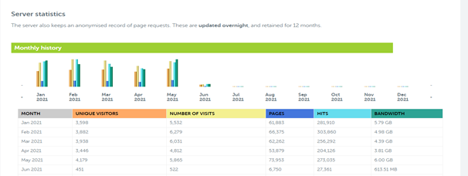

Alongside our school website we have also developed a school app that can be used to communicate with stakeholders. Currently we have 228 users which we hope to increase over the coming months. A feature of the app which has proved useful is the ability of parents to use it to inform the school of any pupil absences. So far this has 173 communications since late November 2020. It is clear that Madras College could make more use of the app to communicate with stakeholders. As of 4 June 2021 we have sent 16 notifications. Partly this is because each notification can only have 100 characters (including spaces). The complexity of communication required during lockdown 2 and the Alternative Certification Model has meant the app has not been the most suitable vehicle for communication.

A social media strategy has been written but has not progressed beyond draft form. This requires revisiting in session 2021-22.

Weekly updates to parents/carers and to staff have been ongoing throughout the session. These are used to communicate a wide range of information about Madras College. The staff weekly update also invites school staff to consider challenge questions taken from HGIOS4.

A short survey was conducted to ascertain whether stakeholders felt communication from Madras College had improved this session compared to session 2019-20. The results are as follows:

- 58% of pupils felt that communication HAD improved (from 65 responses)
- 65% of parents/carers felt that communication HAD improved (from 162 responses)
- 62% of school staff felt that communication HAD NOT improved (from 42 responses)

In order to support our promotion of positive achievement a Temporary PT1 was appointed. He has developed a positive achievement strategy that is ready for implementation in 2021-22. He has linked with many external organisations and all staff in order to raise awareness of the strategy. He has also developed a mechanism by which the achievements of all pupils can be tracked across the school. This strategy will also link with our positive behaviour policy to promote wider achievement across the entire school community.

Next Steps
- Make more use of our school app to communicate with stakeholders
- Investigate why staff have reported communication has not improved and look to implement changes to improve this perception.
- Roll out Achievement strategy.

Key Task 4
Planning required following the SQA announcement change National examinations and qualifications in 2021: Revisit assessment and moderation policies, WuPPA (Write-ups, Projects, Portfolios, Assessments, Assignments) schedule for session 2020-21. Continue to implement strong moderation, verification and quality assurance of assessments/ performance leading to robust SQA estimates, raise attainment. Review whole school SP & BGE Tracking.

Much of the above key task has had to be adapted in light of changes to previously used national certification models. The Alternative Certification Model (ACM) has meant a great deal of planning and preparation had to take place in order to ensure that all senior phase pupils had the opportunity to gain qualifications.
A Verification and Moderation Policy was created by a working group and this was shared with all teaching staff.

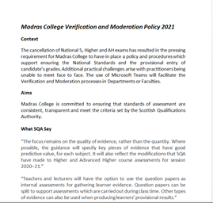
Much time and effort has been spent communicating our plans to parents/carers and to pupils. Year group Teams were used as was a dedicated page on the school website. In addition, information was provided to our Parent Council and elected members. Regular letters and emails were also sent which explained clearly how Madras College would be administering the ACM.

A detailed programme of Evidence Gathering Opportunities was created and shared with all relevant stakeholders:

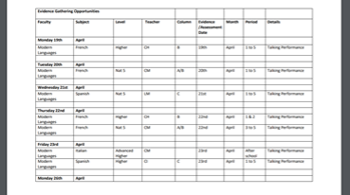

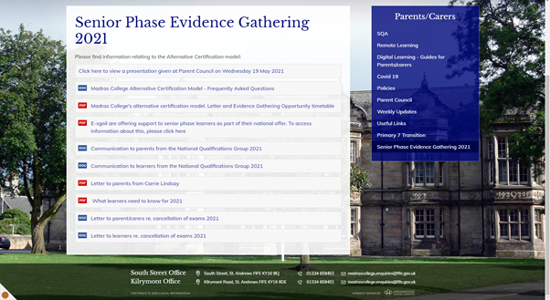

Internal Quality Assurance procedures have been in place and all teaching staff, Principal Teachers and members of SLT have contributed. Teaching staff have engaged with Council wide subject networks with some engaging colleagues outside of Fife in order to maintain standards in line with SQA guidelines.

In addition, Madras College staff have engaged fully with Fife Council’s Quality Assurance process, submitting school and subject level responses to our Head of Service and Education Managers.

In addition to the work being carried out as part of the ACM Madras College has also created a whole school monitoring and tracking resource, The One. This resource contains all relevant date on ALL pupils from S1-S6 and is accessible by ALL teaching staff. Primary 7 data has also been gathered for session 2021-22 and will be used to create the next The One table for our new S1s.
Next Steps:
- Prepare for the appeals process beginning in August 2021
- Encourage all staff to make use of The One table in order to guide their teaching.
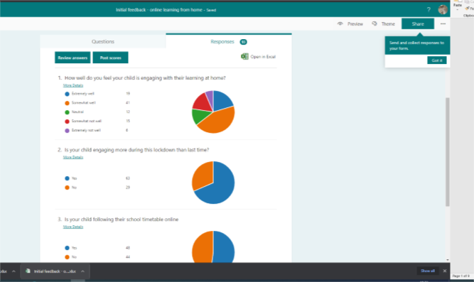
Impact of Local/National resources to support recovery within your setting (digital devices, additionality of staffing)
Number of devices provided to support learning at home | 57 devices were provided up to the end of lockdown 2. An additional 15 devices were provided between May and June 2021.
Additionality in staffing | Teacher of wellbeing

All young people identified in the above digital learning info / survey were issued with IT access, wifi and laptops.

Funding for additional staff member was split between 2 Guidance teachers 0.5 each with a clear focus on wellbeing. This has led to the implementation of HWB triage, follow ups and the introduction of Nurture and Fairshare – addressing food poverty for families.

All pupils completed a HWB face to face and one to one interview post lockdown 1 as part of our HWB strategy linked to this post. The postholders then RAG status all responses and then conducted follow up interviews to ensure the correct support and services were in place.
Key Task 4
Priority

Improve understanding of whole school responsibility - Health & Wellbeing. Focus on pupil and staff wellbeing.

We finalised and published our Health & Wellbeing policy. This was completed after consultation with all staff and 120 pupils in the Broad General Phase – pupils had previously been given the opportunity to tell us what they thought should be included through the Pupil Council.

We undertook a review our school’s Promoting Positive Behaviour Strategy. A working group was created where all staff involved undertook research into the different policies and current research in this area. An action plan was created and initial interventions identified. Staff in the group discussed professional reading and the text by Paul Dix – When the Adult Changes, Everything Changes was highlighted alongside other texts that were purchased for the professional learning section in the library. The Positive Relationships Strategy Group reviewed our current positive behaviour strategy and the action plan for moving forward was created with different groups of staff gathering stakeholder views. Staff and pupils were invited to provide feedback and over 400 young people in the Broad General Phase competed the survey as did 56 staff. The feedback was considered, and a draft policy was created and shared with the group, staff, parents and pupils.

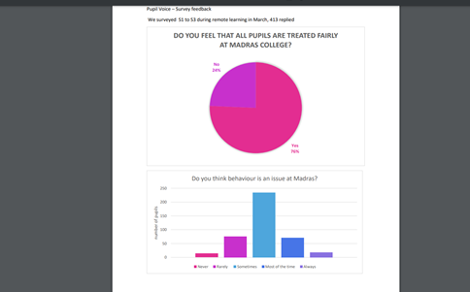

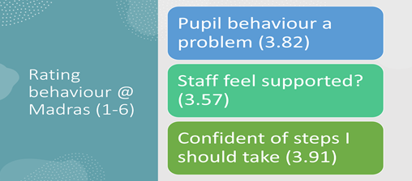
The Health & Wellbeing working group will focus on strategies and interventions to improve pupil and staff wellbeing. Staff wellbeing survey undertaken and issued to all staff through Forms.

Introduction of secret friend system for staff and information from the local authority regarding the new staff wellbeing policy. Five ways information shared as was the information regarding support for staff.
Staff and Pupil Wellbeing

The Health & Wellbeing working group will focus on strategies and interventions to improve pupil and staff wellbeing. Staff wellbeing survey undertaken and issued to all staff through Forms. All staff who requested support or raised issues were spoken to by A McNeill.

Introduction of secret friend system for staff and information from the local authority regarding the new staff wellbeing policy. Five ways information shared as was the information regarding support for staff.

Health and Wellbeing Role

On return to school all young people in the BGE had a return to school triage interview to identify any significant health and wellbeing concerns. We also began a further check in at the end of the year before the school building closed again. During the school closure we worked closely to carry out phone calls to all young people with frequency of calls being determined by the needs of the young person. Almost all young people in the BGE have been taught the wellbeing indicators and have carried out a final self-evaluation before breaking off for the summer break. Any pupil who rates themselves as a three or below is spoken to by their guidance teacher to determine if support is required.

Attainment Scotland Fund Evaluation (PEF/SAC)
Progress:

Clued UP Report – evidence of impact:

Madras PEF Report 2020/21

The last year has been very challenging due to the COVID-19 Pandemic. Clued Up moved quickly into “the virtual world” and continued to offer support to our young people through, phone calls, texts and other forms of social media. Contact with Guidance and Named Persons continued uninterrupted and we were able to share updates about young people with staff and vice versa.
Service delivery
- From 1st April 2020 to 31st March 2021 Clued Up offered 602 sessions to 25 young people. This includes 3 new referrals picked up during lockdown.

There were 9 discharges during this period all with positive outcomes
Normally most of the sessions would have taken place within both campuses but workers had to be creative and flexible due to the pandemic. During the pandemic when the Scottish Government recommendations allowed we were able to meet with young people on a face to face basis. This was welcomed by some young people as they preferred this type of contact. The majority of these sessions took place outdoors, observing the safety recommendations in force at the time. This worked well for young people.

After conversations with deputes we were able to use the CPD house to continue to support young people when the school returned in August 2020. This continues until today.

- Clued Up supported staff to deliver sessions around substance misuse in Social Education, bringing our expertise and knowledge into the wider school community.
- Group work was taken up by three males in October 2020. This took place at Tentsmuir and had an outdoor education focus.
- Our street work has run on Fridays engaging with large groups of young people within the Madras catchment.

Issues discussed
- Family Relationships
- School
- Peer Relationships
- Sexual health
- Bereavement
- Abuse
- Eating disorders
- Sexuality
- Physical abuse
- Mental health
- Self esteem
- Parental Misuse
- Substances
- Crime
- Money
- Aspirations
- Police/Charges
- Referral to other services

Nurture for session 2021-22

- Professional learning this session has included input from Nurture UK and Boxall profiling. personalised curriculum

Numeracy
Overall, the feedback from the Maths focus groups that have been funded by PEF money has been very positive. This does not solely contain pupils from SIMD deciles 1-5. However, as a result of the focus groups, all other classes in S1 have reduced class sizes. Overall attainment in the department shows an improving trend in S4 and this is, in part, due to the success of the structure of classes in the BGE.

Literacy
All National 4 pupils either completed or on track to complete all units and receive award.
Additional online support giving in consolidating skills in Reading for Understanding to specific pupils during lockdown. Funding allowed staff time to create resources for targeted pupils in BGE and attend CPD / training on Reluctant Reader Software.

HWB
PSAs supported 1:1 triage meetings with pupils across S1-S3, with a focus on HWB of those pupils from SIMD deciles 1-5. Information was gathered and then used to inform where best to support pupils on returning to school after lockdown.

Impact:
Due to an overspend in 2019/20 funds available for staffing in 2020/21 were limited. Staffing was therefore only coded to PEF from April 2020 - September 2020. The funds were committed and spent before Mrs McNeill took over as (Interim) Rector
Therefore, impact of progress has not been measured apart from the intervention by Clued UP:
Outcomes
Each young person decides the soft outcomes they would like to work on. Our soft outcomes include:
- Self esteem
- Confidence
- Education and training
- Substance use activity
- Mental health
- Offending
- Motivation
- Aspirations
- Feelings and emotions
- Social skills

Once outcomes are selected they are entered into a star chart and are reviewed regularly (see two examples below):

Example Star Chart 1
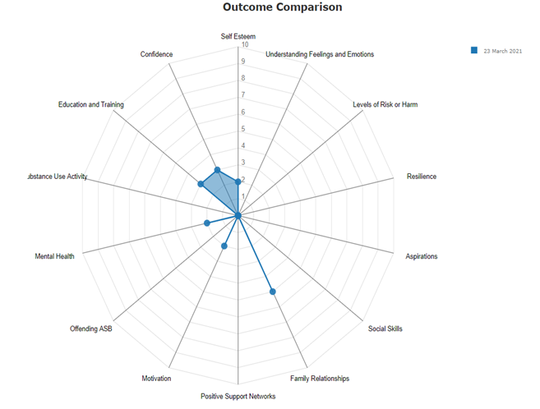
Example Star Chart 2

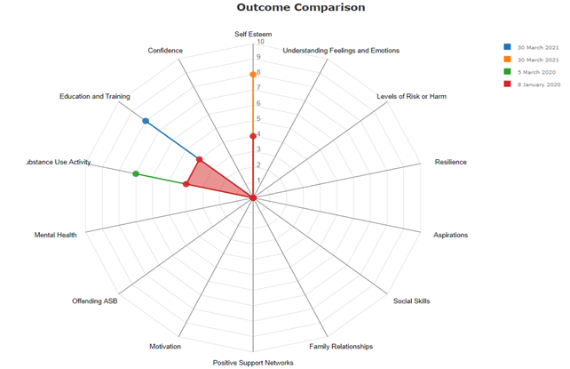
Case Studies – Madras College
Case study A
Child A was referred to Clued Up in April 2019 by her guidance teacher as they felt she needed support regarding her family circumstances. A engaged well until the lockdown in March 2020. Clued Up found it difficult to contact Child A during this period but we kept in touch with Guidance on updates from family. We had no direct contact with A until schools went back in August 2020. Once schools re-opened A returned to their weekly sessions with Clued Up.
During November 2020 Child A’s Clued Up worker was moved to a different area within Fife and A was introduced to the new Project Worker for North East Fife. This was very upsetting for them. They felt like they had begun to trust the previous worker and now A would have to tell their story again. However, Child A did attend regular sessions with the new worker and progress was made once trust was established.
Child A struggled with parents living separately and they have different parenting techniques. One parent has their own personal struggles with alcohol. This is a great worry for child A who always wants to be there for them when staying with the other family member. This causes arguing within the home. A does stay at other family homes to relax. A does not take any substances and is slowly breaking away from social circles. Family issues and being away from school for long periods have caused A to isolate themselves. Child A has no self-confidence, low self-esteem and lacks trust in adults and is reluctant to get help from outside partnerships.
Lockdown 2021 has been difficult for A. I only met with them once while schools were closed. We met for a coffee and had a productive in-depth chat about everything that is upsetting them during the 2nd lockdown. A was glad to have met up and wanted to do this again a week later. Unfortunately, A cancelled the next session as they felt it would not help to talk to me about the same ongoing circumstances again. Child A isolating themselves during the 2nd lockdown has manifested a lot of personal struggles, causing relationships within their year group to become fractured. Currently back at school, A does not feel connected with any friends and cannot concentrate in class.
At the moment we are exploring different techniques to manage A’s personal struggles and are seeing each other more frequently per week during this trying time for them. Child A can be very up and down during our sessions together and can be silent for a period of 10 to 15 minutes some of the time. I feel allowing for this to happen is useful as it is A’s quiet time to sit and think in a relaxed atmosphere, enabling them to reflect on past as well as present events.
Case Study B
Young person B was first referred in September 2018 due to parental misuse. Initially B was very quiet and did not really want to chat. What became apparent was the pressure the she felt to be the same as her peers in terms of dress, mobile phones and behaviours. The initial contacts were sporadic and short but due to the consistency of approach from the worker B started to discuss feelings and emotions. Unfortunately, she chose to withdraw from support in May 2019.
B was re-referred in November 2019 and again was reluctant to speak about issues in their life. It became apparent that the B was starting to use alcohol on Friday nights and the worker’s feeling was that she was experimenting with other substances due to the group she was hanging around with. This was evidenced a few weeks later when Clued Up staff engaged with a group of young people in St Andrews and B was there. This gave the worker an opportunity to bring the use of substances into the weekly chats. B was a bit nervous about speaking about these but eventually acknowledged her use.
Before the pandemic B was struggling and beginning to miss school and regularly use alcohol. There was a turning point when the worker challenged her, which resulted in B breaking down in tears. She opened up about family relationships, self-esteem and worries about failing in school. At the start of the pandemic B would engage in one to one sessions over the phone and through texts. She then agreed to meet the worker outside and began to open up about her feelings and perceived failings. The one to one sessions would sometimes last two hours.
As B was not physically mixing with peers, the substance misuse became zero, her self-esteem grew and she started to engage with school. This has continued to the extent that B has gained major qualifications and will be back for another year. Her relationship with her mother is now very supportive and positive. Mum has said that she has seen big changes in her daughter’s mood and maturity. Guidance staff at school have echoed this. B is also part of a Learning Alliance Research initiative, which means she is engaging remotely with other young people and researchers. B has clear aspirations for when she leaves school and still meets regularly with her worker.
Feedback from young people
“Clued Up has helped me open up more in the past couple of years. They are always available if you need to talk about something and they find ways to help most of the time”
“Clued Up are always there. I can talk to the worker about anything because I trust them”
Feedback from a professional
“I have found the support that has been given by Clued-up to be bespoke to the individual. They have been supportive of pupils and listened to their needs and dealt with them as individuals. What I have really appreciated with the manner in which Clued-Up has worked with individuals is their recognition of being part of the wider team around the child. This has helped young people within my caseload develop their confidence in talking to adults and feeling comfortable enough to share their emotions and struggles. This has allowed Clued-Up to work on giving these young people strategies to help them overcome their difficulties. For some this has been a short term intervention which has impacted positively their attendance at school and their engagement in learning. For others it is a longer term intervention that provides them with some mentoring and a sound board to express their feelings and (helpful) ways to flourish in their situations.”
Conclusion
We continue to work with young people on their substance use as well as that of people they know. Drugs continue to play a part in the lives of some young people and the communication school staff have with Clued Up enables quick referrals to happen. Being part of the guidance suite two days a week enables young people to access staff on their own and helps break down barriers.
Clued Up also supports and advocates for young people at various professional meetings. This enables their voices to be heard.
We are delighted to be seen as part of the support team at Madras and hopefully this will continue in the future.
School/Setting Name ___Madras College/ St Andrews
NIF Quality Indicators (HGIOS 4) School Self- Evaluation
Quality Indicator | 2018 - 2019 | 2019 - 2020 | 2020-2021 | Inspection Evaluation  (within last 3 years)
1.3 Leadership of change | 5 | 3 | 3 -
2.3 Learning, teaching and assessment | 5 | 3 | 3
3.1 Ensuring wellbeing, equity and inclusion | 4 | 3 | 3
3.2 Raising attainment and achievement | 4/5 | 4 | 3

Appendix C Session 2021 -2022 Improvement Plan – PEF Plan
Rationale for PEF Funding |  | Amount of Fund £71,062 (plus £1,123 underspend from 2020/21)
Rationale
When we conducted our survey with all stakeholders about our new vision, values and aims and school improvement priorities, the values of inclusion, respect, equity and kindness featured very strongly from pupils, parents/ carers and staff. Furthermore, the main priority was health and wellbeing. Engagement during lockdown demonstrated that our learners with ASN, furthest from achievement and Care Experienced struggled more with engagement. This puts this group at even greater risk of being less likely to bridge the attainment gap. Hence the reason why they were targeted and brought into school during the second lockdown. Consequently, a key focus is to assist with targeting a few of our most at risk.

ASN Attendance
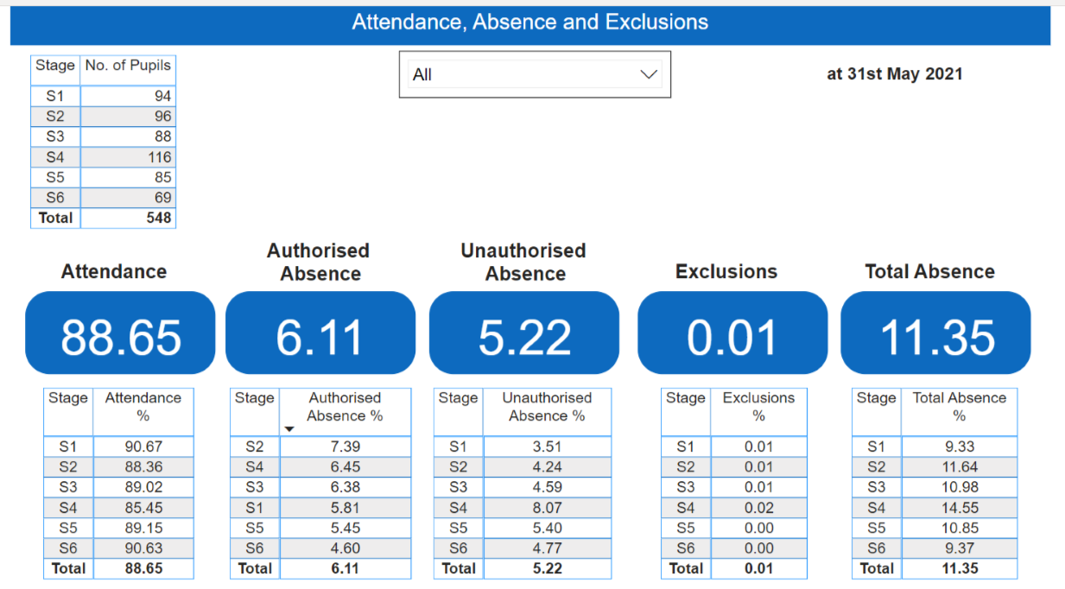

LACC Attendance

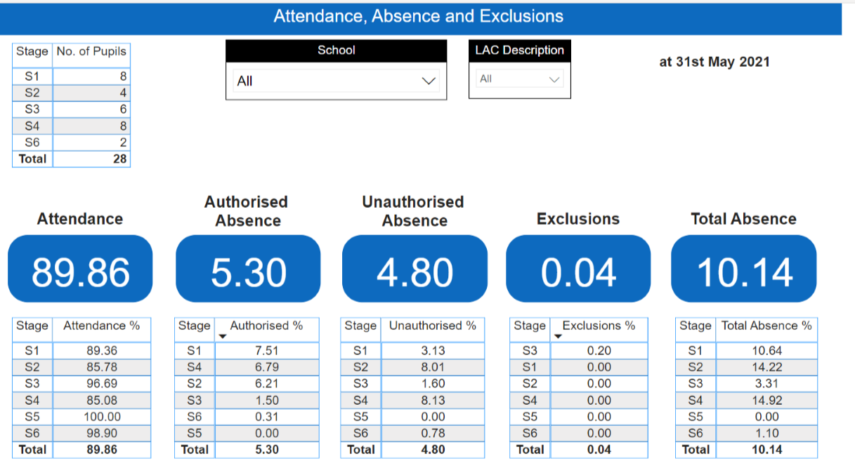
What is the rationale behind your identified actions?
What are your gaps?

Expected Impact | Interventions Planned |  | Measure of Success  (Triangulation of Evidence) | Impact on learners  Ongoing evaluation
Intervention 1  To create a nurture provision within our Support faculty to support our most at risk learners.  The intention is improve safeguarding and inclusion, attainment and achievement for this at-risk group in the BGE.  The aim is to improve attendance by >5%, reduce referrals, exclusions and increase confidence in learning both in nurture and in classes. | A PT1 Nurture and PSA have been allocated from PEF funding to create and establish a Nurture provision at Madras College. They will support this small caseload of most at risk learners to access education and target attendance, social, emotional and behavioural issues. |  | Data will be gathered through Boxall profiling, baseline evidence in terms of the wellbeing web, attendance, exclusions, referrals, pupil voice and tracking wellbeing. | What has been the impact?

Appendix D – Pupil Equity Financial Plan Session 2021 - 2022

Allocated Amount: £71,062
Cluster | School | Focus | Intervention (be specific about service to be provided) | Name of Provider | Annual Amount | Expected Length of Engagement
 | Madras College | N/A | Substance Use Support and Information Service | Clued Up | £5,750 | 1 year (April 2021 - March 2022)
 | Madras College | N/A | Admin Fee | Fife Council | £1,776 | 2.5% of PEF Allocation (April 2021 - March 2022)
 | Madras College | N/A | Staff Travel for CPD | Fife Council | £100 | 1 year (April 2021 - March 2022)
 |  |  | Key
 |  |  | L- Literacy
 |  |  | N - Numeracy
 |  |  | HWB- Health and Wellbeing
 |  |  | IT - IT software/ hardware
 |  |  | PL - Professional Learning
 |  |  | PE - Parental Engagement

Cluster | School | Staff | Intervention | FTE | Amount |  | Staff Key
 | Madras College | PT  Nurture | HWB  (16th Aug 2021 – 31st March 2022) | 0.63  (35hrs/wk) | £38,227 |  | T- Teacher
 | Madras College | PSA  Level 2 | HWB  (16th Aug 2021 – 31st March 2022) | 0.42  (27.5hrs/wk) | £11,445 |  | PT - Principal teacher
 | Madras College | PSA  Level 3 | HWB  (16th Aug 2021 – 31st March 2022) | 0.07  (5hrs/wk) | £2,701 |  | DHT - Depute Head
 | Madras College | PSA  Level 3 | HWB  (16th Aug 2021 – 31st March 2022) | 0.04  (2.5hrs/wk) | £1,351 |  | PSA - Pupil Support Assistant
 |  |  |  |  |  |  | PSW- Pupil Support Worker
 |  |  |  |  |  |  | FL- Family Link
 |  |  |  |  |  |  | EP - Educational Psychologist
 |  |  |  |  |  |  | AD- Admin Support

Appendix D – Pupil Equity Financial Spend Session 2020 - 2021

Allocated Amount: £56,416
Cluster | School | Focus | Intervention (be specific about service to be provided) | Name of Provider | Annual Amount | Expected Length of Engagement
 | Madras College | HWB | Substance Use Support and Information Service | Clued Up | £5,712 | 1 year (April 2020 - March 2021)
 | Madras College | N/A | Admin Fee | Fife Council | £1,703 | 2.5% of PEF Allocation (April 2020 - March 2021)
 | Madras College | N/A | Inter-building Staff Travel | Fife Council | £46 | 1 year (April 2020 - March 2021)
 |  |  | Key
 |  |  | L- Literacy
 |  |  | N - Numeracy
 |  |  | HWB- Health and Wellbeing
 |  |  | IT - IT software/ hardware
 |  |  | PL - Professional Learning
 |  |  | PE - Parental Engagement

Cluster | School | Staff | Intervention | FTE | Amount |  | Staff Key
 | Madras College | T  Maths | N  (1st April 2020 – 31st August 2020) | 0.20  (17.5hrs/wk) | £13,368 |  | T- Teacher
 | Madras College | T  English | N  (1st April 2020 – 31st August 2020) | 0.25  (21hrs/wk) | £16,041 |  | PT - Principal teacher
 | Madras College | PSA  Level 2 | HWB  (1st April 2020 – 31st August 2020) | 0.27  (27.5hrs/wk) | £18,312 |  | DHT - Depute Head
 |  |  |  |  |  |  | PSA - Pupil Support Assistant
 |  |  |  |  |  |  | PSW- Pupil Support Worker
 |  |  |  |  |  |  | FL- Family Link
 |  |  |  |  |  |  | EP - Educational Psychologist
 |  |  |  |  |  |  | AD- Admin Support

