St Patrick’s RC Primary School Lochgelly
Standards and Quality Report – summary of self-improvement through self-evaluation
Achieving Excellence and Equity – 2020 - 2021
Context
Setting/School Roll | School – 176 pupils
FME | 15%
LAC | 2
Attendance (%) | Authorised | 2.14% | Unauthorised | 8%
Exclusion (%) | 0%
Attainment Scotland Fund Allocation (PEF and SAC) | £39000

School Vision: To ensure that we create a caring and positive ethos which is rooted in Christ’s teachings, to enable staff, pupils, and parents to work together to achieve the highest standards of learning, teaching and wellbeing.

School Values: Respect, Honesty, Wisdom and Service (to be reviewed 2021)

School Curriculum Rationale: Created with staff, pupils, parents, and partners – 2018 – Refresh 2021

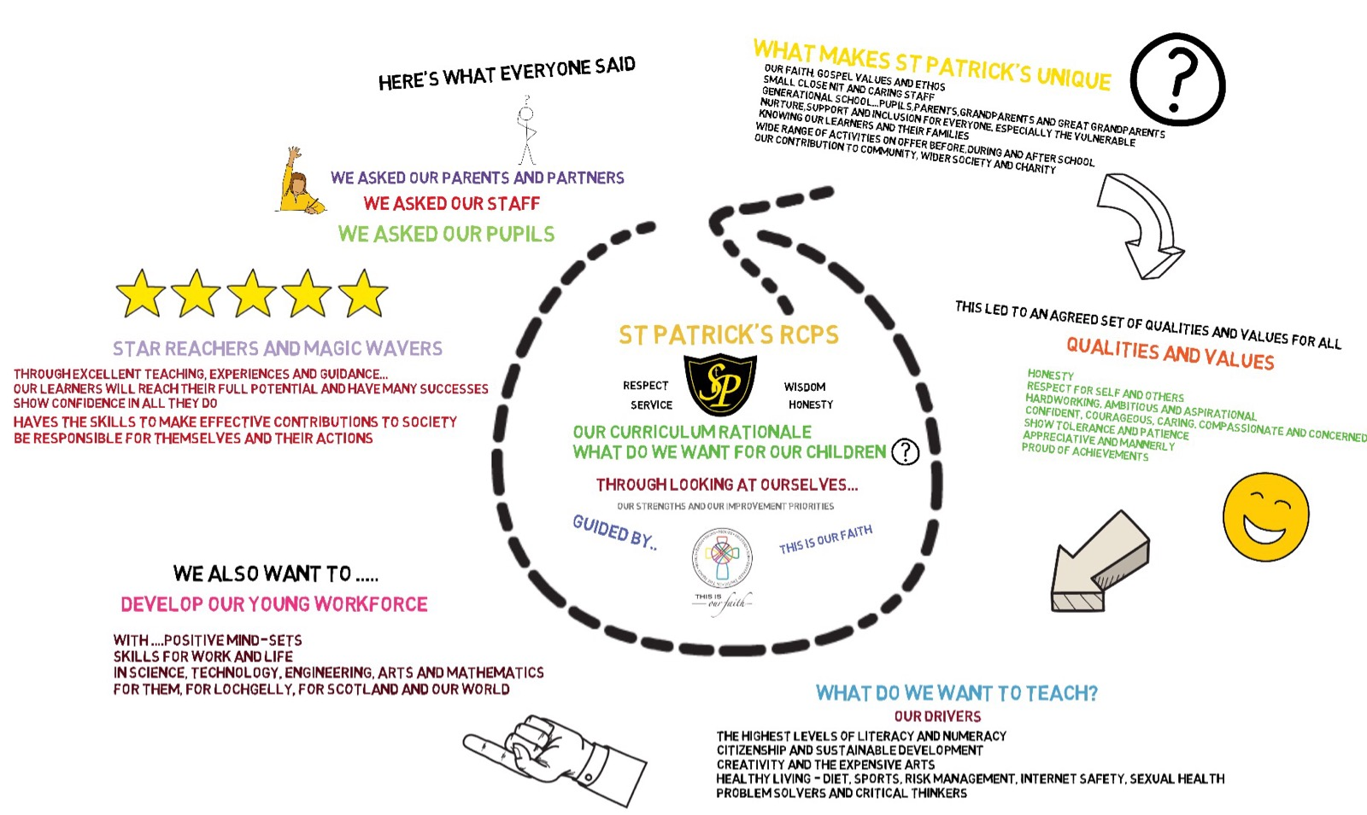

Link to our Curriculum Rationale Video

Improvement for Recovery Priority Work
Session 2020 - 2021
Ongoing School Recovery with whole school community/ Increased capacity for home learning / blended learning
NIF Priority  Improvement in attainment - Literacy and Numeracy  Focused Priority: Ongoing School recovery with increased capacity for home learning and/or blended learning.  NIF Driver  School Improvement  Parental Engagement | HGIOS 4 Quality Indicators  1.3-Leadership of change  2.5 – Family Learning  2.6-Transitions  3.1- Improving wellbeing, equality & inclusion  Developing in Faith Theme 1  Serving the Common Good – School shows commitment to communicate Catholic Social Teaching  HGIOURS Theme 2  Our learning & teaching This includes the curriculum, the quality of learning experiences, the range of teaching approaches and access to high-quality resources for learning.
Strengths identified: August 2020 to March 2021

- All staff were confident in moving from school learning to home learning swiftly due to the previous training and contingency planning between August and January in using Seesaw and MS Teams. Collegiate work during this time allowed staff to share good practice, build confidence and to support each other in getting our digital strategy ready in the event of a school closure.
- Our device allocation was quick and responded to the needs of our school community. Those families who struggled due to not having a device or limited device capacity were supported quickly to access remote learning. Families who required further support were given workshop opportunities and training in a covid safe way within the school. This had a positive impact and increased the number of pupils participating in the remote learning offering to all pupils. It meant all pupils could access even though not all pupils did for every lesson.
- A working party was quickly mobilised to provide CPD sessions with all teaching staff and as a result this enhanced all staff understanding of the capabilities of ICT and its use for online learning. This had a very positive impact on all pupils.
- All staff have improved their digital skills in order to provide accessible and engaging home learning experiences.
- All teachers effectively used Seesaw and Teams to provide a BGE to all pupils across the school. All teaching staff planned, supported, assessed and provided feedback on a minimum of 3 lessons per day including daily literacy, daily numeracy and one other daily lesson from another area of the broad general education which was timetabled across the week to ensure breadth across all curricular areas. Planned events such as Burns Day and World Book Day were also included for children and families to provide normality as this is something we would have recognised and celebrated within school.
- Agreed school expectations for delivery of remote learning contributed to a consistent approach across the school. A robust school policy was created both for staff and parents to ensure that all teachers and all parents were clear about the expectations and to provide a useful resource and reference point for all.
- There was an average 15 percent increase in participation and level of engagement from previous lockdown and increased confidence in being able to track pupil progress and feedback using Seesaw and Teams.
- Feedback was gathered from pupils and parents and this was analysed and acted upon. Overall, this feedback was very positive. Of those who responded to questionnaires it is reported that all parents felt that they had really benefitted from the communication with teachers and the feedback that teachers have given throughout.
- A robust tracking system was established; this included tracking for different cohorts of children. This will now be adapted and used for our overall school tracking system as it allowed SLT to identify issues and concerns very quickly. This was a very useful tool as it allowed us to act quickly to support all families as soon as issues were identified.
- An excellent team working ethos continued even though many worked from home. All staff supported each other throughout and the use of staff Teams meetings, what’s app group and phone calls helped with all our teams mental and emotional wellbeing. The team involved all staff from SLT, teaching staff, PSA staff, PE teacher, Support for Learning teacher and Office staff and teachers who were in school for key worker and vulnerable children. Everyone played a part and showed a real willingness to get things right for remote learning and to support our young people and their families throughout.
- By very effective use of parent questionnaires, pupil questionnaires, and by staff reconnecting with pupils and families we were able to assess pupil’s wellbeing and to look closer at both gaps in learning and what children may have gained from working remotely. Kitbag sessions and Nurture groups were also implemented quickly to reconnect with our most vulnerable pupils. Feedback clearly shows that almost all children coped well during the lockdown due to the level of support offered by staff. Feedback also shows that children’s wellbeing increased after their return to school.
- During March to June effective use of a range of assessments across all stages helped staff to gain a clear picture of attainment gaps and wellbeing.
- Digital Parents evenings during May allowed all parents the opportunity to discuss progress and to report successes and challenges of pupils return.
- All staff were now effective in continuing to use Seesaw and Teams for Homework tasks and to move towards using these platforms for future E-Portfolios.
- Our digital staff teams meetings with individual teachers to discuss benchmarks/coverage of BGE and plans for Term 4 were effective being mindful not to get caught up on in identifying what each pupil had missed out and have now put staff a very good position to share effective transition of learning information for all pupils. This has also helped gain a clearer picture of curricular areas that had not been covered as thoroughly through planning and tracking and in turn this will ensure that all pupils are given experiences and opportunities for those BGE areas as per their entitlement. Example:

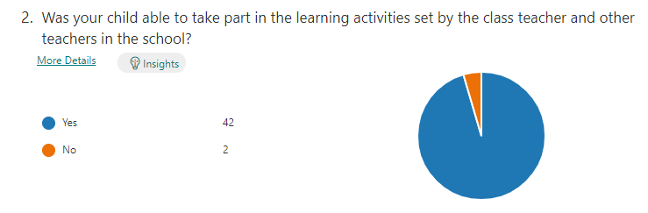

Next Steps at St Patrick’s RCPS…
- Continue to develop a good digital culture within the school including applying for our digital school award.
- Increase the use of technology in all classes and extend range of technologies from laptops and Ipads to other resources. E.g. Spheros,
- Sustain and build upon skills developed during periods of remote learning for both children and staff.
- Existing software and hardware are used to their full potential to support learning.
- Continue to use more online methods to access CPD to allow staff to have a greater confidence in using software and hardware in creative ways.
- Regular digital Literacy development sessions
- School planning to go online using 365 OneNote to improve transition of learning and consistency of approach.

Improvement in children and young people’s health and wellbeing / Closing the attainment gap

NIF Priority  Improvement in children and young people’s health  and wellbeing / Closing the attainment gap  Focused Priority:  Promoting the Wellbeing of our school community  NIF Driver  School Improvement  Assessment of Children’s Progress | HGIOS 4 Quality Indicators  2.4 – Personalised Support  3.1-Improving wellbeing, equality & inclusion  Developing in Faith Theme 1  Developing as a Community of Faith and Learning – An inclusive ethos which aims to honour the life, dignity and voice of each person  HGIOURS Theme 4  Our health & wellbeing This includes access to good quality nutritious food as well as support for our emotional wellbeing, mental health and physical wellbeing.
Progress: Wellbeing focus for all pupils and staff

A wellbeing focus group was created in September to oversee “Wellbeing initiatives and developments” across the school. They worked collegiately from August to December on several projects including the school’s relationship and behaviour policy, staff wellbeing, workload and to look at the 5 ways to wellbeing.

Spiritual Wellbeing

All classes and teachers place prayer, reflection, and spiritual wellbeing as a consistent focus at several parts of the school day. During RE lessons and Health and Wellbeing lessons all children benefit from experiences which focus on their overall spiritual, emotional, and mental health.

All children in P7 who were to receive the Sacrament of Confirmation had significant input on a weekly basis in preparation. The Confirmation took place on Thursday 10th June and all those children felt very well prepared for this after working in small groups with a designated teacher.

Emotional Health – Kit Bag

All pupils who required kit bag sessions benefitted from sessions of “digital kitbag” in small groups or individually, both in the school and digitally during lockdown.
All PSA staff are now trained in the use of Digital Kitbag.

Do be Mindful

Almost all staff received CPD on the Do be Mindful Programme. This was a 5-hour programme which develops awareness, self-regulation and resilience in teachers, parents and children and encourages a calm, kind, and compassionate culture in their classrooms.

Behaviour policy
A working group was set up in August to develop a Relationships and Behaviour policy which would fit with Fife Councils Relationship and Behaviour strategy and bring our own policy up to date. A mix of teachers and support staff worked collegiately and created the initial part of this and have implemented several of the strategies across the school.

Wellbeing Focus for staff/Pupils
Over the course of the year all staff were provided with opportunities for wellbeing meetings. At each staff meeting there were opportunities for staff to share their views on Covid mitigations and their own safety. During terms 1, 2 and 4 all staff completed a questionnaire which focused on wellbeing and offered further support to anyone who required this. The Wellbeing of staff has been a high priority throughout the session and through using email and What’s app groups this continued during the school closure. Pupils were also involved in regular wellbeing conversations through circle time and kitbag.

Impact:

Spiritual Wellbeing
- Most children recognise the importance of prayer in our day to day schedule. All teachers feel that the children have benefitted from prayer and reflection, at times with particular focus on those less fortunate and/or those affected by Covid19. All children are engaged in lessons and activities which focus on Gospel values and social justice enhancing their understanding of current world issues. All children are involved and have benefitted from charity work at points throughout the year, again with a focus on supporting those less fortunate.

Emotional Health – Kit Bag
- Daily feelings check in was introduced to some early years children to allow them to have a soft start due to their sometimes-chaotic morning.
- Kit bag has been used across the school with individual pupils and groups to support emotional health. The impact of this was significant for those who took part and allowed those children to reflect on how they were felling and as a result identify strategies and decisions that would help them to feel better.
- Most pupils who took part could talk about their feelings and how to regulate them.
- PSA staff carry out the sessions and report to PT and HT depending on the outcome. The impact of this has been really positive for the school overall as it allows PT and HT to record circumstances in Latest Pastoral Notes on Seemis which helps build a picture over time for pupil wellbeing. This is particularly helpful in supporting 6 of our young people in Primary 7 who have found it hard to get along with each other.

Do be Mindful
- All staff who signed up to the CPD 5-hour programme are now upskilled on the principles of the “Do be mindful programme” and are far more aware of self-regulation and building resilience within their own practice.
- Staff are more skilled at rolling this out within their own class and in developing resilience in their own learners. As a result, classrooms are calmer and more productive as a learning environment. This needs to be taken to the next level and become an integral part of daily practice within the classroom and to upskill children in their own self-regulation. As a result, classrooms will be calmer, with a compassionate ethos and culture.

Behaviour policy
- The working party began by introducing 3 consistent behaviours across the whole school between September and December. These were “Meeting and greeting in the morning”, “Smart walking” (no running in the corridor but keeping the language the same throughout the school) and “Clear Corridors.” This consistent approach from all teaching staff and support staff had a significant impact on the readiness of children to learn, the conduct of children as they moved around the school building and the tidiness of the school corridors. All staff consistently used the 3 behaviours and used the same language across the school and almost all children responded positively by following the behaviours. The consistency of this approach will continue next session and further behaviours will be added. During discussions and surveys, most pupils indicate that they feel there has been an improvement in behaviour within the school.
- The working party have also set out the draft behaviour policy and some discussion with wider staff and pupils has taken place. Due to Covid19 our committee groups could not meet so these have come from teacher discussion rather than committee groups. The Relationships and Behaviour Policy will continue to be an identified target for next session as part of our overall Health and Wellbeing target.

Wellbeing Focus for staff/Pupils
- Almost all staff have said that their wellbeing has been positive throughout the year both during the school closure and when returning to school in February and March. All staff completed a questionnaire during 3 out of the 4 terms to assess the school’s performance in supporting their wellbeing and in keeping them safe with Covid 19 mitigations. Almost all staff felt that our safety mitigations were appropriate and were working at keeping them safe. Almost all staff felt that the communication was very good around risk assessments and that Covid reviews were useful for sharing any concerns or questions around the mitigations. The graphs below show the consensus of staff and the positive responses they made to these evaluative questions.
- Parents and pupils were asked at points during the school year to reflect on the school’s performance in supporting them during home learning and when children returned to school. Our “Shine” data was positive for most children but identified key areas that will be a focus for next session. Parents felt that the school was doing very well at supporting children and families during the school closure and that the school was providing the right balance of lessons and activities for their children. Several questionnaires were sent over the course of the year to gather this data. On return to school in March 2021 a questionnaire was sent to ask parents how they felt children’s wellbeing was on return to school compared with being at home. The response from this was very positive and provided reassurance across the board that children’s wellbeing overall was good.
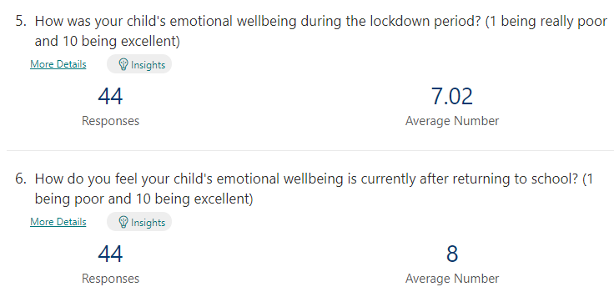

Next Steps:
- In order to support the Covid-19 recovery plan, the school will continue to work on all aspects of wellbeing with all pupils and staff to help support them.
- Continue with kitbag sessions as required and provide CPD for new members of staff
- New class OneNotes in the upper school will be introduced so that children can profile including their emotions and wellbeing.
- Continue with pupil profiling for transition. All teachers will be in a stronger position for transition of learning due to new planners moving to OneNote.
- Teaching staff will receive CPD training on the use of Latest Pastoral Notes to ensure that they have access to relevant information about pupil wellbeing. The hoped impact of this will be that teachers can profile/monitor situations over time and identify any patterns of behaviour or issues relating to pupils in their class and resolve these more easily.

Learning, Teaching & Assessment/ Closing attainment gaps/ Increasing attainment
NIF Priority  Learning, Teaching & Assessment/ Closing attainment gaps/ Increasing attainment  NIF Driver  School Leadership  School Improvement | HGIOS 4 Quality Indicators  1.3 Leadership of change  2.2 curriculum  2.3 Learning, Teaching & Assessment  3.2 Raising attainment & achievement  Developing in Faith Theme 1  Developing as a Community of Faith and Learning – A commitment to the integrated education and formation of the whole person. In close partnership with parents as the first educators of their children.  HGIOURS Theme 2  Our learning & teaching This includes the curriculum, the quality of learning experiences, the range of teaching approaches and access to high-quality resources for learning.  Theme 3  Our school & community This includes the facilities and environment for learning, availability of digital technology, the range of equipment for play and physical activity and ensuring everyone has good access to what’s available. It also includes having positive links between our school and our families and with partner organisations in our community.
Progress:
- Due to school closures there was a particular focus for all teachers and support staff to assess, identify and address any gaps in learning that became evident, including those that are a result of lockdown. Although this is the norm in any school year, teachers were required to baseline and identify gaps during the first 6 weeks of this academic year and to consult with the Learning Support teacher to ensure plans were in place to support targeted groups of children.
- As a school we made a decision for all teachers, other than the probationer teachers, to continue with the same class as the previous year. Through discussion, all teachers agreed that this would ensure the smoothest transition of learning since they had the best possible understanding of the pupils from having them prior to the initial lockdown in March 2020 and had also worked closely with families and their children throughout the school closure.
- As mentioned earlier in this document, teachers were preparing during August to December for a contingency plan to provide home learning. All teachers were far more prepared to use digital platforms to ensure that learning and teaching could continue in an effective way.
- Throughout the school year a wide range of assessments have been used to gather data on pupil progress which has supported teacher’s professional judgement. INCAS assessments were used in each stage other than P2. SNSA and BASE data was gathered and analysed and provided a good baseline in September 2020 and again in May 2021.
- When pupils returned to school in February 2021 almost all teachers returned consistently to using our agreed 4-part model for learning and teaching. Wall displays around the school have not been to the same standards as in previous years due to asking all staff to leave school promptly after 3pm.
- All teachers and parents have been consulted on identifying areas of the Broad General Education that they felt were unbalanced so that the school could meet the entitlements of all pupils. Areas of the curriculum have been identified and have been a focus for term 4 and will continue to be a focus in the new session. Questionnaires were used to identify priorities from parents and teachers and children were involved in class discussions around this subject.
Impact:

Assess, identify, and address any gaps that are evident, including those that are a result of lockdown.

All pupils were assessed using either BASE, INCAS or SNSA’s in August / early September

- All Primary 1 pupils were assessed using Base, providing a starting point for the P1 teacher.
- All Primary 2 pupils were assessed using the end of year BASE assessment which identified most children as having made good progress, but it also highlighted a small group of individuals for whom school closures had had a significant impact. Teachers could then plan with the recovery teacher and our PEF funded PSA to target support for those children. The impact of this has been significant with most of those children who were targeted moving on to First Level.
- All Primary 3 pupils were assessed using the INCAS assessment.
- All Primary 4 pupils were assessed using the SNSAs and took part in an INCAS assessment in May 2021 to add a level of assessment to support teacher judgement on achieved levels.
- All Primary 5 pupils were assessed using the INCAS during October 2020.
- All Primary 6 pupils were assessed using the INCAS during October 2020.
- All Primary 7 pupils were assessed using the SNSAs and INCAS assessments in May 2021.
- All pupils were assessed using the Big Writing criterion scale at points during the year.
- Contextual assessments were carried out by the Learning support teacher in conjunction with class teachers and pupil support staff.
- Pupils who had been using Nessy as a support tool where unfortunately unable to continue with the programme and another programme is being looked at for the year coming.

The overall impact of using these assessments meant that all teachers were able to talk in detail about a range of assessments that they had used both formative and summative and could confidently speak about the level that children were currently working within. Almost all teachers were able to speak confidently about how they had used this data to ensure that plans were in place for those children who were more than a phase behind.

During planning meetings SLT used our newly developed tracker to record the information provided by the teacher and to include details around what was in place to support learners. Using this approach across the year has meant that teachers and SLT have been monitoring the impact of such supports and their effectiveness. Most children who have had additional targeted support have made progress although some have not made the progress that we would expect based on the input.

Gathering viewpoints of parents, teachers and pupils around subject areas of the curriculum that they felt had been less covered has allowed the school to work on these areas during the course of term 4 of this school session and will also have prominence during transition of learning conversations by teachers when passing on information. As a result, teachers can plan to ensure topics and IDL, for example, are tailored to include specific Es and Os from subjects less covered during school closure.

The impact of our Digital strategy and digital working group was mentioned in the evaluation of our first priority (Recovery) but it equally sits within this priority of Learning, Teaching and Assessment. The first priority for the school was to ensure that all pupils could access digital learning and teaching and that we saw an increase in the engagement levels across all classes. This was part of the contingency plan that all staff had been working towards during Term 1 and Term 2 of session 2020-2021. A remote learning policy was created for all teachers to follow and for parents to refer to. The impact of the training provided by our in-school Digital Working Group was significant. All teachers in the school were able to not only engage with pupils and communicate with them and their families but almost all felt more equipped to step up a level of the remote learning offer and to provide face to face learning and teaching directly to groups of children and whole classes. Most upper schoolteachers carried out face to face assessments with classes to track progress in particular areas such as spelling and mental maths.

Our overall evaluation of providing feedback to learners to continue their progress went from good to very good during the school closure in January. This continued when children returned to school with feedback being a priority.

Next Steps:

Curriculum:
- All curricular pathways to be uploaded to MS OneNote (St Patrick’s RCPS Staff Notebook) and used digitally by all teaching staff including NCCT.
- Class and whole school assessment data, including specific cohorts such as SIMD 1and 2, will be added to the OneNote so that teachers can have readily available access to their class/pupil information digitally wherever they are. The hoped impact of this will be a consistent approach across the whole school for both planning and assessing and that agreed targets and plans for children are easily accessible and have more prominence.
- Continue our renewal of high-quality learning, teaching and assessment by building in CLPL opportunities for all staff to revisit and work collegiately on 4-part model being consistent across ALL classes including NCCT.
- Improve learning environments by ensuring meaningful displays and classroom setup is appropriate for wide range of learning and teaching strategies. (eg Cooperative Learning, Group work etc – all covid19 mitigation permitting)
- Assessment and Moderation will be one of our main improvement priorities for 2021-2022 working alongside our cluster schools to ensure a looking outward approach to add to our own in-school moderation work.
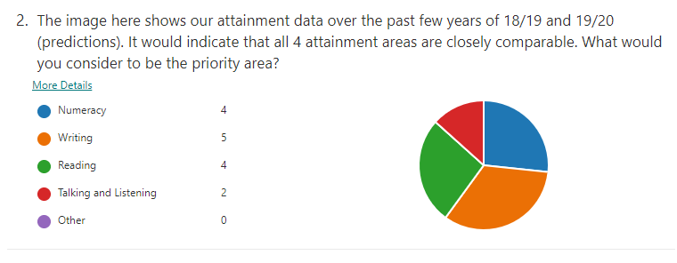

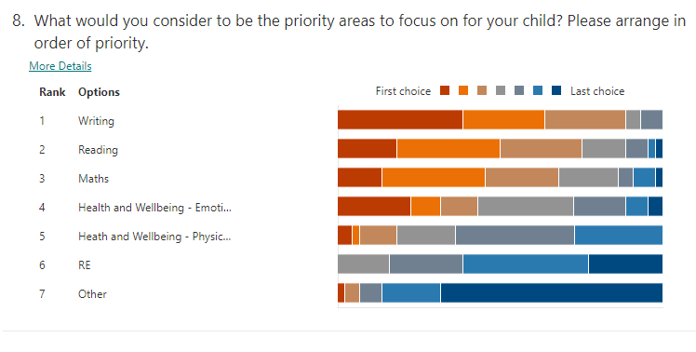

Attainment of Children and Young People - 2018, 2019 and 2020
Writing
Reading
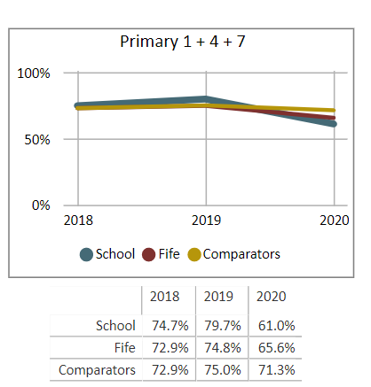
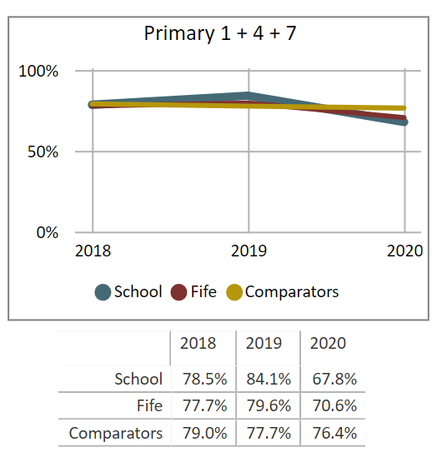
Number, Money, and Measure
Listening and Talking

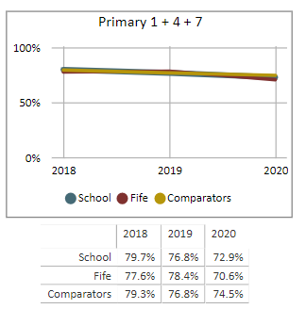
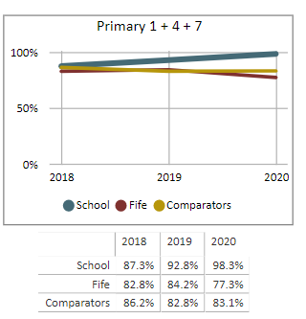

- We have very clear assessment stories on individual children which allows us to explain a child`s journey in school particularly when they are not achieving the levels desired.
- CfE judgements were made based on a wide range of assessments including: BASE, INCAS, SNSA and other assessments across the different subject areas together with teacher judgement
- From our data we can see the impact that Covid / lockdown has had on our pupils, with patterns emerging of different groups and cohorts.
- The figures above for 2020 reflect the percentages of achieved levels for classes P1, P4 and P7 and are much lower than the percentages of the school as a whole. The school have a tracking system in place that shows that our overall percentages for each of these areas (including the data for P1, P4 and P7) are:

Whole School Reading | 82%
Whole School Writing | 76%
Whole School Talking and Listening | 96%
Whole School Numeracy and Mathematics | 80%

- We would have predicted a lower percentage of attainment this year for our P1, P4 and P7 cohorts regardless of school closure. Our current Primary 1 class has 7 children who received very little home support when they came to school in August to December and even less during the school closure. There are cultural reasons for this, and every attempt was made to provide digital platforms and paper packs for those families within our traveller community, but engagement was still much lower from this cohort than across the school. The significant impact of this was that almost all have failed to achieve early level. The school also hold the back story from P4 which has a group of children (6/26) who have significant additional support needs who we would have predicted not to achieve First Level regardless of school closure. In contrast, our P7 class have made excellent progress in all areas and some learners who would have been expected not to achieve second level by the end of P7 have done so.
- Remote learning has provided the platform for all staff and pupils to up level their IT skills. Next session we aim to develop a digital literacy culture as can be seen in the School Improvement Plan section.

Evidence of significant wider achievements
- Our use of Teams and Seesaw kept parents / carers / pupils aware of daily developments in our school community, before, during and after lockdown.
- Pupils, parents & carers were given IT guides to be used during lockdown.
- Our digital working group developed a remote learning policy that we will now adapt to incorporate significant aspects of homework, particularly for the upper school.
- We have introduced interactive virtual assemblies that children can become involved in and help to shape the direction of the school. Over a series of these assemblies we have been able to gather pupil and class viewpoints for the start of our Curriculum Rationale review and update.
- Primary 7 pupils have been involved in the SSERC
- A small group of JRSOs carried out raising awareness Sways to share at home and promoted competitions.
- Bikeability has been introduced for all P6s and they benefitted from a 4-week programme of bike skills and bike safety.
- Through close working with our Parent Council and wider school family we were able to raise more than £10,000 and won a Forth 1 Radio competition for the money raised. The prize for this was an additional £3000. The impact of this has been excellent and after consultation with the children we have installed a brand-new state of the art climbing cube and picnic benches in our gardens.
What have been the success and challenges of school/setting closure period (school/class/playroom isolation, remote learning between January – March 2021)
Successes:

- A much better level of engagement from previous lockdown and increased confidence in being able to track pupil progress and feedback using Seesaw and Teams.
- Pupils and Parents report that they have really benefitted from the communication with teachers and the feedback that teachers have given.
- Parent feedback on using Teams and Seesaw was very positive.
- A robust tracking system was established, and we are now looking to use a version of this for our in-school tracking system.
- Device allocation to support our most vulnerable – although not all engaged all the time even after device allocation.

Challenges:

- Striking the balance between ensuring a good level of engagement but not overwhelming families and adding pressure during an already stressful time.
- Really challenging conversations with families trying to access school learning even though they did not meet criteria. This was probably our biggest challenge.
- Maintaining high levels of engagement – especially as time went on. When infant children came back to school, we saw a drop in older sibling participation. At this point families were really struggling.

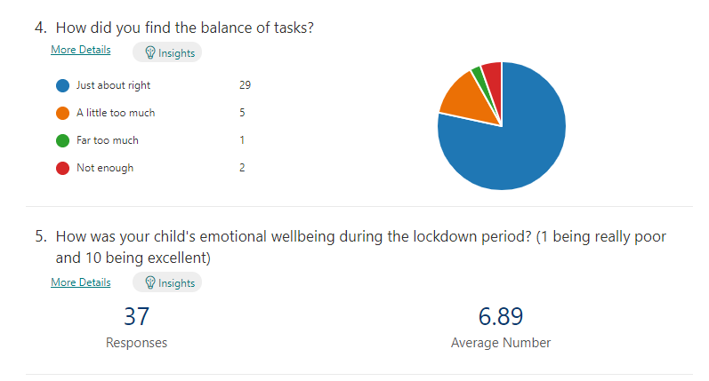
We carried out several surveys to support teacher judgement into remote learning with our families on during January to March. Feedback has been gathered from families using Forms and older pupils through weekly Teams meetings which then impacted on our ongoing planning in staff meetings. Feedback from staff has been gathered informally at each staff meeting and has been used to plan practical next steps to support. Some examples of the questionnaires are below.

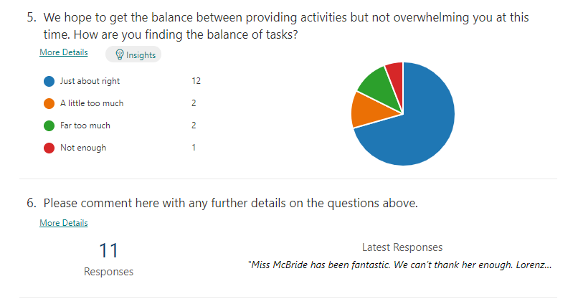
Impact of Local/National resources to support recovery within your setting (digital devices, additionality of staffing)
Number of devices provided to support learning at home | 23
Additionality in staffing | 1

Digital Devices and Tracking pupils
- We have an agreed tracking system in place and have tracked pupil engagement since week one.
- We identified pupils who required extra support in the school (SFL, EAL, Vulnerable & SIMD 1 & 2 pupils and our traveller community.
- Staff identified weekly engagement and shared this with the SLT through an excel tracking system which allowed us to quickly identify non engagement and to act on this. The school was looking for children to engage on 3 activities per day. Staff would send weekly personalised messages to non-engaging pupils via email / phone calls. The HT and PT would support parents /carers in helping with their child’s engagement.
- Non engagement information was collated weekly and further supports were put in place for families and pupils.
- Workshops were introduced within a Covid safe environment to allow a child and parent to attend and for problems to be resolved. The impact of this was that children and families felt much more confident in logging on and carrying out lessons and tasks and we saw an increase in participation as a result.

Challenges | Solutions
Multiple devices required for parents and children / Poor quality devices / no devices | School issued 23 devices to families.
Parents / carers struggling to use devices | Paper copies / packs regularly delivered to families/Workshops introduced
Parents / carers struggling to engage children | Encouraging phone calls, taking the pressure off families. Conversations offering families solutions how to build confidence to deliver lessons. Do what they can, when they can!
Parents / carers family struggling | There were times where families were having “bad weeks”. By engaging in the school in conversation individual solutions were found

Impact of Additionality:
August - December
- From the return to school in August 2020 it was very likely that the school would face significant issues around NCCT cover. As a school, in the past some of this time was covered by an assembly where no longer allowed due to guidance. Having our additionality meant that we could timetable appropriately so that all teaching staff received their entitlement to non-class contact in a safe way. Our additionality teacher was timetabled to work in only one class per day to ensure bubbles were protected. This has been a very successful way of working as it allows the class teacher to have their NCCT but then also allows the additionality teacher to continue to work with that class bubble and support targeted groups with interventions. Almost all children who were supported in this way have made progress and the impact of this approach has also ensured smaller numbers in classrooms, giving more space to adhere to government guidelines and as a result providing a safer environment for all children and staff who work with them.
January - March
- From January to March our additionality had a significant impact in facilitating the smooth running of the school for children who still attended due to being a key worker child or vulnerable. Through discussion and agreement with staff our school implemented two teams to tackle the school closure. Our additionality teacher and non-class contact teacher agreed to be responsible for “In-School Learning” for all key worker and vulnerable children who attended. They did so by following guidance on having bubbles of no more than 10. Using our additionality in this way meant that all “class teacher” could focus on delivering the best package of remote learning to their own pupils and to be there on a daily basis to provide support and communication to families. Feedback from staff clearly identified this as a success from the school closure and parents and carer feedback also indicated that they were reassured and happy with the schools approach and the ability for children to have that consistent, regular input from their own teacher on a daily basis.
March to June
- As a result of the school closure it was anticipated that there would be gaps in learning for some cohorts of children. There was a particular group of 7 children in Primary 1 who we had concerns about in terms of their academic achievement. Through consultation and discussion with class teachers, the additionality teacher was able to be timetabled to specific classes daily and to provide additional support to pupils who were most impacted by lockdown. The impact of this has been excellent in bringing almost all children with gaps forward although this particular group did not manage to achieve early level. In evaluating their progress, all staff who work with this group of children can see gains in the input from additionality. Detailed discussions around transition of learning and with the right support, it will allow this group to progress from Early to First level between October and December 2021. The additionality teacher supported other classes and groups of children in the same way and a similar pattern of progress was made by most learners.
- Emotional and mental wellbeing has been part of our school improvement plan since August and when school re-opened both in February for infants and March for older children, our priority was to ensure all pupils health and wellbeing was considered. Our additionality teacher liaised with our P1 and P4 class teachers and they created “nurture groups” to support children who were struggling with their own wellbeing and the impact that lockdown had had for them. This was a hugely successful project in getting those children ready to learn. An example evaluation of this can be seen by clicking here.

Attainment Scotland Fund Evaluation (PEF)
Progress:

Purchase of Assessments

- The purchase of INCAS assessments provided good evidence and a support for class teachers to sit alongside their teacher judgement in assessing overall attainment. In a few targeted classes this was used twice to track the value added over the course of the year.
- Following the assessments, consultation with teaching staff took place to identify gaps in attainment and to create support packages for these children.
- Regular meetings between PT and SFL with PSA staff took place to ensure the right supports were in place for the right children.
- Disappointingly we had to stop our subscription to Nessy which was proving to be a successful intervention and resource for many of our children.
PSA/EYO (Increased hours and an additional staff member on a Thursday)
- PSAs are used to support learning and teaching across the school and adding further “people time” to support teachers has worked well. Teachers feedback has been that this is extremely valuable in allowing smaller groups of children to have more input either by the class teacher or by our PSA staff.
- The school are very fortunate to have an experienced PSA who is also a qualified EYO. This year we have used some funding to allow her to work in an EYO capacity for the early years due to a particular set of needs within our Primary 1 class. Together with the class teacher the EYO has planned and carried out lessons in phonics, rhyme, numeracy, health and wellbeing and other subject areas for groups of children. This has been very beneficial in ensuring a balance of play-based learning, overseen by the class teacher to take place, as well as allowing less able pupils to be supported in smaller groups.
- The increase in PSA time has also been very valuable for moving and handling, in supporting the physical needs of specific pupils.
- PSAs have been trained and now have used kitbag to support the social & emotional needs of pupils.
- PSA staff are skilled in knowing children and families and are essential in identifying concerns and issues around children’s wellbeing, particularly vulnerable children.
- Our recovery work in terms of playground bubbles would not have been possible on certain days without the increased PSA presence. Overall, the playground bubbles have worked well and kept people safe as each area can be supervised by a PSA.
Experienced Class Teacher - Supply 1 Day per week (Support Raising Attainment)
- An experienced class teacher who has been known to the school for many years has been given supporting several projects. These include raising attainment for a particular group of learners in P7 for numeracy and literacy, nurture projects, outdoor learning support, P3 phonics and spelling and a Primary 2 fine motor group.

Impact:
INCAS bought for Primary 3-7
- Individual results were assessed, and next steps were identified, ensuring that decisions taken around the child’s learning were based on robust information.
- Measuring the impact of identified resources for wellbeing (following lockdown) in whole classes is difficult to measure. Most teachers / parents / carers have noted a positive impact on the behaviours of children.

PSA’s
- Kit bag sessions have been running throughout term 4 and it appears that these are having a positive impact on the children involved.
- Two children who would not have been able to attend school for periods of up to 8 weeks due to mobility have been able to attend school and be supported with their movement around the school and with toileting. Both children and their parents have given very positive feedback at our approach to supporting them to continue to access school and the children continue to make good progress.
- A reduction in the number of incidents in the playground due to less pupils in areas and greater supervision. The school have also seen significant reduction in accidents in the playground.
- PSA’s have been able to identify children who require emotional support due to family circumstances. One family with 3 siblings in the school were identified as being vulnerable by the team of PSAs and supports were put in place which may otherwise have not been. This was due to their conversations and first-hand dealings with this family.
- Significant progress has been made by the targeted group of learners in Primary 1 and instead of not achieving early level until 2022 it is very likely they will achieve in October/November 2021 because of the intervention.
Experienced Class Teacher - Supply 1 Day per week (Supporting class teachers to raise attainment)
- A Primary 7 group of children who were at risk of not achieving second level have successfully achieved due to this intervention.
- Our additionality teacher was trained and supported to run the nurture group which had such positive results in Primary 1 and in Primary 4.
- A small group of Primary 2 children have benefited and now have better fine motor control.
- There has been a marked improvement in the areas of phonics and spelling in Primary for targeted children.
- Our outdoor learning resources and Active Maths resources have been organised in such a way that has allowed all teachers and all children to access much more easily. Further work on outdoor learning will be part of maintenance for next session.

NIF Quality Indicators (HGIOS 4) School Self- Evaluation
Quality Indicator | 2018 - 2019 | 2019 - 2020 | 2020-2021 | Inspection Evaluation  (within last 3 years)
1.3 Leadership of change | Good | Good | . Good
2.3 Learning, teaching and assessment | Good | Good | Good
3.1 Ensuring wellbeing, equity and inclusion | Good | Good | Very Good
3.2 Raising attainment and achievement | Good | Good | Good

Session 2021 -2022 St Patrick’s RCPS Improvement Plan
National Improvement Framework Priority: To Improve attainment for all in writing, focusing on making learning visible through targeted feedback. The aim is to create pupils who are assessment capable learners.
Focused Priority: Implementing universal approaches to the delivery of literacy (specifically writing) across all classes in order to increase attainment by 15% in writing CfE levels by June 2022
HGIOS4 Quality Indicators |  |  | Developing in Faith – Honouring Jesus Christ as the Way the Truth and the Light
2.2 Curriculum  2.3 Learning, teaching and assessment  3.2 Raising Attainment and Achievement |  |  | A commitment to the search for wisdom and light, and the pursuit of excellence, through the development of each person’s god given talents
Expected Impact | Strategic Actions Planned | Responsibilities |  | Measure of Success  (Triangulation of Evidence) | Timescales
All children will experience high quality feedback to improve their writing  Almost all children will have improved their writing and be able to write using different genres – our stretch target for this is to go from 76 percent to 80 percent.  All children will reach their potential for writing  Through the model for improvement target Primary 3 & 5 to do a minimum of 15 minutes additional writing per day. (Above normal writing time)  Create a writing policy including handwriting, presentation and writing overview for the academic year to ensure all genres are covered and will ensure that all children experience a consistent approach to deliver high quality teaching in writing.  Most Children in P3 and P5s handwriting and spelling will improve. | Review current planned experience for all pupils in writing  All teaching staff will attend Inservice/twilight CPD from Osiris VL Feedback  Teachers to work together following pathway that ensures coverage of different genres. Teachers to plan, implement and assess writing across their classes  Following an initial baseline assessment, children who are below where they are in their expected writing levels should have a targeted intervention  Increase in frequency of writing to daily for minimum of 15 minutes (as well as Big Writing Time)  Primary 3 & 5 Teachers to complete a base line written assessment. Teachers to review progress in October  HT / PT / all CTs to devise a writing policy  An increase in writing to a minimum of 15 minutes per day will be piloted as part of the model for improvement enquiry during Term 1. This will be monitored, and data will be gathered to assess the impact. A decision will then be made to roll out across other stages. | All staff / Impact Coaches  CT / EH / PSAs  CT/LS  Primary 3 & 5 teachers  HT / PT / all CTs |  | Initial Base line writing task from Primary 1 – 7, using the Scottish Writing Criterion to track levels of improvement.  All pupils to increase by at least 1 level on criterion scale.  Focus of Learning Partnership to be on writing and feedback  Moderation of feedback in writing impact cycles across school-peer visits  Focus for HT class visits x2  PSAs to feedback to CT from targeted interventions, to determine next steps  Moderate the follow up assessment in October to identify test of change.  A writing / presentation policy creating a consistency across all classes  Questionnaires to parents to gather their views on changes to writing and the writing policy.  Use of SNSA and CEM assessments to support teacher judgement and big writing assessments.  Attendance data will also be monitored throughout the session.
Ongoing Evaluation

National Improvement Framework Priority: Improvement in attainment, particularly in literacy and numeracy, Improvement in employability skills and sustained, positive school-leaver destinations for all young people
Focused Priority: Develop a shared understanding of what a digital culture means at St Patrick’s in order for it to be agreed and undertaken by all staff to ensure all children experience rich learning.
HGIOS4 Quality Indicators |  |  | Developing in Faith – Developing as a community of faith and learning
2.3 Learning, teaching and assessment  2.4 Personalised support  3.1 Ensuring wellbeing, equality and inclusion  3.3 Increasing creativity and employability |  |  | Developing as a Community of Faith and Learning – A commitment to the integrated education and formation of the whole person. In close partnership with parents as the first educators of their children.
Expected Impact | Strategic Actions Planned | Responsibilities |  | Measure of Success  (Triangulation of Evidence) | Timescales
Staff will be more able to use online methods to access CPD (Oracle) which will allow them to have greater confidence in using software and hardware in creative ways with pupils.  All staff will improve in digital technology including TEAMS and SEESAW and introduction of ClassNotebook to support Profiling and Homework initiative.  All school planning pathways will be online using MS OneNote. School planning will be more consistent, and transition of learning will be improved.  Continue the use of technology in learning and teaching but expand to other technologies other than laptops and ipads for example “Spheros”  Assessment and moderation will have an inward and outward approach to ensure standards are accurate  A new digital support package will be in place for less able/dyslexic learners to replace Nessy  Achieve Digital School award by June 2022 or before. | HT and staff attending professional development sessions.  Reinstate the Digital Working Group to help cascade information and provide support  Audit of digital skills for all staff / technology hardware & software.  Professional learning sessions where we further upskill the software and hardware that we are using, discuss possible range of uses – internal and external.  Staff highlight pathways digitally throughout the session. Pathways to be made available on 365. Reviews of plans to take place at Planning and Tracking meetings.  Audit amount of time and devices used by learners in an average week.  Ensure Fife ICT Pathways are the driver for our ICT provision and that coverage/use of IT is consistent and proportionate across the school.  Look at other technologies available.  Use technology to moderate and share good practice with cluster schools – St Ninian’’s and St Columba’s – Writing Moderation on MS Teams.  Digital group along with LS teacher to investigate and trial packages similar to Nessy to identify a suitable replacement.  All staff will contribute evidence and examples of the digital learning which takes place in their classroom or their role. All staff to identify impact of their digital lessons on learners. | HT and Digital Working Party  HT & Digital Working Party and Class Teachers  All teaching staffs  Class teachers supported by Digital Working Party.  Class teachers, SLT, Cluster Colleagues  LS, SLT, PSA and DWP  Digital working party |  | Audit of knowledge, skills and confidence of pupils and staff to create a base line. Review audit January 2022  Digital Working Party take lead in ensuring relevant CPD / good practice is shared across the school during collegiate hours  CT to reinforce Internet safety key messages throughout the year  Parents / carers are actively engaged and aware of changes in digital literacy across the school e.g. class Teams page, school website & Twitter  Pupil profiles and homework will be monitored more rigorously as a test of change when homework is taken online.  Review of pathways during planning and tracking meetings. Discuss early signs of impact, particularly with job share/probationers’ teachers or anyone else who accesses the shared online planners.  Pupil group discussions about the technologies they are using and the digital work they are undertaking. Questionnaires for pupils to establish engagement/level of challenge/fun.  Professional dialogue with cluster colleagues as to the effectiveness of moderating in this digital way.  Analyse data from new support package and compare the data to that provided by Nessy.  All pupils, staff, parents, and partners are more aware of our digital work and celebrate Scotland’s Digital Schools award as recognition.
Ongoing Evaluation

- National Improvement Framework Priority: Improvement in children and young people's health and wellbeing

Focused Priority: Continuing to ensure and promoting the Wellbeing and safety of our entire school community – Year 2
- Emotional Wellbeing of Pupils and families
- Empowerment and Wellbeing – Focus on Empowerment, Mindfulness, reduction of workload, Continuum of Support, Our Minds Matter, Do be Mindful
- Continued creation and implementation of our Relationships and Behaviour Strategy

HGIOS4 Quality Indicators |  |  | Developing in Faith – Developing as a community of faith and learning
2.4 – Personalised Support 3.1-Improving wellbeing, equality & inclusion, 2.5 Family Learning (Support due to Pandemic) |  |  | Developing as a Community of Faith and Learning – A commitment to the integrated education and formation of the whole person. In close partnership with parents as the first educators of their children.
Expected Impact | Strategic Actions Planned | Responsibilities |  | Measure of Success  (Triangulation of Evidence) | Timescales
A complete and comprehensive Relationships and Behaviour Policy will be created, and all staff and children will base their behaviours in line with this. The policy will be personalised for our school but will also follow the overarching Fife Relationships and Behaviour Strategy Document. All stakeholders will have a shared understanding of expectations relating to the policy.  Develop positive behaviour and nurturing relationships by continuing and developing the nurture groups for those children identified. As a result, those children will be much more ready to learn and will be emotionally and mentally well.  All staff will have positive health and wellbeing almost all the time.  All staff will feel that St Patrick’s has a culture of empowerment  Almost all Children will be more resilient and more able to talk about their feelings as a result of being given opportunities to talk about their emotions using an appropriate resource. (Kitbag)  Staff will consistently feel safe and informed in relation to Covid19 procedures and mitigations and as a result will have a positive mental health in relation to their workplace. | Re-establish the wellbeing working party and prioritise collegiate working time hours to allow these members of staff time to research, discuss and create the policy.  Working party will consult and share their work with all adults in the school at in-service days and twilight.  Nurture to be a focus on the Wellbeing working party in line with creation of Relationships and behaviour policy.  Class teachers to consult with lead Nurture contact to establish pupils who require this intervention and the reasons why.  Ensure opportunities for regular and meaningful wellbeing conversations. Using questionnaires with wellbeing scale to establish when wellbeing conversations are required.  All staff are consulted and contribute to ways in which positive changes can be made to support wellbeing and increase positivity.  Continue CLPL on “DoBeMindful” programme and Fife continuum of Support/5 Ways  Opportunities for collegiate discussions at staff meetings to fully evaluate our Culture of Empowerment with a focus on dimension 1of 6 - “Autonomous” staff will  “have confidence and capacity to take steps that meet the needs of learners in innovative and creative ways.  Be professional, courageous and take measured risks to improve outcomes for children and young people; and  Exercise control over workload and have an effective voice in determining priorities based on what makes the most difference for learners in their context.”  Input for all staff during twilight session – All teaching staff will have CPD on Kitbags use and impact.  All current covid19 mitigations and communication systems to be reviewed regularly and improved where necessary. | HT, PT and Wellbeing Focus Group  Nurture Lead, Class teachers and Wellbeing Working party.  SLT  SLT/WTA  All teaching and PSA staff – CPD Lead  SLT |  | Monitor and record behaviours that are not fitting with the expectations of the policy – reduction in negative behaviours.  Feedback from staff, pupils and parents through pupil groups and questionnaires.  Evaluation of Nurture group impact. Pupil discussions and Pupil questionnaires around their thoughts and feelings.  Minutes of meetings and data from questionnaires relating to wellbeing. Minutes from wellbeing meetings.  Audit of DoBeMindful and 5ways  Staff questionnaires. Audit of leadership at all levels.  Notes from focus group meetings.  Evaluations specifically looking at empowerment (with a focus on dimension 1)  Children, parents, teachers, and support staff feedback.  Wellbeing questionnaires showing improved mental and emotional wellbeing.  SHINE Data  Wellbeing and safety questionnaires.  Covid Review Meetings  Use of Covid concern excel.
Ongoing Evaluation

