

**Sinclairtown Primary School Improvement Plan 2021-22**



**Nurture**

**Learning, Teaching and Assessment**

**Curriculum**



Our school curriculum provides equity of opportunity to maximise the successes and achievements of all learners.

**Sinclairtown Primary School—Improvement Driver Diagram: Session 2021-22**

Transformational leadership at all levels

We recognise, value and celebrate the personal achievements of all learners.

**Theory of actions that will enable children and young people to achieve**

**Nurture**

Rigorous and collaborative self-evaluation, focused on improving outcomes for pupils

Learning, Teaching and Assessment approaches are used to support teachers to target their teaching to support learners in their learning.

Learners are engaged and active participants in the learning process

Our school makes use of valid assessment evidence to target our teaching, ensuring our learners make good progress and can apply their learning in new contexts.

‘You can never Aim too High’

**Stretch Aim:**

To raise educational achievement and attainment for all children through improving learning, teaching and assessment and work with partners to ensure all learners are safe, healthy, achieving, nurtured, active, respected, responsible and included in order to reach their full potential.

Our school community makes effective use of technology and digital literacy to support learning and community engagement.

Commitment to career long professional learning to improve pedagogy

High quality learning and teaching

Improved pedagogy is ensuring all pupils are making progress on previous levels, with a focus on literacy and numeracy

Inclusive learning environment

Teachers engage in professional enquiry about what makes a difference to children’s learning and carry out small Impact cycles based on research and our evidence of what is needed in our school/ classrooms.

A learning environment built on positive, nurturing relationships

Positive home/school relationships

We ensure our learning environment seeks and values the contribution of pupil voice

We ensure that we nurture the needs of all learners in supporting them to make progress on prior learning

Universal and targeted support for pupils

Identify target children and implement Literacy, Numeracy and HWB supports to raise attainment

Effective partnership working

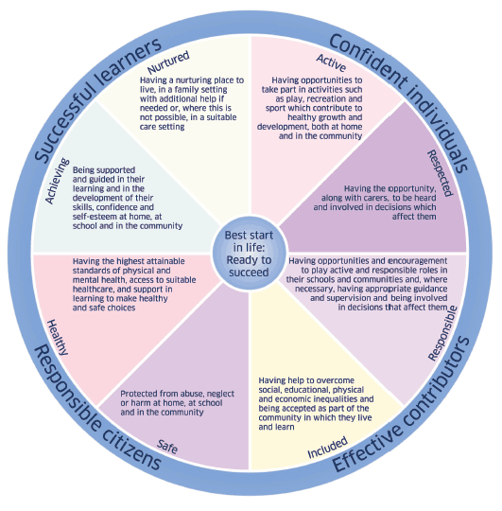

Strong community links

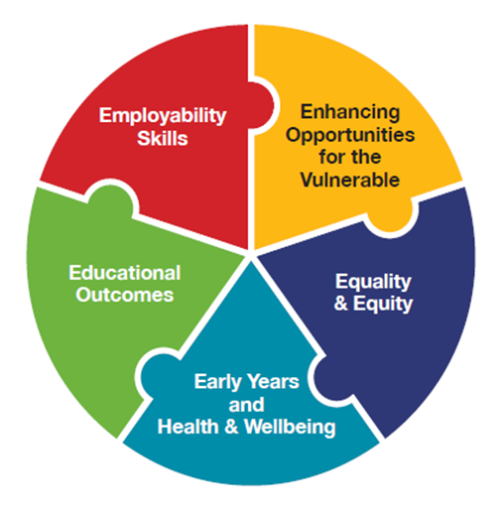

Primary Drivers

Secondary Drivers

**National Improvement Framework Priorities:**

* Improvement in attainment, particularly in literacy and numeracy
* Closing the attainment gap between the most and least disadvantaged
* Improvement in children’s health and wellbeing
* Improvement in employability skills

**Priority 1**

|  |  |  |  |  |  |
| --- | --- | --- | --- | --- | --- |
| **National Improvement Framework Priority:**  Improvement in attainment, particularly in literacy and numeracy  Closing the attainment gap between the most and least disadvantaged | | | | | |
| **Focused Priority: To create a culture of higher order thinking and questioning in every classroom which leads to increased engagement in learning and deeper understanding.** | | | | | |
| **HGIOS4 Quality Indicators** | | | **Links to UNCRC** | | |
| * 1.1 Self-evaluation for self-Improvement * 1.2 Leadership of learning * 2.3 Learning, Teaching and Assessment * 3.2- Raising Attainment and achievement | | | * Article 3 * Article 12 * Article 28 * Article 29 | | |
| **Expected Impact** | **Strategic Actions Planned** | **Responsibilities** | | **Measure of Success**  ***(Triangulation of Evidence)*** | **Timescales** |
| **To Improve learning and thinking skills in order to raise attainment in reading and comprehension by creating a culture of thinking and questioning to encourage deeper learning.**  **All children will demonstrate progress on baseline levels of reading comprehension.** | * Teaching staff will engage in professional reading and development on Making Thinking Visible and quality Questioning led by our PT, * Teachers will implement Visible Thinking routines to scaffold and support learners thinking. * Teachers will begin to plan and use a better quality questions to assess and deepen learners understanding. * Teaching staff will collaborate in Trios to plan and review their thinking and questioning routines and evaluate the impact on our learners. * Our PT and P2 teacher will lead the thinking culture through moderating the implementation of routines and questions through walkthoughs, observations and pupil and staff Voice groups. | Leads: Lindsay Scott  Lynne Wilkie | | * Observation of teachers questioning skills and pupil responses. * Pupil Voice -Interviews * Feedback on Questioning and thinking impact cycles. * Assessment of reading and comprehension activities to show improved outcomes in answers to inferential questions. | Term 1 and term 2 as per collegiate calendar for training and implementation to begin through initial impact cycle on Thinking routines within literacy. Term 2 impact cycle to focus on the use of quality questioning in the classroom.  Evidence of strategic impact to be collected throughout the year with the aim to develop a thinking culture and identify this within our learning dispositions going forward. |
| **Ongoing Evaluation** | | | | | |
|  | | | | | |

|  |  |  |  |  |  |
| --- | --- | --- | --- | --- | --- |
| Sinclairtown Primary School Badge**National Improvement Framework Priority:**  Improvement in attainment, particularly in literacy and numeracy  Closing the attainment gap between the most and least disadvantaged | | | | | |
| **Focused Priority: To plan for and make use of a wide variety of assessment evidence to show where learners are in their learning and identify development needs for learners.** | | | | | |
| **HGIOS4 Quality Indicators** | | | **Links to UNCRC** | | |
| * 1.1 Self-Evaluation for Self Improvement * 2.2 Curriculum * 2.3 Learning Teaching and Assessment * 3.2 Raising attainment and Achievement | | | * Article 3 * Article 28 * Article 29 | | |
| **Expected Impact** | **Strategic Actions Planned** | **Responsibilities** | | **Measure of Success**  ***(Triangulation of Evidence)*** | **Timescales** |
| * Identified groups of learners will show an improvement effect size of greater than 0.4 (based on the Visible Learning effect size calculator) over the timescale of a planned intervention. * All children will have the opportunity at Key points in learning to demonstrate their learning and skills through planned holistic assessment of numeracy benchmark. | * Teachers will plan effective baseline diagnostic assessments in reading, maths and mental maths to assess where children are in their learning. Teachers will use the baseline data to identify gaps for learners and inform planning. * Tracking meetings with SLT will support teachers to identify key areas for improvement in literacy or numeracy for groups of learners using the data. * Teachers will plan an impact cycle, based on baseline data, for groups of learners which will aim to ‘close this gap’. This will then inform a continuous cycle of data gathering and assessment. Data for focus groups will show an improvement effect size greater than 0.4 (based on the visible learning effect size calculator). * Teachers will work collegiately to become more informed of the moderation cycle and the range and purposes of assessment. * Teachers will work collaboratively to design and moderate examples of holistic assessment in numeracy. * Staff will use their knowledge of holistic assessment to plan to assess the benchmarks at the end of a period of learning, including the end of a level. * Staff will use holistic assessment to collect data on learners application of knowledge and skills in unfamiliar contexts in order to assess the benchmarks in numeracy. * Staff will work collaboratively to moderate holistic assessments. This will lead to improved professional judgement of attainment of a level in numeracy. * Class teachers will collect a range of assessment evidence in Numeracy for each learner which will support TPJ of attainment. Folders will be moderated across a level with stage partners. (Cluster partnership??) | Class Teachers  Teacher trios  Raising attainment teacher | | Data collection grids for baseline assessment.  Use of effect size calculator to collect data on impact of interventions.  Moderation of the quality of assessments alongside professional collaboration to interrogate and design examples of holistic assessments.  Quality of evidence of achievement and application of the benchmarks to support Teacher professional judgement of where learners are in their learning.  Planning and tracking meetings more focussed identifying targeted approaches to raise attainment for specific groups and for evidencing attainment. | Collegiate time to plan baseline assessment and impact cycles in term 1.  Term 3 and 4 collegiate calendars to dedicate hours to research design, implement and moderate holistic assessments. |
| **Ongoing Evaluation** | | | | | |
|  | | | | | |

**Priority 3**

|  |  |  |  |  |  |
| --- | --- | --- | --- | --- | --- |
| **National Improvement Framework Priority:**  Improvement in children’s health and wellbeing | | | | | |
| **Focused Priority: To develop emotionally literate learners who feel included, engaged and involved in the life of the school through Universal, Targeted and intensive approaches underpinned by children rights.** | | | | | |
| **HGIOS4 Quality Indicators** | | | **Links to UNCRC** | | |
| * 2.2 Curriculum * 2.3 Learning, Teaching and Assessment * 2.4 Personalised support * 3.1 Ensuring Wellbeing, Equality and inclusion | | | * Articles 3, 2, 4, 5, 12, 13, 15, 23, 28.29, 39, 42 | | |
| **Expected Impact** | **Strategic Actions Planned** | **Responsibilities** | | **Measure of Success**  ***(Triangulation of Evidence)*** | **Timescales** |
| * All children in school are engaged and involved in school. * All children are beginning to develop their ability to identify emotions and feelings and describe how this makes them feel. This is a next step on our nurturing School Journey and links with the Cluster plan. * The majority of children show good progress towards understanding the role of children’s rights in our school. * The majority of parents are aware of the role of children’s rights in our school. | * Teachers will use Leuven scales and The Glasgow Motivation and wellbeing profile to gather baseline data about wellbeing, engagement, agency, affiliation, autonomy and keeping healthy and safe. * Baseline data will be discussed at planning and tracking meetings to identify groups and individuals who would benefit from nurture support. The Glasgow profile will support staff to define areas where children needs support and the nurture programmes will focus on these areas. * Resources to be purchased with PEF funds * Emotion works will form part of our HWB programme on a universal level. * Intensive support will be provided to identified learners who will work with our nurture PSA on a more targeted programme created by SfL teacher. * **Teaching and Learning about rights**: for the whole school community through training, curriculum, assemblies, topics, focus days/weeks, displays. * **Teaching and Learning through rights**: by modelling rights respecting language and attitudes and making strategic decisions that involve students. * **Being ambassadors for the rights of others**: developing as rights respecting citizens | * Class Teachers to carry out initial information gathering and discuss with SLT. * SfL teacher and Nurture PSA to plan and co-ordinate identified groups and collect information through regular review. * All staff * SLT at assemblies if permitted. * Mrs McIntyre * Staff focus group * Rights Respecting pupil group * Parents group | | * The Glasgow Motivation and Wellbeing Profile will be completed at the beginning of terms 1 and 4. The Leuven scale will be completed once per term. Information gathered will support identification of targeted groups and individuals who may require targeted/ intensive support. * Targeted groups will be reviewed every six weeks through discussion/ feedback from children on areas of perceived need being targeted through each group. * All learners recognise what the cogs represent. * Most learners are talking about their emotions in relation to the cogs which represent emotion triggers, body sensations, emotion behaviour and regulation strategies. * RRSA Silver accreditation which will involve triangulation of views and evidence to show we have achieved the accreditation. | * End of August for initial baseline data and termly baselines thereafter. * Six weekly for targeted groups. * Introduce Emotion works in term 1. * Weekly input for learners. * By August 2022 |
| **Ongoing Evaluation** | | | | | |
|  | | | | | |